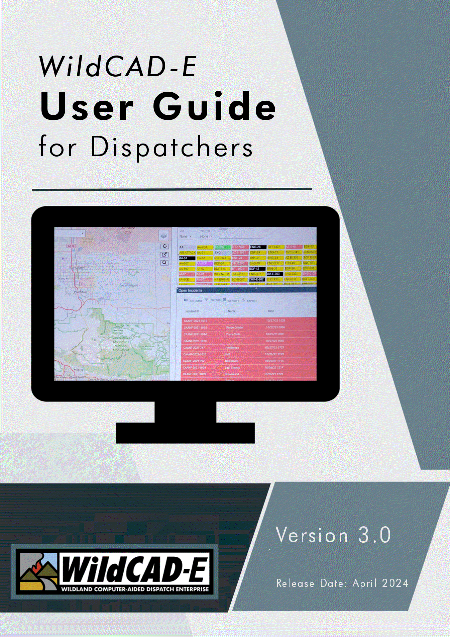
Version 2.0.1
December 2025
Table of Contents
Introduction 1
Format of the User Guide for Dispatchers 1
User’s Environment 1
Considerations to Ensure Continuity in the Use of WildCAD-E and Workspace Suggestions for the User 1
Alternate Authentication When FAMAuth is Unavailable 1
WildCAD-E Roles 2
Application Rules of Behavior and Security 2
HelpDesk Service Request 2
Part I: Home Page 3
Section 1: The Ribbon 4
▪ About 4
▪ Help 4
▪ Username and Center ID 6
▪ My Profile 6
▪ Save Layout 7
▪ Clear Layout 7
▪ Save Map Layout 7
▪ Clear Map Layout 7
▪ Switch Centers 7
▪ Log Off 8
Section 2: Icons and Function Keys 8
Section 3: Hamburger (Pull-down Menu) 8
Part II: Daily Routines 9
Section 1: Whiteboard 9
To Add an Entry: 10
To Delete an Entry: 11
Section 2: Station Dispatch Sequence 11
Section 3: Foreign Resources 12
Section 4: Restore Archived Resources 13
Section 5: Rostering Authorization 13
Section 6: Rotations 14
Record Assignment Grid 14
Assignment History Grid 15
Section 7: Web Comments 15
Section 8: Contracts 16
Section 9: Set Response Level 17
Section 10: Reassign Resources 17
On the left side of the panel: 17
On the right side of the panel: 18
Section 11: Restore VOID Incidents 18
To restore a voided incident: 18
Section 12: Line Ups 19
To change a status on all resources: 19
To change a status of one resource: 20
Multi-Select Resources 21
Section 13: View IRWIN Incidents/Resources 22
Section 14: View Merged Incidents 24
Section 15: Clear Resource Groups 24
Part III: Opening Operations 25
Section 1: Map Icon (F5) / Map Tab 25
Function Key 26
Map Tab 26
Layers List 26
Select the Center Data 29
Displaying Line Features 30
Other Data – Overlapping Polygon Features 30
Select from either Incidents, Resource, WildCAD Data or Other Data 31
Plus, and Minus sign Icons (Upper Right Corner of the Map) 32
Auto-Refresh Incident and Resource Icons 32
Show Incident Type, Acres and Fire Dates 32
Lightning (Last 24 hours or Last 7 Days) 33
Vehicle Layer Tracking 34
Temporary Flight Restrictions (TFR) 36
Military Training Routes (MTR) 37
Recent Map 38
Clear Point 38
Dropped Point 38
Map Footer 39
Your Data - Add layer from a linked Uniform Resource Location (URL) 41
Your Data - Add Layer from a Zipped Shapefile 42
Create Incident 43
Section 2: Search Bar and Find Panel 44
Using the Search Bar 44
Using the Find Panel 45
Lat/Lon: 46
UTM 46
T/R/S 47
Response Area 49
Finding a drop point using Bearing and Distance 49
Finding a drop point using Triangulation: 50
Place Name: 51
Mile Post: 52
Section 3: Using Display Information 52
Section 4: Print Map Function 54
Section 5: Search Incident Panel (F2-or Search Icon) 56
Section 6: Resource Status Panel (F7 or Resource Icon) 57
Resource Status Filter: 58
Dispatch Location Filter: 58
Adding Comments about a Resource to Daily Log 60
Adding Comments about a Resource to Incident Log 61
Resource Current Dispatch Location 62
Map Location Button 62
Creating a Groups 64
General Rules for Groups 65
Cancelling a Groups 66
WildShare 66
Starting Law enforcement (LE) incidents from Resource Panel 68
Resource Status Color Code 69
Section 7: Integration 69
Resource Integration 69
IRWIN Observer 70
Incident Quarantine Warning 71
Section 8: Open Incident Panel (F8 or Open Incident Icon) 72
Method 1 – Incident Type, or Mine or Stage 72
Method 2 – Incident Type 73
Export (Open Incidents to CVS File) 74
Section 9: Daily Log Panel (F12 or Daily Log Icon) 74
Add Log Entry 74
Editing or Viewing the Daily Log by either Incidents or Resources or Both 75
Highlight and Action 76
Part IV: Roster 77
Section 1: Rostering 77
Creating a Roster 78
Section 2: Picklist Setup 81
Part V. Incidents 84
Section 1: Search Incident Panel (F2 or Search Icon) 84
Section 2: New Incident (F9 or Incident Icon) 85
Create Incident 85
Header Information – Upper Portion 88
Map Button 93
Options Button (PDF, IWI, MIR, MERGE WF and FI) 93
PDF 94
Incident within an Incident (IWI) 94
Medical Incident Report (MIR) 97
Merge 102
IRWIN Integration 104
Home Tab (HOME) 106
Incident Log Tab (LOG) 106
Response Tab (RESP) 109
Comments Tab (CMNT) 118
Aircraft Tab (AIR) 118
Distance Tab (DIST) 119
Fires Tab (FIRES) 120
Frequency Tab (FREQ) 123
Fiscal Tab (FISC) 124
Questions Tab (FI - Wildfire or varies) 125
Actions Tab (ACTNS) 126
Numbers Tab (ADMIN) 126
Notifications Tab (NOTIFY) 127
Incident Command Post Tab (ICP) 127
Hazard Tab (HAZ) 128
Incident Commander Tab (IC) 129
Move Up Tab (MU) 129
Contracts Tab (CONT) 130
Relationship Tab (REL) 131
IRWIN Status Tab (IRWIN) 132
Conflict Status Tab (CONF) 132
Timer Tab (TIMER) 134
Transfer Wildfire Tab (XFER) 134
Incident within Incident Status Tab (IWI) 136
Final Fire Reporting (FFR) 137
Field Interrogation File Tab (FI) 137
Section 4: Prescribed Fire Escapes, Post Fire Events and Out of Area Response 138
Prescribed Fire Escapes (FI – Prescribed Fire) 138
BAER (FM – Emergency Stabilization) and Rehab (FM – Fire Rehabilitation) 141
Fire Support (FM – Out of Area Response) 143
Section 5: Timers 145
Open Timers (F4 or Open Timer Icon) 145
Creating a New Timer 146
Sound 149
Section 6: Complexes 151
Create a Complex 151
Incident Name 152
Log and IRWIN Buttons 152
Incidents Button 153
Releasing Incident from a Complex 155
Section 7: Law Enforcement Incident 155
Creating a Field Interrogation File (FI File) from a Law Enforcement Incident 156
Field Interrogation File (F3 or FI File Icon) panel 158
Part VI: Phone Directory 162
Section 1: Using the Phone Directory 162
Searching the Phone Directory by Columns 162
To Look Up a Person in the Phone Directory 162
To Clear the Search 163
To Refresh the Phone Directory 163
Adding a person to the Phone Directory 163
Section 2: The Phone Directory Layout 164
Part VII: Text/Email 164
Section 1: Using Text/Email 164
Two Ways to Send Text/Email Messages 165
Select Recipient Name Text/Email Message 165
Compose Preset Messages 167
Selecting a Group Name Text/Email Message 168
Part VIII: Reports 169
Section 1: Available Reports 169
Summary Graphs/Reports 169
Normal Response Run Card 170
Daily Log Report 173
Morning Lineup Reports 175
In Service Report 176
Timer Report 176
Custom Incident Report 177
Part IX: HelpDesk Service Request 181
Section 1: Opening the Service Request Window 181
Section 2: Viewing Pending Service Requests 181
Section 3: Creating a New Service Request 183
Part X: Alternate Authentication (When FAMAuth is Unavailable) 186
Part XI: Links 188
Section 1: Websites and Documents 188
Websites 188
Documents 188
Part XII: Appendices 190
Appendix I – Icons and Function Keys 190
Appendix II - Grids 192
Sort Order of a Grid 192
Add a Record or Row to the Grid 193
Delete a Row to the Grid 193
Actions and Settings at the Top of the Grid 194
Appendix III - Reports 196
Available Reports 196
Morning Lineup Reports 196
Responding Resource List 197
Open Incident 198
Incident By Date 198
Fire Report 198
Monthly Fire Summary 199
Contract Report 200
Appendix IV – Incident Types 201
Appendix V – Resource Command Line 203

Introduction
Welcome to WildCAD-E, the web-based Computer-Aided Dispatch (CAD) system developed by Bighorn Information Systems for wildland fire agencies and targeted for Emergency Communications Centers of all sizes.
The purpose of the WildCAD-E User Guide for Dispatchers is to lead a Dispatcher through a typical duty day.

Format of the User Guide for Dispatchers
The WildCAD-E User Guide for Dispatchers is set up in multiple parts, with various associated sections described to lead the user through each part.

User’s Environment

Considerations to Ensure Continuity in the Use of WildCAD-E and Workspace Suggestions for the User
- Dispatchers need a computer with either a Google Chrome or Microsoft Edge browser. Make sure the browser used is current.
- Field employees doing rostering can use a computer, tablet or phone.
- Two computer monitors available to WildCAD-E will allow the dispatcher to drag items to a separate monitor.
- A cell-based hotspot is recommended for backup in the event the user loses internet connectivity.
- A fast internet is essential. Evaluate your internet speed at https://www.speedtest.net.
- The previous session timeout of 8 hours has been removed. Current timeout will occur 8 hours after the user logs out of WildCAD-E. FAMAuth Profile Management Access
Org Unit Managers use their FAMAuth Profile Management screen to:
- Complete steps the Org Unit Managers must take through FAMAuth to assign centers and roles.
- Approve or deny user requests and grant access, even when a user has not previously requested it.
- Approve access requests submitted by users and grant access to their dispatch center for users who have not requested access.

Alternate Authentication When FAMAuth is Unavailable
Alternate Authentication (See Part XI) feature to allow users to log into WildCAD-E using an alternate secure method, if FAMAuth is experiencing an outage and is unavailable.

WildCAD-E Roles
- Center Administrator provides access to the Center Admin menu.
- Dispatcher allows access to all dispatcher-related screens.
- Roster provides access to just rostering capabilities in WildCAD-E.
A dispatcher who will also roster will need both the Dispatcher role and the Roster role.
- Read Only Users with “Read-Only” role will be allowed to login to the WildCAD-E application and view most pages and panels except the Center Administrator pages.
Read Only users:
- This role takes priority over Dispatcher or Center Admin roles.
- Any changes the user may try to make are prevented from being saved.
- May still save their personal settings (Home layout, Map layout, etc.)
- The application banner is orange and displays the user is in “Read Only” mode.
- In the MIR Panel/Incident MIR Tab, the print and save buttons are disabled.
- If the “Roster” role is assigned to the user, they can roster as normal.
- Any changes to roster status are immediately broadcast to other dispatchers.

Application Rules of Behavior and Security
The user will be presented with a splash screen page for Rules of Behavior and Agencies Security Requirements that must be agreed to before entering into the application.

HelpDesk Service Request
If a user needs technical support from WildCAD-E, a user can submit a Service Request or view a pending Service Request directly within the WildCAD-E application. Review the Service Request procedures in Part XII: HelpDesk Service Request.

Part I: Home Page
The Home page is divided into three major sections: 1) the ribbon across the top, 2) the Icons, and 3) the pull-down menu or the “Hamburger” menu (≡), which displays the pull-down menu.
Figure 1- Home Page Ribbon shows System, Status of CAD, About, Help, User, Dispatch Center and Chat Icon (L-R)
Figure 2 - The Icons are located below the Ribbon.
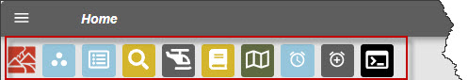
Figure 3 - The "Hamburger" is located above and to the left of the Icons.
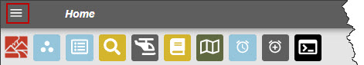
Implemented application-wide, the following library updates and aesthetic user interface changes for accessibility compliance were made:
- added a focus indicator (or focus ring/outline), which is a visual cue to show which element currently has keyboard focus;
Figure 4 – Focus Ring, Font and Color Scheme
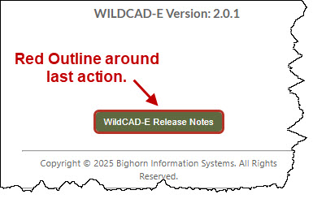
- made slight changes to the font and color scheme with less use of stark white space; and
- added a grid row alternating colors and updated grid header appearance for easier viewing.

Section 1: The Ribbon
The Ribbon includes:
- System – Indicates current operating environment and version.
- CAD Status – On or offline.
- About –By clicking on “About,” a pop-up window will open. Closing the pop-up will return the user to Home Page. Users can view the current version and system being used. Click on “WildCAD-E Release Notes” button to retrieve all the release notes.
Figure 5 - Further defines what is available under “About.”
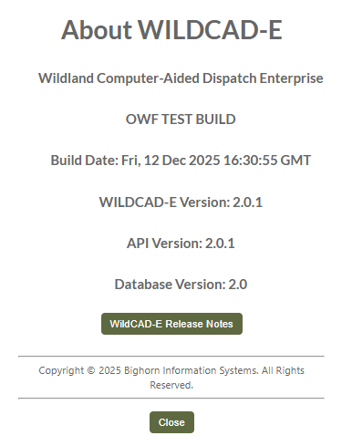
Figure 6 - Release Notes
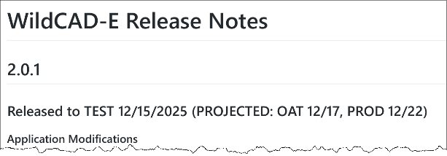
- Help – Clicking on “Help” will take the user to pop-up window that has links the following pages, then click on one of them to open a new tab.

Figure 7 – Help Pop-up
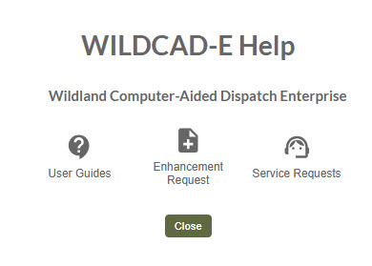
- User Guides (and Videos) - Provides comprehensive documentation and step-by-step guidance for the use of WildCAD-E features and functionality.
Figure 8 – User Guide and Training
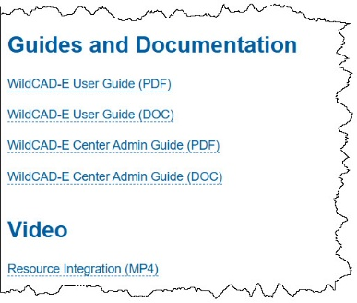
- Enhancement Request -Maybe used to suggest enhancements to WildCAD-E. These requests go directly to the WildCAD-E (WCE) Change Control Board (CCB) Members.
Figure 9 – Enhancement Request
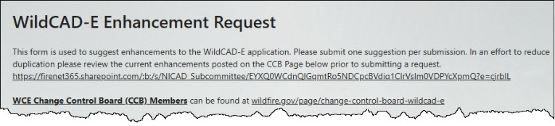
- Service Request -See Part XII: HelpDesk Service Request
Figure 10 - Service Request
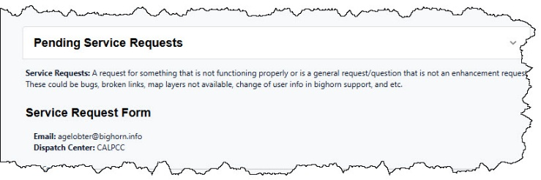

Username and Center ID
Indicates user, the current dispatch center, and where you can find the profile information for the current user. You can do this by clicking on the name.
Figure 11 - Further defines the information available under "Username and Center ID."
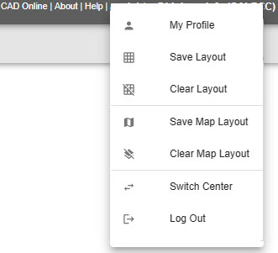

My Profile
Click on “My Profile” to display the following by clicking on the user’s email in the upper right corner:
Figure 12- My Profile provides information about the User.
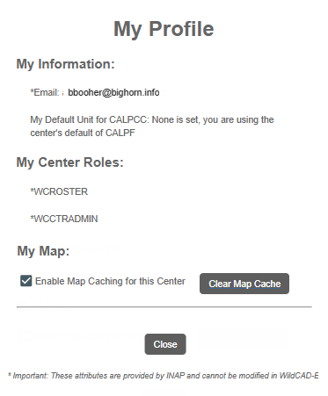
The “My Profile” option opens as a pop-up rather than opening on a new page. This allows the user to maintain the same content on the home page and not refresh when checking their profile.
Displays the attributes provided from iNAP and cannot be modified in WildCAD-E. Any changes will need to be made through the Center’s iNAP Org Unit Managers.
- My Information – Displays the user’s Email, Current Dispatch Center, and Current Unit that the user set as the Default.
- My Center Roles – This is a listing of what roles the user has, such as Center Administrator, Dispatcher and or Roster.
- Manage Map – By checking the box next to “Enable Map Caching for this Center,” the shapefiles can be cached to improve map load time. If, however, you experience problems loading the map after turning this on, uncheck it and click "Clear Map Cache.", this clears the user’s browser’s cached map data to resolve map issues. This feature only applies to the users only for the center to which they are logged in.

Save Layout
Use this menu item to save the current layout of user screens – which windows are open and where they are located – so that the same layout will appear at startup the next time the user launches WildCAD-E.
If an incident panel is open, saving the home layout will save the location and dimensions of the panel. The next time the application is refreshed, new or existing incident panels will open with the same dimensions and location instead of the default top left.
If the Resource Status Panel is part of the user’s layout, the filter toggle will be saved in the position it set as part of a user’s saved layout.

Clear Layout
To remove the saved screen layout, use this menu item.

Save Map Layout
Use this menu item to save the current map layout including zoom level, map center, and active layers. The save layer applies to both map panel and map in a separate tab – so that the same layout will appear at startup the next time the user launches Map.

Clear Map Layout
To remove the saved map layout, use this menu item.

Switch Centers
- Under “Switch Center,” use the dropdown menu to locate the appropriate dispatch center.
- Select the correct center from the list to change centers.
Figure 13 - Switch Dispatch Centers
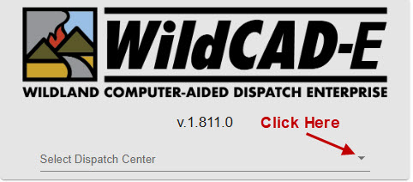
Figure 14 - Select the new dispatch center from the dropdown menu.
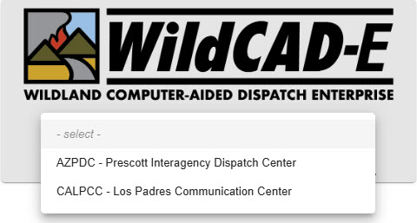

Log Off
- The action of logging off will require the user to log in as before.

Section 2: Icons and Function Keys
Icons and Function Keys make up the second area of the Home Page and are reviewed in Appendix I – Icons and Function Keys. When a function key is available, users can either use the icon or function keys to access those panels within WildCAD-E.

Section 3: Hamburger (Pull-down Menu)
Click the “Hamburger” symbol (≡) on the Ribbon, and the pull-down menu will appear.
Figure 15 – Click on the ≡ (Hamburger) to access the pull-down menu.
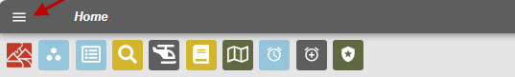
Click on the appropriate topic in the pull-down menu, which will then allow the user access to each one of the menu items. Each menu item will open in its own “Tab,” except Links:
- Maps
- Phone Directory
- Text/Email
- Daily Routines
- Roster
- Reports
- Links
Figure 16 - Hamburger Pull-Down Menu
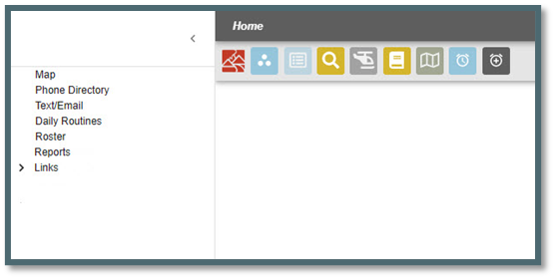

Part II: Daily Routines
Figure 17 - Daily Routines open into a separate map.
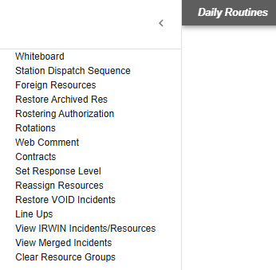

Section 1: Whiteboard
Figure 18 – To add an entry click on the plus sign and put the entry in a category.
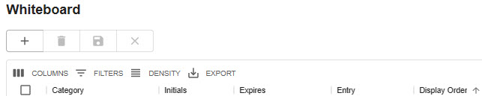
The whiteboard is intended as a place to temporarily maintain information (for a day or two), it is NOT for long-term storage of information or a place to maintain a long history of any action or incident.

To Add an Entry:
Figure 19 - Whiteboard Dropdown Menu.
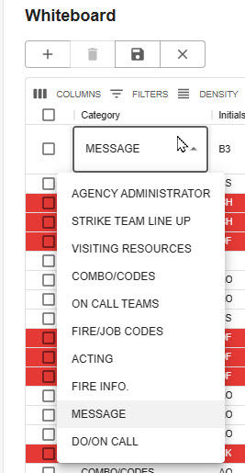
To add a row, click the plus sign and enter the following:
- Category – use the Dropdown to select the category.
- Initials – enter the dispatchers initials.
- Expires – enter the date and time this whiteboard entry will expire. Note: when whiteboard entries reach the expiration date, they will turn red.
- Entry – enter the message text.
- Display – the number entered will determine the message display order with the smallest number being displayed first.
- Click the “Save” icon.
Figure 20 – Click the “Save” Icon
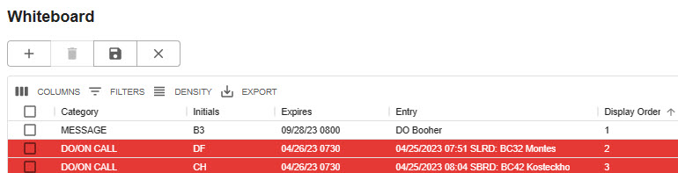

To Delete an Entry:
- Check the box for the entry to be deleted.
- Use the trash can to delete the entry selected.

Section 2: Station Dispatch Sequence
Figure 21 - Station Dispatch Sequence is set by the Center Administrator allowing resources to be dispatched in a preferred order.
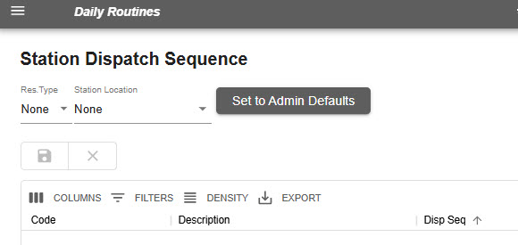
Center Administrator sets the Admin Defaults for the station dispatch sequence and does so for each resource type, allowing those resources to be dispatched in preferred order. Although the sequence is set, there may be times when resources are not dispatched according to the admin defaults.
Example of Re-sorting Station Dispatch Sequence. An example would be if Engine 311 is sequenced to go out before Engine 1R; but for that day, Engine 1R needs to go out before 311. To make that happen, assign a high number to Engine 311 and save it. The system will automatically re-sort the priority, so if only one engine is required for the day, Engine 1R will be dispatched first.
- Use Station Dispatch Sequence to set or reorder resource dispatch order by assigning the appropriate number in the sequence to the “Disp Seq” column.
- Identify the resource that should be top priority for the day.
- Assign a higher number to the current priority resource.
- The system will automatically re-sort the priority for that resource.
- To revert to the admin defaults, click the “Set to Admin Defaults” button.

Section 3: Foreign Resources
Figure 22 - Foreign Resources are those resources temporarily assigned to the user’s assigned Dispatch area.
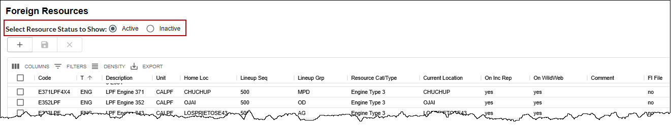
In WildCAD-E, the term “Foreign Resource” means resources from outside the Dispatch area that are temporarily assigned to the Dispatch area. Although only the WildCAD-E Center Administrator can add or edit the users own Resources, all dispatchers may add/edit/Set Active (Yes/No) Foreign Resources as they come and go from the users assigned Dispatch area.
To view “Active” or “Inactive” Foreign Resources select the appropriate button for resource status to be shown.
- To add a Foreign Resource, press the “+” enter or select all required information, and click Save.
- Make any necessary edits and click “Save.”
- Code: Keep this as short as possible, since it will be displayed on numerous reports and lists. For example, use E31, not ENG31SQF.
- Type: Select from the dropdown the resource type (engines, dozers, etc.).
- Description Type: The description of the resource.
- Unit and Home Loc (Home Location) are all dropdown lists that the user created earlier.
- Lineup Seq (Line Up Sequence) controls the order in which Resources are listed on the morning Lineup Panel. This has nothing to do with the order in which they are dispatched - merely the appearance on the screen.
- Lineup Grp (Lineup Groups) are all dropdown lists that the user created earlier.
- Resource Cat/Type (Categories and Type) are all dropdown lists that the user created earlier.
- Dispatch Location are all dropdown lists that the user created earlier.
- On Inc Rep Yes or No if the user wants this Resource listed on the printed Incident Reports.
- On WildWeb: Unless this is “Yes,” this Resource will not show on the internet reports from WildCAD-E called WildWeb.
- Active: Select “Yes” is the Foreign Resource still available. You cannot inactivate “No” resources while on an incident. Once a resource is inactivated, the resource will show the list of “Restore Archived Resources.”
- Comments: Enter text as it relates to this resource.
- F1 File: Select “No” is the Foreign Resource not authorized for law enforcement activities.

Section 4: Restore Archived Resources
To restore an archived resource, go to the “Restore Archived Resources” screen, and change the “Active” status from no to yes.
Figure 23 -Restore Archived Resources
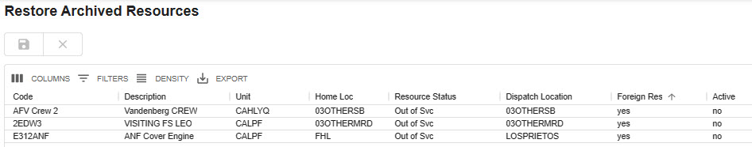
Figure 24 - Restore resource by changing the "Active" column from no to yes.
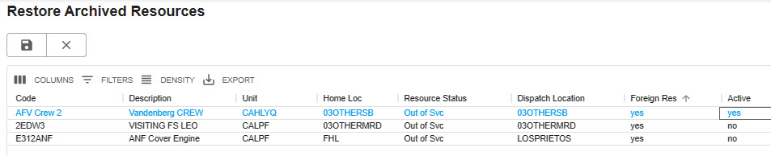

Section 5: Rostering Authorization
Figure 25 - Rostering Authorization
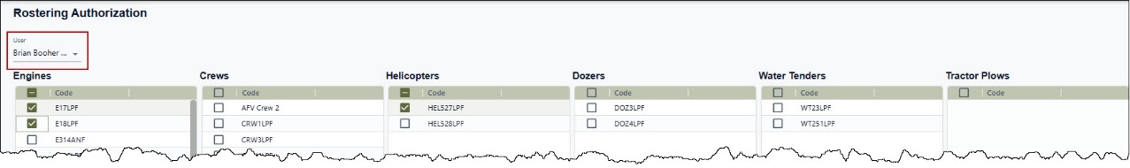
Rostering Authorization opens in its own Tab. Dispatchers can only authorize those personnel who have the Roster Role in WildCAD-E. If a Dispatcher is also going to do the actual rostering, the Dispatcher should have been assigned both the Dispatcher Role AND the Roster Role.
- Select the person’s name the user wants to have rostering authorization.
- Click the check boxes of which specific resources they will be authorized.

Section 6: Rotations
The Center Administrator sets up rotations at their respective center. Once rotations are set, they will appear here in WildCAD-E.
Figure 26 - Once rotations are set, they appear on the "Rotations" panel.
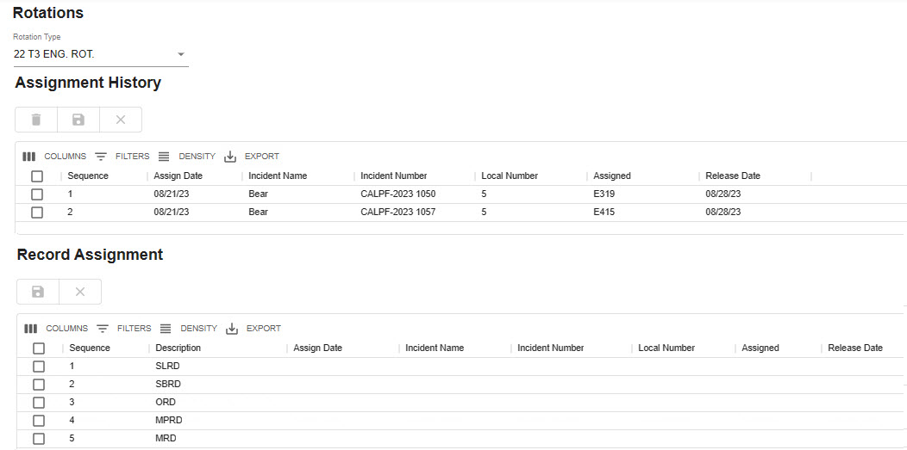

Record Assignment Grid
- Data is filtered by selected Rotation Type, set by dropdown at the top of the page.
- Enter “Assign Date,” “Incident Number,” “Local Number,” “Assigned,” and “Release Date.” The columns are visualized to match rotation data.
- All columns are editable in the grid except for the “Sequence” and “Description” columns.
- Once a row has been edited, Click save, and the record will be added to rotation table.
Figure 27 - Record Assignment

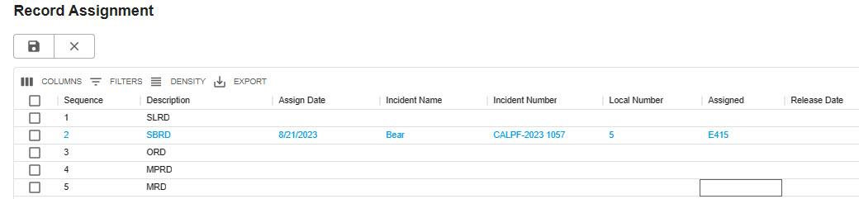Assignment History Grid
- On this grid, the only entry allowed is the Release Date.
Figure 28 - Assignment History
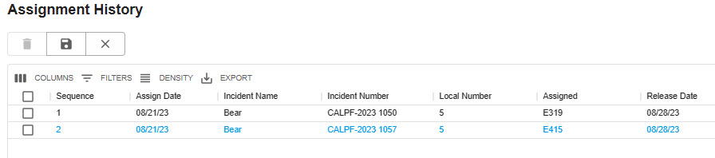

Section 7: Web Comments
Figure 29 - Web Comments are used to share any type of free text message.
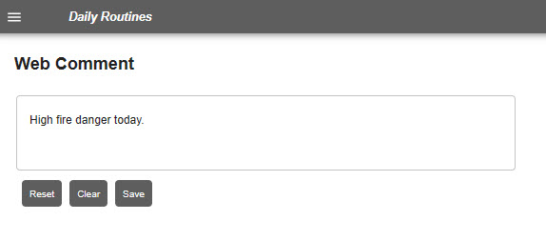
Web Comments is an option for use by a dispatch center to share any type of free text messaging.
- Use the “Reset” button to display the last saved comment.
- Use the “Clear” button to clear contents.
- Enter comments and then click the “Save” button.

Section 8: Contracts
Figure 30 - Contracts.
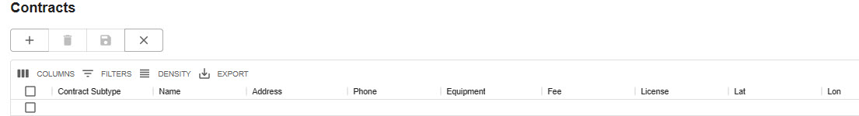
A dispatcher uses “Contracts” to manage the list of contractors for which the Center has agreements/ contracts for incident support. “Contracts” was developed before Viper, so many WildCAD centers now use Viper and no longer use the contracts concept in WildCAD. “Contracts” is where the dispatcher enters this information, so that the contracts will show up on the “Incident Contracts” tab. Dispatchers can add, edit and/or delete contract resource information here.
To add a contract resource:
- As with other grids, click the plus sign to add a new row.
- Use the dropdown to select the appropriate type of contract and any subtypes established by the users respective Center Administrator.
- Complete the required information.
- Click the “Save” button.
NOTE: It is important to have the latitude and longitude for the incident because the LAT/LON will drive the proximity to the incident on the contracts tab.
Figure 31 - Contract Map shows the location of Resources.
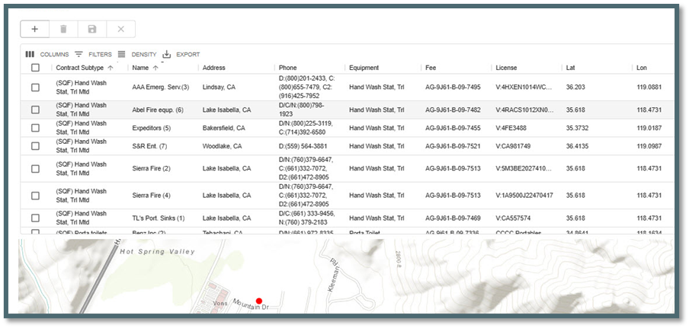
- No Action is required. These are informational screens. These screens allow the user to search for a specific resource to determine incident / location.

Section 9: Set Response Level
Figure 32 -Set Response Level
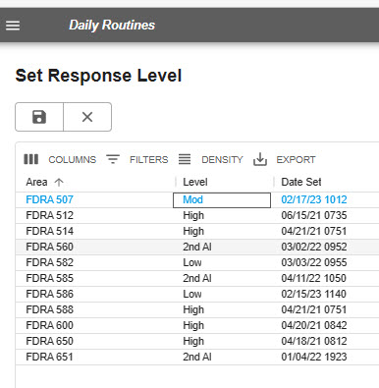
- “Set Response Level” screen allows the user to set the daily response level for each resource by modifying the “Level” column.
- The date and time will automatically be modified to document the change.

Section 10: Reassign Resources

On the left side of the panel:
- Select the “Source Incident” by either typing a few letters of the name or selecting from the dropdown list.
- Once the Incident is selected both the “Resource Code” (Name of Resource) and “Resource Status” will be populated.
Figure 33 - Reassign Resources
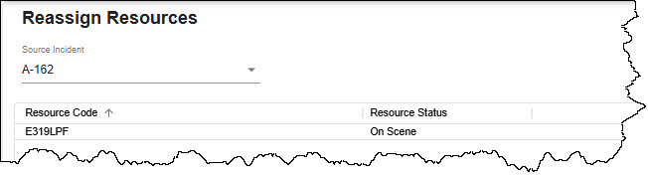

On the right side of the panel:
- Select the “Destination Incident;”
- Click “Re-assign Resource from Source to Destination.”
Figure 34 - Confirmation of reassignment.
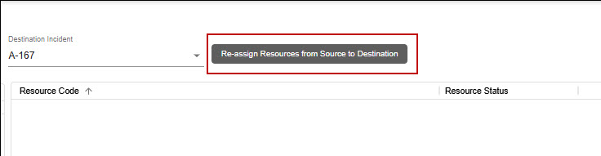
Confirm reassignment of all resources from the old incident to the new, by selecting “OK.”
Figure 35 - Confirmation of reassignment.
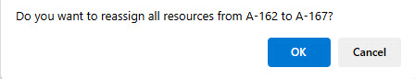
All resources listed will be reassigned to Destination Incident as “Committed.”
Figure 36 – Reassign resources from source to destination.
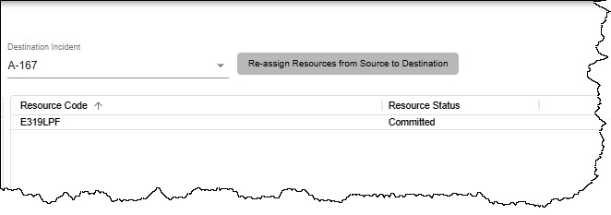

Section 11: Restore VOID Incidents

To restore a voided incident:
- Enter “Discovery Date” (From/To).
- Select the incident “Type” from the pull-down menu.
- Click “Search button or “Clear’ button to start over.
Search fields for date to and from and the incident type were added, as well as search and clear buttons. Since the page can only return up to 250 records, adding this feature will allow the user to search for any void incident no matter how old. If you exceed 250 records, an alert will appear.
Figure 37 - Restore VOID Incidents
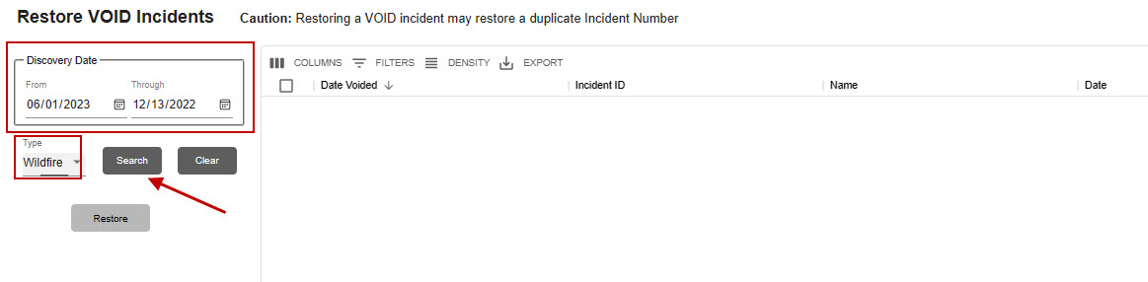
After clicking the search button, the list of incidents will appear.
Figure 38 - List of VOID Incidents
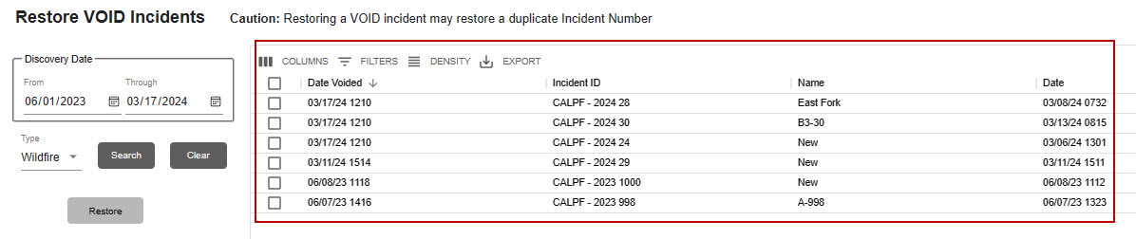
Select the appropriate incident by checking the box next to the VOID incident and use the “Restore” button to restore the incident.
Figure 39 - Restore VOID Incidents
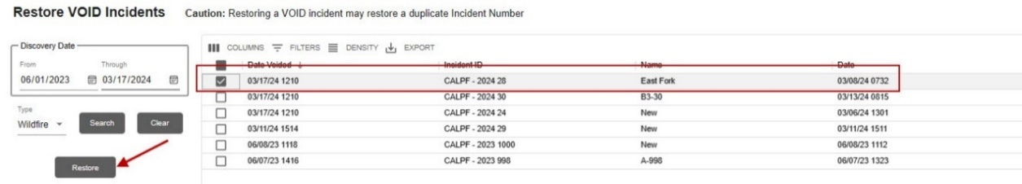

Section 12: Line Ups

To change a status on all resources:
- Select the Lineup Group from the Lineups dropdown list.
- Click on either the “Out of Svc” or “Available” button. The user will be asked for confirmation.
Figure 40 - Line Ups Panel - All Resources
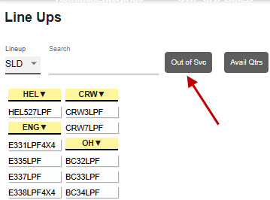
Figure 41 – Confirmation of Change to Out of Service
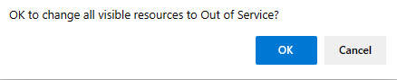
Figure 42 - Line Ups Panel - Out of Service
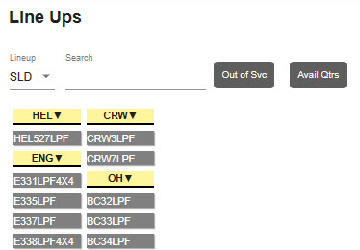

To change a status of one resource:
- Select the Lineup Group from the Lineups dropdown list.
- Select the resource by either typing a few letters of the name or by selecting from the list. The status and location of the resource will be displayed.
- Select the appropriate status from the Resource Status dropdown list.
- Use the Resource Status dropdown list to change the status.
Figure 43 - Select the Resource
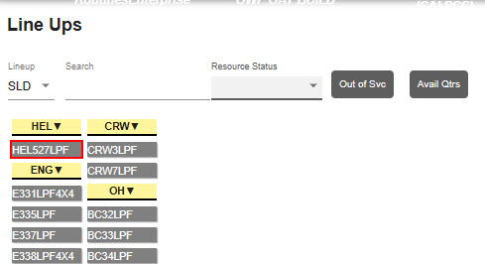
Figure 44 – Resource is Now Available
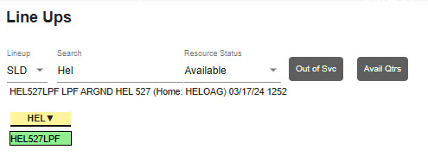

Multi-Select Resources
- Select the Lineup Group from the Lineups dropdown list.
- Ctrl + Click on multiple resources.
- A red box will be displayed on selected resources
- Select the appropriate status from the Resource Status dropdown list.
Figure 45 - Selecting multiple resources.
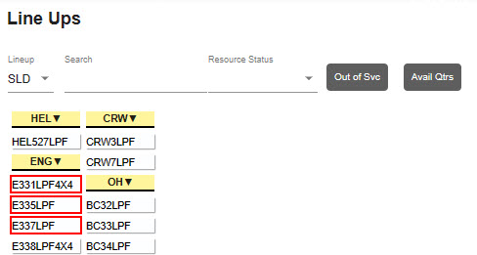
Figure 46 - Selecting Multiple Resources
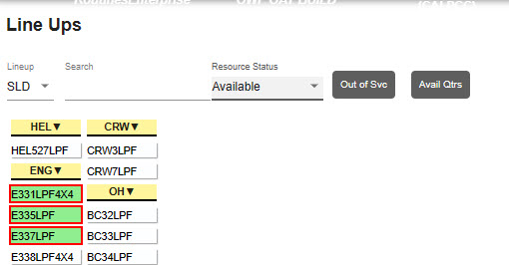

Section 13: View IRWIN Incidents/Resources
This panel allows the users to view the data associated with WildCAD-E resources that have been matched Resources in IRWIN. Select a resource in the “Resource Code” column and the “IRWINRID” and associated information will be displayed to the right.
Below the “Resource” information is displayed the resource “Capabilities” and “Open Capability Requests” information. This will display information associated with capabilities and requests for that resource and any field which displays a date/time.
Figure 47 - View IRWIN Resources
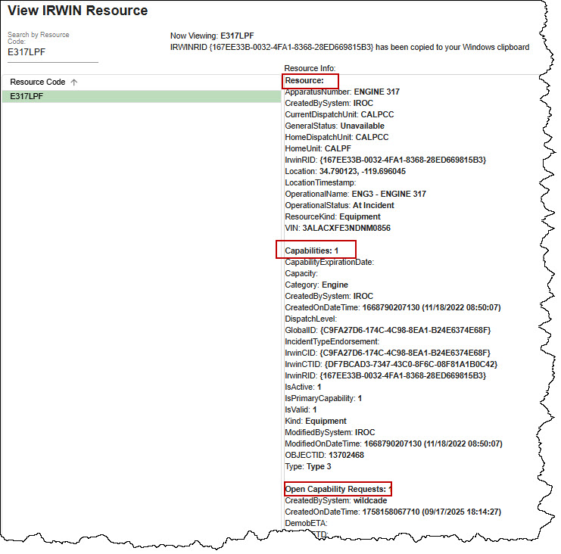
The user can search for specific resource by enter the “Resource Code” in line below “Search by Resource Code.”
Figure 48 - Search for a Resource
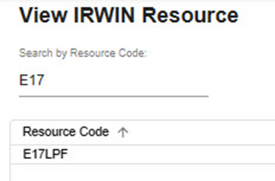
Select an incident in the “Incident Name” column, and the following information will be displayed as read only:
- “Incident Infor” – associated with WildCAD-E.
- “Final Fire Report” – associated with fire reporting.
Figure 49 - View IRWIN Incidents
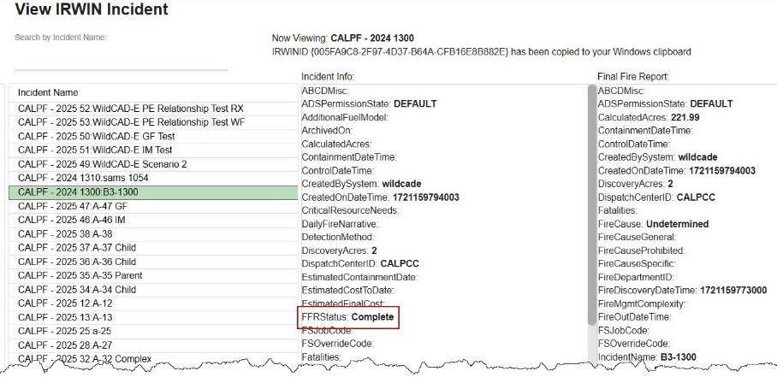
The user can search for specific incident by enter the “Incident Name” in line below “Search by Incident Name.”
Figure 50 - Search for an IRWIN Incident by Incident Name
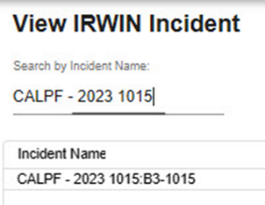

Section 14: View Merged Incidents
The user can view “View Merged Incidents” by clicking on the link.
The data is displayed by:
- Parent Incident ID and Name – the incident accepting the other incident.
- Child Incident ID and Name – the incident merging into the other incident
- Associated – Date and time the merge occurred.
- Associated By – the dispatcher that created the merge.
Figure 51 – Merged Incident
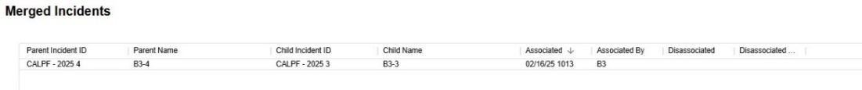
- Disassociated – Date and time the merge was unmerged.
- Disassociated By – the dispatcher that removed the merge.
Figure 52 – Unmerged Incident
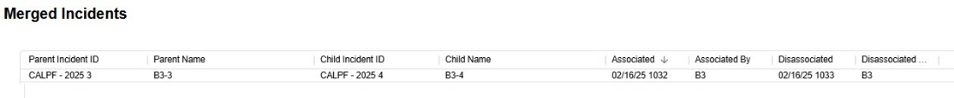

Section 15: Clear Resource Groups
Use this menu item to clear (delete) all Resource Groups.
Figure 53 - Clear all Resource Groups button.
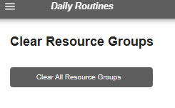
Figure 54 – “Clear All Resource Groups” button.
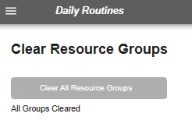
After using the “Clear All Resource Groups” button will indicate all groups have been cleared.

Part III: Opening Operations

Section 1: Map Icon (F5) / Map Tab
The Map can be opened in two ways:
- By selecting from the menu, the map will open in its own “Tab.”
- By clicking on the Map Icon button, the map will open on the “Home Page” screen.
The full screen map page has all the functionality of the map panel. In addition, it will show updated (live) incidents and resource locations every three seconds.
When launching WildCAD-E or when first opening the map panel, the map will take a second to load all the layers before it recenters the map on the extent shape layer identified by the center.
When the response area layer is refreshed for a center, the user is now alerted that a new file is available, and the user is instructed to refresh their map to see the new file. When a user logs in, the Response Area cache is refreshed if a new layer has been uploaded.

Function Key

Figure 55– Map Icon (F5)
The Map Menu (F5) allows the user to view and utilize various GIS layers, which were integrated with WildCAD-E.

Map Tab
Figure 56 - Map on Home page.
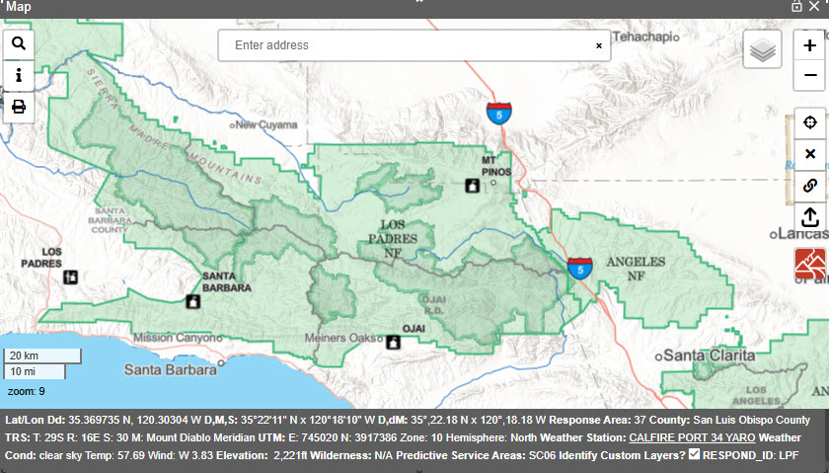
There are two (2) types of layers - Points and Polygons.
- Point data are shown as clustered icons on the map with a number showing how many points are in the cluster. These clusters will “explode” into smaller groups as the user zooms in or clicks on the cluster. Hover over a single icon on the map to show the identifying popup.
- Polygon data are displayed with different transparency and colors based on how the administrator has set up the layer. Click inside the polygon to get information about it. It will either be displayed on the map footer, or the point info panel (described below).

Layers List
Figure 57 - Layers List Icon

Figure 58 – Layers List has two sections—the Base Map Layers and Group of Data Layers
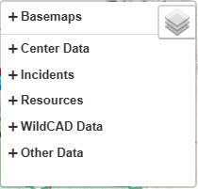
Clicking on the Layers Icon will display two sections.
- Upper Section – Base Map Layers
- Lower Section – Five groups of data from Layers List
The upper section allows the user to select one of the eleven map layers by selecting the radio button for which layer to be displayed. A horizontal scroll bar that is visible if the map panel size is smaller than the point info panel size.
Figure 59 - Base Map Layers
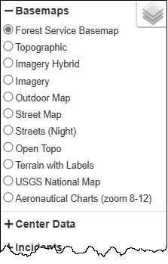
The lower section allows the user to select from five (5) groups of data in the layers list:
There are five (5) groups of data in the layers list:
- Center Data – These layers pertain to the center operations and are uploaded into WildCAD-E by the Center Administrator.
- Incidents - These are points for open incidents broken out by incident types.
- Resources - These are points broken out by resource type.
  - Resources are displayed at the incident's location only when their status is Responding or On Scene or Available At Incident.
  - Resources with status "Out of Service", "Duty Officer Out Svc", "Unavailable for Assignment" and "Day Off" no longer display on the map.
  - Resources are displayed at their current dispatch location in all other cases.
  - Resource's home dispatch location and current dispatch location can be the same.
- WildCAD Data – These are layers that have been added by the WildCAD-E Administrator. Examples of few of these layers are:
  - Dispatch Location
  - Response Areas
  - Hazards are points shown on the map as a large circle representing the hazard radius. Turn on the layer and hover over the circle to show the hazard name and the alert miles.
- Other Data - These are points and/or polygon data that have been added by the WildCAD-E Administrator.

Other Data section has a timeout for map layer services to respond slowly, which previously caused the map to spin indefinitely during initial loading. The map now waits a set amount of time before skipping the unresponsive layer and finishing the load. Additionally, when dropping a point, the map footer could get stuck on “Loading.” It will now wait a set amount of time before displaying “OFFLINE” for the layer.

Also, when an EGP site is not available or there is a token issue. The map skips those layers and finishes loading rather than continually trying to load. Any service layer that is not responding will display “OFFLINE” in red text next to the layer name. If the layer is used in the footer and is not responding, “OFFLINE” will also be displayed for that layer in the footer.
Figure 60 - Map Layers Unreachable
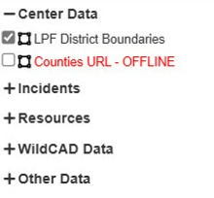
Figure 61 - Map Layers Unreachable Displayed in the Footer
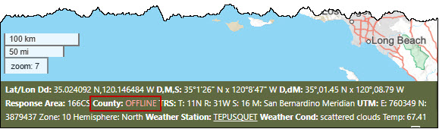

Select the Center Data
To view the data (points or polygons), click on the “Plus” sign next to Center Data, then select from the layers group checkboxes.
Figure 62 – Center Data Section
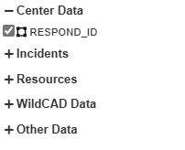
The Center Data layers that are shapefiles are downloaded once they are added to the map, instead of when the map is opened. This prevents a delay with the map being functional when it is first opened.
The Center Data Layers:
- have a “display field,” and are set up by the Center Administrator;
- are itemized in the layers list under “Center Data;” and
- may or may not be displayed on the map.

When the user checks the “Identify Custom Layers” box, a message “Data Loading” will appear. This message should eliminate any confusion on whether the checkbox is working.

Figure 63 – Center Data Section
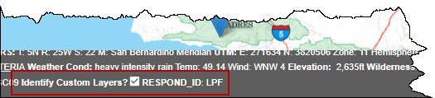
In addition, on the Map Footer there is a checkbox, “Identify Custom Layers?” When this checkbox is selected, information from the Center Data will be displayed, even if the Center Data layers are not checked.

Hazards are points shown on the map as a large circle representing the hazard radius. Turn on the layer and hover over the circle to show the hazard name and the alert miles.

Displaying Line Features
Center data layers that are line features can now have a display field. Once set, when a user hovers over the line feature, the attribute will show. Also, the line will be slightly thicker and will change to a contrasting color for that feature. The Center Administrator will need to define a valid display field within the layer whose value will then be shown on the map.
Figure 64 – Displaying Line Features.
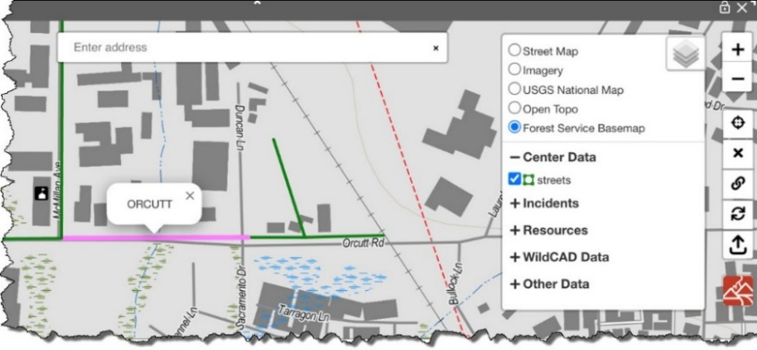

Other Data – Overlapping Polygon Features
Polygon feature layers from the Other Data section now display information for all overlapping features by right clicking the map.

Figure 65 – Other Data Overlapping Features
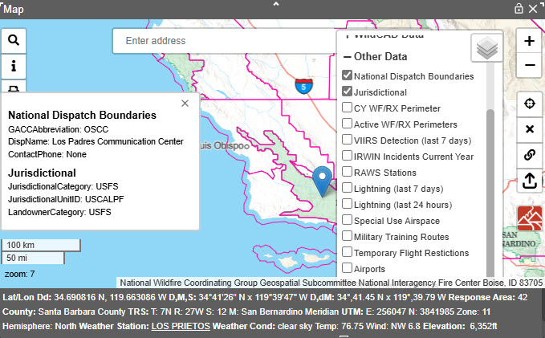

Select from either Incidents, Resource, WildCAD Data or Other Data
The workflow is the same as Center Data. Below is an example using the Resources data.
Figure 66 - Map Feature Resource Locations assist the user in locating resource types.
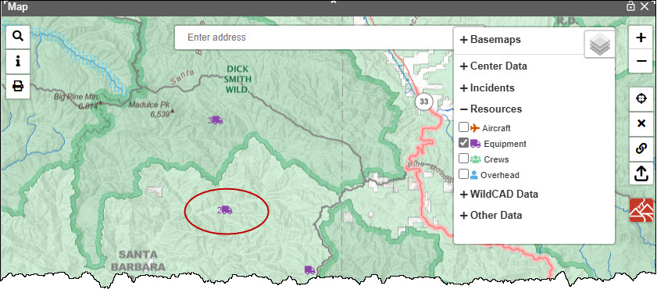
By checking the boxes next to “Equipment,” this will display the resource types and their locations on the map; and if the user hovers over them, it will display the actual resource names. The number next to the resource indicates how many resources are at the location. Click on resources with a number to display the resource at that location.

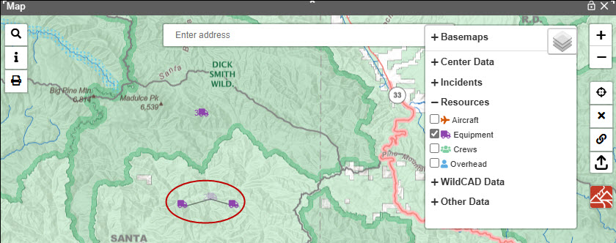
Figure 67 – Map displays location of resources.

Plus, and Minus sign Icons (Upper Right Corner of the Map)
The “+ “and “- “sign icons are used for zooming map in or out. The mouse scroll wheel can also be used for zooming the map in or out.

Auto-Refresh Incident and Resource Icons
When new incidents are added, or an incident is updated, the map icons will update without the user needing to close/open the map. For example, if the map is currently showing wildfire type incidents, and the user creates a new wildfire incident, a new icon will appear for that new incident. In addition, any changes to the incident name, type or location will also automatically be updated on the map.
Resource icons on the map will move locations as the resource’s status is changed without needing to close/open the map. The resource icon will move to the incident’s location once the resource status is set from committed to responding. In addition, when a resource location is moved using the resource status panel, the icon will auto-refresh.

Show Incident Type, Acres and Fire Dates
Hovering over an Incident Icon the pop-up will show:
- Incident name, the incident
- Incident Type (if it is listed as “Other” on the map)
- Acres (if there are acres in the Fire Report Information section of the Fires tab)
- Fire dates (if any).

Figure 68 – Incident Icon Pop-up Information.
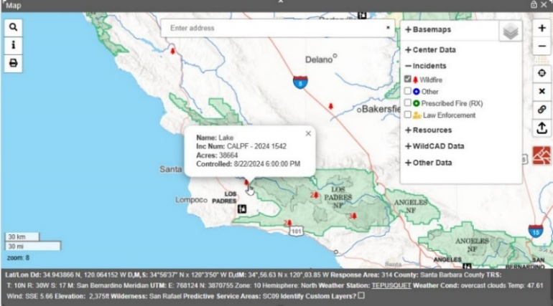

Lightning (Last 24 hours or Last 7 Days)
By checking the boxes next to “Lightning (last 24 hours),” this will display a RED lightning symbol indicating lightning activity clusters.
By checking the boxes next to “Lightning (last 7 Days),” this will display an ORANGE lightning symbol indicating lightning activity clusters.

Figure 69 – Lightning last 24 hours (Red) and last 7 Days (Orange) Lightning Symbol).
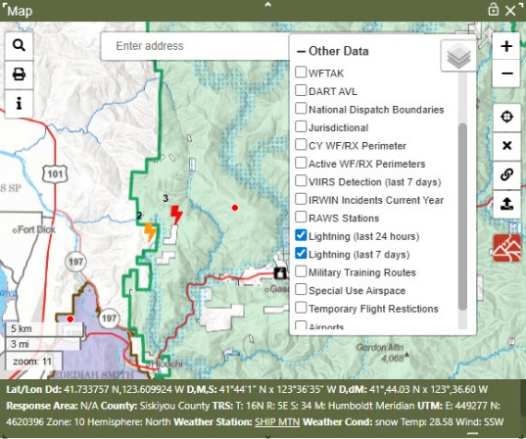
Hovering over a cluster point will display a polygon area indicating the extent of that cluster.
The number next to the lightning symbol indicates the possible number of strikes.

Figure 70 -Lightning Last 24 hours.
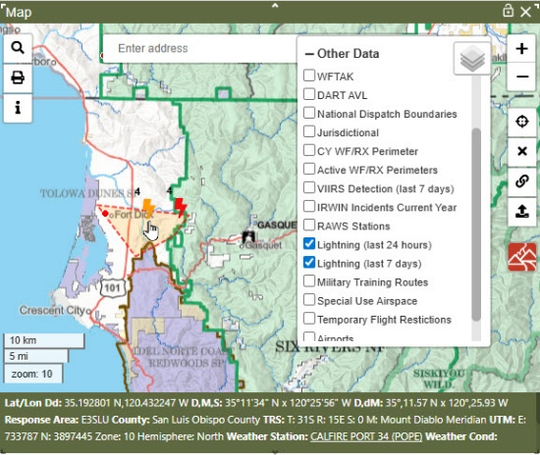
The user can view lightning strike points cluster at any zoom level. The points are no longer clustered at zoom level 12.
Figure 71 -Information regarding one of the lightning strikes in the cluster.
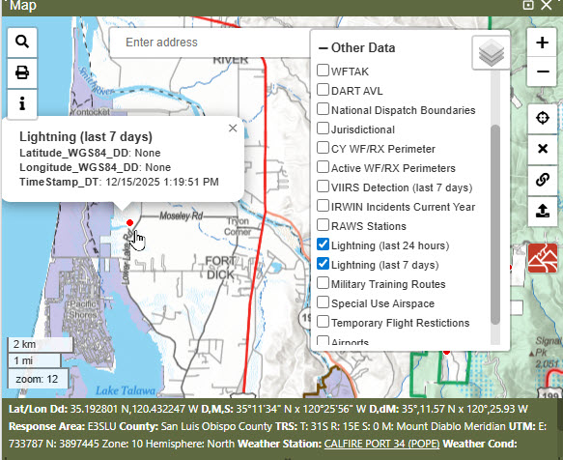

Vehicle Layer Tracking
The Wildland Fire Team Awareness Kit (WFTAK) and Dingell Act Resource Tracking (DART AVL) layers are resource tracking systems.
These systems refresh at a given interval and will show the points on the map moving to their new location automatically.
By checking the boxes next to “WFTAK” this will display an ORANGE symbol indicating the number of resources within the clusters.
Figure 72 -WFTAK cluster.
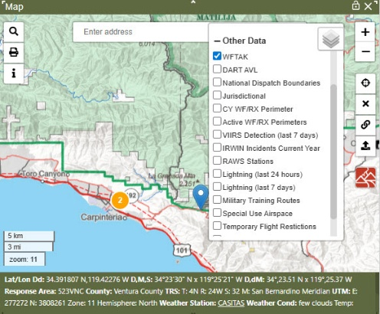
The user can view resources points cluster at any zoom level. The points are no longer clustered at zoom level 12. Click on that resource point to view the information regarding that resource.
Figure 73 -Zoom to one resource.
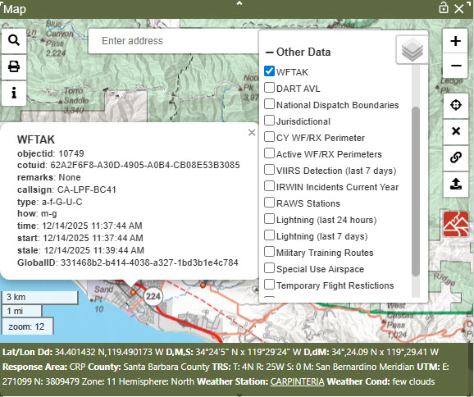
By checking the boxes next to “DART AVL” this will display a GREEN symbol indicating the number of resources within the clusters.

Figure 74 - DART AVL Clusters
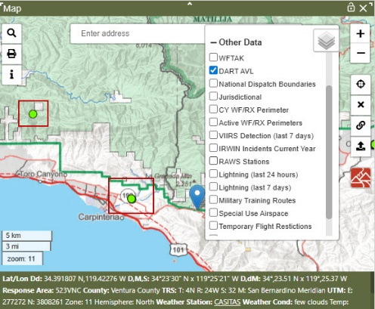
The user can view resources points cluster at any zoom level. The points are no longer clustered at zoom level 12. Click on that resource point to view the information regarding that resource.
Figure 75 -Zoom to one resource
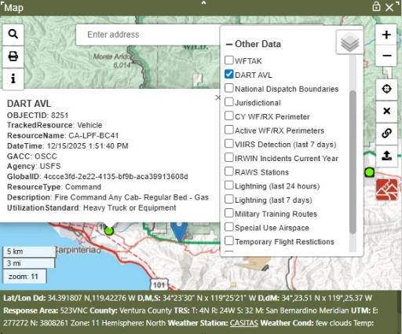

Temporary Flight Restrictions (TFR)
By checking the boxes next to “Temporary Flight Restrictions,” this will display a yellow box indicating the TFR location.
Right-click on a TFR, the ID for that TFR displayed in the box at the lower right of the map is an active link.

Figure 76 -The yellow area is -the location of the TFR.
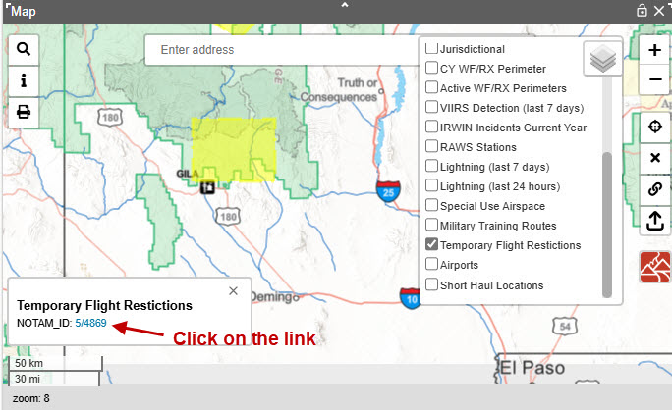
Clicking that link will open the FAA TFR site on a new tab specific to the selected TFR.
Figure 77 -FAA information regarding the TFR.
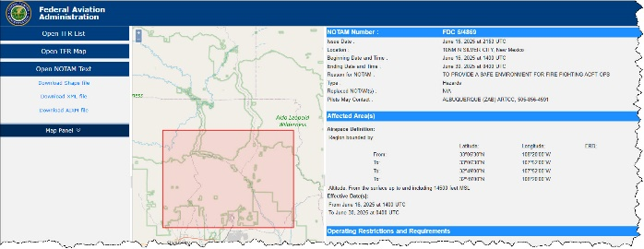

Military Training Routes (MTR)
By checking the boxes next to “Military Training Routes,” this will display the routes; and if the user hovers over the line the pop-up will show:
- “IDENT” number
- “WIDTHLEFT” and “WIDTHRIGHT”

Figure 78 – MTR information.
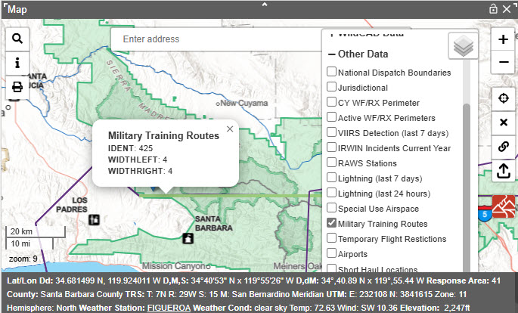

Recent Map
Figure 79– This icon is to zoom the map back to the starting position.
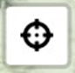
This will zoom the map back to the starting position, which is the extent of the dispatch center’s response areas.

Clear Point
Figure 80 - Use of the "x" icon clears the drop point from the map.
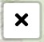
This clears the drop point from the map, which was created when clicking the map. This also closes the map footer and the point info panel and clears the fields in the search panel.

Dropped Point
Figure 81 - This is the drop point icon.

Figure 82 - A point can be added to a map in several ways.
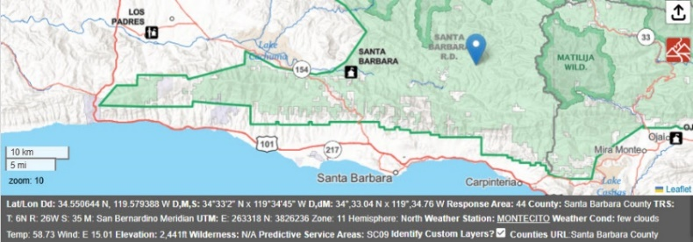
A point can be added to the map in several ways:
- Click anywhere on the map.
- Use the Search Bar (Enter Address, Place or Lat/Long)
- Use the Search Panel (Various search options such as, Lat/Long, TRS, Response Areas, Place Names, etc.)
The map footer will show information about the point. The point can be dragged to a new location, and the map footer info will update.

Map Footer
Anytime the user turns on the layer and hovers over a single icon or polygon on the map to show the description of that layer and some of which will be shown on map footer.
Single clicking anywhere in the map will “drop a point.” This action will open the “Map Footer,” which contains information about where the point is located.
Figure 83 - Map shows footer information.
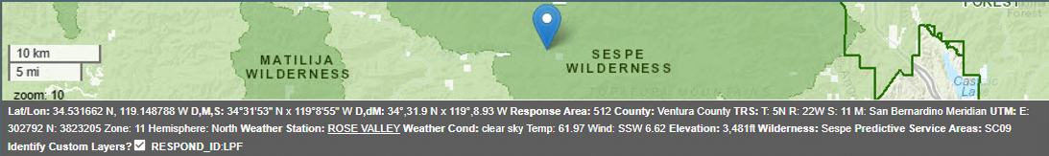
The information fields are:
- Lat/Lon
- Response Area
- County
- TRS (township/range/section) TRS returned from the BLM service with no values will show in the footer as “N/A.”
- Meridian
- UTM Zone (eastings, northings, zone, hemisphere)
- The Current Weather Conditions include a general description of the weather, the temperature in degrees Fahrenheit, and wind speed (mph) and direction (cardinal direction). This information is from a MesoWest Weather Station link for the closest RAWS station at the dropped point and return observations within the last 24 hours of current day/time.
- Elevation.
- The Wilderness Names.
- The Predictive Service Area.
In addition, on the Map Footer there is a checkbox “Identify Custom Layers?” When selected, information from the Center Data will be displayed. The Center Data Layers:
- Have a “display field.” This is set up by the Center Administrator.
- Are listed in the layers list under “Center Data.”
Map Services: If one of the mapping services that is used in the map footer is down or unresponsive, the footer will display “OFFLINE” for that layer’s data.
Figure 84 – Example a down or unresponsive layer.
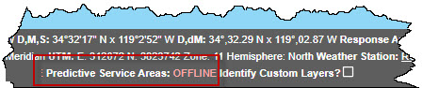
The WildCAD Administrator can set that layer to be inactive. In the case where the layer is set to inactive, the footer will also display “OFFLINE” for that layer.

Zoom Level
Figure 85 - Zoom Level
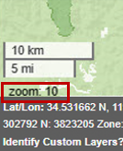
Zoom level value is now displayed in the bottom left portion of the maps so the user can easily see the zoom level of the map.
- The plus (“+”) and negative (“-”) sign icons are used for zooming the map in and/or out.
- At zoom level zero (0), the base map will display the entire globe.
- Each click of the plus (“+”) sign will increase the zoom level by one (1) zoom level, and one click of the negative (“-”) sign will decrease the zoom level by one.
When first opening the map, the zoom level will be automatically set to your predetermined extend zoom, usually the response area.
Your Data

Your Data - Add layer from a linked Uniform Resource Location (URL)
Figure 86 - URL icon.
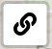
Dispatchers can add URL data to their map from various sources such as map services hosted by ESRI. This data will not persist when the page is refreshed and is not visible on anyone else’s WildCAD map.
Enter the map URL and a name to display in the user’s layers list.
Figure 87 - Box used to enter Map URL and Map name to display in the User’s Layer.
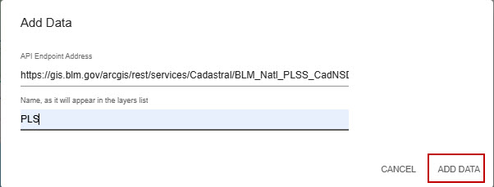
If the URL is invalid the following will be displayed.
Figure 88 - Invalid URL
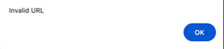
The user will also see the file added to the layers list under a new heading, “Your Data.”
Figure 89 - Your Data
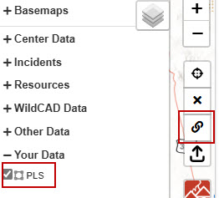

Your Data - Add Layer from a Zipped Shapefile
Figure 90 - Uploading Icon

Dispatchers can add data to their map by uploading a zipped shapefile from their computer. This data will not persist when the page is refreshed and is not visible on anyone else’s WildCAD map.
Click the upload icon. A file browser will open. Locate the zipped shapefile, it must have at least these four (4) files extensions .shp, .shx, .dbf, and prj.
After selecting the file, it will be added to the user’s map, and the map will zoom to the file’s extent. The user will also see the file added to the layers list under a new heading “Your Data.”
Figure 91- Dispatchers can add data by uploading a zipped shape file from their computer.
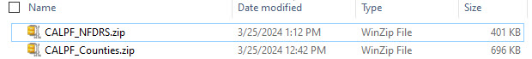
Figure 92 - File will be added to the layers list.
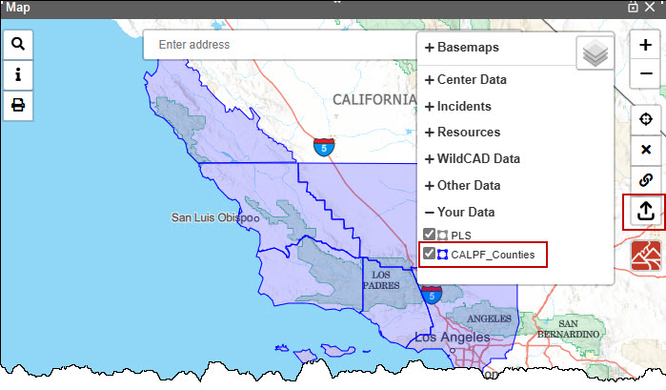

Create Incident
Figure 93 - Create a new incident icon from the map.

Incidents can be created directly from the map. After dropping a point on the map, click the new incident button. If using the map panel, this will open a new incident panel with the location information pre-populated.
Incidents can be created in the eastern hemisphere (i.e., Guam incidents). This can only be done by creating an incident from the map, or by dropping a point and clicking the “Use Map” button on the incident panel. Eastern longitudes and southern latitudes cannot be manually entered into the incident panel coordinate boxes.

Section 2: Search Bar and Find Panel

Using the Search Bar
Figure 94 - Search Bar
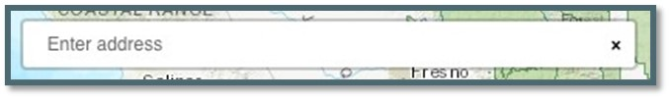
The Search Bar is a Google powered address locator. Search for addresses, place names or Latitude/Longitude. For example, type Joshua tree and the park will be located.
Figure 95 - Use the search bar to locate a specific area on the map.
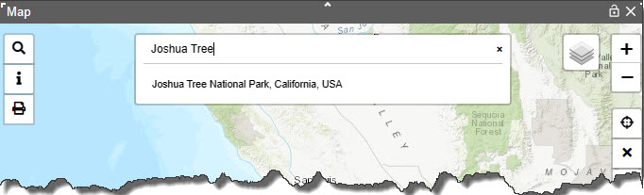
Select the suggested search results. The address bar will reset; the map will zoom to that location, drop a point, and display information about the location in the map footer.
Figure 96 - Drop point is added to map for the location the user selects from the dropdown menu.
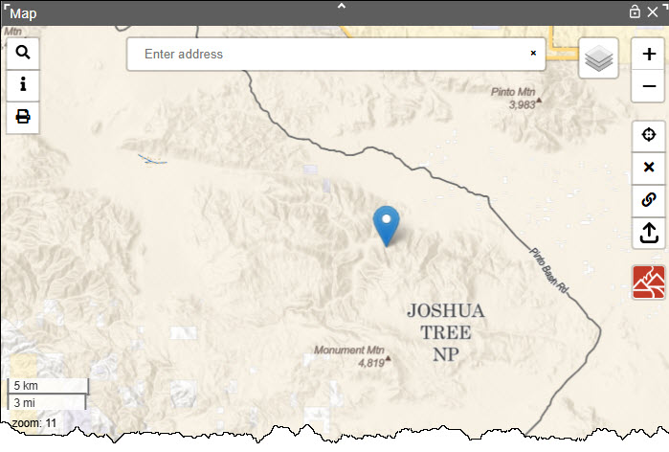
The user can also search by typing coordinates. For example: “35.122018, -119.549866.” or “53.122018 -119.549866”
Figure 97 - Option to use Lat/Lon in search bar.
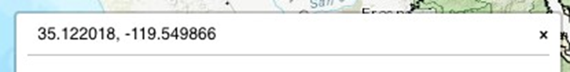

Using the Find Panel
When typing into any of the fields in the Map's Find Panel, users can use the keyboard’s "enter" key in addition to clicking on the "GO" button. All functions work the same as when clicking the "GO" button. For example, if a value is missing or no location is found, the user will be prompted with a message.
Figure 98 - Search icon.

The Find Panel has a vertical scroll bar that is visible if the map panel size is smaller than the find panel size. This allows the user to easily get to find panel functions without resizing the entire map panel.
When searching for response areas the code in the table will be matched to the code in the map regardless of if the case (upper/lower) is different between the 2 values.
UTM can use a default zone if set by the Center Administrator.
Figure 99 – If valid search, map will zoom to location and drop a point; the map footer will open and display relevant information.
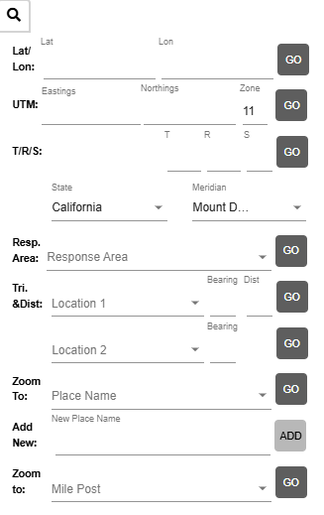
Upon entering data into a new search row, the previous search criteria will be cleared.

Lat/Lon:
- In the search panel, you can now enter Lat/Lon in D,M,S and D,dM format and tab over without changing the format.
- In addition, the user can enter a space as well as a comma between degrees, minutes and seconds for latitude or longitude search.
- Then, click “Go,” and you will be taken to that drop point on the map.
Figure 100 – Entering the latitude and longitude.
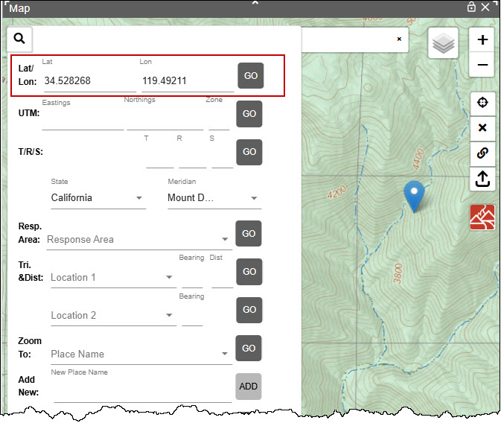

UTM
In the search panel, you can now enter Eastings, Northings and Zone. Then, click “Go,” and you will be taken to that drop point on the map.
Figure 101 - Enter UTM
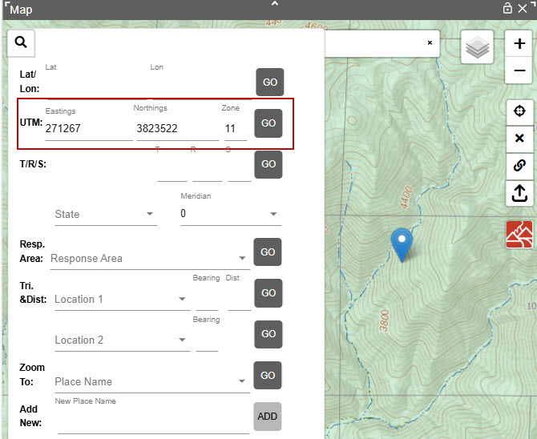

T/R/S
Enter the Township (T), Range (R) and Section (S) and then click “Go.”
Make sure the correct state and meridian are selected from dropdown to the TRS search. State and meridian default values are set by Center Administrator are used or the user can select a value.
Figure 102 - Correct State and Meridian
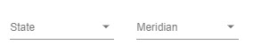
General consideration while searching for T/R/S:
- Half townships and ranges now return the correct T/R/S.
- Find function returns a T/R/S when searching outside of the dispatch center's associated state.
- That PB stands for 'Protracted Block,’ which is an unsurvey area of which parts of, but not the entire, boundary has been surveyed.
  - A protracted block is identified by its unique numbering system. The lowest protracted block number will be PB37.
  - Map users should be aware of this difference in Section numbering from the standard 1-36.
  - The old section number is no longer the official identification number for that piece of land until the section is completely surveyed and accepted by BLM.
Searching for an old section number (T4S/R26E/S36) that is a Protracted Block, WildCAD-E will show “no record found”.
Searching for a section that does not have a matching section in the BLM service, it now returns to a drop point at the approximate center of the requested section. In this case, there is no section polygon to display on the map, (example of issue is 31N 51W 15, Nebraska, 6th Meridian).
Figure 103 - Searching for Section that is in Protracted Block.
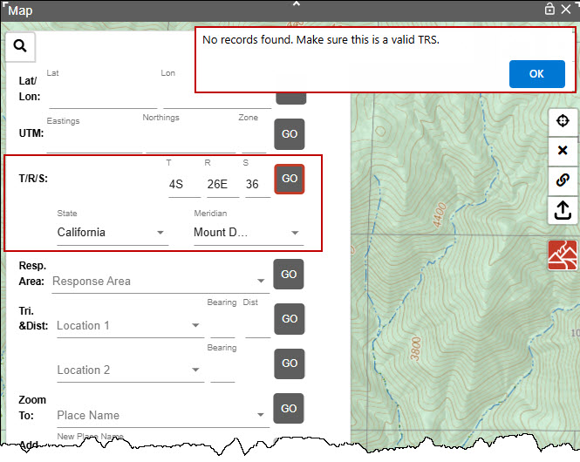
Searching with a Protracted Block number (Section 51) and the same T/R, WildCAD-E will show “Old Section Number.”
Figure 104 - Searching for Section that is in Protracted Block Section Number (51)
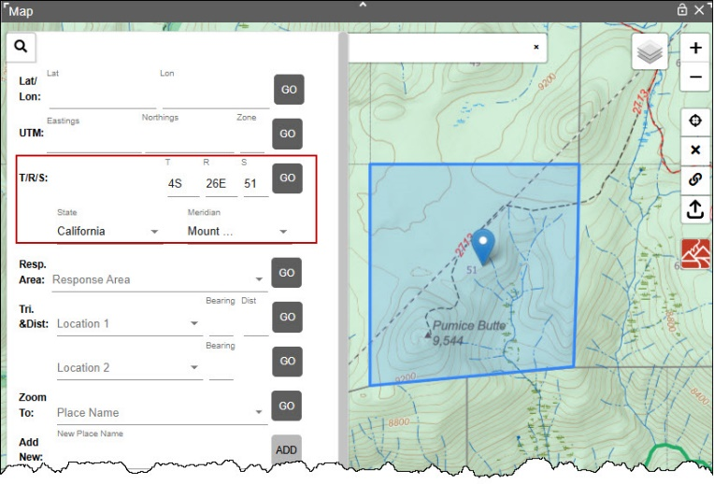

Response Area
Start typing the response area; and then, select from the dropdown or just click on the dropdown and select the response area. Then click “Go.”
Figure 105 – Searching for a Response Area
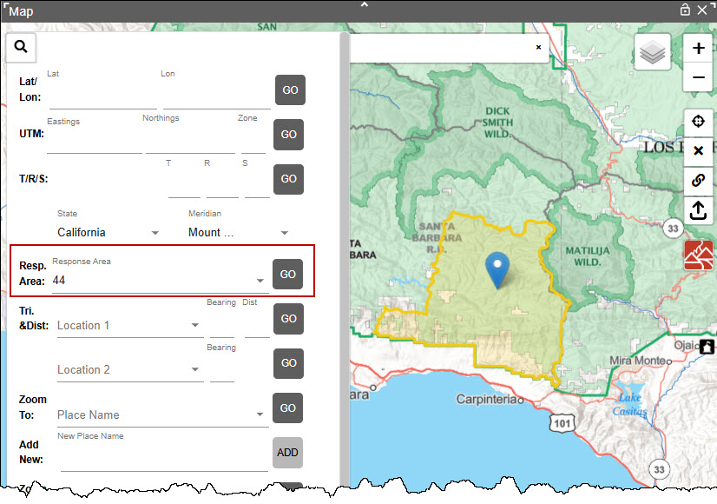

Finding a drop point using Bearing and Distance
- Start typing “Location 1” and then select from the dropdown or just click on the dropdown and select the known location.
- Enter the Bearing and Distance.
  - Bearing and Distance labels change to indicate calculation after the user selects a location.
  - IF the location selected is designated a "Lookout", the label for Bearing is "(true)" and Distance is "(mi)" indicating the calculation uses true north and statute miles.
  - If the location selected is NOT designated as a "Lookout", the label for Bearing is "(mag)" and Distance is "(nm)" indicating the calculation uses magnetic north and nautical miles.
  - Then click “Go.”
Figure 106 – Lookout Bearing and Distance
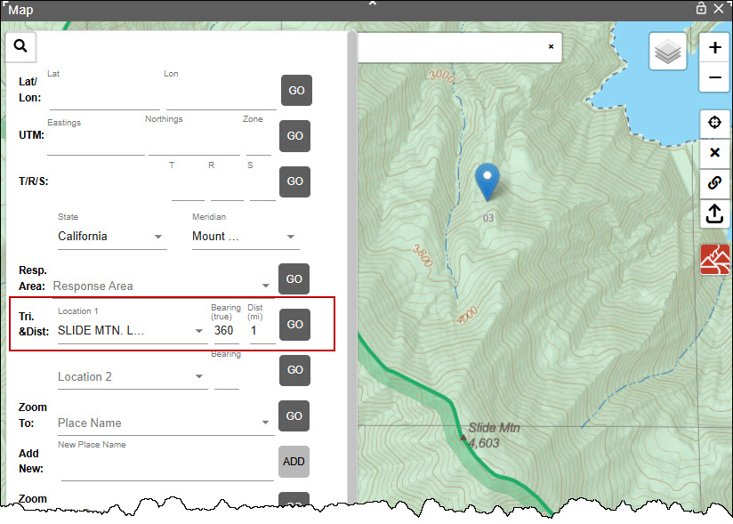
Figure 107 - Aircraft Bearing and Distance
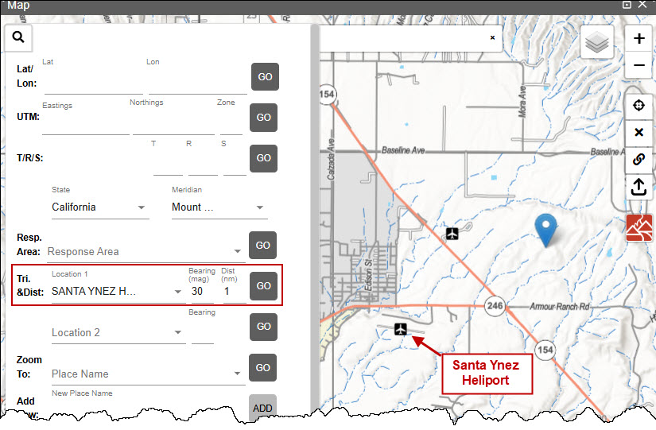

Finding a drop point using Triangulation:
- Start typing “Location 1” and then select from the dropdown or just click on the dropdown, select the known location, and enter the Bearing and Distance.
- Start typing “Location 2” and then select from the dropdown or just click on the dropdown, select the known location, and enter the Bearing.
- Then at “Location 2” click “Go.”
Figure 108 - Triangulation.
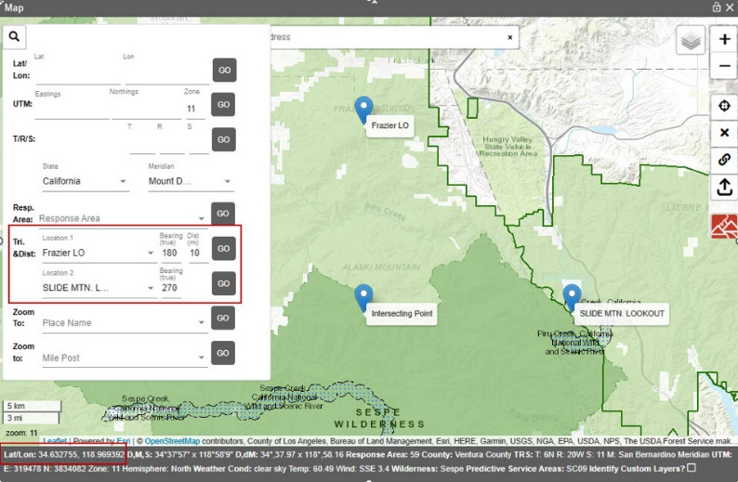

Place Name:
Searching for a Place Name
- Centers that have large lists of place names will now see their place names in the dropdown on the map search panel.
- Select the Place name and click “Go" to zoom to the location.
Figure 109 - Place Names
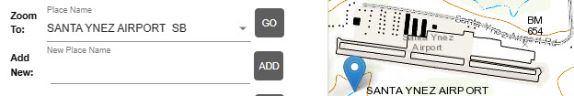
Adding New Place Name
- Click the location of the new place name on the map.
Figure 110 - Drop Point on the Map
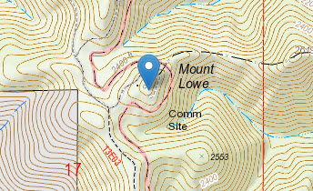
- Enter the name for the new place name and click the "ADD" button.
Figure 111 - Enter the name for this drop point.
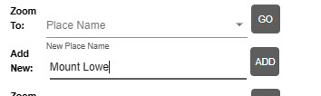

Mile Post:
Centers that have Mile Posts will now see their mile post in the dropdown on the map search panel and can select & hit "Go" to zoom to the location.
Figure 112 - Mile Post
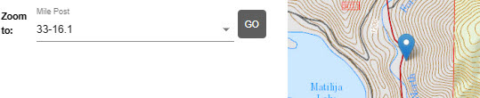

Section 3: Using Display Information
Figure 113 - Display Information Icon

With the Center Data layer turned on, the point info panel will display the attribute information for each Center Data layer that the dropped point falls within. If an additional layer is turned on which encompasses the point, their attribute information will be automatically displayed.
The layers listed under “Center Data,”
- may or may not have a “display field;” and
- must be turned “On.”
As Example,
- The “Counties” layer under “Center Data” is turned on.
- A drop point falls within this layer.
- Click on the ‘I” Icon to display every attribute from this layer.
Turning off the layer will remove it from the point info panel. Clearing the point using the “X” button on the right will remove the data grids in the panel, close the map footer and remove the point.
Figure 114 – Center Data – Select a Layer
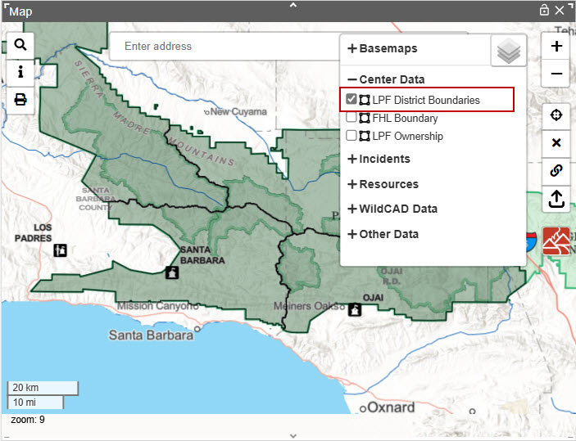
Figure 115 – Center Data – Drop Point on Map
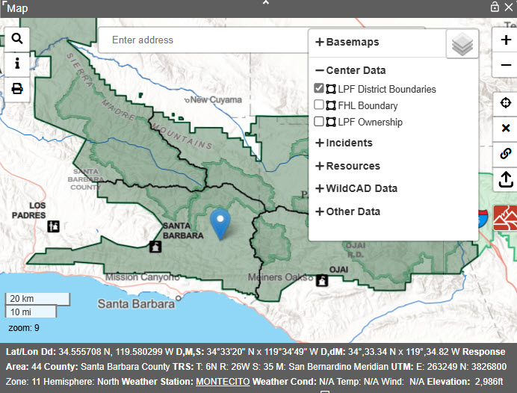
Figure 116 - Center Data – Click “I” Icon
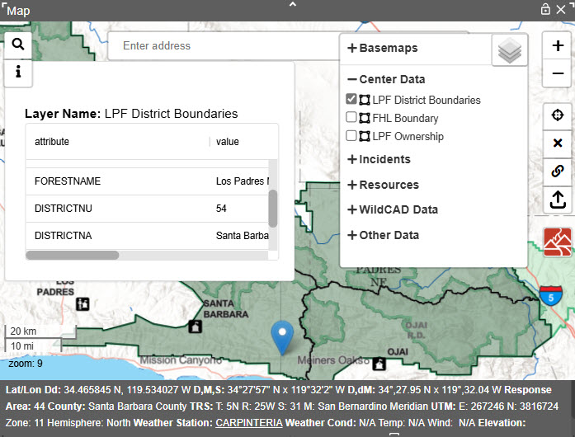

Section 4: Print Map Function
The Print Map button is in the upper left corner of the map. This button will produce a .PDF of the current map view with any layers that are turned on. Layer legend and map footer (where applicable) are displayed below the map.
Figure 117 Click on the Print Map Button
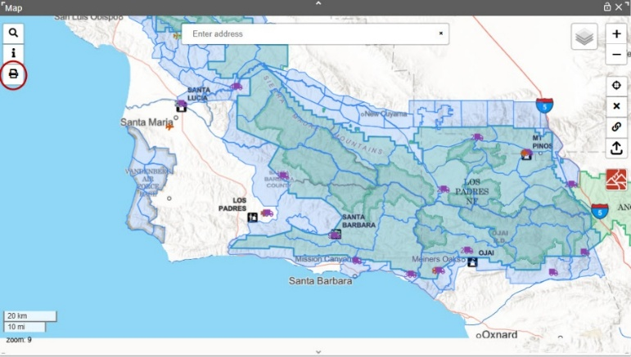
After clicking on the Map Button, the user will give the Print Map a file name.
Figure 118 Enter the File Name
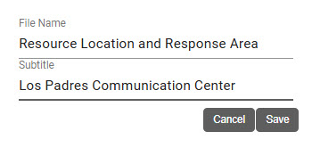
Figure 119-Dispatchers Select the PDF file from their computer.
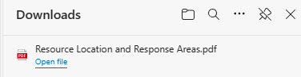

Figure 120 Example of a Print Map
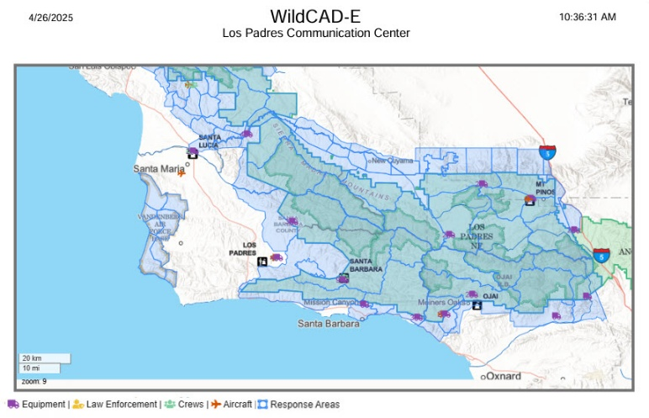

Section 5: Search Incident Panel (F2-or Search Icon)
Figure 121 - F2 or Search Icon

In the “Search Panel” each row represents one method to search for an incident.
As example,
- Enter a date from and to and what the user wants to search for on the incident.
- Click the Search button to execute the search. If the search was valid, the search will return to a list of incidents.
To clear an enter, Click the “Clear” button.
Figure 122 Search Incidents using date only.
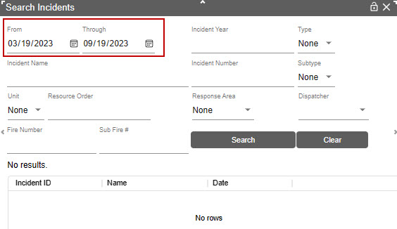
If search results exceed 250 records, the user is promoted to further limit the search to see all records.
Figure 123 - Search results by date ONLY 243 of 416 were returned.
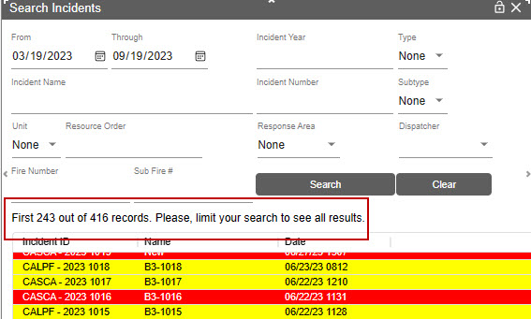
Figure 124 - Search results were reduced to 56 records.
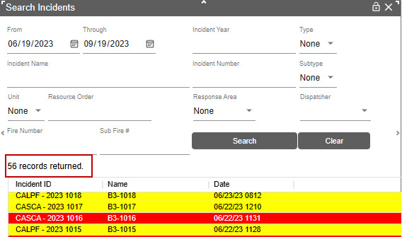
Search results by dates were reduced, and only 56 records were returned.

Section 6: Resource Status Panel (F7 or Resource Icon)
Figure 125 - Resource Icon

On the Resource Status Panel, the user can set the resource status, dispatch location and enter comments.
The background color on the filter/search section is now pale yellow to distinguish those fields from the fields displayed once clicking a resource.
The Resource Status Panel has a filter toggle that can show or hide the filter options on the Resource Status panel.
Figure 126 – Filter Toggle
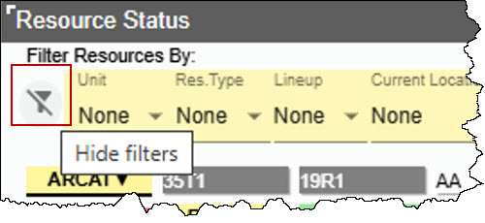
The “Resource Status” and “Dispatch Location” filters all listed resources by those fields. The “Assigned Incident,” will be populated once the resource is committed to the incident, and this field is not editable from this panel.
List of Value in the dropdowns allow searching by all characters entered by the user. The dropdowns now accept free text to filter the results. Previously these only accepted one character for filtering.

Resource Status Filter:
- Click on the Resource. (The resource has a black border).
- Using the pull-down under “Resource Status,” select a status in (# 1).

Dispatch Location Filter:
- Click on the Resource. (The resource has a black border).
- Using the pull-down under “Dispatch Location,” select a status (# 2).
Figure 127 - Resource Status Panel.
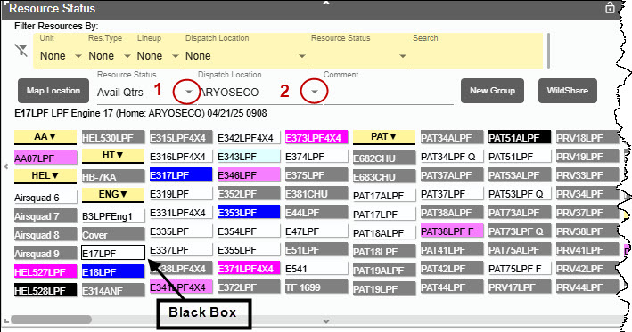
The Resource Status Panel shows all resources. By using the pull-down functions, the panel can be sorted in four ways.

Sort by:
- Unit
- Unit and Resource Type or just by Resource Type.
- Unit, Resource Type and Lineup or just by Lineup
- Search by individual resources name (“Code”).
Figure 128 - By Unit
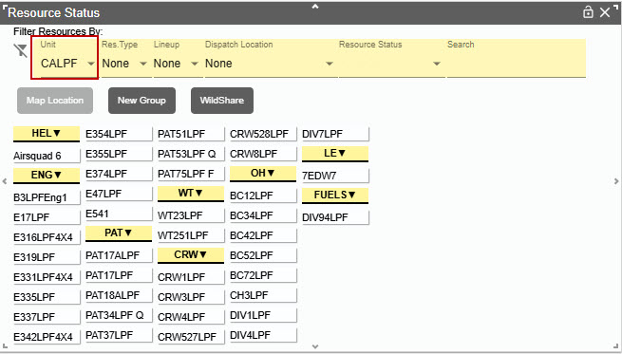
Figure 129 – By Unit and Resource Type
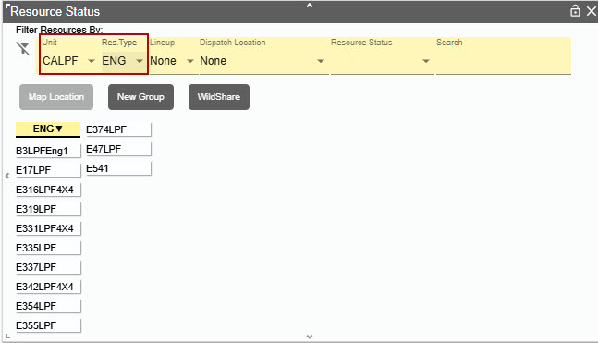
Figure 130 - By Unit and Resource Type by Lineup
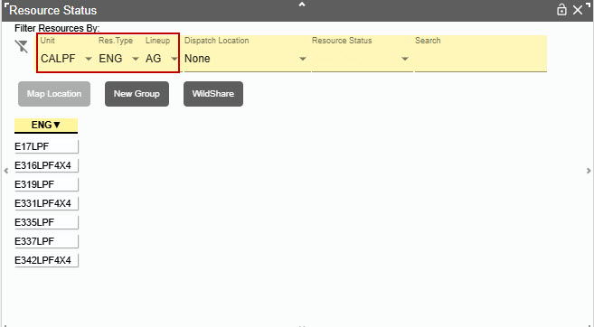
Figure 131 - Resource by Name ("Code")
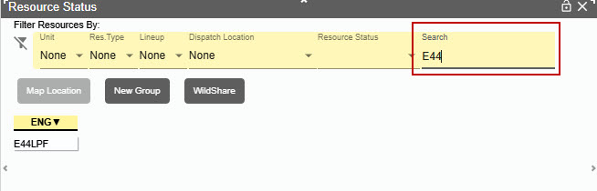
For example, if the user searches by name (E44LPF), the select resource display shows:
- Resource Status “Avail Qtrs.”
- Dispatch Location “RINCON”
- Resource ID, Home Location, Date/Time
Figure 132 - Select E44LPF
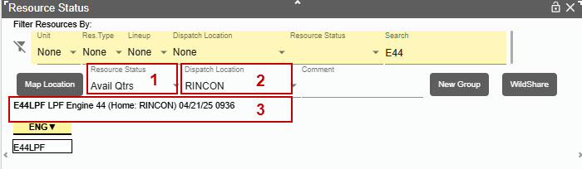
If the resource is ‘Committed” to an Incident, the name of Incident would be displayed.
Figure 133 - E44LPF Committed to an incident.
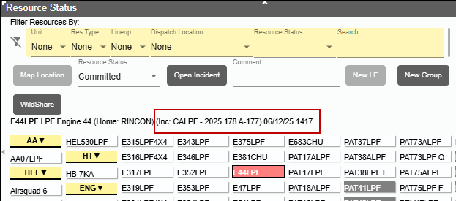

Adding Comments about a Resource to Daily Log
- Enter the Comment in free text. Comments do not clear with location changes.
- Change the Resource Status. Comments will clear with status changes.
---or---
- Click “Enter” to get the comment written to the Daily Log for the selected resource.
Figure 134 - Example of entering a comment.
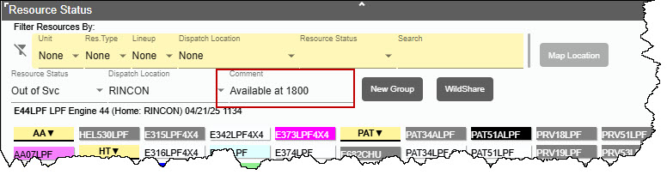
The comments will be displayed on the Daily Log.
Figure 135 - Example of entry on the Daily Log.
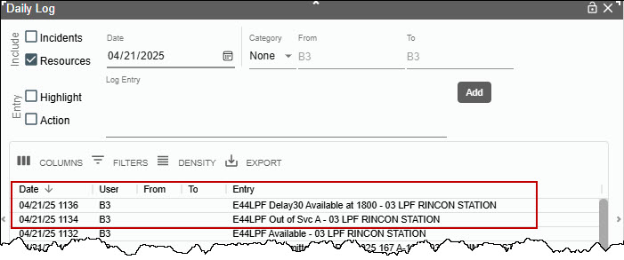

Adding Comments about a Resource to Incident Log
On a Resource that is assigned to Incident, E44LPF is assigned to Incident "CALPF-167".
- Added comment will appear in the Incident Log Tab.
- Change the Resource Status or click “Enter” to get the comment written to the Daily Log for the selected resource.
- Incident "CALPF-167"can be opened from this screen.
Figure 136 - Example E44LPF Committed Incident CALPF-167.
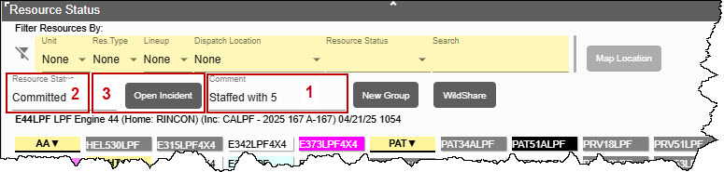
Figure 137 - Example of entering on the Incident Log.
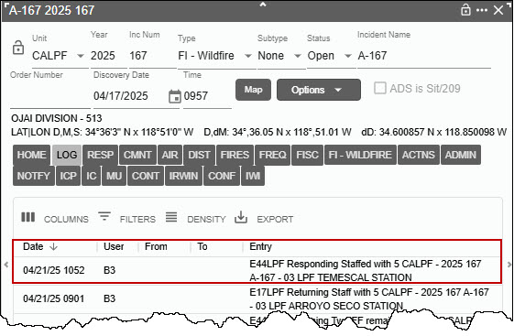

Resource Current Dispatch Location
Implemented business rules to properly set a resources current dispatch location based on their status:
- If their status is “Responding, On Scene, or Available at Incident” then the resource's current dispatch location is the dispatch location associated with the incident.
- If their status is “Committed, Returning or Available in Quarters,” then the resource's current dispatch location is the same as their Home Dispatch Location.
- If their status goes from “On Scene” to “Available,” then the resource's current dispatch location is the dispatch location associated with the incident.

Map Location Button
The “Map Location” button that can update a selected resource’s current location to a point dropped on the map if the resource is not assigned to an incident.
If there is a dispatch location that is nearer to the dropped point, a prompt will appear to choose to change the dispatch location to the nearer one or leave it at the current location.
When a user selects a resource in the panel, then opens the map and clicks a point on the map, the “Map Location” button will be enabled.

Figure 138 – Select Resource to change locations.
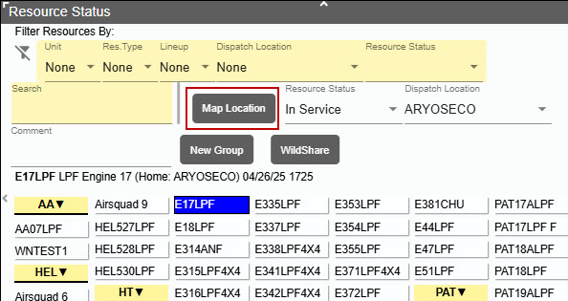
Figure 139 – Drop a point for the new location.
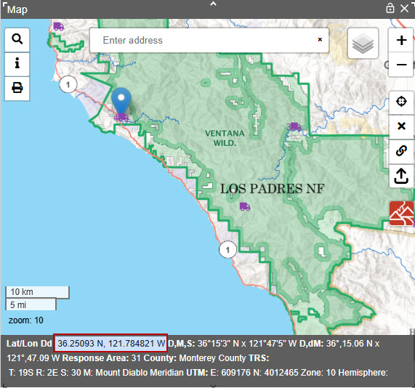
Click the “Map Location" button on the resource status panel.
Clicking the button will change the current location of the selected resource to the latitude and longitude of the location of the pin on the map.
A decision box will appear confirming or rejecting the change of location.
Figure 140 – Update the location of the resource.
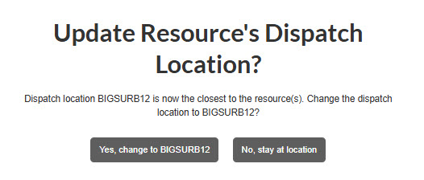
Figure 141 – Resource location has been changed.
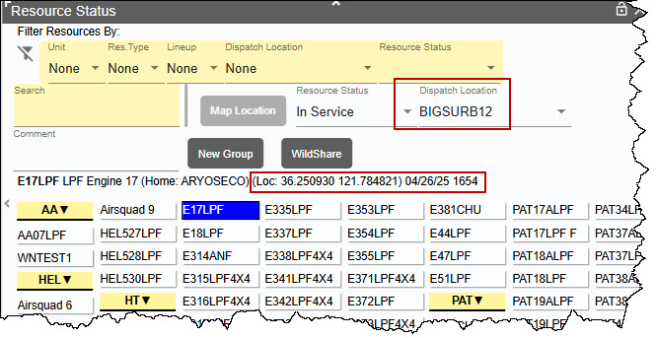
When the Map Location is pressed, the log entry includes values from status, comment, coordinates, and dispatch location.

Creating a Groups
Step1: Click the “New Group" button to start selecting multiple resources for a group.
Figure 142 – Creating a Group, Step 1
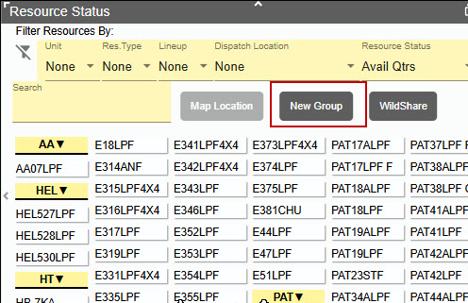
Step 2: Hold the Ctrl key down to select multiple resources. The selected resources will be outlined in RED.
Step 3: Select “Dispatch Location” from the dropdown menu.
Step 4: Click the “Save Group" button to save the resources selected for a new group.
Figure 143 – Creating a Group, Steps 2, 3 and 4
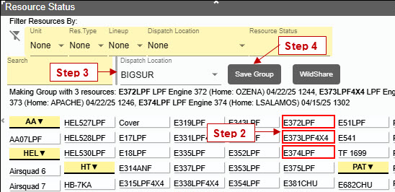
When a group is selected, the resource description string will now show details for every member of the group.
Figure 144 – Selected Group will describe the members of the group.
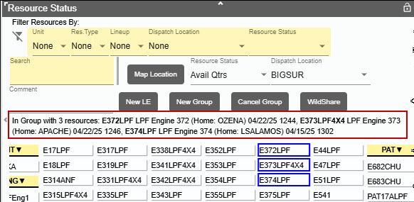

General Rules for Groups
- Status and location changes made to any member of a group will apply to the entire group.
- When a comment is entered for a resource that is part of a group, that comment log entry will be applied to all resources in the group.
- When a resource's location is changed for a resource that is part of a group, the location change log entry will be applied to all resources in the group.

Examples
When assigning any part of a group is selected a pop-up asked:
- Send the entire group – this sends all resources in the group.
- Send just selected resource – this just sends the selected resource and removes this resource from the group.
- Cancel – the individual or all will not be sent.
Figure 145 - Assign Group pop-up.
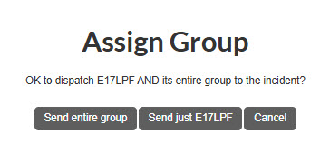
- If you have three resources in a group all can be assigned to an incident.
- If only one of three resources is assigned to the incident the group will remain with two resources.
- If only one resource is left in the group, then the group will be cancelled automatically.

Cancelling a Groups
- Select one or more of the resources. The resources in the group will have a “Blue Box” around them.
- Click the “Cancel Group” button. This cancels the entire group.
Figure 146 - Cancel Group
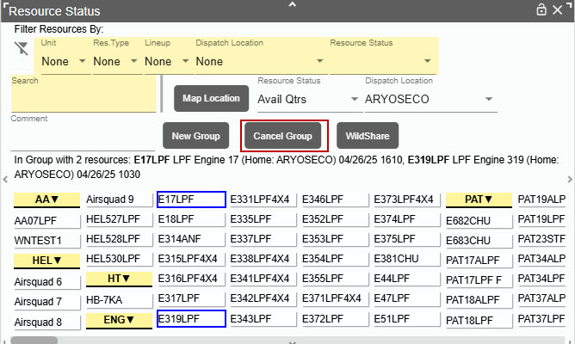

WildShare
WildShare allows any center to make the status of one or more resources available to other centers. In turn, a center can view the status of another center’s shared resources.

The Center Administrator for CALPCC is sharing (WildShare) Engine E371LPF by setting “YES” in the WildShare field.
Figure 147 – Allowing a resource to be shared.
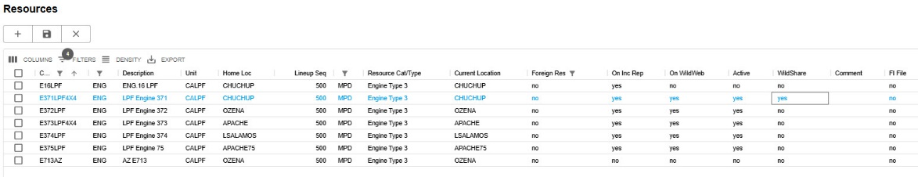

After the Center Administrator set in Viewing Center panel by selecting CALPCC resources, the Dispatcher on CASBCC will from the Resource Status panel, will click on WildShare button that opens another panel showing dispatch center that has shared resources.
Figure 148 – WildShare button on the Resource panel.
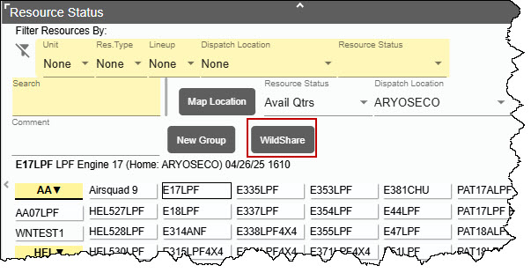

The WildShare panel will open listing the center that has been shared. Click the down arrow to view the shared resources. WildShare panel can be sized and positioned and then saved as part of the users saved layout.

Figure 149 – WildShare panel.
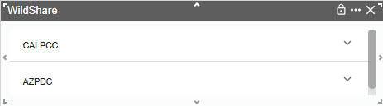
Select the center to see what resources have been shared.
Figure 150 – Resource availability.
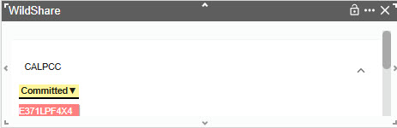

Starting Law enforcement (LE) incidents from Resource Panel
This feature can only be used if the center and Dispatchers have been FI Authorized. Unless the dispatch is authorized and "FI Authorized” is set to "Yes," the Dispatcher will not have access to navigate to and use the FI File panel.
- Select the resource to be committed to LE Incident.
- Click the “New LE” button.
Figure 151 - Committing a Resource to a new LE Incident.
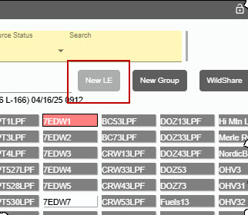
- A new incident panel will open.
Figure 152 - LE Incident Panel
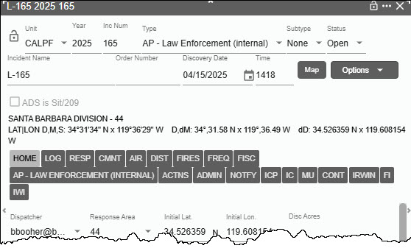

Resource Status Color Code
This code cannot be changed and is set up by the government.
Figure 153 - Resource Status Color Codes.
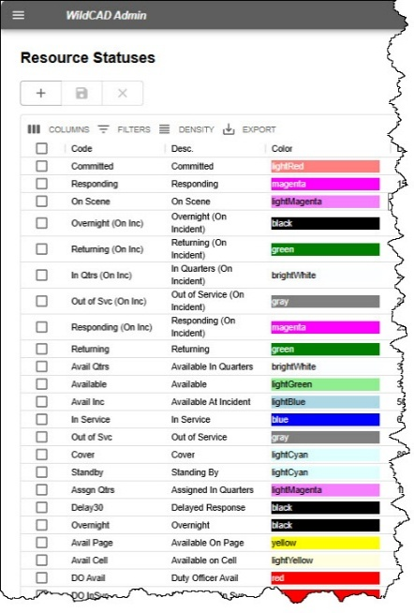

Section 7: Integration

Resource Integration
Resource integration means exchanging information about WildCAD-E resources, such as engines, crews, helicopters, etc., and the people staffing them via IRWIN with other systems like IROC, IQS, and IQCS. These five systems have worked closely over the past three years to develop standards and methodologies for exchanging WildCAD-E resource information.
WildCAD-E passes resource statuses to IRWIN where other connected systems can read them. WildCAD-E automatically creates filled requests for local resources sent to local fires and experience will automatically be generated for people staffing the resources. Dispatchers will still use IROC for other tasks such as placing or filling unfilled requests.
When a dispatch action closes a filled request (e.g., set the resource status Avail), the last step is to set the resource's General Status to Available.
When a resource that is on a filled request is reassigned from one incident to another, the current request will always be closed first before creating a new request.
WildCAD-E will block creating capability requests if the resource's Current Dispatch Unit is different from the unit of the user's dispatch center.
Resource's status values are no longer set in IRWIN when the resources are assigned to NON-IRWIN incidents.
Users may create a new request for a resource sent to their center on a preposition.
A resource's primary capability is read directly from IRWIN when the resource is assigned rather than only when the resource is matched between IRWIN and WildCAD-E. This solves issues where the resource's primary capability may have changed after the WildCAD-E resource was matched to the IRWIN resource.
IRWIN Resource General Status - setting a resource’s status to “Available At Incident” sets the IRWIN General Status to Unavailable.

IRWIN Observer
In IRWIN Observer the resource request will appear once a resource is responding – provided the resource has been IRWIN Matched in WildCAD-E and the incident has been sent to IRWIN.
IRWIN Observer will show the operational status as Mob En Route when the resource is responding and the IRWIN Capability Request Mobilization Times are set based on when the resource’s status is set in WildCAD -E rather than when the capability request is created. This applies to the Mob ETA, Mob ETD, and Needed By. The ETA is the WildCAD-E date and time plus 20 years. WildCAD-E uses plus 20 years so that IROC’s “travel job” does not automatically change resource statuses.
Figure 154 –The Resource is Responding – ETA set plus 20 years.
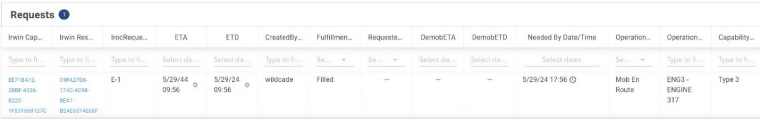
IRWIN Observer will show the operational status as Demo En Route when the resource is returning, will show DemobETD as current date and time, and will show the DemobETA current date and time plus 20 years.
Figure 155 –The Resource is Returning– DemobETA set plus 20 years.
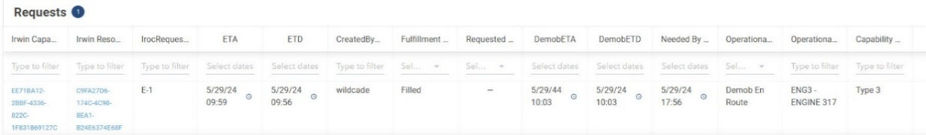
IRWIN Observer will show the resource request Closed and the DemobETA is set to the actual date and time the resource status was set to any status not on the current incident.

Figure 156 –When Request is closed - DemobETA and set the current date and time.
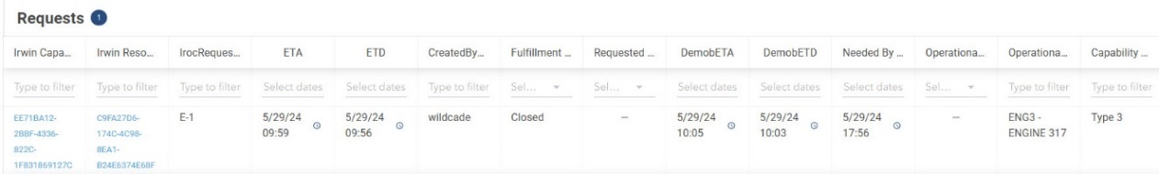
If a resource is diverted (mobilized but does not get to the incident), WildCAD-E will set the resource’s Mob ETA to the time of the Divert, which would be the same time as the Demob ETD.

Incident Quarantine Warning
The IRWIN team implemented quarantine fall-off rules. This means that existing incidents that have been in quarantine for longer than eight days will be set to invalid by IRWIN. After an incident has been in conflict for more than 24 hours, we have added an alert that will show after they open the incident that will tell them to resolve the conflict in the conflict tab. Also, after 24 hours, the Conflict tab will flash red.
Figure 157–Quarantine Alert
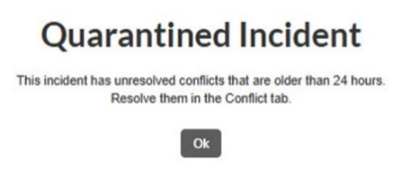
If the conflict is not resolved, and IRWIN sets the incident as invalid, the incident header will now show “IRWIN Invalid” in red where it usually says, “IRWIN Incident.”
Figure 158 –Incident set to Invalid.
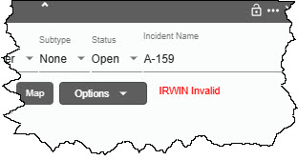
A log will be added to the IRWIN tab telling the user it has been set invalid by IRWIN.

Figure 159 –IRWIN log as displayed by the IRWIN Tab
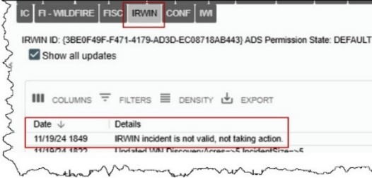
Once the incident is invalid, the “Assign” button on the Response tab will be disabled, and no new resources can be assigned to the incident. Also, any changes made to IRWIN fields on the incident will not be updated in IRWIN.
Daily Routines/View IRWIN Incidents/Resources
- The Final Fire Reporting data in a column to the right of the IRWIN incident data for incidents that have final fire report data records regardless of the status.

Section 8: Open Incident Panel (F8 or Open Incident Icon)
Figure 160 - F8 Open Incident Panel

There are two methods for sorting open incidents.
- By clicking the radio buttons next to Type or Mine or Stage.
- By clicking the radio buttons next to Type or Mine or Stage and selecting an incident “Type” from dropdown.

Method 1 – Incident Type, or Mine or Stage
On the Open Incident panel there are three main ways to sort open incidents by clicking on one of the radio buttons. Each of the radio buttons will retrieve all “Incident Types” based on the radio button selected.
As example,
- Type - will retrieve all open incidents regardless of which dispatcher is associated with that incident.
- Mine - will retrieve all open incidents that are associated with an individual dispatcher.
- Stage – is like “Type” and will retrieve all open incident but will color code to represent their stage.
- Red - Not Contained
- Blue – Contained
- Green – Controlled
- Black – Not a Wildfire
Figure 161 - Selected by Type for the entire Center.
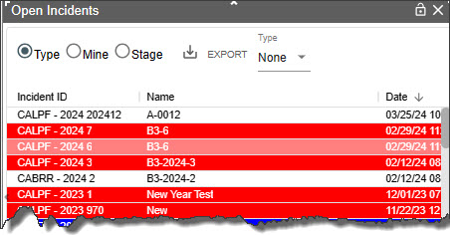

Method 2 – Incident Type

Sorting by the incident type
As example,
- Selected Type radio button to retrieve all incidents by specific incident type.
- From dropdown select “Wildfire”
If you select “Mine” instead of “Type” and “Wildfire” you will sort all incidents that are yours. You also do the same by selecting “Stage” and “Wildfire” to retrieve the incident status.
Figure 162 - Select using the dropdown menu for incident types.
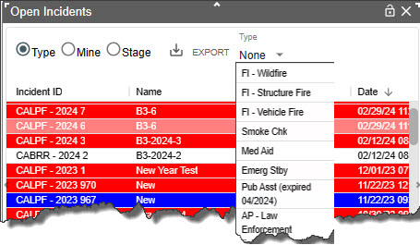

Figure 163 – Sorted by Wildfire
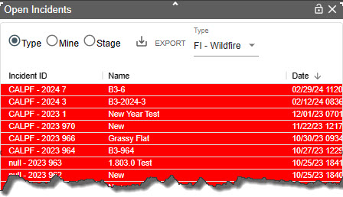

Export (Open Incidents to CVS File)
All open incidents can be downloaded as a CVS file or printed.
- Select “Type” radio button to retrieve all open incidents.
- Select “Mine” radio button to retrieve your open incidents.
- Click “Export”

Section 9: Daily Log Panel (F12 or Daily Log Icon)
Figure 164 - Daily Log Panel Icon

The Daily Log allows the user to enter log comments each day without the need to open a separate Incident just for this purpose. The user may also view all Incident and/or Resource activities for the day.

Add Log Entry
- Select Category (if applicable) and change Initials if necessary.
- Type the ‘Log Entry”
- Click “Add” to save.
Figure 165 - Log Entry and Add
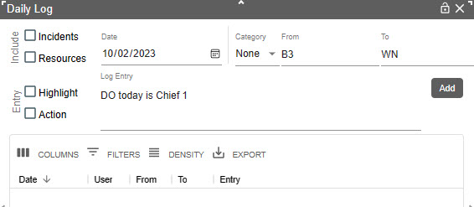
Figure 166 - Log Entry and Save
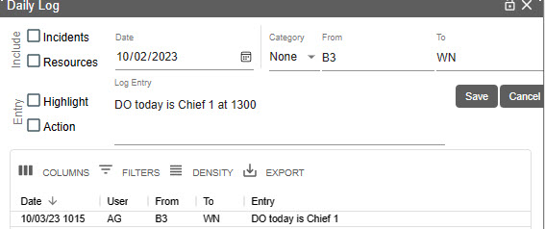

Editing or Viewing the Daily Log by either Incidents or Resources or Both
- Incidents – shows information regarding the incident.
- Resources – shows information the dispatch location of a resource any time the status is changed. Changing a resource's status back to Avail Quarters, now shows its home location.
- Text/Email – posted to the Daily Log will include subject line and recipient’s names.
- Comments – shows from the “Comment Box.”
Figure 167 - Incidents on Daily Log Panel
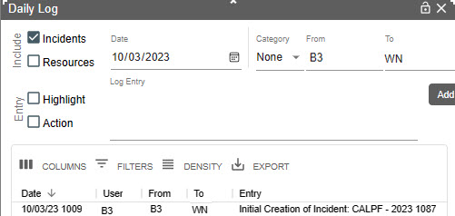
Figure 168 - Resources on Daily Log Panel
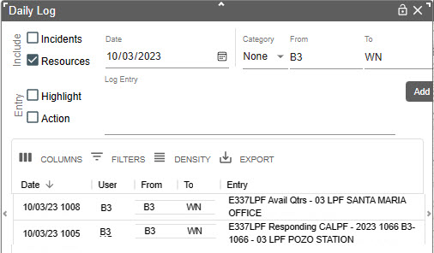

Highlight and Action
For both Highlight and Action complete the following:
- Select the log entry to Highlight (or Action)
- Check the box (Highlight or Action)
- Click “Save”
Figure 169 - Select entry to be Highlight or Actions
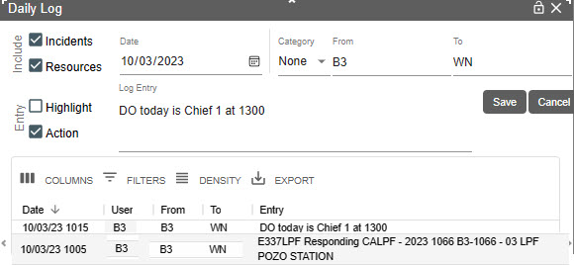
Checking “Highlight” shows the entry in red. “Action” shows in blue until the item’s status changes and action is turned off.
Figure 170 - Highlight on Daily Log Panel
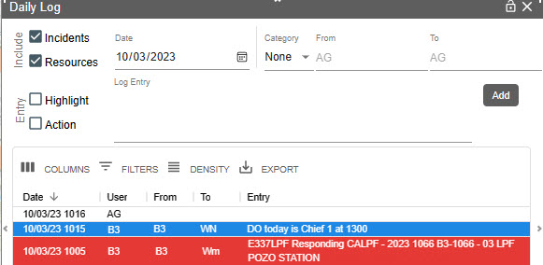

Part IV: Roster

Section 1: Rostering
To be able to Roster a resource in WildCAD-E, a two-configuration step will be performed. The Center Administrator will complete the first configuration step, which is to match the center’s WildCAD-E resources with the corresponding resources in IRWIN and IROC. Although we are matching the same physical resource, it is not necessary to name the WildCAD-E resource the exact same name as it has in IROC.
The second step is to authorize people to roster specific resources. An example might be that the same person located at a station might do the morning rostering for an engine and a dozer, and an FMO might have the right to roster those same two resources plus many others.
Dispatchers can only authorize those people who have the Roster role in WildCAD-E; so, if dispatchers are also going to do the actual rostering, they should not only have the Dispatcher role, but also the Roster role.
Figure 171 - Roster Menu
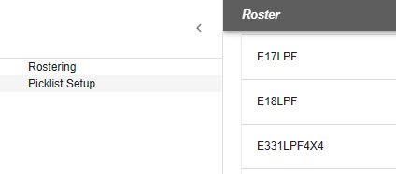
Clicking on Rostering, the menu will display resources that the user has been Authorized (Daily Routine Section). The Picklist Setup will be discussed in Section 2.
Left side of the Roster Panel is the list of Resource that can be rostered by this user.
Figure 172 - Roster Panel, left side reflects the resources this user is authorized to roster.
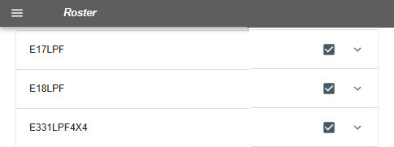
The right side of the Roster Panel has two functions.
- The check box:
- if the box has a checkmark, that means that resources are available.
- If the box is blank, that means that the resource is out of service or on an assignment. The assignment status of Committed, Responding, On Scene, etc. will be shown.
- Down Arrow:
- Click the down arrow up, and the staffing on the resource will be displayed.
Figure 173 – Rostered Resource and Adding Position
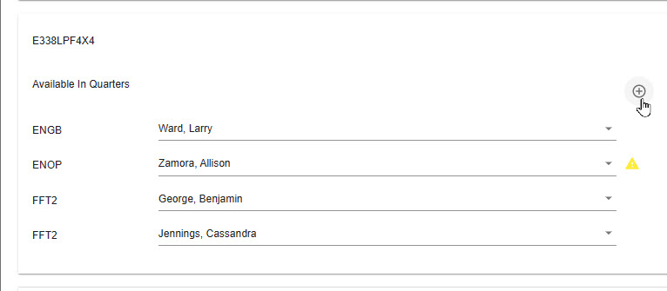

Creating a Roster
Every Roster has a standard NWCG staffing pattern. As an example, the Type 3 Engine has four positions. The user can add a fifth or more by clicking on the “Circle with Plus Sign.”
By selecting the “Circle with Plus Sign,” this action allows the user to select another position from the dropdown list.
Figure 174 – Selecting a Position
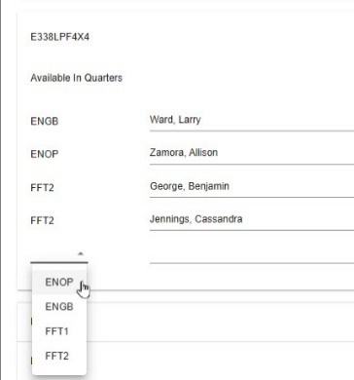
The next step is to select a person to staff the position.
There are two ways to select the person.
- From the Picklist – the personnel the users have assigned to their respective resource’s picklist will be visible and can be selected from the list.
- Name Search – in the line to the right of the desired position, start typing a minimum of three letters within the name. Once the name appears, click on it.
Figure 175 – Complete Rostering Resource
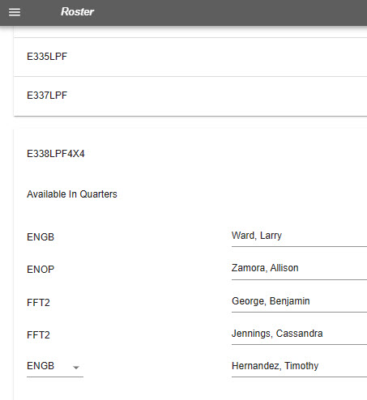
The rostered personnel are assumed to be qualified for the position they are filling.
- If the individual is not qualified a “Yellow Triangle” symbol will appear to the right of their name. WildCAD-E does not prevent the user from rostering a resource with a person who lacks the qualification. WildCAD-E will allow that assignment because at times there are delays in entering experience and training to maintain a person's qualifications. The bottom line is that managers and supervisors in the field have the final say over who goes out on what resources, not WildCAD.
- If the individual is a trainee, a “Green T” symbol will appear to the right of their name.
Figure 176 -Roster Status
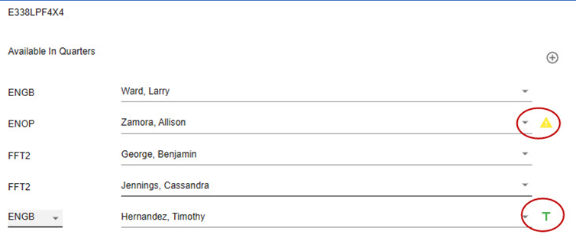
Figure 177 - Red Firefighter indicates resource is currently assigned.
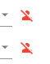
- If the individual has a “Red Firefighter” with a line on it symbol, that indicates the person’s General Status in IRWIN is not currently Available.
- When adding an individual to a rostered resource, users will see individuals that are currently on another roster and will show the resource and dispatch center to which they are currently rostered. The resource is not selectable and appears grayed out until the resource is removed from the other roster.

Figure 178 – Example an individual currently on another roster.
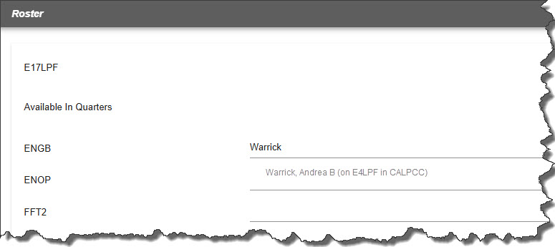

Section 2: Picklist Setup
Figure 179 - Picklist Setup is used by a Dispatch Center when a group of individuals routinely performs work together as a resource, such as an engine, etc.
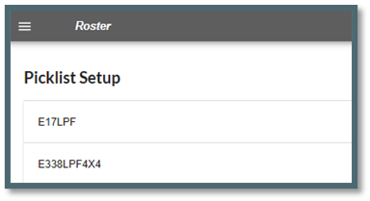
When a dispatch center has a group of individuals who routinely perform work together as a resource, such as an engine, crew, etc., a Picklist can be created which makes dispatch more efficient. This step is optional, and users can roster a resource without creating a picklist. These lists are intended to save time.
When performing rostering in WildCAD-E, one can attach any person who has a record in IQS or IQCS to our engine crew, etc.
Figure 180 - Add a name to a Picklist.
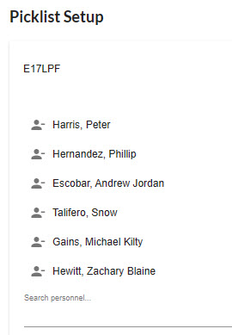
To Set Up a Picklist
- Identify the individual resources that combine to create a resource appropriate for a Picklist (e.g., engines, crews, etc.).
- If an individual is added in error, click right of the name and once prompted, remove the individual resources from the list.
  - Click the up and Down arrow to view the names on the Picklist.
- Save your work.
Figure 181 - Example Picklist Setup
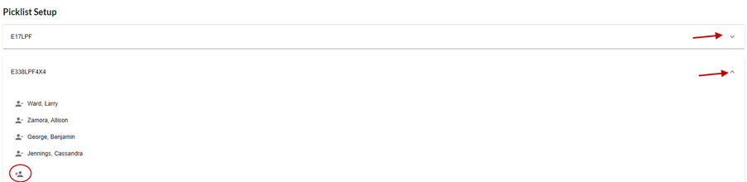
- When adding an individual to a Picklist, users will see individuals that are currently on another roster and will show the resource and dispatch center to which they are currently rostered.
- The individuals are still selectable and can be added to the Picklist even if they are currently rostered on a different resource.

Figure 182 – Example an individual to a Picklist that is currently on another roster.
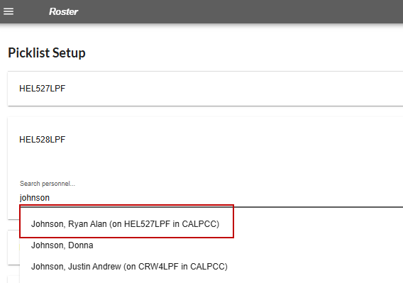
Create a Roster
To create a roster for an Engine, assign an engine boss and crewmembers. A Picklist comes in handy to complete this task.
Figure 183 - Panel to create a roster.
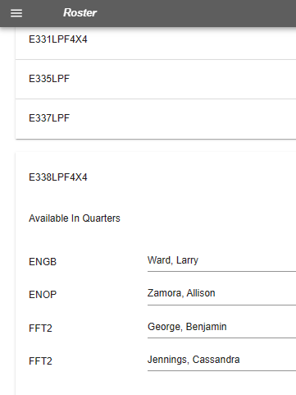
- To create the resource, use the button in the upper left to add the position.
- To add additional members not on the picklist, type the individual’s name.
- A green “T” to the right of a name indicates a trainee status.
A user can add people only if:
- The current dispatch unit is their home unit,
- If the person is not presently on a filled request, and
- The individual is not presently on another roster in WildCAD-E.
If the user wants to assign that resource today, the user will need to contact the person who manages the roster for that other resource and have them release that person.
Once a resource is on an assignment, meaning they are on a filled request in IROC, substitutions or reassignments of any people are completed in IROC.
Those WildCAD-E users who have only the roster role come right to this screen when they log in, they do not have access to any other WildCAD-E features. The user clicks on rostering, and the screen will size itself well for use on a tablet, even a cell phone, so people in the field will have that option to do rostering from a computer or a tablet and potentially even a cell phone.

Part V. Incidents

Section 1: Search Incident Panel (F2 or Search Icon)
Figure 184 - Search Incident Panel
Each row in the search panel represents one method to search for an incident.
As example,
- Enter a date, from and to, and the information about what the user wants to search for on the incident.
- Click the Search button to execute the search. If the search were valid, the search would return to a list of incidents.
- To clear an enter, Click the “Clear” button.
Figure 185 - Search Incidents using date only.
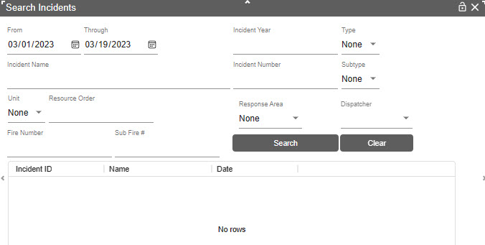
Figure 186 - Search results by date.
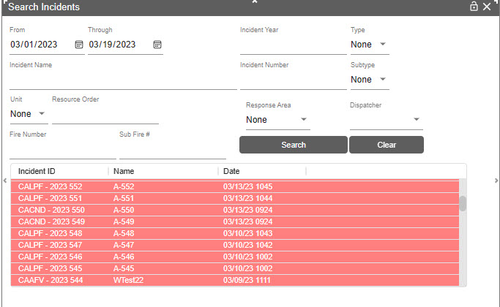

Section 2: New Incident (F9 or Incident Icon)
Figure 187 - New Incident F9 Icon

Create Incident
Incident can be created in the following ways:

Manually
- Click the New Incident Icon without the location (Lat/Long)
- Manually enter the location on the Location (LOC) tab

Use the Drop Point
- Click on a location on the map, and to set a “Drop Point.”
- Click on the New Incident Icon on the lower right side of the map. This auto populates the Lat/Long and TRS on the Location (LOC) tab.
Figure 188 - Use the Drop Point to create an Incident.
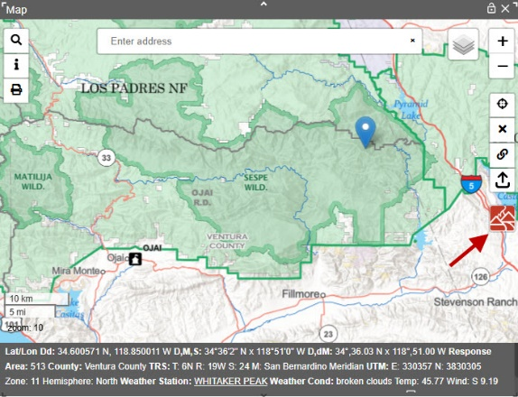
Figure 189 – New Incident created by using the Drop Point.
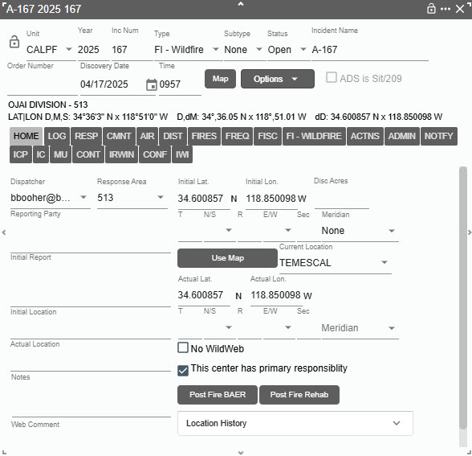

The “Use Map” Button
- Click New Incident Icon or F9.
- Open the map and set the drop point location.
- Clicking the “Use Map” button will auto populate both the Lat/Long and TRS Location (LOC) tab.
Figure 190 – Use “Use Map” button to auto populate Lat/Lon.
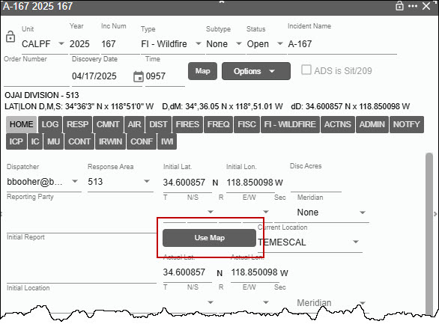

Find Panel Icon
Click on the “Find Panel” Icon upper left of the Map and use any one of the methods for finding a location, then click the “GO” button.
Click on the New Incident Icon on the lower right side of the map. This auto populates the Lat/Long and TRS on the Location (LOC) tab.

Search Bar
- In the “Search Bar” on the Map, enter a place name, Lat/Long, etc., then click to go to a location.
- Click on the New Incident Icon on the lower right side of the map. This auto populates the Lat/Long and TRS on the Location (LOC) tab.

“Map” Button
If an incident has a location, the Map button in the incident header will be enabled. Click the Map button, the map panel will open (if it was closed) and zoom to a point located at the actual Lat/Lon of the incident.
Figure 191 - Map button in the incident header is enabled.
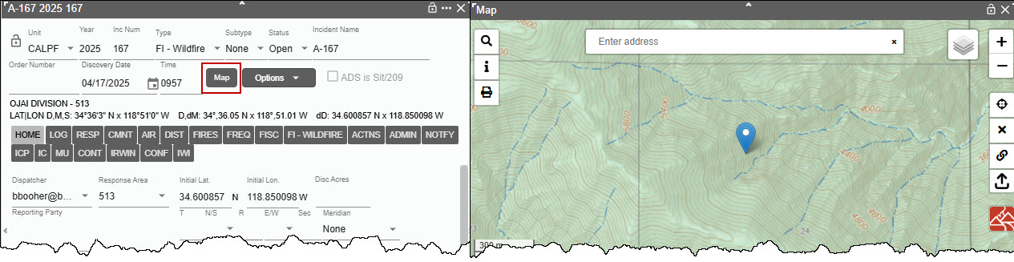
Section 3: Incident Panel and Tabs
Creating an incident WildCAD-E, auto populates several items on the Incident Panel’s Header and LOC Tab.

Header Information – Upper Portion
Figure 192 - Upper portion of Incident Panel Header
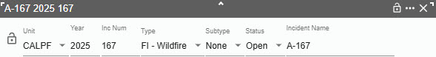
- Unit - Enter the Unit.
- Year – Enter the Current Year.
- Inc Num (Incident Number) – Is auto-populated by adding one number to the last used incident number. The last used incident number may be set up by the Center Administrator. The incident number cannot be changed.
- Type – For this Dispatch Center, the default type is “FI - Wildfire.” Incident Types are set and cannot be changed. Appendix III – Incident Types contains the current list. Some Incident Types will have “Expired” dates, which will allow for searching, editing, and reporting incidents with expired types.
Foreign Incident Types –- FI GF Foreign Incident, FM IM International Mobilization.
- FM-IM International Mobilization can be selected at any time. Once set to this type, however, the incident can only be changed to GF Foreign Incident.
- The FI-GF Foreign Incident is treated the same as a wildfire.
Figure 193 - Incident Type Dropdown Menu
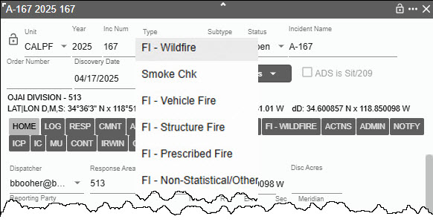
Subtype
- Display “None,” which can be changed by using the dropdown menu.
- Incident Subtypes dropdown menu excludes expired subtypes from the list.
Figure 194 - Incident Sub-Type Dropdown menu.
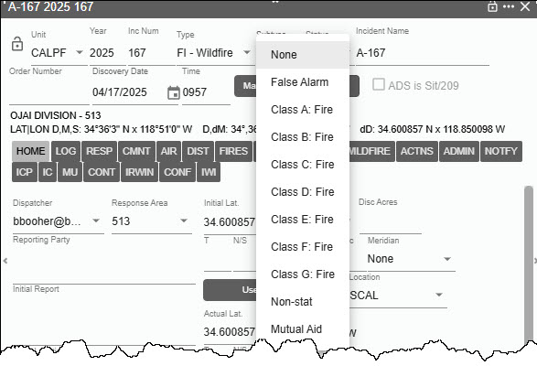
- Status (as “Open”)
Before an incident can be set to close, the user must clear all resources assigned to the incident. The user will now get a prompt when attempting to close an incident that has resources assigned. The incident cannot be closed until all resources a cleared from the incident. The “Assign” button will be disabled when the incident’s status is “Closed.” This is to prevent resources from being assigned to closing incidents.
Figure 195 - Incident Status Dropdown menu.
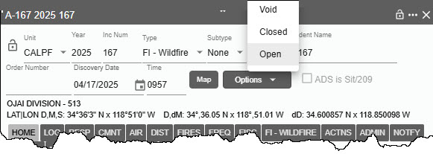
The user will now get a Popup Confirmation when changing an incident status to Void.
Figure 196 - Void Incident Confirmation
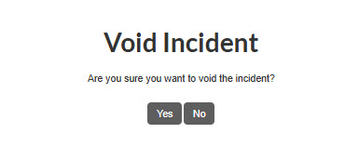
- Incident Name - Displays “New,” which will be replaced automatically as the user type in the actual name. WildCAD-E will check for duplicate incident name in the same calendar year and indicate a duplicate with “DUP,” next the second incident name entered. VOID incidents and incident types are not considered in evaluating duplicate incidents.
Incidents names with the “&” (ampersand character) in the incident name were not successfully to added to IRWIN.
Figure 197 - Incident Name
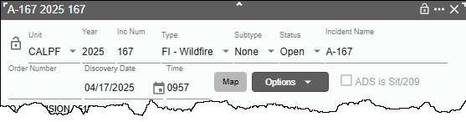
Figure 198 - Duplicate Incident Name
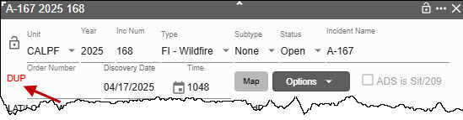
- Discovery Date and Time – Enter the date and time that the Incident was discovered.
- Dispatcher – Name of Dispatcher at the time the incident was created.
- Response Area – Initially display “None,” which can be changed by using the dropdown.
IRWIN Managing Dispatch Center ID
- The incident panel will display the “Requesting Managing Dispatch Unit” Center ID from the IRWIN table.
- Log into IRWIN oat/next and update that incident record with a value in the field:
[{'attributes': {'RequestManagingDispatchCenterID': 'CALPCC'
- The incident should now display the text in the incident header: “Managing Dispatch Center:”
- This will only be displayed if the IRWIN value is not null.
Figure 199 - Requesting Managing Dispatch Unit
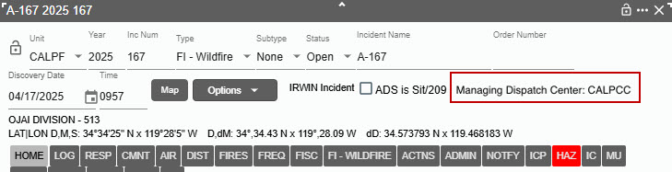I
Docking, Locking and Closing the Panel
In WildCAD-E, two or three symbols are located on the right side of the ribbon panel. These symbols are:
- Lock – The Lock allows the user to lock or “Freeze or Un-freeze” the panel in place on the Home page.
- Three Dots – The three dots to the right of the lock, dock the panel on the Home page ribbon.
- The “X” – The “X,” to the right of the three dots on the Home page ribbon, closes the panel from view; but does not delete the panel.
Figure 200 – Symbols at the far right of the panel ribbon lock the panel in place; dock the panel on Home; and closes the panel from view.
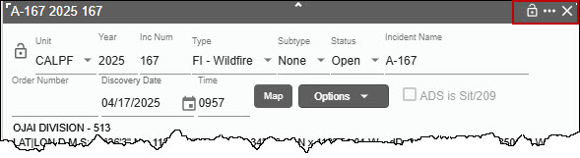
Figure 201 – The Freeze Lock in the “Open” position allows the panel to move. The “Close” position docks the panel in place on the Home page.
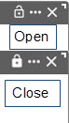
Figure 202 - Example of a "Dock" Incident Panel.
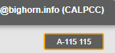

Header Information – Lower Portion
On this portion of the Header, there are Two buttons:
- Map Button – Zooms on the map to the incident location and displays a Drop Point.
- Options Button – Has four dropdown menus:
  - PDF – Prints this Incident Report to a PDF File. Associated merged wildfires are shown in the related incidents section of the report.
  - IWI – Creates an “Incident within an Incident” incident panel.
- MIR – Creates Medical Incident Report(s) (MIR) and opens a MIR form.
- MERGE – Will show when the incident is a Wildfire incident and opens a “Merge Incident Info” panel.
Additionally, these option buttons will open:
- WF – Will show when it is a Prescribed Fire type and has related incidents.
- FI – Will show when it is a Law Enforcement incident.

Figure 203 – Map and Options Buttons
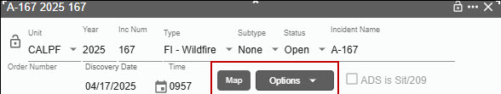
Figure 204 –Options Dropdown Menu
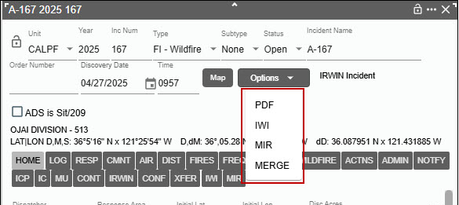

Map Button
Clicking on the Map Button the map will zoom to the incident location and displays a Drop Point.
Figure 205 - Display the location of the incident after clicking the “Map Button.”
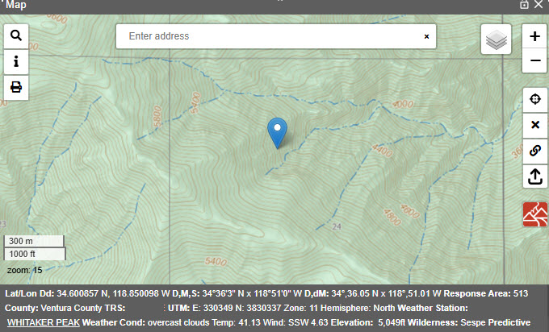

Options Button (PDF, IWI, MIR, MERGE WF and FI)
- WF Option is discussed in section called “Prescribed Fire Escapes (FI – Prescribed Fire”
- FI Option is discussed in section called “Creating a Field Interrogation File (FI File) from a Law Enforcement Incident).

PDF
After clicking the ‘PDF’ option, a pop-up will ask to confirm the inclusion of resource status.

Figure 206 - Report to include resource status or not.
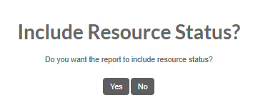
Figure 207 - Example of a file created using the PDF button.
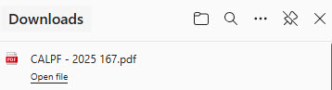
In this example notice the relationship section, which indicates the relationship between the parent incident (Wildfire) and the child (Merged and Med Aid (IWI)
Figure 208 - Example of an "Incident Report."
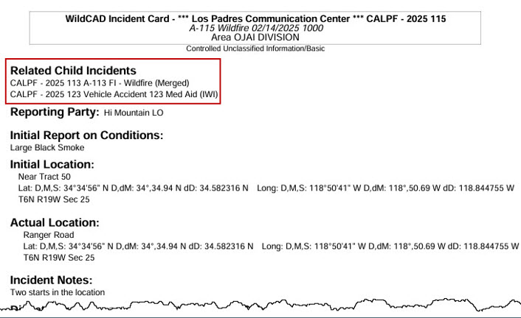

Incident within an Incident (IWI)
There are two places to add “IWI”
- From “Options” dropdown menu on the Incident panel. Click on the “IWI” option this will open a new incident panel for the IWI.
- From the “IWI Tab” Click on the “IWI Tab” this will open a new incident panel for the IWI.
In both cases the user can enter the information associated with the incident within the incident.
Figure 209 – Creating an IWI from Options Dropdown.
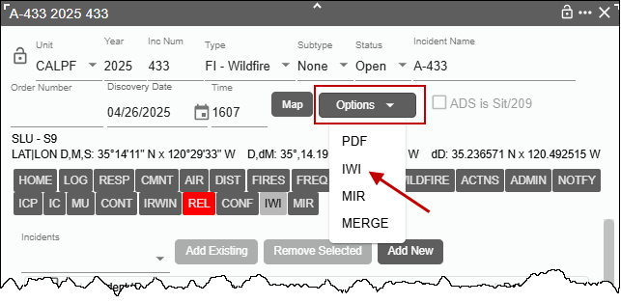
Figure 210 – From the IWI Tab, open the IWI Panel.
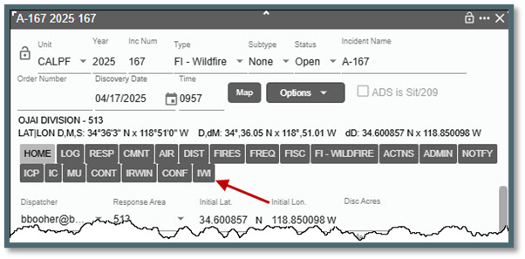
Any IWI associated with the original incident will be listed.

Figure 211 – The list of IWI Associated with Original Incident.
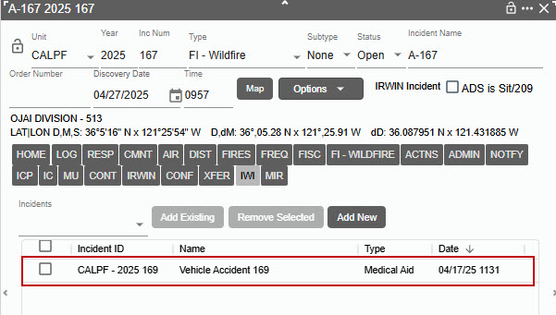
Double-click on the IWI to open incident panel for that IWI. If the incident is a child of an IWI Parent, the parent incident is listed on the child incident.

Figure 212 – Associated Child to the Parent.
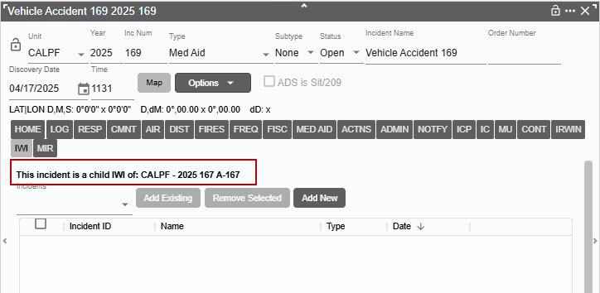

In addition, from this panel the user can add a new IWI. Incident IWI can create an IWI for an incident that is already an IWI of another incident by clicking on the IWI Tab.

Figure 213 – Adding IWI from the IWI Panel.
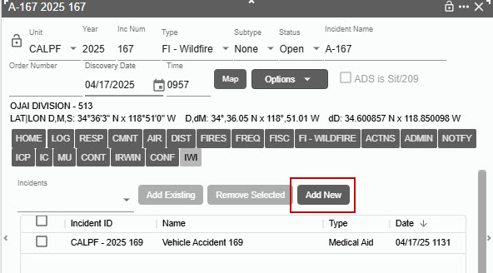

Then by clicking on the “Add New IWI” button that opens an incident panel has the same functionality as a normal incident panel and will associate this main incident with its own Tab on the original incident.

To add an existing IWI:
- Use the “Incidents” dropdown menu to select an IWI.
- Click the “Add Existing IWI” Button to add this existing IWI to the list.

Figure 214 – Add Existing IWI.
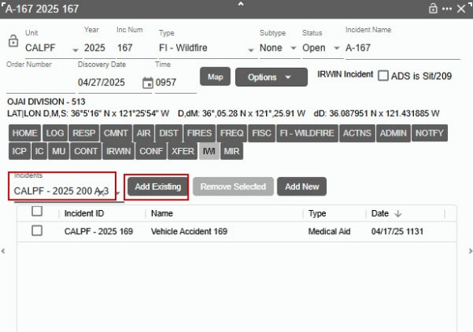

To remove an IWI from the list:
- Click the box next to the “Incident ID.”
- Click the “Remove Selected IWI” Button to remove this IWI to the list.
- To remove more than one IWI at a time just click all the boxes next to the IWI you want to remove.

Figure 215 – Remove IWI.
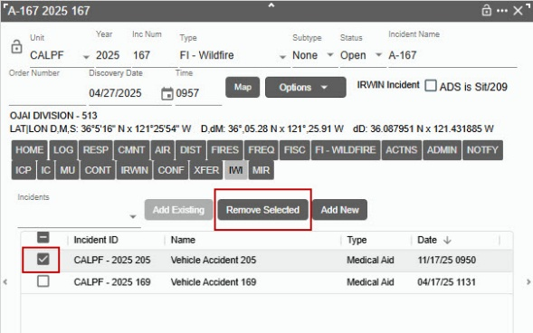

Medical Incident Report (MIR)
Medical Incident Report(s) (MIR) can be created using the incident’s “MIR” option under the incident panel’s Options menu. Multiple individual reports can be created for a single incident. All associated reports are listed under the MIR tab of the incident. Individual MIRs can be saved/printed and can also be appended to the incident’s PDF report.
To create a new MIR, open an existing or new incident and click the Options Menu and then the MIR Button.
Figure 216 – Option Menu and MIR Button
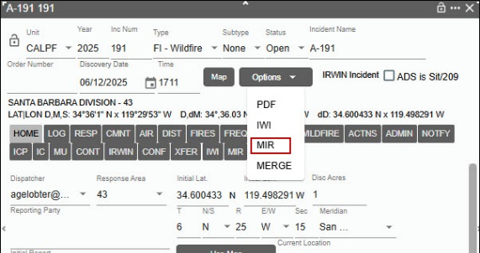
This will open the MIR Form. Fill out the form with the relevant information.
Figure 217– Enter the MIR information into the form.
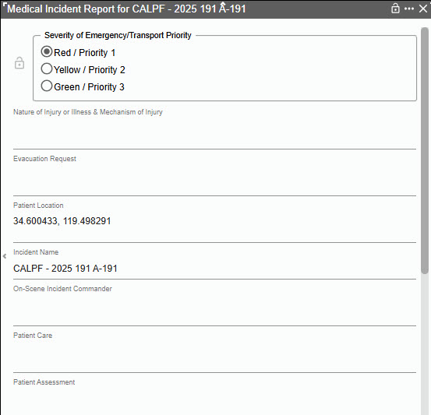
After entering the information click the “Save” button at the bottom of the form. Click the “Save & PDF” button will save the form to the user’s computer which can also be printed. The “Save,” “Save & PDF” buttons are disabled when a user has the read only role.

Figure 218– Click “Save” or “Save & PDF” Button
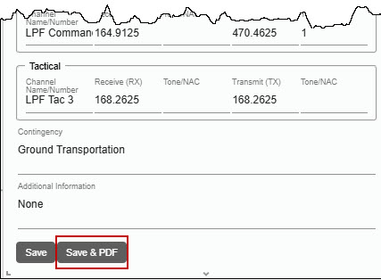
Figure 219 –The saved PDF on the user’s computer.
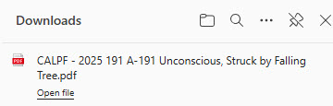
In the incident panel, click the MIR tab to view all associated MIRs.
Figure 220 – To View MIR information, click the MIR tab.
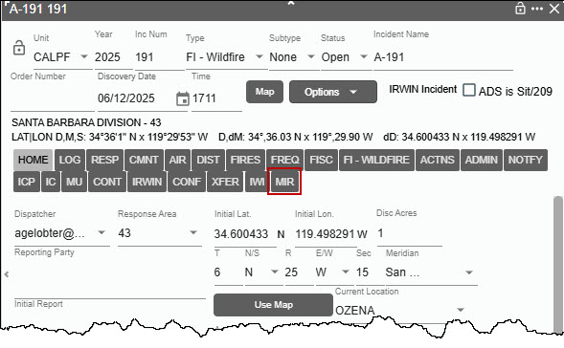

Figure 221 – The list of MIR’s will be displayed.
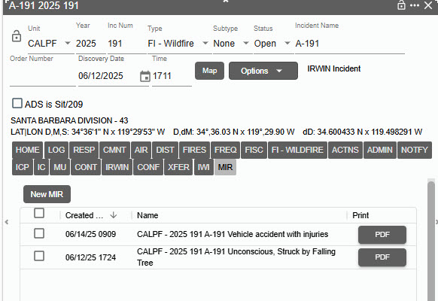
In the MIR tab, click the PDF button next to one of the reports. This will save the form on the user’s computer.
Open the MIR for additional editing. Double Click on the MIR File name.
Figure 222– Editing an existing MIR.
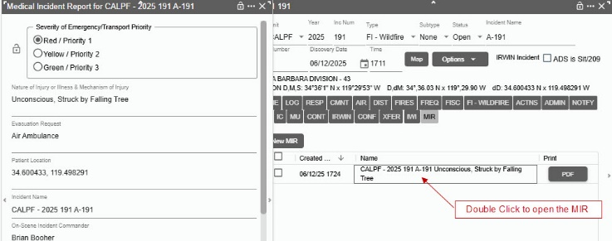
Click the “New MIR” button to create a new report from related to the exiting incident.

Figure 223 – Creating a new MIR.
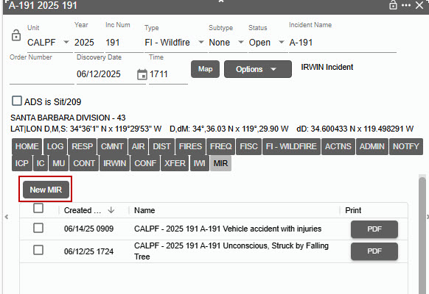
Click the lock icon in the top-left corner of the MIR panel to lock the MIR. This should lock the MIR and prevent any user from editing the fields.
Figure 224 – Lock the MIR
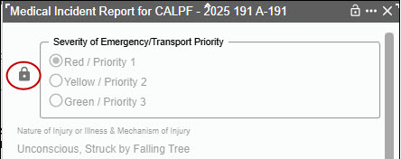
Click the lock icon again and this will unlock the MIR and allow any user to edit the fields again,
Figure 225 – Unlock the MIR
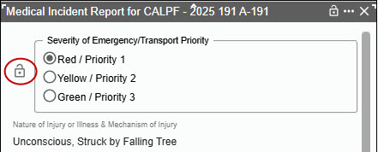

Merge

Background (from NWCG Standard for Merged Wildfires)
Merged Wildfires: Two or more wildfires that burn together to form a single burned area and which, by management action, may be declared merged and managed as a single incident to improve efficiency and simplify incident management processes.
Definition Extension:
- Management can decide to declare wildfires as merged or not.
- A merged wildfire requires a Merged Date and association with the remaining active wildfire, i.e., Merged Parent, to be identified correctly in operational and historical data.
Create merge relationships from an incident, open a wildfire incident and click the “MERGE” option to open the Merge Incidents panel.
Figure 226 – Merge Option Panel.
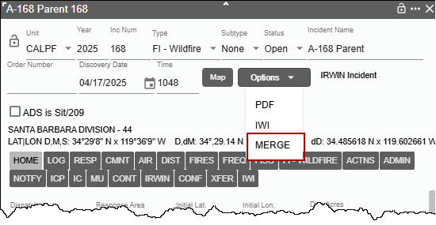
On the Merge Incidents panel, select an incident in the dropdown that you would like to merge with.
Figure 227 – Selecting the Incident to be merged.
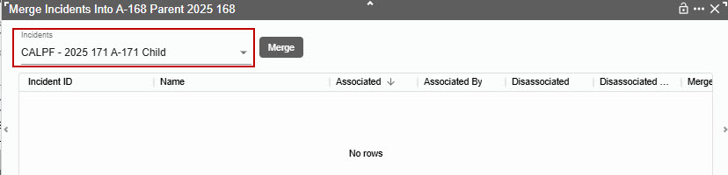
Click “Merge”
Figure 228 – Click the Merge Button.
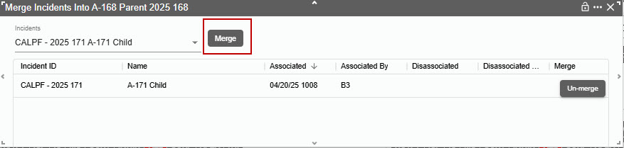
Click the “Un-merge” button to disassociate the merge incident.
Figure 229 – Click the Unmerge Button.
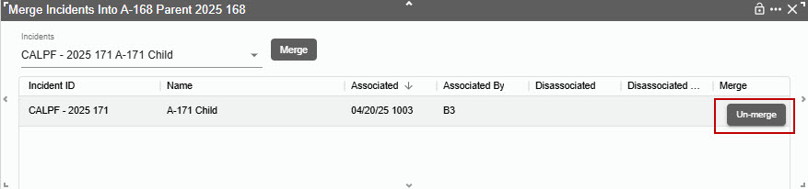
Figure 230 –The Merged Incident is Disassociated.
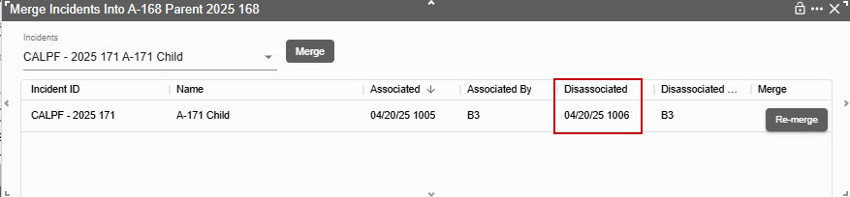
Click the “Re-merge” button for that same record.
Figure 231 – Click the Re-merge Button.
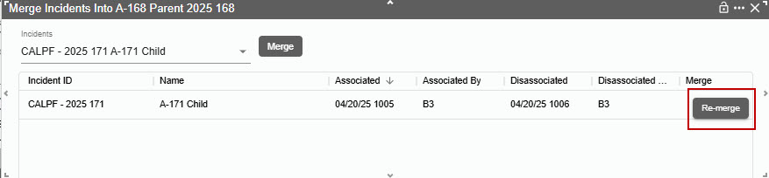
View “Merge” relationships for an incident in the “REL” Tab (Relations)
Open incident that created merge relationships for the parent or child.
Figure 232 – REL Tab.
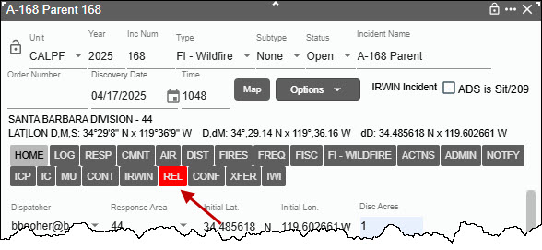
Click the “REL” or Relationships tab.

Figure 233 – Merge Button.
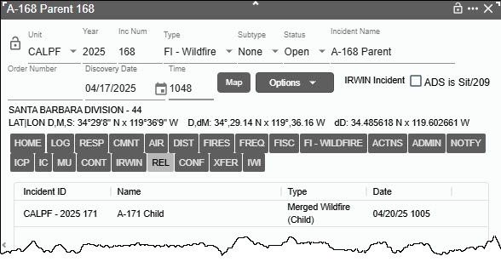
To view “Merge” relationships for the entire dispatch center, go to Daily Routines/View Merged Incidents page.

IRWIN Integration
The fields required to have an Incident be sent to IRWIN are:
- “Disc Acres” - Discovery Size (new field “Disc Acres” on Location Tab)
- “Incident Name” - Once the user starts typing the word “New” will be replaced.
- “This center has primary responsibility” for this incident must be checked.
      - If the user’s center is NOT responsible for the incident, the user would un-check the box.
      - If the user UNCHECKS the box for a fire, the user’s information about this Incident will not flow through IRWIN to other systems.
Once the above is completed the incident panel will display “IRWIN Incident.”
Figure 234 - Example of IRWIN Incident.
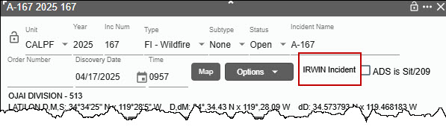

Changing from an IRWIN Integrated Incident to Non-Integrated Incident
When changing from an IRWIN Integrated Incident to a Non-Integrated Incident type, any filled resource capability requests on the incident are closed and the IRWIN incident is set to invalid. Also, the following log entry is added to the IRWIN Log for the incident - “Changed to a non-integrated type, IsValid set to false.”
Changing the incident type back to an integratable type uses the prior IRWINID and sets IsValid=true (example, Wildfire accidentally changed to Misc, dispatcher notices the error and changes back to Wildfire).
When changing from a non-integrated incident to an IRWIN integrated incident type, the incident is sent to IRWIN once all the requirements are met. Filled capability requests are created for any IRWIN resources assigned (w/ status Responding, On Scene, or Returning) to the incident.
In the case where the incident type is changed to “FI - Wildfire" the following rules are applied:
- When changing from an IRWIN integrated incident to a "FI - Wildfire" and the incident does not have discovery acres, the discovery acres are set to 0.01 by WildCAD-E. The incident continues to be integrated.
- When changing from a NON-integratable incident (i.e., Smoke Check, Misc), the discovery acres are now NEVER set by WildCAD-E
In the case where an escaped "FI - Wildfire" is created from a "FM - Prescribed Fire" (via the WF button on the incident header), WildCAD-E sets the wildfire's discovery acres to 0.01 regardless of the value in the prescribed fire's discovery acres.
The incident type cannot be updated for the following special cases:
- If the incident is part of an integrated parent/child relationship
"FI - Wildfire" related to a “FM - Emergency Stabilization".
"FI - Wildfire" related to “FM - Fire Rehabilitation".
"FI - Wildfire" related to a "FM - Out of Area Response".
"FM - Prescribed Fire" related to a "FI - Wildfire".
- If the incident is a "FM - Preparedness/Preposition." When an incident type is changed to a "FM - Preparedness/Preposition,” the user is prompted with a dialog to confirm or cancel the change. The incident type can ONLY be updated to a "FM - Preparedness/Preposition" if the incident is not in IRWIN and the incident has no resources assigned.

Authoritative Data Source (ADS is Sit/209)
If the Center has turned over responsibility for updating the Incident to another entity (e.g., to an Incident Management Team), check “ADS is Sit/209” box. From then on, changes to the center data for this Incident will not flow to IRWIN. If the box was inadvertently unchecked and resources were then assigned, it was not possible to check it without releasing all the resources.

Incident Panel Tabs
As users work with WildCAD-E, they will frequently manage Incidents on this Incident Panel. The panel contains numerous "Tabs," each of which is described below. All Tabs have a set maximum length limit on all entry fields to avoid issues with user would try to save data with too many characters and the result would be that no data was saved.

Home Tab (HOME)
Most of the information on the HOME tab is completed as the user creates the incident.
Such as,
- The “Current Location” is the dispatch location associated with the incident response area. A dropdown dispatch location is available to change the dispatch location.
- For resources assigned to the incident, their current dispatch location will be set to the associated dispatch location for the incident.
- Added the ability to add half (x.5) decimal values for Township and Range.
- The “Dispatcher” dropdown will display the Dispatcher Name and ID Code.

The lower left side (Red Box #1) of the HOME tab has several free text areas that are optional.
As the incident’s actual location changes, a record is kept of all previous locations and added to a “Location History” (Red Box #2) grid on the HOME tab as well as the PDF incident report.
Figure 235 – Home Tab (HOME)
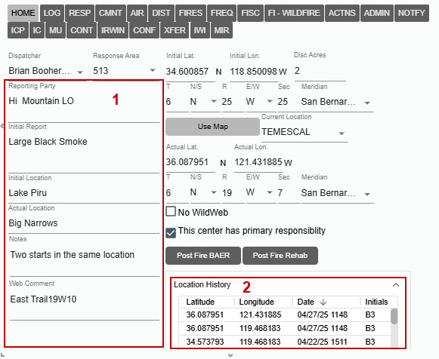

Incident Log Tab (LOG)

Adding an Entry into LOG Tab
- Click on “Log Entry,” and type the entry. Partial log entries are retained until saved even if the dispatcher switches tabs.
- In the “From/To,” enter the name or initial for the individual the message is coming and going to.
- The Add button is disabled until the dispatcher types something into the From, To or Log Entry fields. Click “Enter” key or “Add” button to save the entry.
- The Dispatcher’s initials will be displayed under the “User” column.

Editing a LOG entry
- Click on the entry line the user wants to edit, and the entry will be displayed in Log Entry line.
- Make the edits.
- Click the “Save” button.
- Click “Save” for either case.

Voiding a LOG Entry
- Click on the entry line the user wants to void, and the entry will be displayed in Log Entry line.
- Click the check box next to “Strikethrough” to indicate this entry was void.
Click the “Save” button.
Figure 236 – Editing LOG Entry
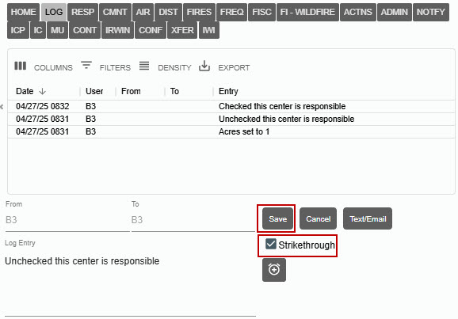

Figure 237 -An Example of void LOG entry (Strikethrough)
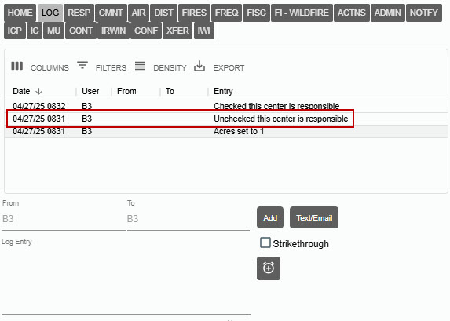
Text/Email
Clicking on the Text/Email button takes the user to the Text/Email panel on a separate tab. Text messages sent from within an incident will now appear in the Incident Log and the Daily Log

Timer
Click on the Timer Icon to start a timer.
Figure 238 -An Example of void LOG entry (Strikethrough)
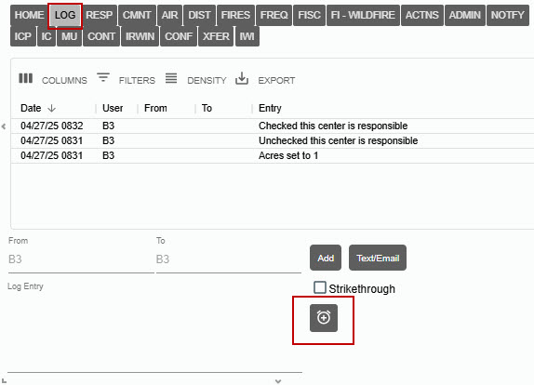

Resource Status Changes
Resource Status Changes only appear on the Log if a “Comment” has been included with the status change.

Response Tab (RESP)
Manage the responding resources on this tab. RESP tab is NOT visible for incident types of FM - Preparedness/Preposition ("Prepo”) or FM - Out of Area Response.
Figure 239 - Response Tab (RESP)
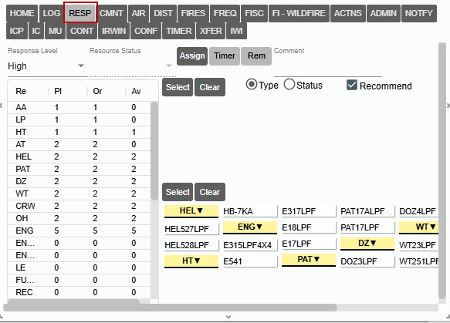
The left side of the RESP Tab:
- Response Level - will default to the response level set in the Daily Routines. To start a response:
    - Use the dropdown to change the response level.
- Resource Status – will default to “Committed” once a resource is “Assigned.”
      - Use the dropdown to change the response status.
- Quantity - the preplanned number of resources to be dispatched at a select response level. These numbers are set in Center Administrator within the “Dispatch Strategy,” The quantity are defined:
  - Re – Resource Type
  - Pl – Number preplanned
  - Or – Number requested (ordered) for this Incident.
  - Av – Number available
The user can change the quantities in the Ordered (Or) column to, for example, request the next closest engine.

Assigned Resources
The top portion right side of the RESP Tab includes:
- Assign -The Assign button commits the resource(s).
- Timer – Click on a resource, then the button will start a timer for that resource.
- Rem - The “Remove” button can be used to completely remove a resource from the incident, along with any associated actions on the Incident.
- Comment - When a resource is assigned, you can enter a comment by changing status or click the “Enter’ key to create a log entry.

Committed Resource
The middle portion on the right side of the RESP Tab includes:
- Select – Click on resource the use the dropdown “Resource Status” to change status.
- Clear - will clear the user’s last entry, such as select a resource and decided the user pick the wrong, click “Clear.”
- Type or Status – The user can sort the list of resources by Resource Type or Resource Status.
- Recommend – Click on the box to display the recommended response and click off the box and “Not Recommended” will be displayed. Current Dispatch Location is used for recommending resources.

Recommended Resources
The lower right side of the RESP Tab includes:
- Select – Click on resource and use the “Assign” button to commit the resource (multi select).
- Clear - will clear the user’s last operation, such as a select-a-resource and/or it is decided the user pick the error wrong, click “Clear.”

Selecting from the RESP Tab within the Recommended Resource portion:
To select ALL Resources:
- Click “Select” and each resource will have a red box around the resource.
- Click “Assign” which moves the resources to the Committed portion.
Figure 240 - Select.
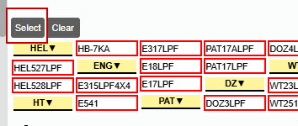
Figure 241 - Assign.
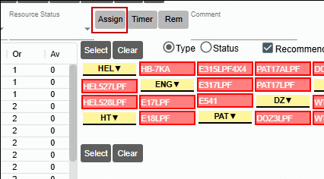

Within the Committed portion:
- Use the Resource Status dropdown to status the resources Committed, Responding, or At Scene, etc.
Figure 242 - Resource Status
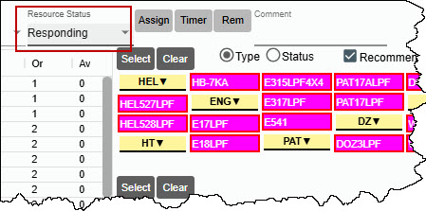

Figure 243 - Committed Status Dropdown List’
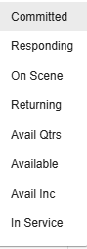
Figure 244 - Committed
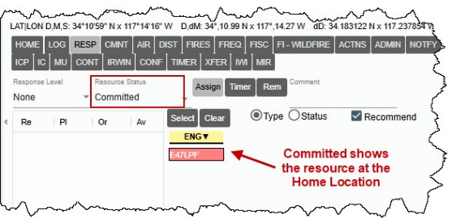
Figure 245 - Responding
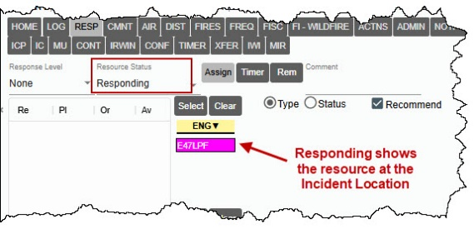

Figure 246 – On Scene
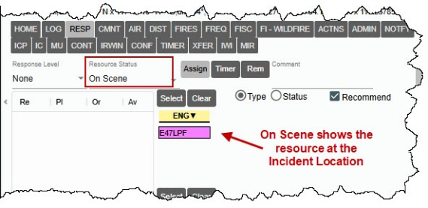
Figure 247 - Returning
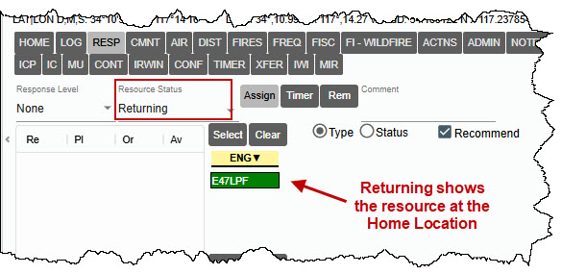
Figure 248 – Available at Incident
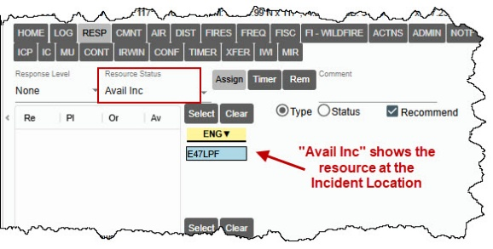

To track resources assigned to an incident but have returned to Home Location
Once a resource has been assigned “Responding,” the resource status dropdown list will add five (5) additional statuses.
To better track resources assigned to an incident but not physically at the incident, these status codes have been added:
Overnight (On Incident)
Returning (On Incident)
In Quarters (On Incident)
Out of Service (On Incident)
Responding (On Incident)

Key Rules for These Statuses
- Resources on an Incident Only
These status categories can only be applied to resources that are currently assigned to an incident.
- Action Logging
Any change to one of these status categories is recorded in the Actions Tab and the Daily Log.
- Map Location
The map location for the resource is set back to the resource’s home location for all status categories except “Overnight (On-Incident)” and Responding (On Incident),” which sets the location back to the incident location.
- IRWIN Status
There are no changes to the IRWIN general or operational status for the resource in an “On Incident” status. The resource will remain on a filled request until it is changed to a non-incident status.
- Rostering
If the resource is rostered and personnel changes are needed while the resource is in any of these “On Incident” status categories, take the following actions:
- First, status the resource off the incident.
- Make the roster changes.
- Then, status the resource back onto the incident.
Figure 249 – Changing Personal on a Roster
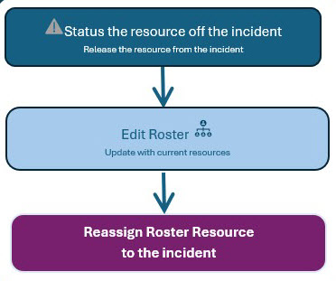
Figure 250 - Response Status Dropdown List
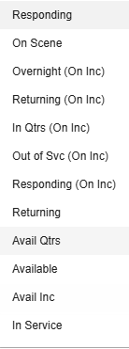
The resource status bar will have a “Red” notch on the right side, indicating that assigned to one of the following resource status codes:
Figure 251 - Overnight (On Incident)
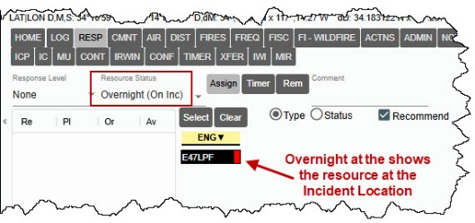
Figure 252 - Returning (On Incident)
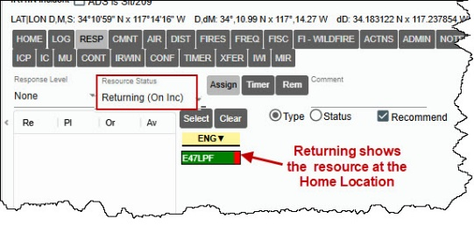
Figure 253 - In Quarters (On Incident)
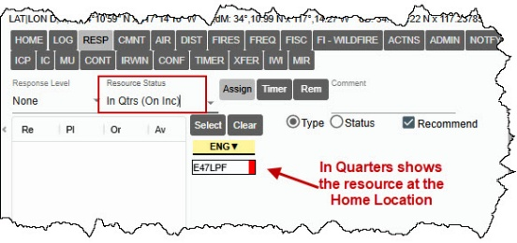
Figure 254 - Out of Service (On Incident)
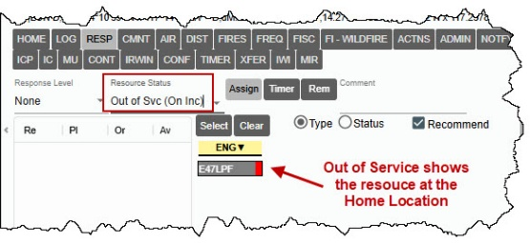
Figure 255 - Responding (On Incident)
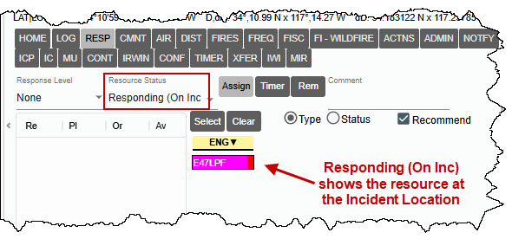
When updating the resource status, ensure that you select the appropriate code to accurately reflect the resource’s location and operational readiness. If a resource changes status during an incident, update the dropdown immediately to maintain an accurate log and facilitate effective coordination among responding teams.

To Multi-Select SOME Resources
Within the Recommended Resource portion
- Hold the “Ctrl” key and click on the resources the user wants to commit (can be one or more than one resource).
- Click “Assign,” which moves the resources to the Committed portion.

Within the Committed portion:
- Hold the “Ctrl” key and click on the resources the user wants to commit (can be one or more than one resource).
- Use the Resource Status dropdown to status:
  - To make the all the resources Committed, Responding, At Scene, etc.
  - Click on one resource, If the users only once to send one resource.

To Send One Resource
Within the Recommended Resource portion
- Click on the resources the user wants to commit.
- Click “Assign,” which moves the resources to the Committed portion and the Resource Status will be “Committed.”
Type or Status – the user can sort the list of resources by Resource Type or Resource Status.
Figure 256 - Resource Status - By Type
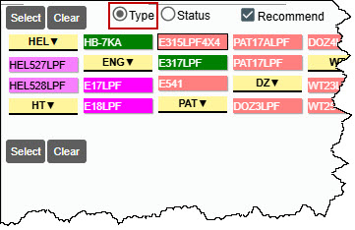
Figure 257 - Resource Status - By Status
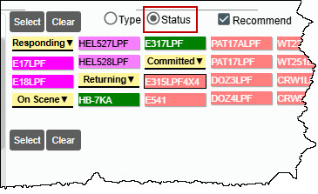
Timer – Click on a resource, then the button will start a timer for that resource.
Figure 258 – Starting a Timer
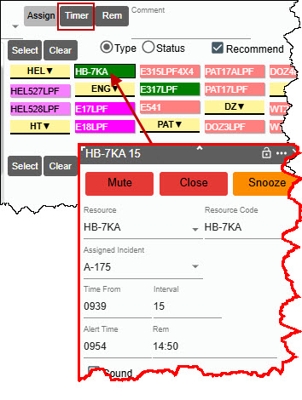

Comments Tab (CMNT)
This tab shows information entered by the Center Administrator for this response area.
Figure 259 - Comment Tab
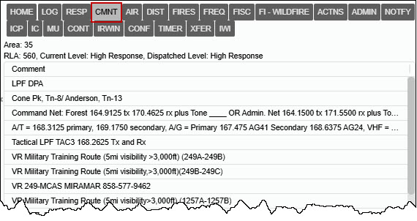

Aircraft Tab (AIR)
The following portions of the AIR Tab are automatically populated:
- Legal
- Frequencies
- ATB, Helibase, VOR, Hospital, and Burn Center
Enter free text for:
- Flight Restrictions
- MTR/SUA
- Hazards
- Other Aircraft
- Reload Bases
- Ground Contact
Figure 260 An Example of the AIR Tab
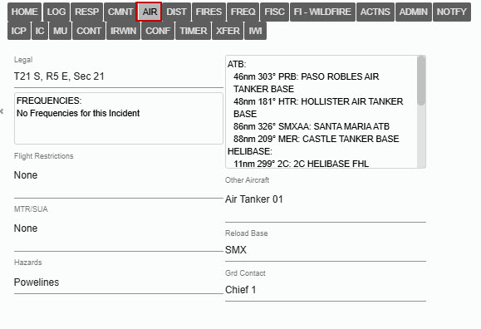

Distance Tab (DIST)
These six lists are sorted according to air miles, with closest shown at the top. Each time the user visits this tab; the lists are recalculated based on the Lat/Lon shown on the Location tab. Expanded the geographic declination lookup used by WildCAD-E to include areas outside the continental United States so that the bearing calculations could be performed in Alaska and other areas outside the U.S.
Figure 261 - Distance.
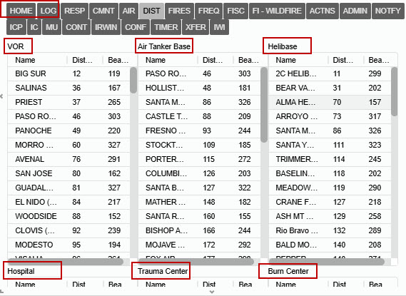

Fires Tab (FIRES)
Figure 262 – The FIRES Tab
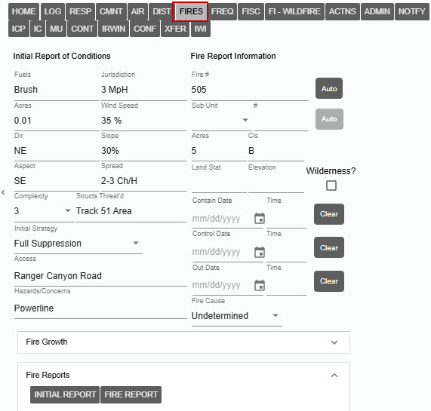
The FIRES Tab is used for two different purposes:
- On the left, enter the “Initial Report of Conditions” using free text along with a dropdown menu for “Initial Strategy,” enter the following:
- Fuel
- Jurisdiction
- Acres
- Wind Speed
- Direction
- Slope
- Aspect
- Spread
- Complexity (Dropdown - Incident Complexity values 1-5)
- Structures Threaten
- Initial Strategy (Dropdown – Confine, Full Suppression, Monitor, None, Point Zone Protection)
- Access
- Hazard Concerns
- On the right, enter the final “Fire Report Information,” which will be used for the fire summary reports.
The “Auto” buttons will automatically assign the next Fire Number and next Sub-Unit Fire Number.
- “Subunit” (Dropdown – the is created by the Center Administrator)
- “Acres” and “Cls” (Fire Class - A, B, C, etc.)
- When the user changes acres, the class will automatically be updated.
- Land Status
- Elevation
- Wilderness Check Box

The Contain, Control, and Out Date
- Enter the date and time for each, and use the “Clear” button to change entries:
    - The Contain (date and time) can’t be before the Discovery Date and Time but can be equal.
    - The Control (date and time) can’t be before the Contain Date and Time but can be equal.
    - The Out Date (date and time) can’t be before the Contain Date and Time but can be equal.
If any Date/Time is before the other, an alert will be displayed, and the date will be highlighted in Red along with a red line.
Clear button for Contain/Control/Out dates to allow clearing the value. Clearing Contain/Control/Out dates, clears their corresponding values in IRWIN.
Once the user enters the Out Date (date and time), WildCAD-E will lock several entries while other Systems are finalizing the Incident.
“Fire Cause” – Use the dropdown to set the cause as one of the three classifications below:
- Human
- Natural
- Undetermined (Default)
On the lower portion of the of the FIRES Tab, the user can enter additional information, such as:
- Fire Growth
- Fire Reports (Information)
  - Initial Report
  - Fire Report
Figure 263 - Fire Growth History is a summary of the acres.
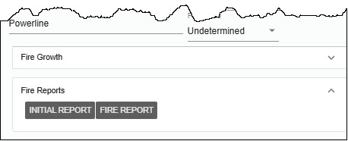
The “Fire Growth History” is a summary of acres from the entry of acres on the right, under “Fire Report Information.”

Figure 264 - Fire Growth History is a summary of the acres.
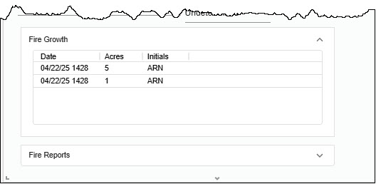
Figure 265 - An Example Initial Report Information
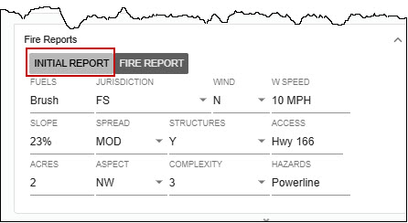
Figure 266 - An Example of Fire Report Information
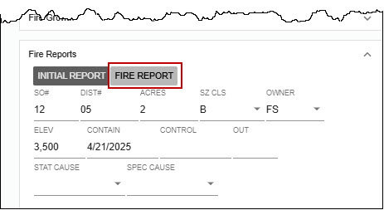

Frequency Tab (FREQ)

Adding a Frequency
- Under “Frequencies Type,” use the dropdown to select a category (e.g., Ground).
- Once a category is selected, a list of “Default Frequencies” descriptions will be displayed.
- Click the appropriate box adjacent to the frequency type to be used.
- Click the “Add” button to add a frequency type, and a description will be added to the list.
Figure 267 - Adding Frequency -Type
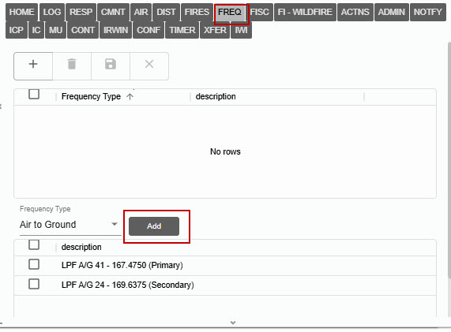
Figure 268 - Example of Completed FREQ Tab
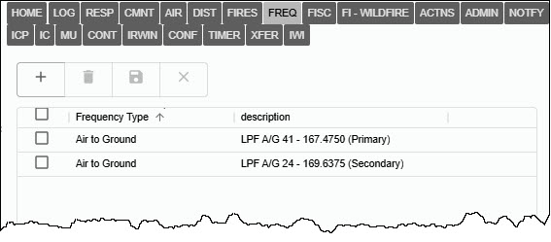

Deleting a Frequency
- Click the box next to the frequency that will be deleted. The “Trash Can” icon will be highlighted.
- Click the trash can icon, and a warning will appear asking to either accept “OK” or “Cancel.”
- Click OK to delete or cancel to make no changes.
Click “Save” in either case.

Fiscal Tab (FISC)
Once an Incident has gone to IRWIN, the user can have WildCAD-E automatically request a FireCode via IRWIN. This is done on the Fiscal Tab by pressing the “Get FireCode” button.
This button is only enabled for use after all the required fields have been successfully sent to IRWIN, and IRWIN has accepted them.
After clicking “Get FireCode,” wait several seconds and the Auto FireCode will appear. The user cannot edit this Auto FireCode.
The user may manually enter additional fiscal codes.
These codes will be sent to IRWIN. They include:
- ABCD Misc.
- U.S. Forest Service (FS) Job Code
- FS Override
- State Fiscal Code
Clearing the above-listed codes clears their corresponding values in IRWIN.
However, Other Fiscal Codes will not be sent to IRWIN. The user may manually check the box for inclusion within the financial report. The following may be checked:
- FS Assisted
- Multi-Jurisdictional
- Trespass
- Reimbursable
Use the dropdown menu to select “Unprotected Response Reason:”
- Threat to Protected Lands
- Burned Onto Protected Lands
Figure 269 - Example of a FISC tab.
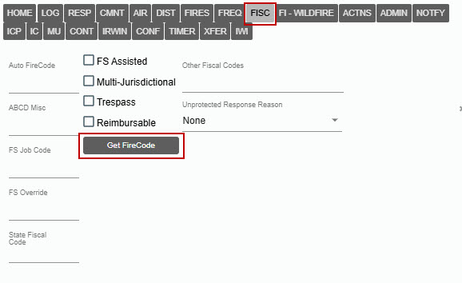

Questions Tab (FI - Wildfire or varies)
The name of the Tab between Fiscal and Action will change according to the Incident Type and will contain additional questions based on the Incident Type selected. This information is developed for use by the Center Administrator.
To enter information for a question, click on the question, and type the response in the “Answer” area below. Then, click “Save.”
Figure 270 - Example of a Question Tab for Wildfire
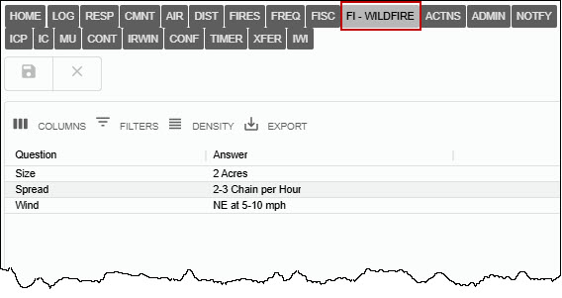

Actions Tab (ACTNS)
The Actions Tab shows all the status changes for resources on this Incident. When a resource is set to a status that makes it no longer assigned to the incident, the Actions tab now shows that the resource was either "Released" from the incident or “Reassigned” to another incident along with the date/time. This record will also be in the status history of the incident.
Figure 271 - Actions Tab
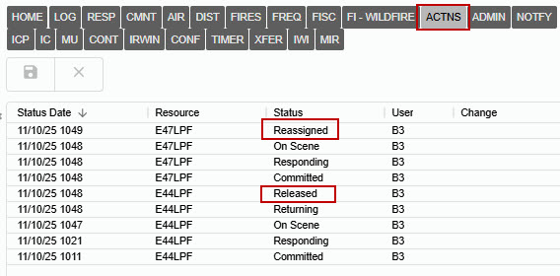

Numbers Tab (ADMIN)
The Center Administrator creates categories of numbers (Descriptions), which the users can then enter the “Value.”
- Text or Non-changeable Numbers are entered directly.
- Sequence of Numbers is set up as an “Use Auto” by the Center Administrator, the user will click the “Next Number” button to retrieve the next number. This will change the number to +1 of the last number that was on the ADMIN Tab.
Figure 272 – ADMIN Tab – Add Numbers and/or Text.
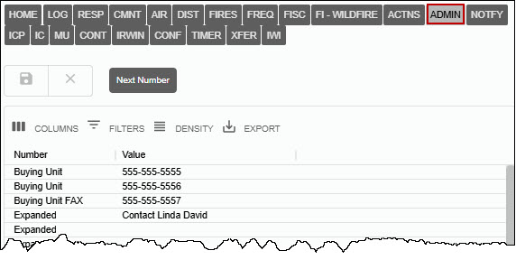

Notifications Tab (NOTIFY)
The Center Administrator creates the Notifications list. Once the list is available:
- Click on the line of the entity to be notified.
- Under “Comment “column, enter brief details about the notification and click to text notification.
- Click “Save,” and the date and time will be automatically populated.
If certain Notifications are required for this Incident, they will appear at the top in red.
Figure 273 - Notify Tab.
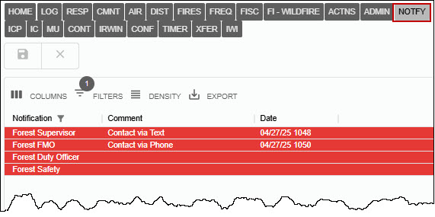

Incident Command Post Tab (ICP)
Enter information about the Incident Command Post on this tab.

ICP Location – Free Text
The user can select the following by clicking one of the check boxes:
- “Use Incident Lat/Lon for ICP”
- OR enter specific Lat/Lon for ICP; and then, type in the Lat/Lon.
Enter with free text:
- Description
- Staging, Helispots or other specific information.
The Functions in the lower portion of ICP Tab are pre-established, and all the user completes are the respective phone numbers.
Figure 274 - Incident Command Post Tab.
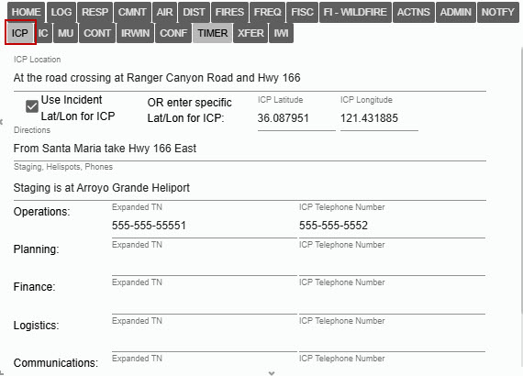

Hazard Tab (HAZ)
The Hazard Tab appears in red when hazards are near the incident.
Figure 275 - Hazard Tab.
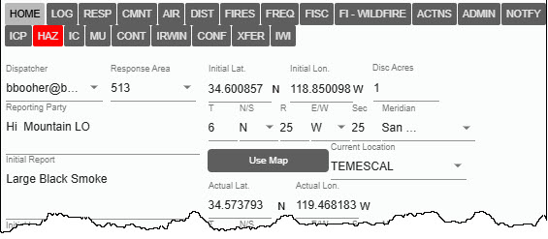
Click on the HAZ tab to view:
- Hazard Name – descripted by the Center Administrator.
- Distance from Hazard – miles from the hazard to the incident.
- Alert Miles – radius of hazard in miles.
Figure 276 – Information about the Hazard.
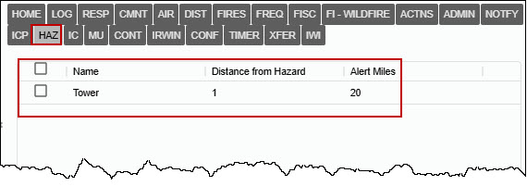

Incident Commander Tab (IC)
Use this tab to create a history of the Incident Commander. The user may also enter Trainees. To do so, enter the same information, and click in the box below “Trainee” and type “yes.” The grid sorts by Created Date in descending order.
Figure 277 - An Example of the IC Tab
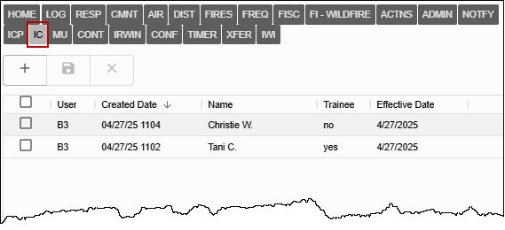

Move Up Tab (MU)
On the left side of the tab are the “Pre-planned Move Ups” for this Response Area, Response Type, and Level are shown.
Select the resource to move up.
- Click the “Move Up” button.
- Then, on the right side of the tab select:
  - Resource to move from the dropdown (e.g., E335LPF)
  - Location for the resource to move to (e.g., Big Sur)
  - Click the “Move UP” for the additional move up.
Figure 278 - Move Up Resources
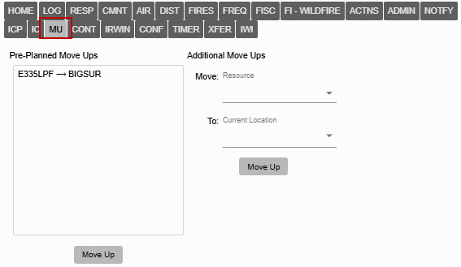
The Resource Panel will display the actions from the Move Up.
Figure 279 - Move Up Resources
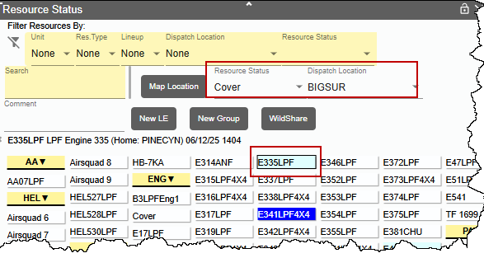

Contracts Tab (CONT)
By selecting, the “Type” or “Sub Type” of contract, a list of known contractors will be displayed and sorted by air miles to the Incident.
- To see information about a specific EERA/Contract, simply click on that respective contractor from the list.
At the bottom of the panel, enter the “Date” and “Resource Order #,” and select appropriate status for the Contractor on this order:
- F – Filled
- D – Declined
- U – Unable to Contact
Figure 280 – Selecting a Contract
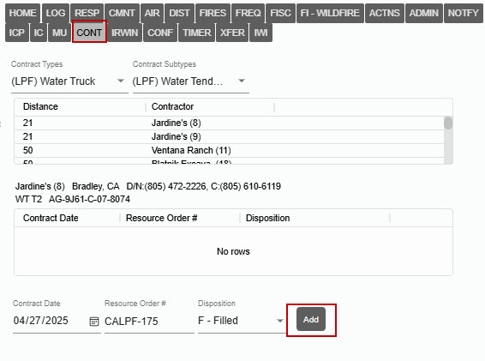
Click “Add” to add this history for the Contractor.
Figure 281 – Add the Contractor and appropriate status.
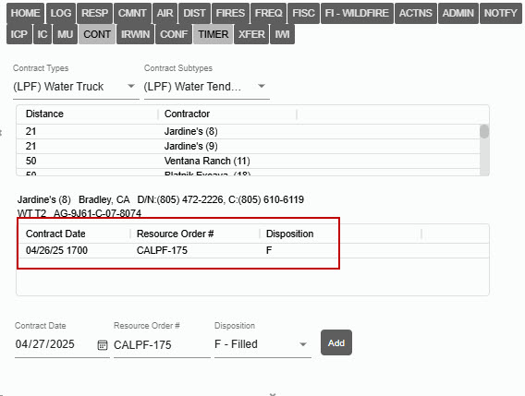

Relationship Tab (REL)
As discussed in the “Merge” section, Relationship Tab will display incidents associated with the parent incident.
Figure 282 – REL Tab
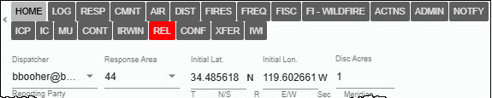

Figure 283 – List of Related Incidents
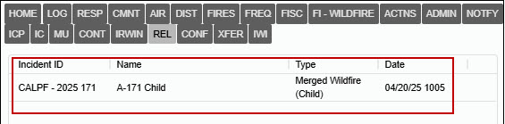

IRWIN Status Tab (IRWIN)
This tab displays information about the Incident and IRWIN:
- The Date/Time the IRWINID was received (when IRWIN accepted the Incident).
- When the FireCode was requested.
- When the FireCode was received.
- Any error messages from IRWIN in response to the user’s attempt to update this Incident in IRWIN.
- To show all updates check the box next to “Show all updates.”
- IRWIN logs will show dispatcher initials.
Figure 284 - An Example of an IRWIN Tab.
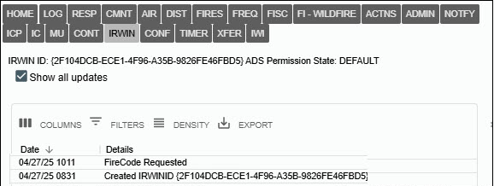

Conflict Status Tab (CONF)
Prior to submitting a new Incident to IRWIN, WildCAD-E checks for any Incident conflicts. A conflict is defined as another Incident already existing in IRWIN which:
- Is managed by a different Dispatch Center (Dispatch Center ID)
- Is within ½ mile (Initial Latitude and Initial Longitude)
- Was discovered within 6 hours (Fire Discovery Date and Time)
Figure 285 - Conflict Status - No Conflict
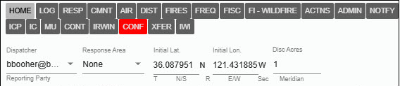
If IRWIN detects one or more potential conflicts, WildCAD-E will display the background in RED alerting users to the fact that the incident conflicts with another IRWIN incident. CONF tab is only visible for incident type “FI.”
Figure 286 – Conflict.
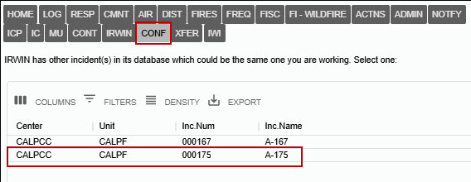
If a new Incident has potential conflict(s), the Dispatch Center managing the Incident has the primary responsibility for resolving the conflict(s).
Figure 287 –– Conflict Resolved
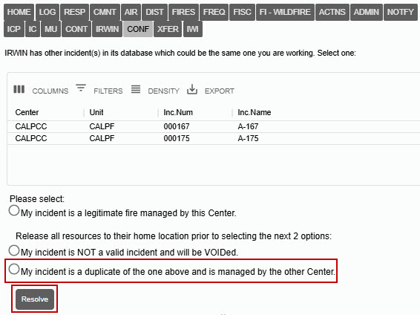

Select one of the following solutions:
- My incident is a legitimate fire managed by this center.
- This means there are “no duplicates.”
Release all resources to their home location prior to selecting the next 2 options.
- My incident is NOT a valid incident and will be VOIDED.
- This means to change this incident to “Void.”
- My incident is a duplicate of the one above and is managed by the other center.
- This means that the resulting conflict resolution will now be set to the incident type of "FM- Out of Area Response."
In some cases, the other system did not clear the quarantine. Those conflicts are now left on the CONF tab for the dispatcher to clear.

Timer Tab (TIMER)
Provides a history of Timers for the incident. Double Click on the Timer to open.
Figure 288 – Timer History
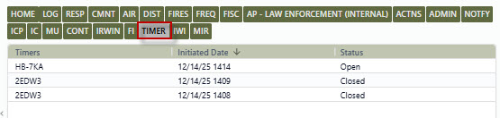

Transfer Wildfire Tab (XFER)
The user can transfer an incident from one center to another. The incident must be an IRWIN incident and identified as an open wildfire incident. After transfer, the destination center gets a new incident that is tied to the IRWIN incident already created, and the source center’s incident becomes a Resource Order. The order is not valid in IRWIN anymore.
Create a new Wildfire incident in the Sending Center and send it to IRWIN.
Figure 289 –– New Incident from the Sending Center
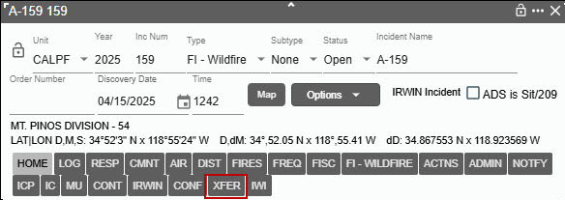
Go to the XFER tab on this incident, in this case the incident has one assigned resource that after the transfer, IRWIN must handle the filled request.
Figure 290 –– Example of one resource assigned.
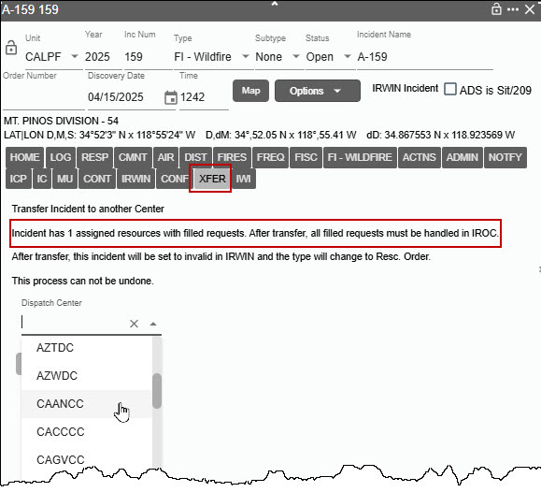
Pick a center to be Receiving Center and press Transfer.
Figure 291 –– Transfer the incident to the Receiving Center
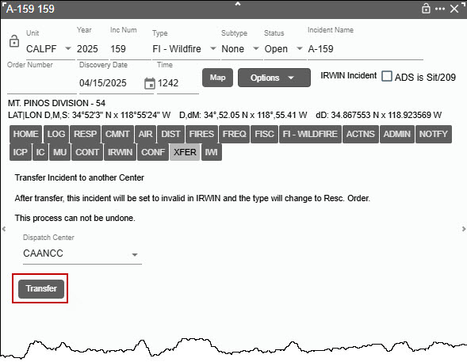
The tab should change to show the incident has been transferred, and the header should now show a “Resc Order” as the incident type and “IRWIN Invalid” as the IRWIN status.
Figure 292 –– Completed transfer.
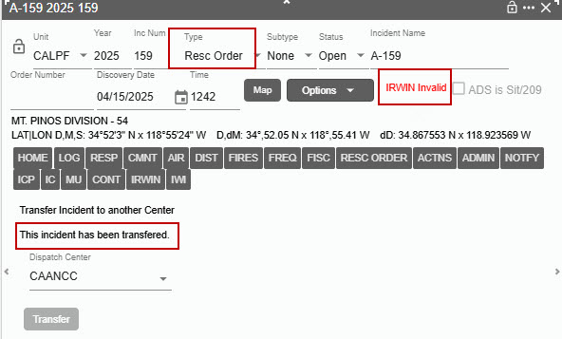
In the Receiving Center, a new incident should appear with the same name. Unit and Inc Num will be selected from the Receiving Center defaults.
The following fields should be identical between the Sending Center and the Receiving Center.
Name, Disc Acres, Discovery Date, Initial and Actual Lat/Lon, Initial Report, Initial Location, Actual Location, Notes, all Fires Tab fields except the custom center fire report at the bottom.
Additional information entered by the Sending Dispatch Center can retrieve by selecting the “PDF” on the “Options” dropdown. This includes but is not limited to the Incident Log, Fire Code, Resource Details, etc.

Incident within Incident Status Tab (IWI)
As discussed earlier, the IWI Tab lists the IWI information, which includes:
- Incident ID
- Name
- Type
- Date and Time
The user can also add additional IWI from this IWI Tab, including:
- “Add New IWI”
- The “New” IWI will be automatically added to the list.
- A new Incident Panel will open, and the user can begin to enter in the information regarding the IWI.
The user can also remove an IWI:
- Click on the check box for the IWI.
- Click the “Remove Selected IWI.”

The user can also add an IWI to a different existing Incident or IWI:
Use the Incident dropdown to select an existing incident.
- Click the “Add Existing IWI.”
- The “New” IWI will be automatically added to the list.
WildCAD Incident Card (PDF) - The report header will contain "This incident has IWIs" followed by a list of children incidents. Note: Each child incident is generated as a separate PDF when the report is run for the parent incident.

Final Fire Reporting (FFR)
The Final Fire Reporting tab on the incident panel.
- If the incident is an IRWIN incident, and the IRWIN Final Fire Report Status (ref IRWIN Incidents. FFRStatus data element) is “Complete” or “Certified,” the tab will display read-only information from the IRWIN table Final Fire Reporting.
Figure 293 – Final Fire Reporting Tab
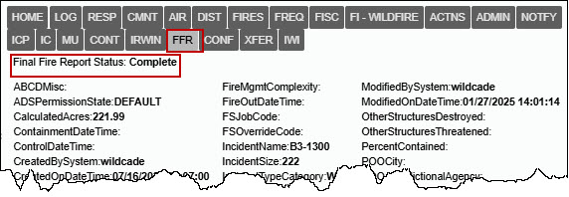
- The same data will also be visible on the “View Irwin Incidents/Resources” page under Daily Routines. Not every IRWIN incident will have data. If no data is returned, the tab will show “No Final Fire Report.”

Field Interrogation File Tab (FI)
On the Incident panel click on the FI Tab to display any Field Interrogation File(s) that are associated with this incident.
Figure 294 –Incident Panel, FI Tab
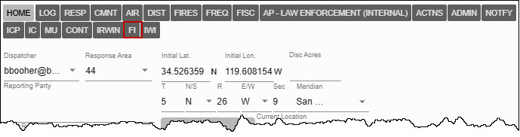
A list of Field Interrogation File(s) can be accessed by clicking on them.
Figure 295 –List of FI Files.
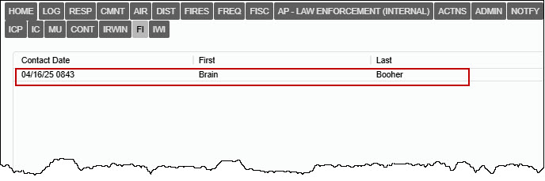

Section 4: Prescribed Fire Escapes, Post Fire Events and Out of Area Response
Section 4 includes the following topics:
- Prescribed Fire Escapes (FI – Prescribed Fire)
- Post Fire BAER (FM – Emergency Stabilization)
- Post Fire Rehab (FM – Fire Rehabilitation)
- Fire Support (FM – Out of Area Response)
For both Prescribed Fire and Post Fire Events, a red “REL” tab will be displayed on both the original Prescribed Fire or Wildfire and the Escape Prescribed Wildfire and Post Fire Events. These incidents must be related to IRWIN incidents. The related incidents are listed and can be opened from the list by double-clicking.

Prescribed Fire Escapes (FI – Prescribed Fire)
To create a Prescribed Fire incident panel:
- Step 1 - Create the “Incident Panel,” as you would with a Wildfire.
- Step 2 - Select the Incident Type “FI Prescribed Fire”
- Step 3 – Name to Incident with “RX” within the name
Note – No Discovery Acres are required for the Prescribed Fire to become an IRWIN incident but can be entered.
Figure 296 - Prescribed Fire Incident Panel
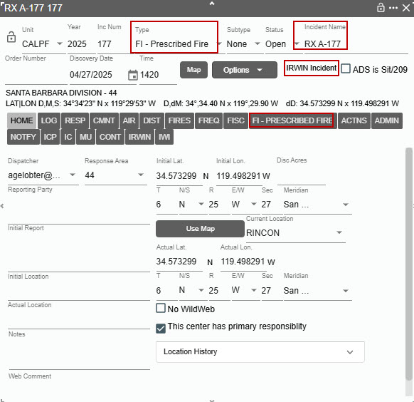
To create an Escape Prescribed Fire, choose “WF” on the dropdown Options Button. The user will create a new wildfire incident that is related to the prescribed fire by clicking the “WF” button. If there are resources on the Prescribed Fire when it escapes, the resources will not be reassigned to the wildfire. The user can reassign the resources at any time.
Figure 297 - Escaped Prescribed Fire Selection dropdown.
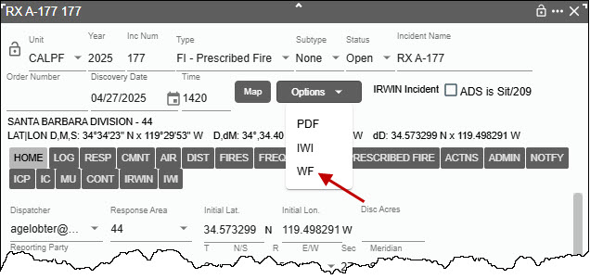
Once you click on the “WF” and a pop-up will require the user to confirm “Create Escape Wildfire”
Figure 298 - Create the Escaped Prescribed Fire
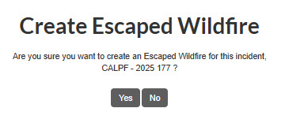

In IRWIN, a "Prescribed Escape" relationship is created between the two incidents with the RX as the parent and the WF as the child.
- The wildfire discovery date/time is defaulted to the current date/time.
- The wildfire incident name is the same as the prescribed fire with the “RX” removed from the name.
- All the incident header and “LOC” tab data elements from the Prescribed Fire are copied to the related Wildfire.
- The Discovery Acres on the Escaped Wildfire area set to 0.1 acres if the Prescribed Fire does not have a value for discovery acres.
- Once the two incidents are related, the incident type for both the parent Prescribed Fire and the Wildfire cannot be changed.
Figure 299 - New Wildfire Incident Panel
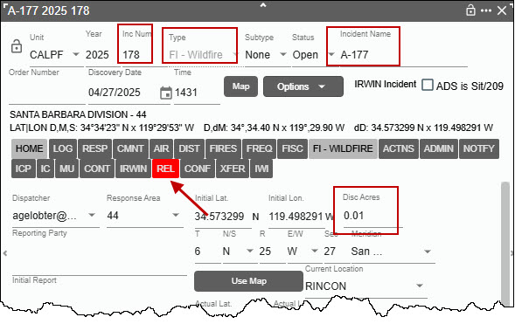
Note the following changes:
- Incident Number
- Incident Type
- Incident Name
- Acres
Click on the “REL” tab to view the related Prescribed Fire, then, the user can also click on the Incident listed to open that incident.
Figure 300 - Related Prescribed Fire Information
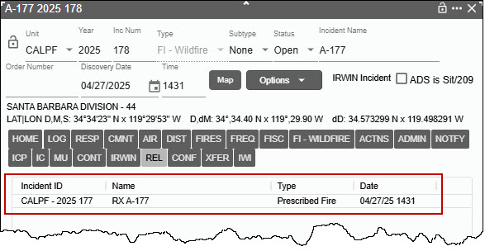
The Prescribed Fire Incident will have the same “REL” tab to view the relationship between Prescribed Fire and the Escape Wildfire.
Figure 301 - Related Prescribed Fire Information
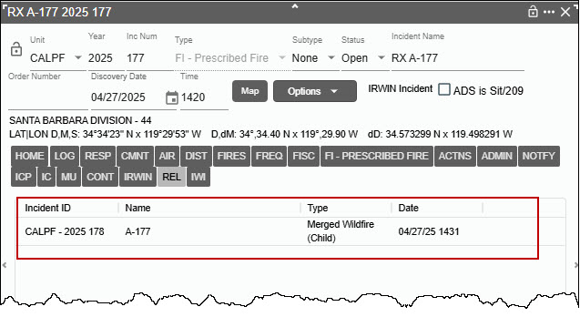

BAER (FM – Emergency Stabilization) and Rehab (FM – Fire Rehabilitation)
For incident type "FI – Wildfire," has two buttons for creating related post wildfire incidents - "Post Fire BAER" and "Post Fire Rehab."
Figure 302 - "Post Fire BAER" and Post Fire Rehab" Buttons.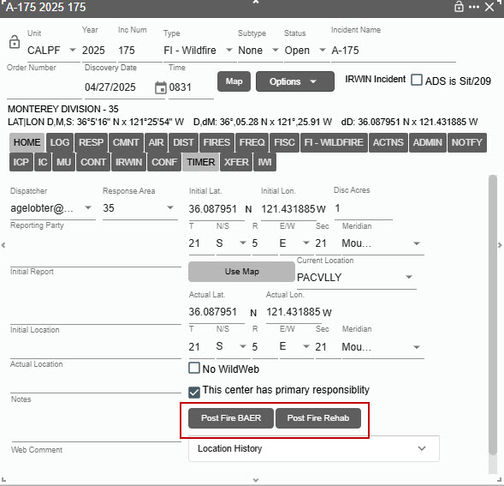

Both the "Post Fire BAER" and "Post Fire Rehab" incidents are created in the same way. Once user clicks on the either "Post Fire BAER" or "Post Fire Rehab" button a pop-up will require the user to confirm the “Create Post Fire.”
Figure 303 - Create the Post Fire Incident
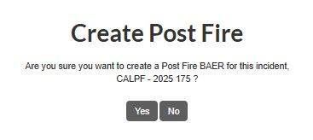
In IRWIN, a "Post Fire" relationship is created between the two incidents with Wildfire as the parent and the BAER or Rehab as the child.

- The BAER or Rehab discovery date/time is defaulted to the current date/time.
- The BAER or Rehab name is the same as the Wildfire with the “BAER” or “Rehab” added to the front of the incident name.
- All the incident header and “LOC” tab data elements from the Wildfire are copied to the related BAER or Rehab.
- Once the two incidents are related, the incident type for both the parent Wildfire and the BAER or Rehab cannot be changed.
Figure 304 - New BAER or Rehab Incident Panel
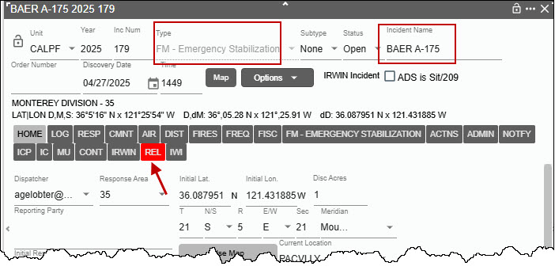

Note the Incident Type and Name.
Click on the “REL” tab to view the related Wildfire and the user can also click on the Incident listed to open that incident.
Figure 305 - Related Prescribed Fire Information
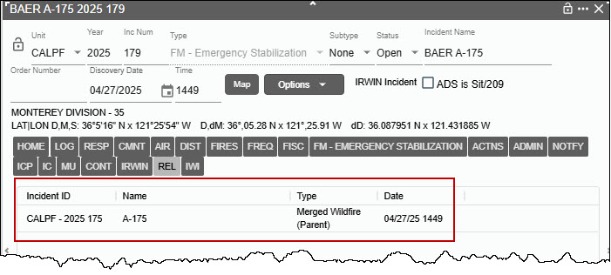
The Wildfire Incident will have the same “REL” tab to view the relationship between BAER or Rehab.

Fire Support (FM – Out of Area Response)
For IRWIN incidents type "FI - Wildfire" with NO resources assigned, the user can now change the type to "FM - Out of Area Response," when the incident is NOT part of an IRWIN conflict.
If resources are still assigned the checkbox will change to said “This center has primary responsibility (release resources first)” when there are resources assigned to the incident
Figure 306 – Resources still assigned to the incident.
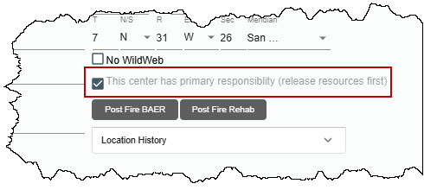
In this example, FI – Wildfire (2025-CALPF 180) is the supporting (OR) incident and FI – Wildfire (2025-CABDF-32) the parent incident.
To create a "FM - Out of Area Response:"
- Step 1: Uncheck the "This center has primary responsibility," checkbox.
- Step 2: Enter the “Incident being Supported” Unique Fire ID (2025-CABDF-32) of Supported Incident.
- Step 3: Click the "Get Inc Info" button.

Figure 307 – Creating an FM - Out of Area Response
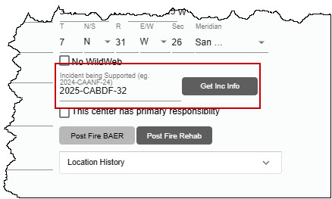
Once you click on the “Get Inc Info” button, a pop-up will require the user to confirm “Create Relationship.”
Figure 308 - Create Relationship
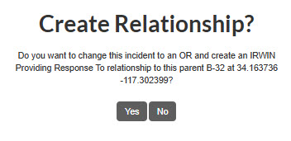
YES, will change the incident type to an OR (FM - Out of Area Response) and create an IRWIN "Providing Response To" relationship to the parent incident (2025-CABDF-32). For this type of OR there is no “REL” tab, the providing support incident Fire ID is to the right of the “IWI” button.
Figure 309 - Supporting Incident A-053.
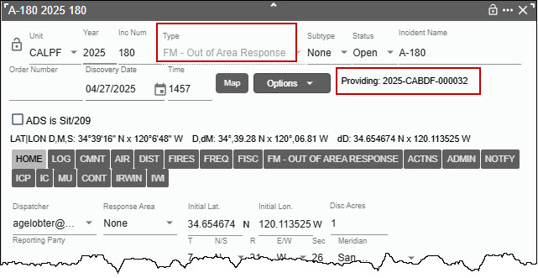

Section 5: Timers

Open Timers (F4 or Open Timer Icon)
Figure 310 – Open Timer Panel Icon

Figure 311 - Open Timer Panel
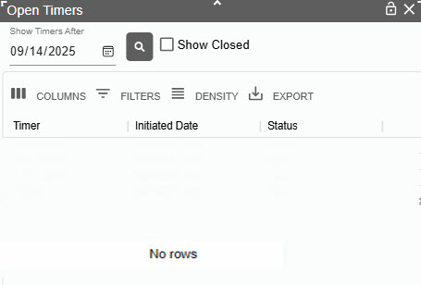
- Enter a date under “Show Timers After,” to show a timer after a certain date.
- Click the “Search” button.
Figure 312 - Show Open Timers
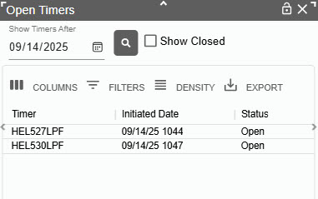
Figure 313 - Show Closed Timers
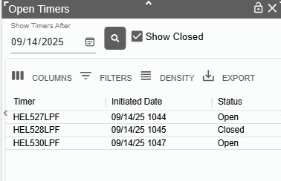
By default, only open timers are displayed. To show Closed Timers:
- Click the “Show Closed” timer box.
- Double Click on a timer to open in that timer.
Figure 314 - From the Panel, Open a Timer.
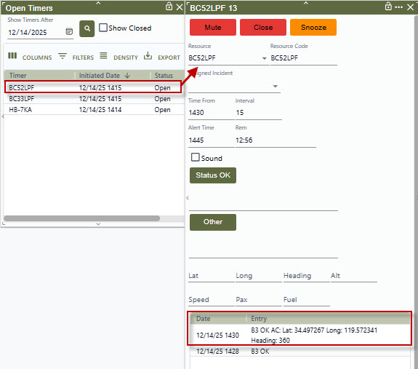

Creating a New Timer
Figure 315 - New Timer Panel Icon

WildCAD-E allows the creation of “Timers,” which remind the user to act after a certain number of minutes.
To start a New Timer:
- The user will select the Timer Icon or use F4 to see the Timer screen.
Figure 316 - New Timer
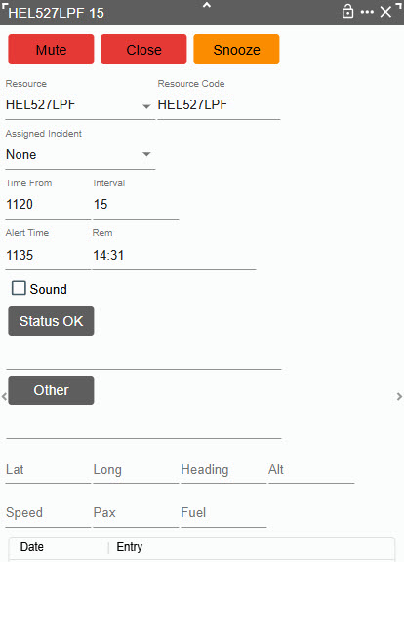
To Select the Resource to be monitored:
- Use the dropdown or enter the resource manually.
The following entries are automatically populated:
- Time From– The time the alert will start and will change after the “Status OK’ button is pushed.
- Interval – The number of minutes before the timer wants an “Ok Status.” This time is set by the Center Administrator.
- Alert Time – Number of minutes until the alert will end and will change after the “Status OK’ button is pushed.
- Rem (Remaining Time) – The time counts down from the set start minutes and will restart after the “Status OK” button is pushed. T
Click the 'Enter' key, after typing text, this functions the same as clicking on "Status OK" or "Other" buttons.
Aircraft have additional optional fields to complete if the user selects “Aircraft” as their resource:
- Lat/Lon
- Heading
- Altitude
- Speed
- Passenger
- Fuel
Figure 317 – Select Resource Timer
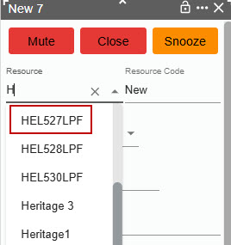
Figure 318 – An Example of a Typical Timer
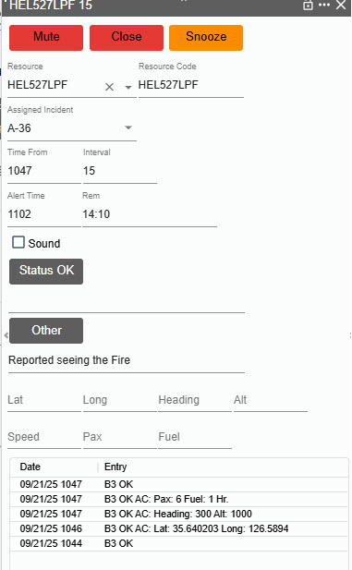

Sound
Check the box next to “Sound,” and sound will occur automatically,
- Uncheck the box to disable the sound.
Alerts – Two different alerts are visible.
- The first alert occurs when the time remaining (REM) reaches zero minutes. This alert will be a “Flashing Red Line” around the timer. The timer countdown continues after zero showing negative count instead of stopping at zero.
- The second alert occurs if no action is taken by minus (-) minute. This alert will be a “Flashing Red” fill the entire timer.
Figure 319 – Flashing Red Line Around Resource Timer
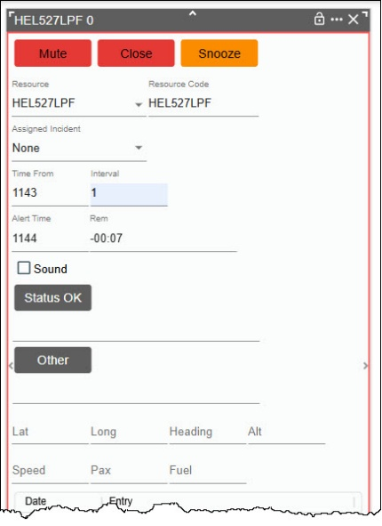
Figure 320 - Flashing Red fills the entire Resource Timer
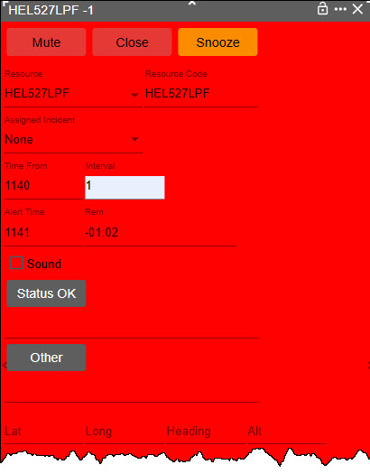
The user can “Dock” a Timer, just like with the Incident Panels, by using the three dots in the upper right corner of the Timer panel.
- If docked the same automatic alerts occur, they will become undocked and cannot be docked again.
- The timer will remain on top of all other panels.
Figure 321 - Docking AA07LPF 6 Resource Timer.
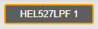
Figure 322 - Alert for Docking AA07LPF 6 Resource Timer
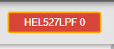
Figure 323 – Snooze button timer.
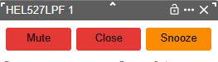
These buttons control the management of the timer:
- Mute – Use the button to stop the Alert Sound.
- Close – Use the button to end the Timer.
- Snooze - Use the button to put the Timer on hold.
After a timer has been status in “Snooze,” the button will automatically change to “Resume.”
- To re-start the timer, click on the Resume button.
Figure 324 - Resume Timer
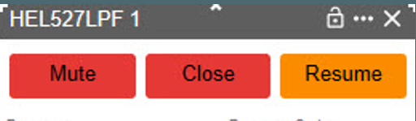

Section 6: Complexes
Figure 325 - Complex Icon


Create a Complex
When the “Complex Icon” is initially clicked,2 the user will be prompted to confirm a complex is intended to be created before the Complex can be created.
Figure 326 - Dispatcher will confirm the creation of a Complex incident before the action is taken.
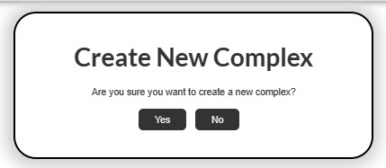
Figure 327 - Creating a Complex
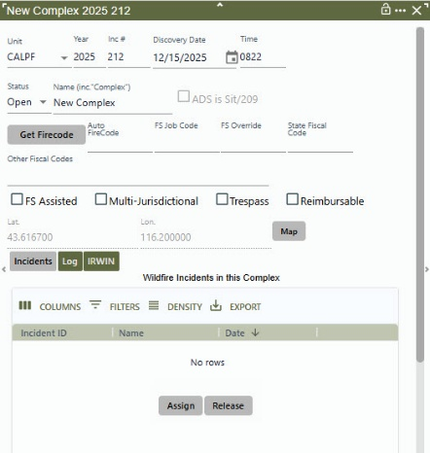
After clicking on the Icon, WildCAD-E auto populates the following list of items on the Complex Panel’s Header:
- Unit - Uses the default as set by Center Administrator in.
- Year – Uses the current calendar year.
- Inc Num (Incident Number) – The Center Administrator may have added a prepend with calendar year and/or an ending suffix to the end of the incident number. This is common when a Center defined code is used to identify different units within the same Center.
- Discovery Date and Time – Date and time incident was discovered.
- Status (as “Open”)
- Lat/Lon – The initial Lat/Lon is a temporary location until the Incident is added to the Complex. Once one incident is added the Lat/Lon becomes the location. As more incidents are added, the Lat/Lon is calculated to a center point of all incidents.
- “IRWIN Created” will not display until the Complex name is entered.

Incident Name
- Displays “New Complex” until the user types in the actual name of the Complex.
- “New Complex” is automatically replaced at this point.
- For every Complex, the name MUST include the word “Complex,” as example “A-212 Complex.”
Figure 328 – Complex Name and IRWIN Created
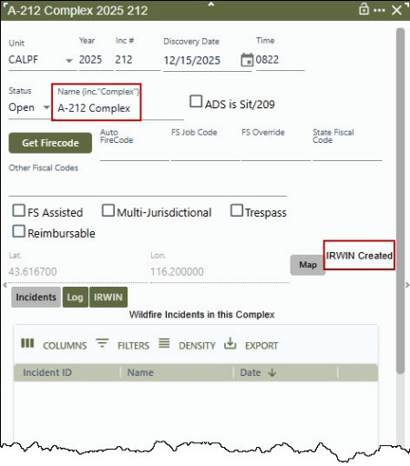

Log and IRWIN Buttons

Log Button
The “Log” button opens a screen like the Incident Panel Log Tab.
- Add Log Entries
- Text/Email

IRWIN Button
The “IRWIN” button displays:
- IRWIN ID
- ADS Permission State
- History of transaction with IRWIN

Incidents Button

Adding an Incident to the Complex
- Select an incident from the Open Incident Panel.
- Click “Assign” at the bottom of the Complex panel. (An Incident must have an IRWINID to join a Complex and be a Wildfire.)
- Click “OK” to confirm.
  - The “OK” action will automatically change the Lat/Lon to the add incident Lat/Lon.
Figure 329 – Add an Incident to a Complex
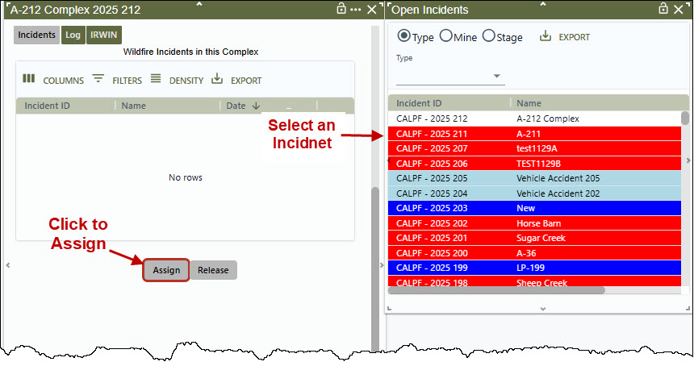
Figure 330 - Confirmation that the user wants to add an Incident to a Complex.
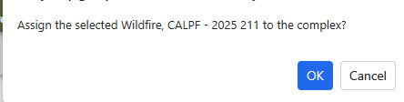
Figure 331 - The Added Incident to the Complex
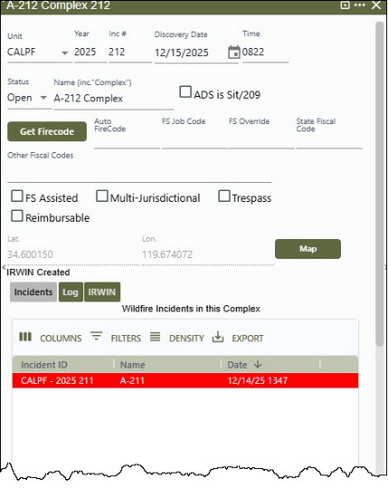
There is no limit to the number of Incidents (wildfires) that the user can attach to an Incident Complex. The user can add or remove Incidents from a Complex at any time based on incident management strategies.

FireCode
- After adding an incident, click on the “Get Firecode” button, and the FireCode number will be displayed.
- A FS Job Code and FS Override can be entered using free text.
Figure 332 - Get Firecode Button Panel
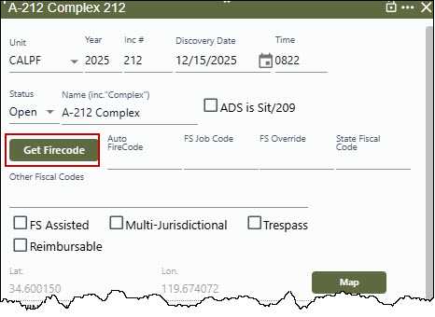
Figure 333 - The FireCode is displayed.
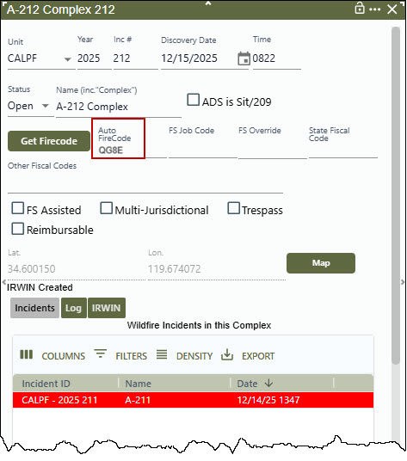
However, Other Fiscal Codes will not be sent to IRWIN. The user may manually check the box for inclusion within the financial report. The following may be checked.
- FS Assisted
- Multi-Jurisdictional
- Trespass
- Reimbursable

Map
After adding an incident, click on the “Map” button. If a Complex Incident has a location (lat/lon) and at least one incident assigned. When clicked, the map will open and drop a point at the location of the Complex Incident.

Releasing Incident from a Complex
- Click on the Incident to be released.
- Click the “Release” button.
Figure 334 - Confirmation that an incident is to be released from a Complex.
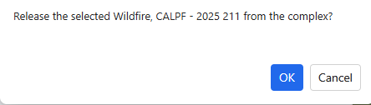

Section 7: Law Enforcement Incident
All users with the role of “Dispatcher” or “Center Administrator” roles can create incidents of type “AP - Law Enforcement (Internal).”
Incidents of type “AP - Law Enforcement (Internal)” are integrated through IRWIN with the same rules as other non-fire type incidents.
Field Interrogation File (FI File) may be used by any dispatch center. If a center wants to use the FI system, they need to request access with a Service Request to Bighorn Information Systems.
Figure 335 - Unless the dispatcher is authorized and "FI Authorized" in the system is set to "yes," they will not have access to navigate and use the FI File panel.
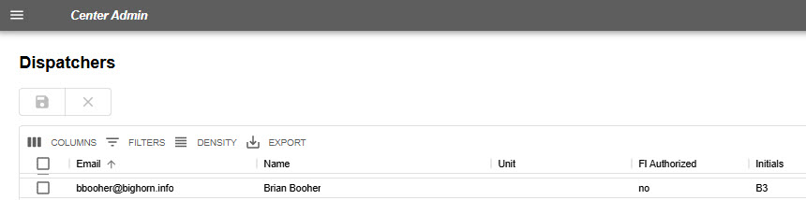
The Center Administrator will grant a Dispatcher “FI Authorized.” Only dispatchers who are “FI Authorized” can create, edit, or view FI records.
Figure 336 - Dispatcher set to 'yes,' is authorized for the FI System.
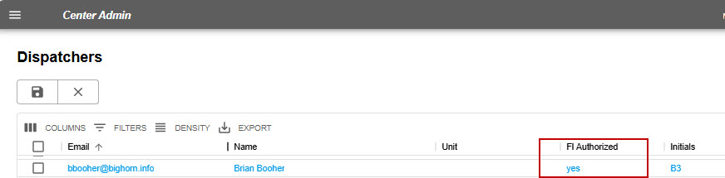

Creating a Field Interrogation File (FI File) from a Law Enforcement Incident
  - Create the new incident (use F9 or the New Incident Icon or from the map).
  - Select incident type: AP – Law Enforcement (Interanl)
  - Enter the name of incident
To create a Field Interrogation File, select from the Option dropdown menu - “FI.”
The Options Menu only includes “FI” for Dispatcher or Center Admin with FI Authorized enabled in centers that have FI File enabled.
Figure 337 – Law Enforcement Incident and FI File
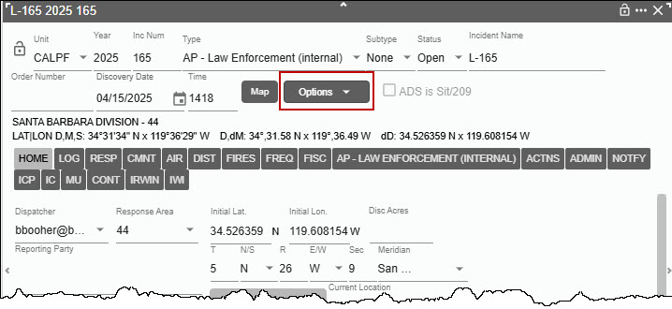
Click on the FI dropdown.
Figure 338 – Law Enforcement Incident and FI File
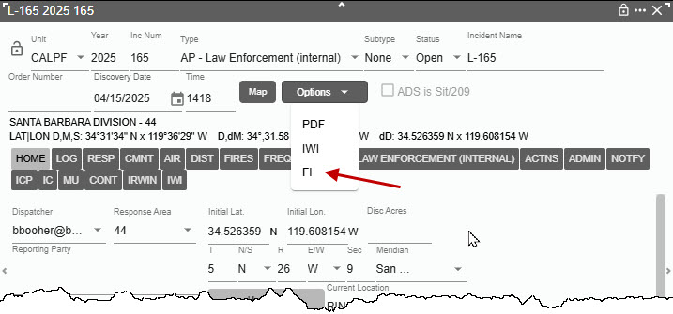
The FI dropdown menu will open the blank Field Interrogation File with the Incident Name displayed. Once the information is entered, click the Save Edit button.
When a new FI File record is created, the incident log will enter “FI Record Added” with the user’s initials in the User and To fields
Figure 339 –Blank FI File
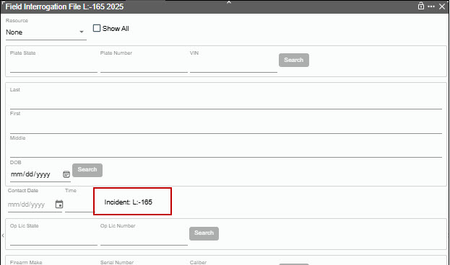
On the Incident panel, click on the FI Tab to display any Field Interrogation File(s) that are associated with this incident. FI actions are not logged to the related incident log.
Figure 340 –Incident Panel, FI Tab
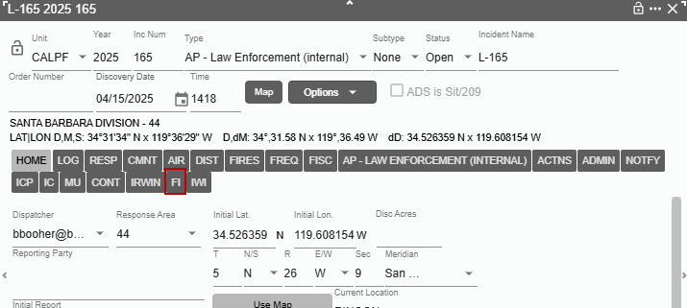
A list of Field Interrogation File(s) can be accessed by clicking on them.
Figure 341 –List of FI Files.
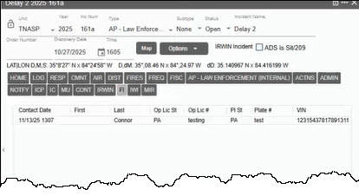

Field Interrogation File (F3 or FI File Icon) panel
Figure 342 – FI Icon

The “Open FI File (F3)” Icon on the Home Page ribbon only appears for Dispatcher or Center Admin with FI Authorized enabled in centers that have FI File enabled.
The “Open FI File (F3)” Icon opens the FI screen for search or creating an FI record does not tie to Incident. The Home Page “FI” Icon does not allow starting a LE Incident. From the Home Page only one instance of the FI File search panel can be open
Multiple FI File panels that are associated with incidents can now be opened simultaneously multiple Panel by clicking the incident panel.
To search the FI record by:
  - Resource (Block 1)
  - Vehicle Plate (State, and/or Number, and/or Vin) Block 2
  - Name and or DOB (Block 3)
  - Contact Date and Time (Saves automatically by clicking “Save New” or “Save Edit” Button) Block4
  - Op Lic State and/or Number (Block 5)
  - Firearm (Block 6)
  - View a description (Save by clicking “Save New” or “Save Edit” Button) Block 7
  - Open a record associated with the search. (Block 8)
Figure 343 - FI Panel
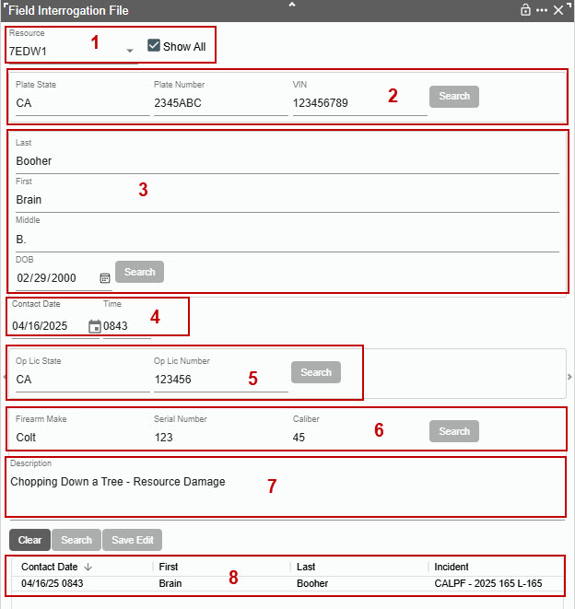

Searching by Resource (Block 1)
The only resources that will show in the dropdown will be Resources that the Center Administrator indicated that the Resource is authorized the use of the law enforcement Field Interrogation File.
- Either type in a Resource Name (Code)
- Click the “Show All” to the list of resources authorized.
- Then click the “Search” Button near the bottom of the FI Panel
Figure 344 - Search by Resource
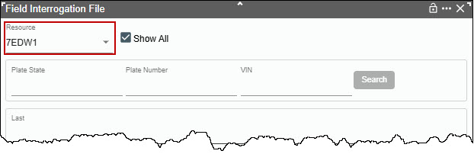
This will return any records associated with that resource.
- The record will show in Block 8
- Click on any record associated with the search.
- As an example, this search only had one record,
- Add any changes and click the “Save Edit” button.
Figure 345 - Results of Search by Resource 7EDW.
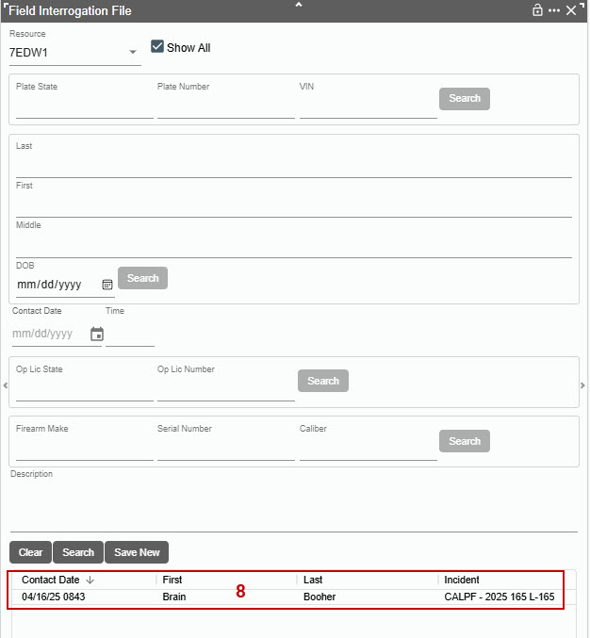

Searching by Name/DOB or Op License State/Number or Firearm
In each of the Blocks 2, 3, 5 and 6 enter a minimum of one search criteria.
As example,
- In Block 2 the search criteria used was the last name only (Booher)
- Enter “Booher” and click the “Search” Button in this block.
Figure 346 - Results of Search by Name
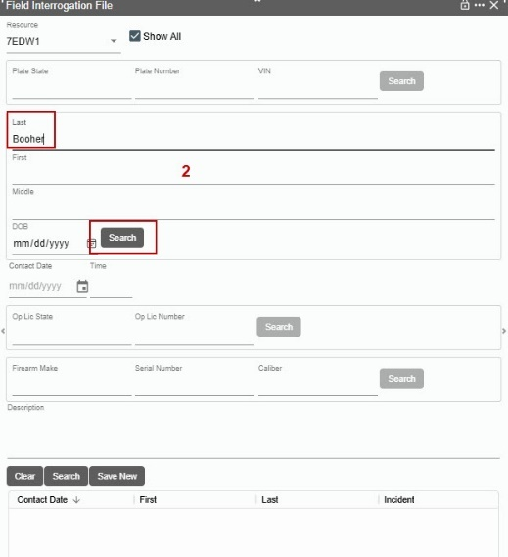
- This search criteria displayed one (1) record for the last name.
Figure 347 - Results of Search by Name
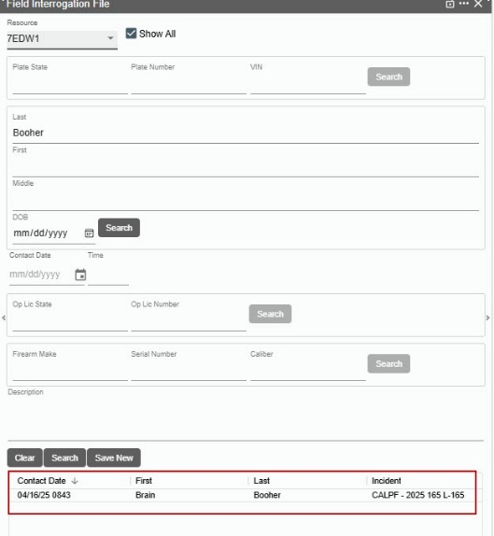
- Single click on one of the records will fill in the data regarding that record.
Figure 348 - Results of Search by Name
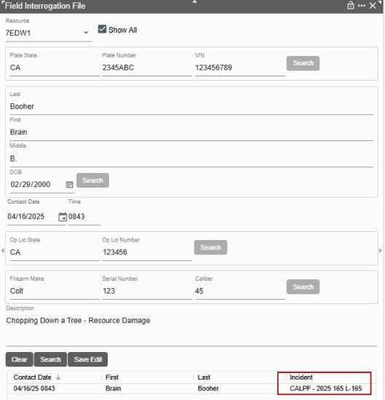
Double click will open the incident (CALPF-2025-165 L-165) associated with that record. Figure 349 – Result of Search Incident

Part VI: Phone Directory

Section 1: Using the Phone Directory
The Phone Directory will open in its own Tab.

Searching the Phone Directory by Columns
The search field now defaults to searching ALL VISIBLE columns for the text being entered.
To search by any visible columns, click the “Search By” drop-down and select a visible column to search. As an example, select “Title.”
Figure 350- Selecting a visible column.
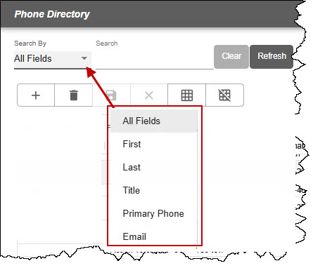
In the “Search” enter a text related to the desired search criteria.
Figure 351- Example search criteria “Tile, AAA.”
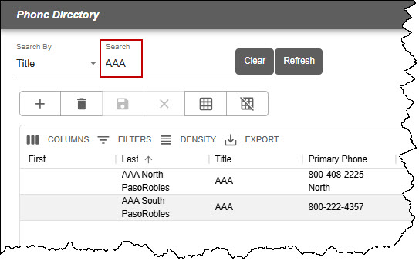

To Look Up a Person in the Phone Directory
With the “Search By” field set by default to “All Fields,” enter a person name. As example, entered in the “Search” line “Bighorn.” Two hits are visible. Select the name desired and the selection will have a light gray background.
Figure 352 - Phone Directory Panel
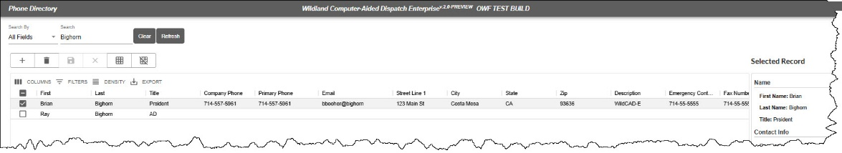The right-side panel (“Selected Record”) will show all fields with data.
Figure 353 – Right Side of the Phone Directory Panel
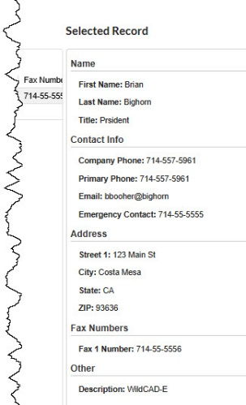
If the fields with no data will not be displayed on the right-hand panel when the record is selected. This makes the panel more readable and easier for the dispatcher to find the contact info they are searching for - especially for copy/paste to another place.

To Clear the Search
- Use the “Clear Icon” to clear the search.

To Refresh the Phone Directory
- Use the “Refresh Icon” to refresh the entire phone directory.

Adding a person to the Phone Directory
- Click the Plus (‘+”) Icon and a new line will appear.
- Enter the required information under each column.
- Click the “Save Icon.”

Section 2: The Phone Directory Layout
Users can adjust the grid properties and save it. The grid will always load with this setting. The properties that are saved are:
- Column Order
- Column Visibility
- Column Width
- Column Sorting
- Grid Filtering
- Grid Density
Once you established the desired layout, click on “Save Grid Layout.” Layout” button. To clear the saved layout, click on “Reset Grid Layout.”
Figure 354 – Saving or Setting Phone Directory Layout
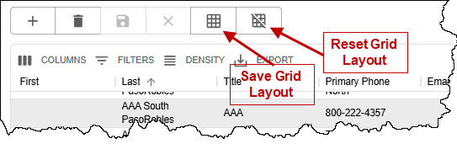

Part VII: Text/Email

Section 1: Using Text/Email
Text/Email opens in its own Tab. The Center Administrator has several roles, responsibilities, and tasks to complete within the Text/Email function that must be completed before the Dispatchers can use this function. Dispatch Center Members is one area that must be completed by the Center Administrator
Figure 355 - Dispatch Center Members
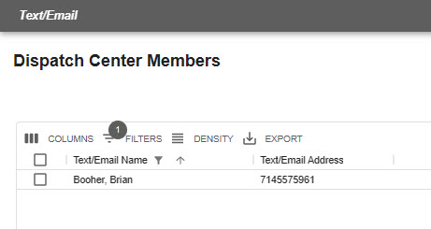

Two Ways to Send Text/Email Messages
- Select Names of Recipients – usually more than one is selected.
- Group Name – This is a pre-loaded list of recipients (created by the Center Administrator).

Select Recipient Name Text/Email Message
The users can:
- Select who will receive the message by clicking on the check box next to the respective name.
- Click on the “Add to Recipient List.”
  - The name(s) and Text/Email addresses will be displayed on the right side of the panel.
- IF the message is regarding an Incident, click on “Re” to select an incident; and then, click on the “Add Map Link” for that respective incident.
- Enter the “Subject” using free text.
- The "Subject" is included in the text after any "Always Start With" and before the body.
Figure 356 – Always Start Your Message with . . .
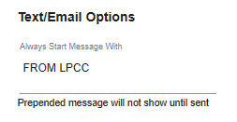
- When a Text is sent related to an incident, the subject now includes the incident information formatted as Year - Protecting Unit - Incident Number and Incident Name. For example: "2023-CABDF-000023 Bald Mountain" plus text of subject if added by user.
Figure 357 – Text related to Incident.
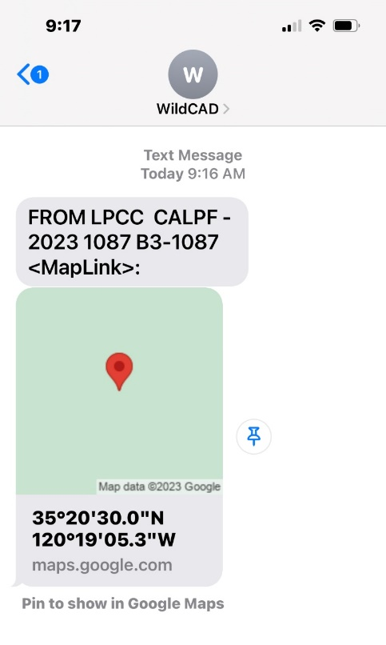
- On “Message” line enter the message using free text.
- Click “Send” and send the message to the people on the Recipient List.
- Text messages sent will now appear in that user's Daily Log/Incident Log.
Figure 358 - Select Dispatch Center Members
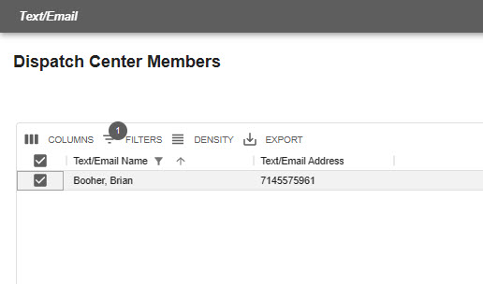
Figure 359 - Add to recipient list.
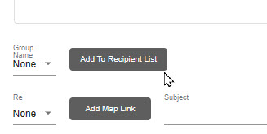
Figure 360 - Recipient List
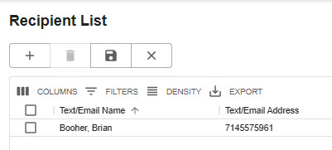

Compose Preset Messages
- Select the previously composed message from the “Use” dropdown.
- Enter the required information for the item in the preset message.
- The subject for pre-set messages is now autofill by defaulting to the canned message name.
- Follow all the steps to either send as a “Name Select” or “Group Select” message.
Figure 361 - Sent Message
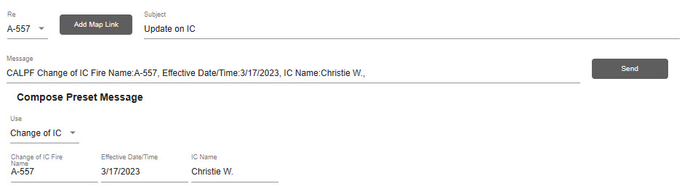

Selecting a Group Name Text/Email Message
- Select the “Group Name” from the Dropdown.
- Click on the “Add to Recipient List.”
  - The names and Text/Email Addresses will be displayed on the right side of the panel.
- If the message is regarding Incident, click on “Re” to select an incident and then click on the “Add Map Link” of that incident.
- Enter the “Subject” using free text.
- On “Message” line enter the message using free text.
- Click “Send” to send the message to the people on the Recipient List.
Figure 362 - Group Select.
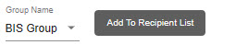
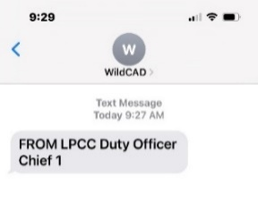
Figure 363 - Example Text Message

Part VIII: Reports

Section 1: Available Reports
Reports Tab
Reports will open into their own Tab.
Figure 364 - Reports Menu Screen
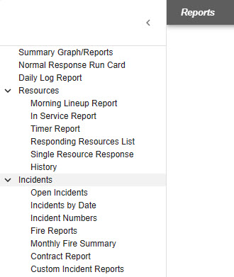
The list of reports stated above will be increased over time. Below are examples of the main reports.
- Summary Graphs/Report
- Normal Response Run Card
- Daily Log Report
- Morning Report
- In Service Report
- Timer Reports
- Custom Incident Report
The remaining reports for Resources and Incidents are in Appendix II.

Summary Graphs/Reports
The Summary Graph/Report can be created by selecting:
- Date Range – From and Through.
- Type – From the dropdown menu select specific incident type or none for all incident types.
- Unit – From the dropdown menu select a specific unit or none for all units.
- Radio Button (Type, Day, Hour) – Select the radio button for the summary report and graph.
- Last step – Click on Pie or Bar to create the summary.
- Clear – to start over and clear current summary.
- Print – To print the summary to a PDF. After clicking on the Box next to Resources, from the dropdown menu select an individual resource.
Figure 365 - Summary Graph Reports by Type
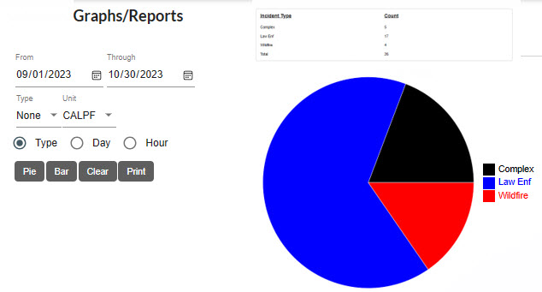

Normal Response Run Card
The Normal Response Run Card can be created:
- Singular – Click on a response area.
- Select All – Press Ctrl + A inside of the Response Area Box
- Multiselect – Holding down Ctrl while selecting the response areas.
- Clearing Multiselect – Click on any response area without holding Ctrl.
The following optional sections can be included in the report output by clicking on the boxes next to these sections.
- Prioritized Dispatch Locations
- Resource Quantities by Type
- Comments
For any one of selection criteria, next select the “Response Type” from the dropdown menu.
Figure 366 - Creating a Normal Response Run Card without boxes checked.
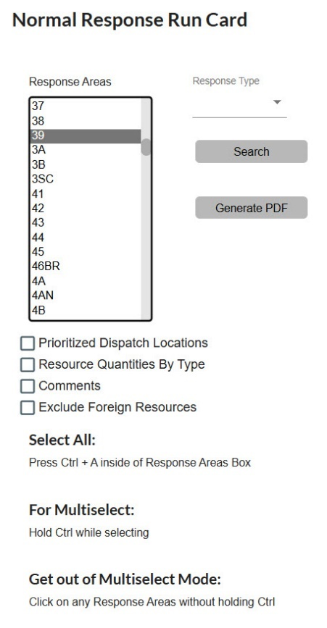
At this point, the user would click “Search” to view the Normal Response for a response area. The panel will display a spinner and snack bar alert for when the data is loading.
Figure 367 – The data is being loaded.
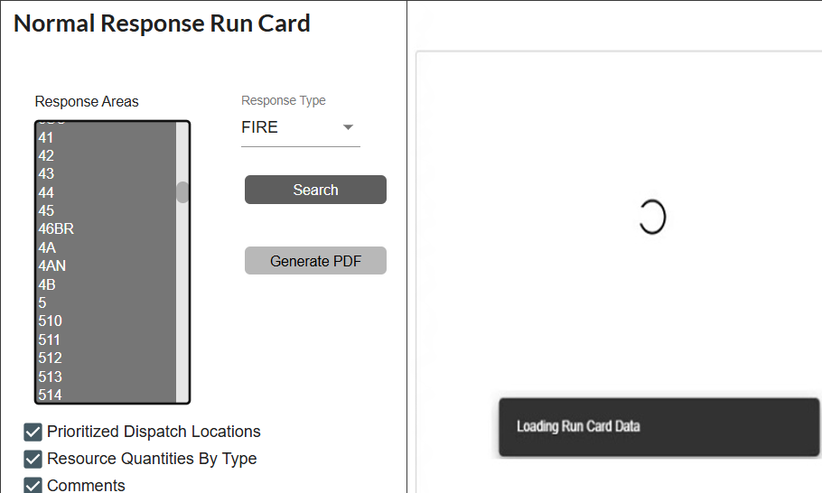
If the data being loaded is too big a detailed message that the report data has failed.
Figure 368 – The Report has failed.
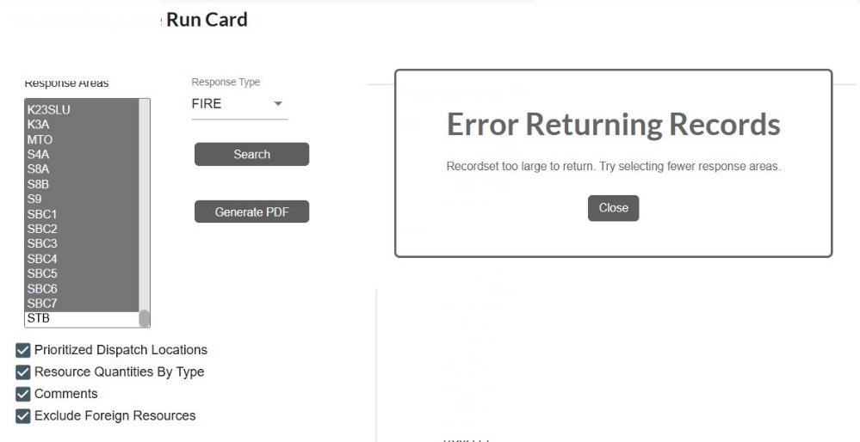
Figure 369 - Searching for a Normal Response Run Card
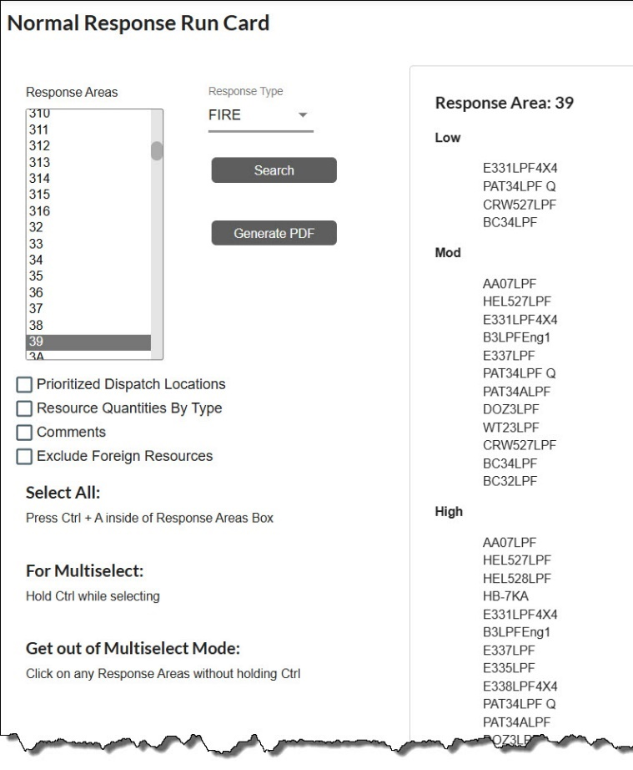
Click on the boxes next to:
- Prioritized Dispatch Locations
- Resource Quantities by Type
- Comments
- Exclude Foreign Resources. This parameter optionally excludes foreign resources from the report results.

This will your selection to be added to the Normal Response for a response area.
Figure 370 - Creating a Normal Response Run Card WITH the boxes checked.
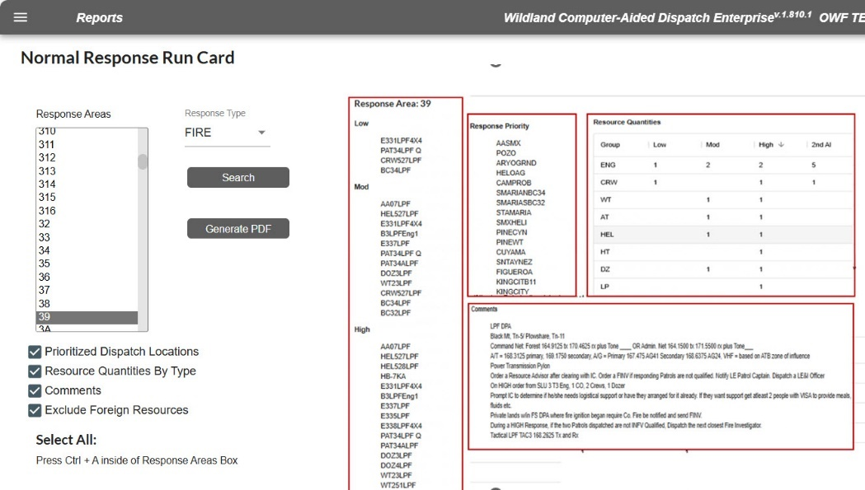
Also, from this panel you can create a “PDF” for this response area. If you selected all or multiselect the search and PDF would be generated to all selected.
Figure 371 - WildCAD-E Run Card
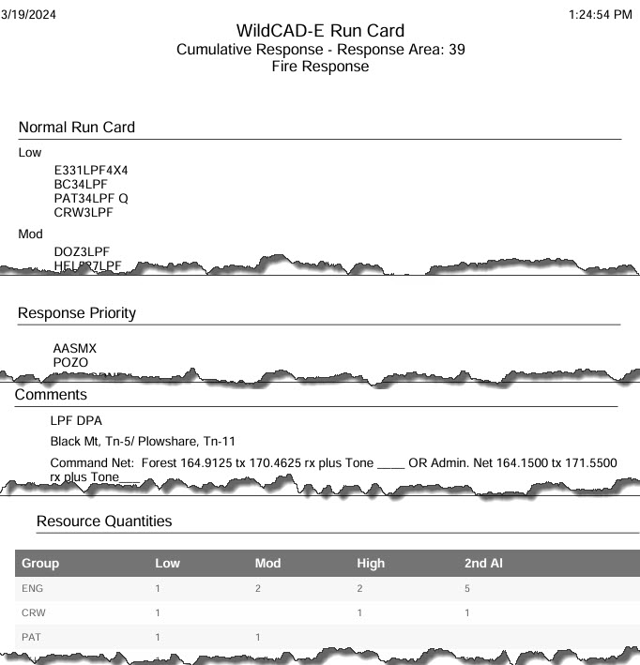

Daily Log Report
The Daily Log Report can be created by selecting:
For daily entries:
- Date Range – From and Through the daily log entries will be displayed.
- Category (Optional) – that was created by Center Administrator
For Incident and Resource entries:
- Incident and or Resources - Include one other or both.
- Resources – After clicking on the Box next to Resources, from the dropdown menu select an individual resource.
Figure 372 - Creating a Daily Log Report
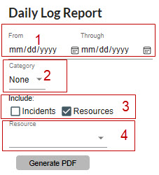
Once you have created the version of the report click “Generate PDF” to save.
Figure 373 - Sample Daily Log Report
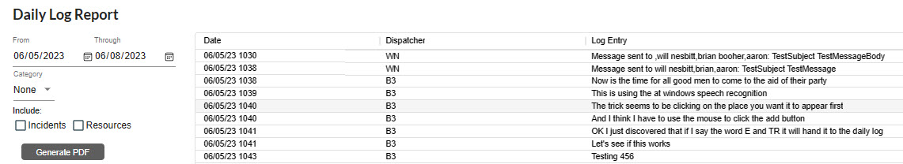
Figure 374 - Sample Daily Log Report for Incidents
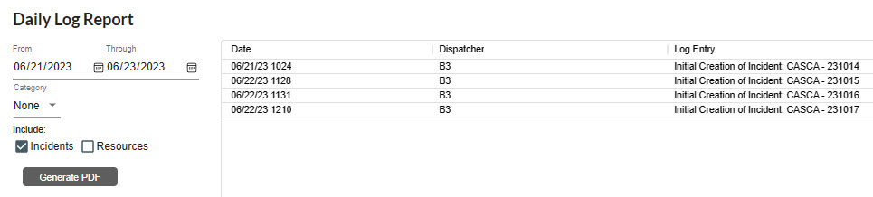
Figure 375 - Sample Daily Log Report for Resources
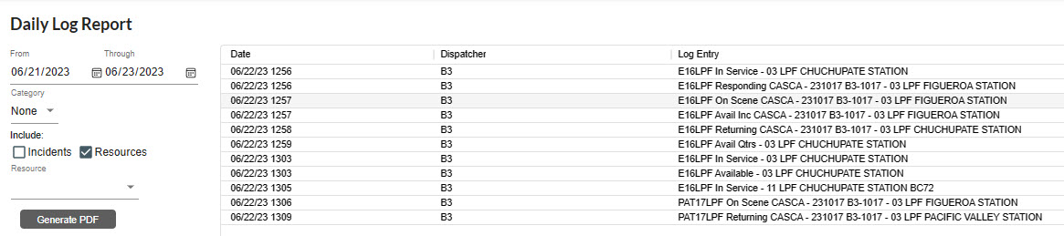
Figure 376 - Sample Daily Log Report for both Incidents and Resources
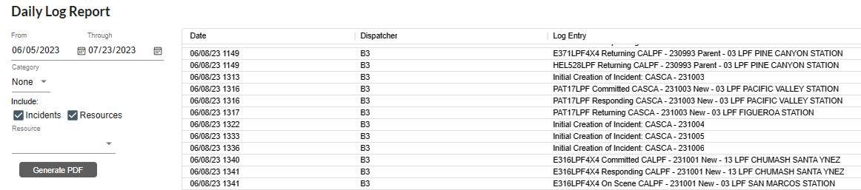

Morning Lineup Reports
Figure 377 - Morning Line Up Report
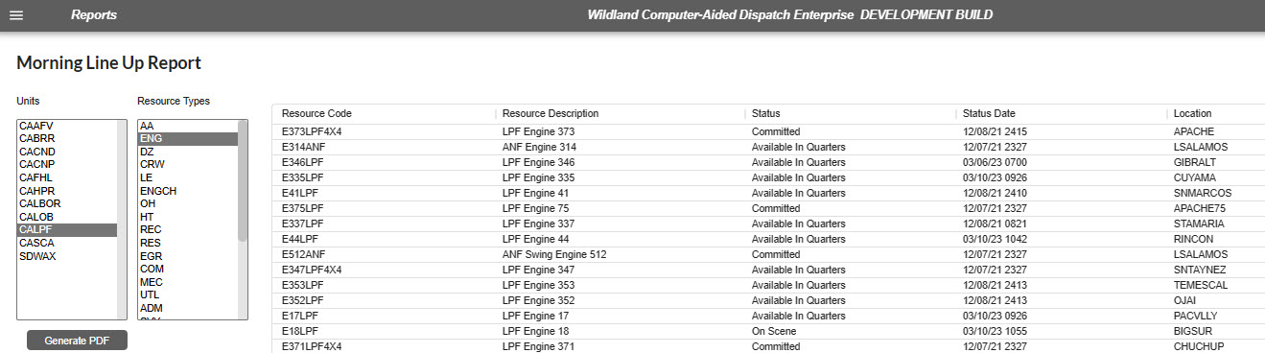
Figure 378 - Example Morning Line Up Report
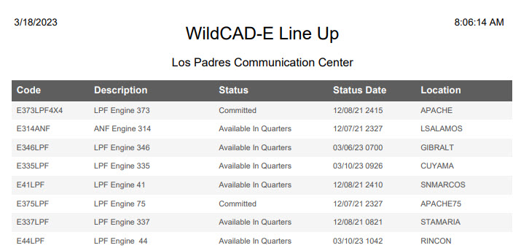

In Service Report
Figure 379 - Example of In-Service Report
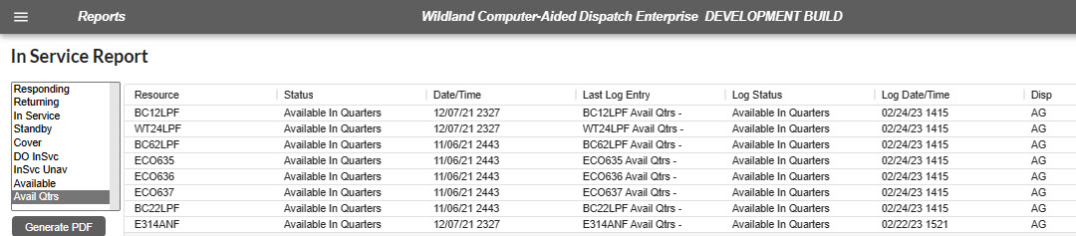
Figure 380 - PDF Morning Line Up Report
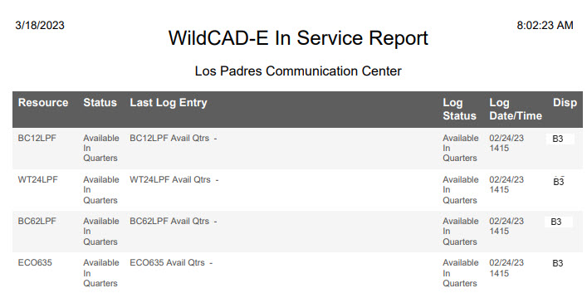

Timer Report
Figure 381 - Timer Report selected by date range
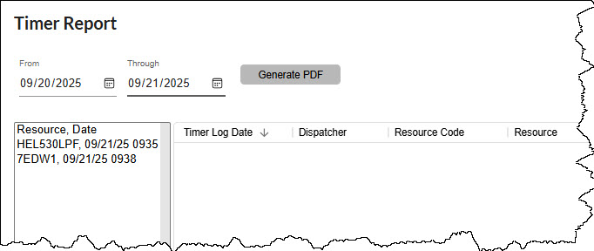
Figure 382 – Timer Report selected by “Resource, Date”
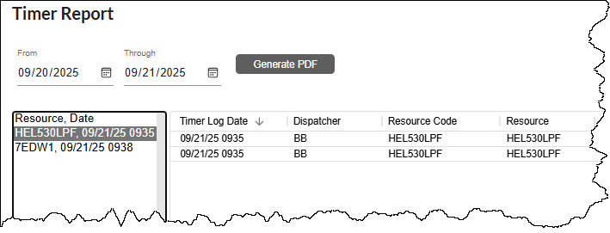
The Timer Report log entries are sorted descending by default. The user can change the sorting by clicking on any of the grid headings if a different sort order is needed.
Figure 383 – PDF-Incidents and Non-Daily Log Report
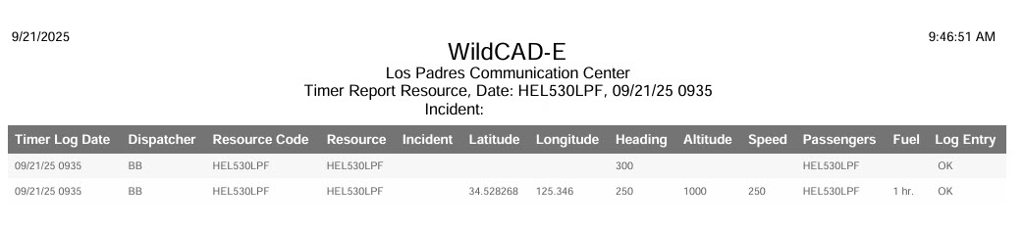

Custom Incident Report
This report allows the users the ability to create custom reports for incident data.
- Select date range.
- Incident types and incident subtypes (if any). The default incident types are Wildfire, Vehicle Fire and Structure Fire.
- Select columns to be displayed.
Figure 384 - Custom Report Description
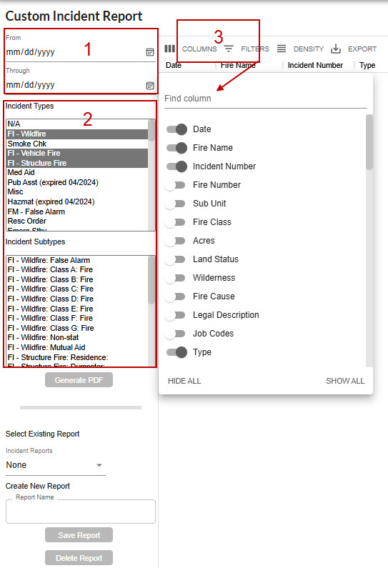
Figure 385 – Example of Steps 1 – 3.
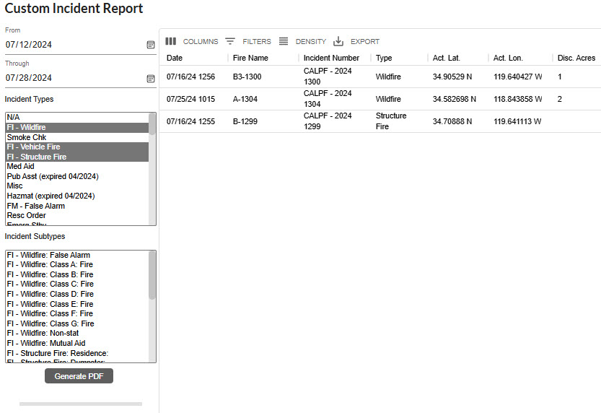
At this point you can generate a PDF report by clicking on the “Generate PDF’ button.
Figure 386 - PDF file is created,
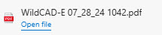

Example of the Report
Figure 387 - Example of the Report.
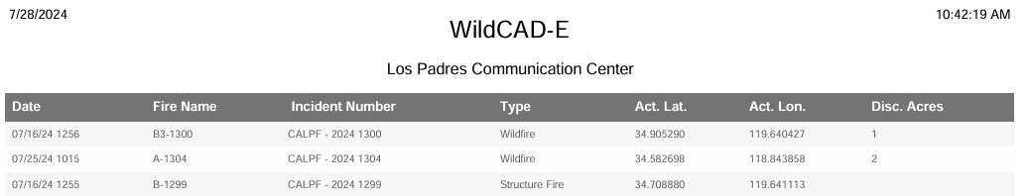

To save a report
- Give the report a “Report Name.”
- Click on the “Save Report’ button.
Figure 388 - To save the report.
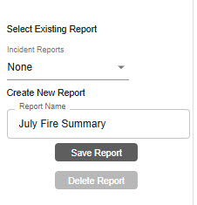

To Retrieve a Report
- Use the dropdown menu under “Incident Reports.”
- Click the named report that has been saved.
- Existing reports cannot be edited. Create a new report if changes are needed.

To Delete a Report
- Select an existing report.
- Click the “Delete Report’ button.
Figure 389 – Save a Report.
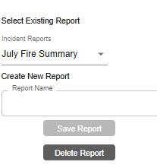

Part IX: HelpDesk Service Request
If a user needs technical support from WildCAD-E, a user can submit a Service Request or view a pending Service Request directly within the WildCAD-E application. Once the Service Request Form is complete, a Support personnel member will respond as soon as the form is received.

Section 1: Opening the Service Request Window
From the WildCAD-E Home page, navigate to the “Help” link in the top right of the header.
Figure 390 – Home Page Header.
In the WildCAD-E Help window, click the “Service Requests” button to open the Service Request “Brower Tab.”
Figure 391 – WildCAD-E Help window.
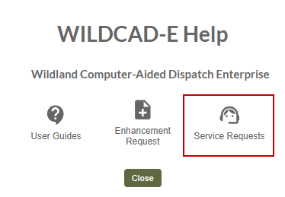
Figure 392 – Pending Service Requests.
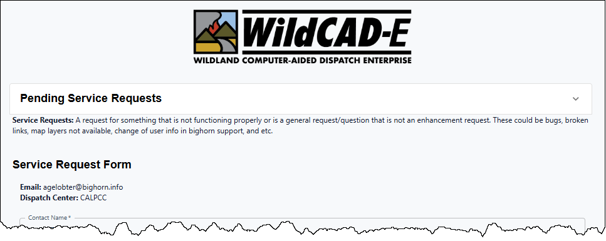

Section 2: Viewing Pending Service Requests
To view Pending Service Request (SR), click on the down arrow at the upper right side of the page.

Figure 393 – Viewing Pending Service Requests.
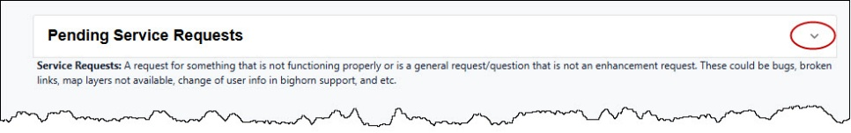
Figure 394 – Current Active Service Requests.
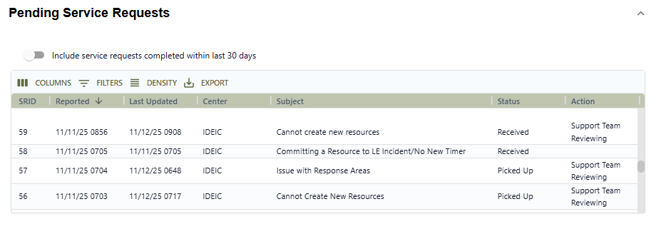
The current pending service requests will display:
- SRID – Numerical sequence assigned to each SR.
- Reported – Date and Time.
- Last Updated – Date and Time that last Status change or Action taken.
- Subject – As submitted by the user.
- Status – The service request statuses are.
  - Received -The SR was logged into the WildCAD-E application.
  - Pick Up – The SR was assigned to a Support Team member.
  - Waiting for Customer – Team member is waiting to hear back from user.
  - Support Handing – The SR has been turnover to a Dev Team member.
  - Closed – The SR has been closed, and no further action is required.
- Action
  - Support Team Reviewing – Support Team member is verifying the issue.
  - Dev Team Reviewing – Dev Team member is verifying the issue.
  - Completed - The SR has been closed, and no further action is required.
  - Bug Fix Scheduled or Pending - The software will be updated.
  - Improvement Pending – The software will be updated.
  - Dev Team Completed - The SR has been closed, and no further action is required.

To review the Service Requests completed within the last 30 days, move the slider button to the right.
Figure 395 – Viewing Active and Closed Service Requests.
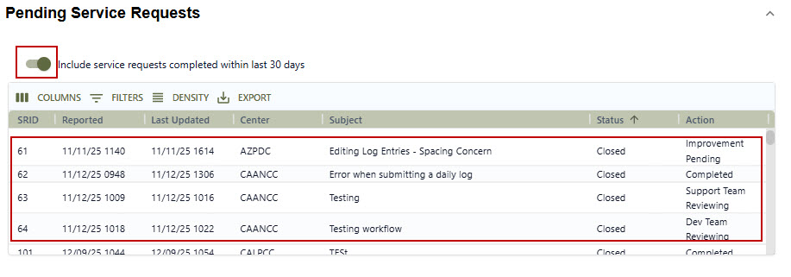

Section 3: Creating a New Service Request
After opening the Service Request form, the application will automatically import the user:
- FAMAuth Email
- Dispatch Center (the center currently logged into)
- Contact Name
- Contact Phone Number (registered with FAMAuth)
The Name, Phone Number and Extension fields are editable. If the contact phone number is not a mobile phone, the users will not receive text messages but will be able to submit the service request.
Figure 396 – Not a Mobile Phone Number.
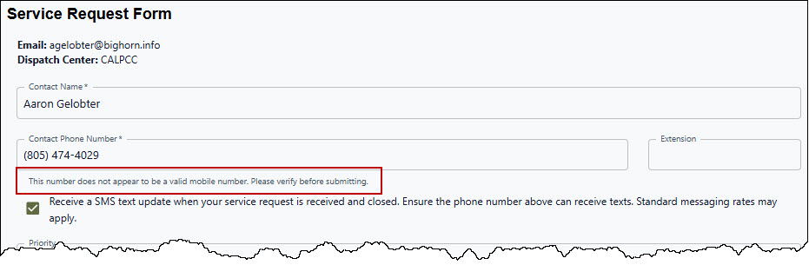
To receive SMS text updates, leave the “Check Box” checked. “Un-click” the check box if no updates are desired.
The next section in the Service Request Form consists of four parts.
Part 1 Priority – which is based on how the issue is currently impacting the center. Within this section, there are three choices.
- Non-Urgent (Operations not impacted)
- Important (Center is impacted)
- Urgent (dispatching impacted)

Part 2 The three required fields
- Brief Description – A short description of the issue.
- Module - The module in the application where the issue is happening (i.e., Incident Panel, Center Admin, Resource Status Panel, etc.).
- Details – A very detailed description of the issue.

If one or more of the required fields are not included, the user will receive a message to complete those fields before the request can be submitted.
Figure 397 – Completing the Required Fields.
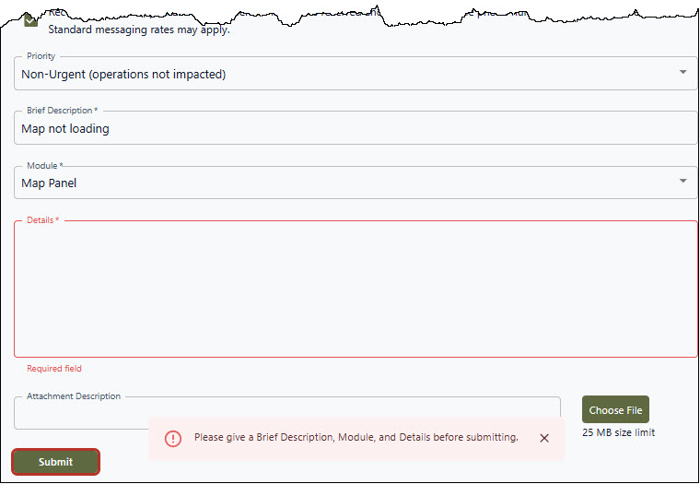
Part 3 Attachments
Toward the bottom of the page, there is a field for “Attachment Description,” as well as a “Choose File” button that will allow the user to attach a screenshot, pdf, or short video/screen recording of the issue.
- Step 1 - Enter “Attachment Description.”
- Step 2 - Click on the “Choose File.”
- Step 3 - Navigate to the location of the attachment file.
- Step 4 - Select the file and click “Open.”
Figure 398 – Adding an Attachment.
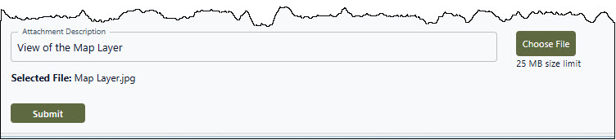

Part 3 Submission
Once the Service Request is ready, click the “Submit” button at the bottom of the Service Request form.
Figure 399 – The Submit Button.
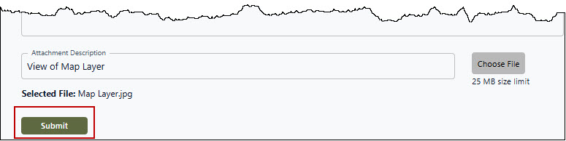
After clicking the Submit button, a message will appear that “Your service request #(SRID) is submitted.” This will clear the form and be ready for a new Service Request, if needed; otherwise close this page.
Figure 400 – The Service Request is Submitted.
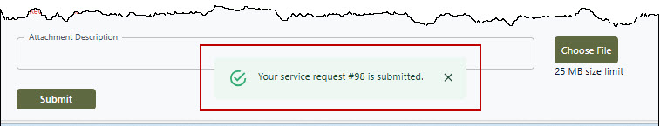
After submitting, check the “Pending Service Requests” to see the Service Request appears om the list.

Part X: Alternate Authentication (When FAMAuth is Unavailable)
The Alternate Authentication feature enables users to log into WildCAD-E using a secure alternative method. If FAMAuth is experiencing an outage and is unavailable, users are automatically redirected to this feature when attempting to log into WildCAD-E.

If FAMAuth is unavailable, the user can access WildCAD-E by going directly to the URL associated with the desired environment:

- WildCAD-E OAT is accessible at: wildcadoat.firenet.gov.
- WildCAD-E PROD is accessible at: wildcade.firenet.gov.
In the case where FAMAuth is fully functional, WildCAD-E still has “AltLogin” is enabled (mode=on), WildCAD will allow the user to login through the portal rather than forcing the alternate login method.
WildCAD-E will do “health checking” and error handling for cases where the FAMAuth hosted server is up but doesn’t fully load the FAMAuth page or starts loading then resets the connection.
Previously, a user must have accessed at least one center in WildCAD-E via the FAMAuth method to successfully use the alternate authentication. After entering the URL for OAT or PROD and WildCAD-E detects that FAMAuth is unavailable, the user is prompted to generate a one-time secure code.
To start the process, click on “Generate Code.”
Figure 401 – Select Generate Code
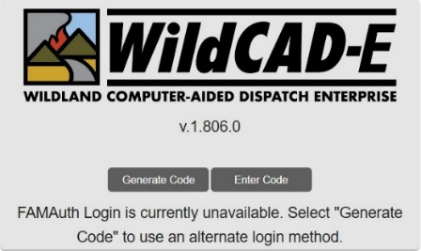
The user is prompted to enter their email associated with their FAMAuth ID account for the code and link to log into WildCAD-E. Then, click on “Go.”
Figure 402 – Enter your e-mail.
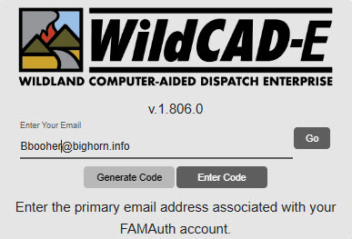

Enter the user’s email. The code/link is only valid for two (2) minutes.
Figure 403– Go to your e-mail.
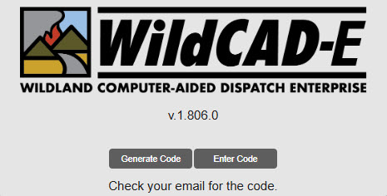
The user can click directly on the link in the email or copy the code and enter the code back to the WildCAD-E login page.
Figure 404– Email Link or Code.
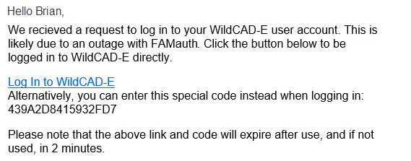
Entering the code in the WildCAD-E login page, then click on “Go.”
Figure 405 – Using the Code.
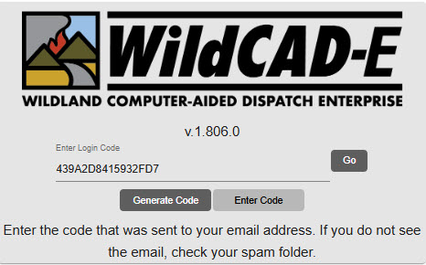
Users will be logged into the last center or select a center with the same roles assigned as the last time you were working in that center.
Figure 406 – Select a center.
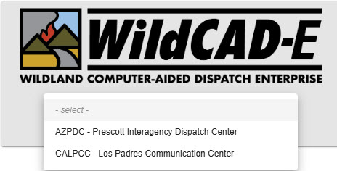

Part XI: Links

Section 1: Websites and Documents

Websites
The Links Menu will only appear if the Center Administrator created a list of web pages for use by Dispatchers. If the menu is shown, merely select any one of the listed sites.
Right-click on the display to pop up a menu that allows the user to perform tasks such as going Back, Forward, Printing, etc.

Documents
If the Center Administrator established a list of documents in WildCAD-E, the user can open one or more documents from this menu. Examples might include User Guides or word processing templates.
The Links menu expands when the user clicks on the “>” symbol.
A list of Links Categories will be displayed.
Figure 407 - Links Menu Categories
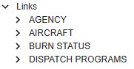
The Links Categories (“AGENCY’) expands when the user clicks on the “>” symbol.
A list of Links Web Sites or Documents will be displayed.
Figure 408 - List of Web Site or Documents
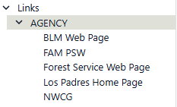
Select for example “BLM Web Page,”
- Upon selecting BLM Web Page from the list, a new tab will open with the website loaded.
- If the user goes back and selects another website, the BLM Web Page website would close and be replaced with the next website.
  - Only one web site is open at a time.
Figure 409 - Website Link
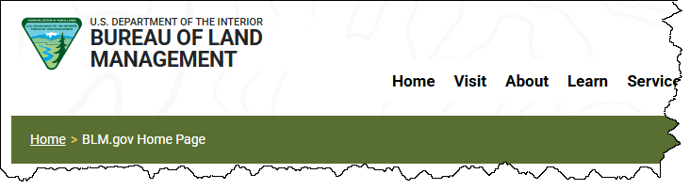

Part XII: Appendices

Appendix I – Icons and Function Keys
When a function key is available, users can either use the icon or function keys to access those panels within WildCAD-E.
Table 1- Table of WildCAD-E Icons
WildCAD-E Icon | Function Key | WildCAD-E Icon Definition
 | F9 | Create a New Incident Panel Icon - Starts a new Incident, although the user will have to enter all information such as location and response area.
 | N/A | Create a New Complex Panel Icon – There is no function key available for “Create a New Complex Panel.” Users will use the icon to access this function.
 | F8 | Open Incidents Panel Icon – Opens the screen that displays existing, open Incidents.
 | F2 | Open Incidents Panel Icon – Opens the “Search Incident Panel” for the user.
 | F7 | Resource Status Icon – Opens the screen where the user can perform status changes that are not related to Incidents, such as “In Service.”
 | F12 | Daily Log Panel Icon – Opens the screen that display the “Daily Log,” where the user can document the activities not directly related to a specific Incident.
 | F5 | Map Panel Icon – Opens the WildCAD-E map.
 | F4 | Open Timers Panel Icon – Opens the Timers Panel for the user.
 | N/A | Create a New Timer Icon – There is no function key associated with the “Create a New Timer” icon. Users will use the icon to access this function.
 | F3 | Create a New Field Interrogation Fire (FI) or be able to search for existing FI files.
 | N/A | Opens a Resource Command Line panel that allows a dispatcher to status a resource from a command line (See Appendix VI)

Appendix II - Grids
Grids are a spreadsheet style interface with a variety of features available to those with Center Administrator access to WildCAD-E.

Sort Order of a Grid
- Click on any column heading or label.
- Sort by ascending (alphanumeric) by clicking once on the arrow pointing up.
- Sort by descending by clicking once on the arrow pointing down.
- For no sort, click a third time.
- When adding a new record or editing an existing record if sorting is enabled, it can make the record jump to a different location due to the sorting.
Figure 410- Arrow pointing up indicates a sort by ascending.
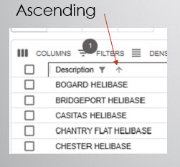
Figure 411 -Arrow pointing down indicates a sort by descending.
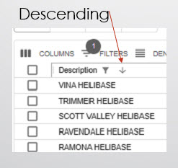
Figure 412 - Click three times to choose no sort.
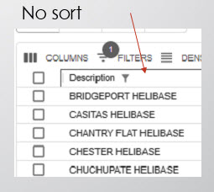

Add a Record or Row to the Grid
Figure 413 - The "+" sign opens a blank row at the top of the grid.
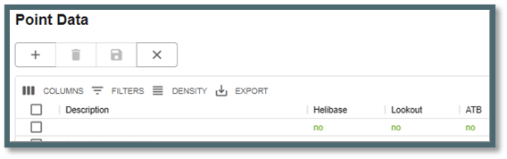
- Click the plus “+” sign to open a new blank row at the top of the grid.
- Enter all information across the row.
- When the entry is completed, exit the cell you are currently editing by clicking anywhere outside of the grid before saving the new or edited record by clicking on the “Disc” icon.
Figure 414 - The "Disc" icon saves a new record or edits an existing record.
Figure 415 - Use the "x" icon to cancel the new record.
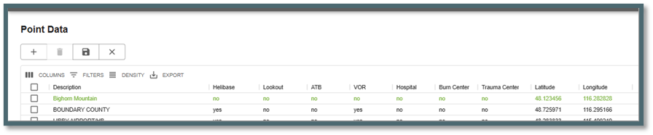
- Cancel a new record by clicking on the “x.”

Delete a Row to the Grid
Figure 416 - Select row for deletion by checking the box.
- Select the row for deletion by checking the box to the left of the row.
- Click the “Trash Can” icon.
- Click the “save” icon to complete deletion of the row.

Actions and Settings at the Top of the Grid

Columns
- On the grid, columns can be either hid or viewed.
- To hide, turn off the “slider” for the respective column.
Figure 417- Slider column.

Filters
- Filters allow the user to search for specific records.
  - Select “Filter;” then the column.
  - Using the “Operation” dropdown menu, select contains, starts with or equals.
  - In the “Value” area, type in what the user wants to search for.
Figure 418 - Filters allow the user to search for records.

Density
- Density slightly changes the width and height of the information on the grid.
Figure 419 - Density slightly changes the height and width of the information on the grid.

Export
- Export typically downloads to a CSV file.
Figure 420 - Export is used to download a .csv file.
- The .csv file will download into the user’s workstation “Download” folder.
Figure 421 - .CSV file downloads to the Center Administrator or users station download files.
- If the user sorted the grid record first, the sorted information would be the only information exported to the .csv file.

Appendix III - Reports

Available Reports
Reports will open into their own Tab. All the reports are generated in a similar process.
The key processes are:
- On the right side of the report panel are sortable selection. Such as:
  - Unit
  - Resource Types
  - Status
  - Use of Line up groups
  - Incident Types and Subtypes
- Date ranges are required except for:
- Morning Line Up Report
- In-Service Report
- Responding Resource List
- Open Incident
- On the left side of the report panel are the results from the selection process.
- Generate PDF will create the report based on the selection criteria.

Morning Lineup Reports
Figure 422 – Example Morning Line Up Report
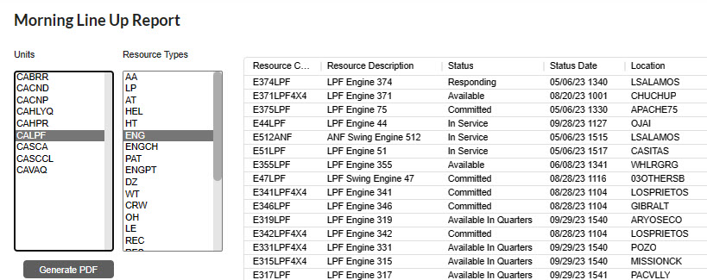

In Service Report
Figure 423 - In Service Report
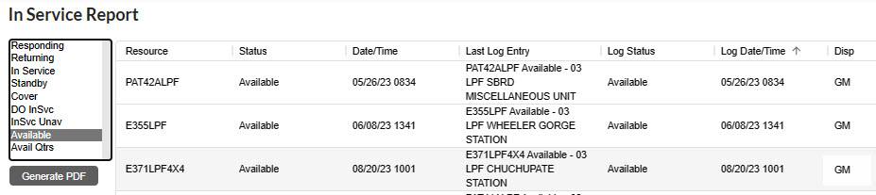
Timer Report
Figure 424 – Timer Report
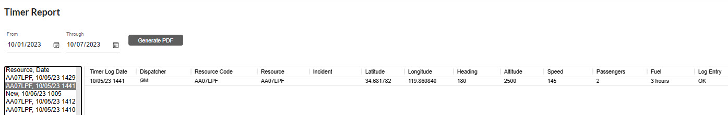
Timer Report - Added remaining columns from Timer panel to report page and generated PDF.

Responding Resource List
Figure 425 - Responding Resource List
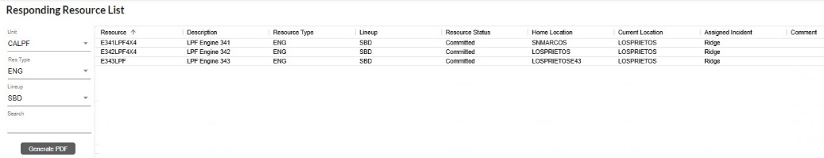
Single Resource Response History
Figure 426 – Single Resource Response History
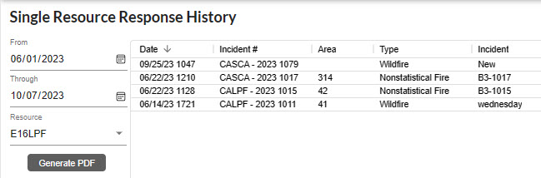

Open Incident
Figure 427 – Open Incident
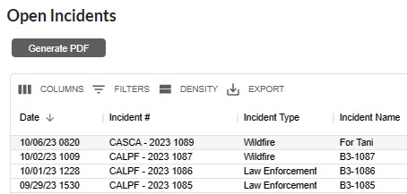

Incident By Date
Figure 428 – Incident by date.
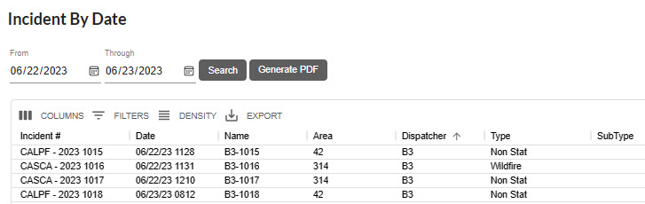
Incident Numbers
Figure 429 – Incident Numbers
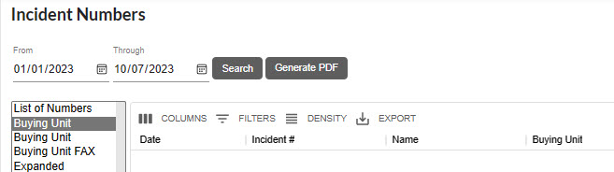

Fire Report
Figure 430 – Fire Report
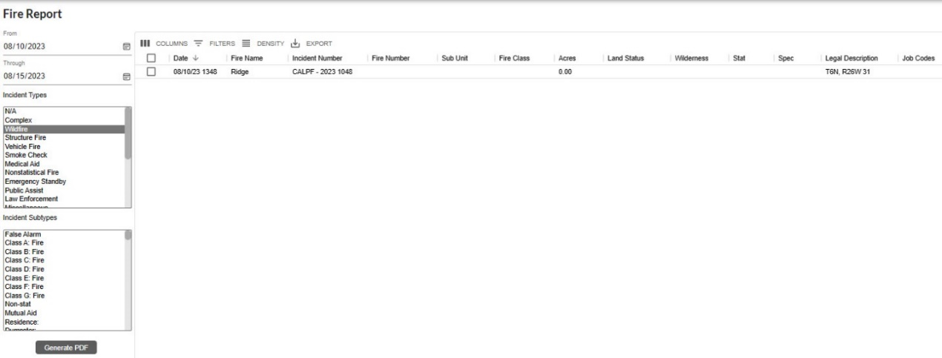

Monthly Fire Summary
Figure 431 – Monthly Fire Summary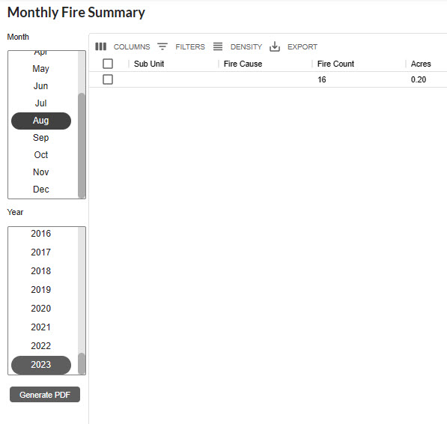

Contract Report
Figure 432 – Contract Report
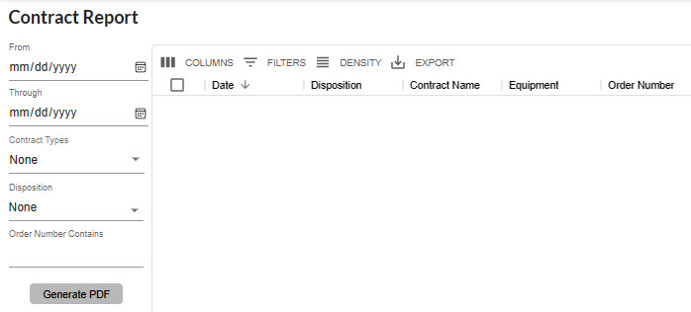

Appendix IV – Incident Types
Table 2 - Incident Types
Code | Description | Expired?
A/C Down (expired 4/2024) | Aircraft Down | Yes
AC – Air Accident | Aircraft Accident | No
AC – Marine Accident | Marine Accident | No
AC – Motor Vehicle Accident | Motor Vehicle Accident | No
AC – Rail Accident | Rail Accident | No
AC – Structure Accident | Structure Accident | No
Aircraft | Aircraft | No
AP – Critical Incident Stress Management / Peer Support | Critical Incident Stress Management / Peer Support | No
AP – Law Enforcement (internal) | Law Enforcement | No
AP – Management Event (internal) | Management Event (internal) | No
AP – Resource Programs (internal) | Resource Programs (internal) | No
Emerg Stby | Emergency Standby | No
F1 – Debris /Product Fire | Debris Fire | No
F1 – Non-Statistical/Other | Nonstatistical Fire | No
F1 – Prescribed Fire | Prescribed Fire | No
F1 – Structure Fire | Structure Fire | No
F1 – Vehicle Fire | Vehicle Fire | No
F1 – Wildfire | Wildfire | No
F1 GF – Foreign Incident | Support of a Foreign Incident | No
FM IM – International Mobilization | Support of an International Mob. | No
FM – Complex Incident | Complex | No
FM – Emergency Stabilization | Emergency Stabilization | Yes
FM – False Alarm | False Alarm | No
FM – Fire Rehabilitation | Fire Rehabilitation | Yes
FM – Incident/Event Support | Incident/Event Support | No
FM – Out of Area Response | Out of Area Response | Yes
FM – Preparedness/Preposition | Preparedness/Preposition | No
Hazmat (expired 04/2024) | Hazmat | Yes
HZ – Biological or Toxic Conditions | Biological or Toxic Conditions | No
HZ – Explosives or Electrical Dangers | Explosives or Electrical Danger | No
HZ – Flammable as, Oil, and other liquid conditions | Flammable Gas | No
HZ – Radioactive/Nuclear Conditions | Radioactive/Nuclear Conditions | No
Med Aid | Medical Aid | No
Misc | Miscellaneous | No
MRO | Manage Res Obj | No
N/A | N/A | No
NatDisastr (expired 04/2024) | Natural Disaster | Yes
ND – Earthquake | Earthquake | No
ND – Flooding | Flooding | No
ND – Hurricane/Typhoon | Hurricane/Typhoon | No
ND – Landslide/Mass Earth Movement/ Avalanche/Sinkhole | Movement/Avalanche/Sinkhole | No
ND – Severe Winter Weather | Severe Winter Weather | No
ND – Thunderstorm/Tornado/High Winds | Thunderstorm/Tornado/High Winds | No
ND – Tsunami | Tsunami | No
ND – Volcano | Volcano | No
PA – Community Event | Community Event | No
PA – Infrastructure Event | Infrastructure Event | No
PA Public Service Organization Event | Public Service Organization Event | No
Pub Asst (expired 04/2024) | Public Assist | Yes
Resc Order | Resource Order | No
SAR (expired 04/2024) | Search & Rescue | Yes
Smoke Chk | Smoke Check | No
SR – Marine Search/Rescue/Recovery | Marine Search/Rescue/Recovery | No
SR – Medical Assist | Medical Assist | No
SR – Urban Search/Rescue/Recovery | Urban Search/Rescue/Recovery | No
SR – Wildland Search/Rescue/Recovery | Wildland Search/Rescue/Recovery | No
TR – Classroom Training | Classroom Training | No
TR – On-the-Job Training | On-the-Job Training | No
TR – Proficiency & Currency Event | Proficiency & Currency Event | No
TR – Simulation | Simulation | No

Appendix V – Resource Command Line
This feature allows a dispatcher to status a resource from a Resource Command Line panel. (i.e., “E17LPF AV” command sets the status for E17LPF to Available).

The Center Administrator will enable this feature for the dispatchers. Once the feature has been enabled a new icon will be displayed on the Home Page.

Figure 433 – Resource Command Line Icon
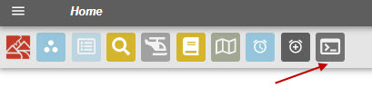
Click on the Command Line Icon to open the Resource Command Line panel. Text Field  will be focused when opened. If the Text field is not focused on the panel, click inside the text field again.

Figure 434 – Resource Command Line Icon
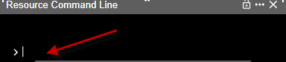
Type the resource code followed by a space then the status. Status commands are:
- AV – Available
- AQ – Available Quarters
- OS – Out of Service
- IS – In Service
- RES – Responding
- AI – At Incident (On Scene)
Then press return.
Figure 435 – Resource Code and Command Status
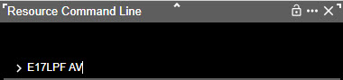
If successful, no error text will be displayed.
Figure 436 – Status OK
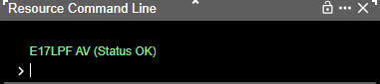

Causes for Errors
Invalid Resource - Resource name entered is not found in the active resources list.

Figure 437 – Invalid Resource
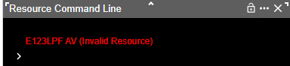

Invalid Status Command - Status command entered is not part of the available commands list.

Figure 438 – Invalid Status Command
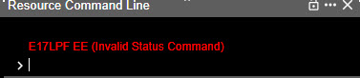

No Incident Assigned – For the commands “RES” and “IA” the resource must be “Assign” to the incident to use these commands.

Figure 439 – No Incident Assigned
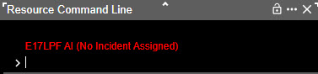

Not Enough Arguments – No space between the resource and the entered command. Multiple spaces within the resource name are allowed since some resources have spaces in their name.

Figure 440 – Not Enough Arguments
