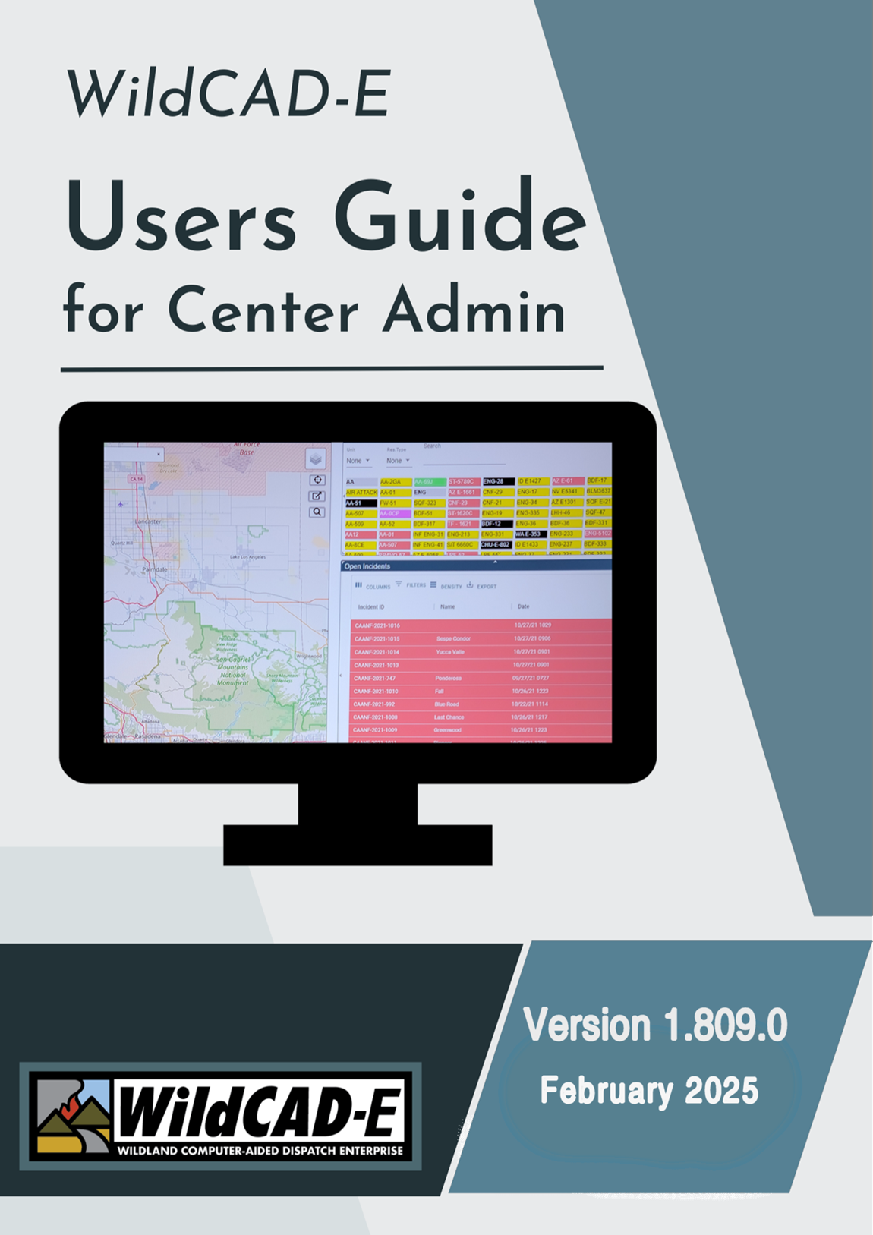
Version 2.0.1
December 2025
Table of Contents – Center Admin User Guide
Introduction 1
Format of the Center Admin User Guide 1
User’s Environment 1
Considerations to Ensure Continuity in the Use of WildCAD-E and Workspace Suggestions for the User 1
FAMAuth Profile Management Access 1
Alternate Authentication When FAMAuth is Unavailable 2
WildCAD-E Roles 2
Application Rules of Behavior and Security 2
Home Page 3
Part I: Configure Map 5
Point Data, Hazard and Place Names 5
Add or Modify the Hazards Layer 6
Custom Layers 7
Place Names 13
Milepost 14
Response Area GIS Layer (Zip File) 15
Part II: Configure WildCAD 16
Preferences 16
System Administrator Choices 16
New Incident 17
Fire Numbers 17
Who Responds First from a Station? 17
Incident Report Show Resource Detail 17
LE Timer When 18
Auto Timer for LE 18
Test/Email Option 18
Map Options 18
Incident Types 18
Part III: Center Operations 19
Dispatchers 19
Links 20
Phone List Categories 21
Whiteboard Categories 22
Daily Log Categories 23
Text/Email Addresses 23
Text/Email Groups 24
Assign Text/Email to a Group 24
Text and Email Preset Messages 24
Part IV: Resources 25
Units 25
Subunits 26
Dispatch Locations 27
Line Up Groups 28
Resource Types 28
Resources 29
Add a Resource 29
Resource Identification 30
To Editing a Resource 35
Admin Station Dispatch Priority 36
Rotation Builder 37
Match Resources in IRWIN 37
Viewing Centers (WildShare) 39
Part V: Response Areas 39
Response Level Areas 40
Response Areas Panel 40
Response Areas – Data Entry 40
Part VI: Dispatch 41
Response Types 42
Incident Subtypes 42
Response Levels 43
Dispatch Strategy 44
How to Build the Dispatch Strategy 44
Copy Priority Locations from One Response Area to Another 47
Copy Quantities from One Response Area to Another 48
Resource Status 49
Part VII: Configure Incident Tab 49
Batch Comments 50
Assigned to Response Area by Resource Type 51
Sequence Comments 52
Area Notifications 53
Notification to Incident within Particular Response Area 53
Notification to Response Area by Response Type 53
Next Step 54
Frequencies 54
Fires Tab 55
ICP Phone Categories 56
Numbers 57
Questions 57
Contracts 59
Move Ups 59
Appendices 61
Appendix I – Icons and Function Keys 61
Appendix II - Grids 63
Appendix III – Incident Types 67
Appendix IV - Alternate Authentication When FAMAuth is Unavailable 69

Center Admin User Guide

Introduction
Welcome to WildCAD-E, the web-based Computer-Aided Dispatch (CAD) system developed by Bighorn Information Systems for wildland fire agencies and targeted for Emergency Communications Centers of all sizes.
The purpose of this document is to assist the Center Administrator with the initial setup and subsequent maintenance of WildCAD-E. Dispatchers who will be using WildCAD-E should refer to the WildCAD-E User Guide for information on how to operate the software.
Please note that the Center Admin tab in WildCAD-E will only be visible with Center Admin access from iNAP.
The following pages will guide you through the various menus in WildCAD-E for Center Admin.

Format of the Center Admin User Guide
The WildCAD-E User Guide for Center Admin is structured to guide Center Admin through each menu item. It is divided into multiple parts, with each part containing associated steps to lead the user through the process effectively.

User’s Environment

Considerations to Ensure Continuity in the Use of WildCAD-E and Workspace Suggestions for the User
- Dispatchers need a computer with either a Google Chrome or Microsoft Edge browser.
- Ensure the browser used is the most current version.
- Field employees doing rostering can use a computer, tablet or phone.
- Two computer monitors available to WildCAD-E allow the dispatcher to drag items to a separate monitor.
- A cell-based hotspot is recommended for backup in the event the user loses internet connectivity.
- A fast internet is essential. Test your internet speed at www.speedtest.net.
- The previous session timeout of 8 hours has been removed. Current timeout will occur 8 hours after the user logs out of WildCAD-E.
- FAMAuth Profile Management Access.

FAMAuth Profile Management Access
WildCAD-E users with Center Administrator role use their FAMAuth Profile Management screen to:
- Assign centers and roles.
- Approve or deny user requests and grant access, even when a user has not previously requested it.
- Approve access requests submitted by users and grant access to their dispatch center for users who have not requested access.

Alternate Authentication When FAMAuth is Unavailable
- Alternate Authentication (See Appendix IV) features to allow users to log into WildCAD-E using an alternate secure method, if FAMAuth is experiencing an outage and is unavailable.

WildCAD-E Roles
- Center Administrator provides access to the Center Admin menu.
- Dispatcher allows access to all dispatcher-related screens.
- Roster provides access to just rostering capabilities in WildCAD-E. A dispatcher who will also roster will need both the Dispatcher role and the Roster role.
- Read Only users will be allowed to login to the WildCAD-E application and view most pages and panels except the Center Administrator pages. Read Only users:
- This role takes priority over Dispatcher or Center Admin roles.
- Any changes the user may try to make are prevented from being saved.
- May still save their personal settings (Home layout, Map layout, etc.)
- The application banner is orange and displays the user is in “Read Only” mode.
- If the “Roster” role is assigned to the user, they can roster as normal.
- Any changes to roster status are immediately broadcast to other dispatchers.

Application Rules of Behavior and Security
The user will be presented with a splash screen page for Rules of Behavior and Agencies Security Requirements that must be agreed to before entering into the application.

Home Page
The Home page is divided into three major sections: 1) the ribbon across the top, 2) the Icons, and 3) the pull-down menu or the “Hamburger” menu (≡), which displays the pull-down menu. See the User Guide for Dispatcher for more details regarding the Home Page.
Figure 1 - Home Page Ribbon shows System, Status of CAD, About, User and Dispatch Center (L-R)
Figure 2 - The Icons
Figure 3 - The Hamburger is located above, and to the left of, the Icons.
Implemented application-wide, the following library updates and aesthetic user interface changes for accessibility compliance were made:
- added a focus indicator (or focus ring/outline), which is a visual cue to show which element currently has keyboard focus.
Figure 4 – Focus Ring, Font and Color Scheme
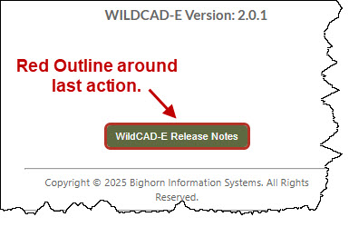
- made slight changes to the font and color scheme with less use of stark white space; and
- added a grid row alternating colors and updated grid header appearance for easier viewing.

Figure 5 - The "Hamburger" symbol opens this pull-down menu.
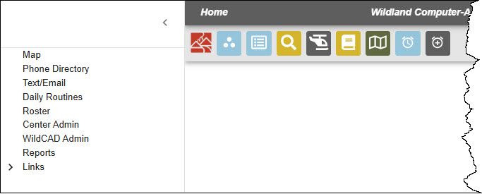
Click on “Center Admin,” which allows access to:
- Maps
- Phone Directory
- Text/Email
- Daily Routines
- Roster
- Center Admin
- Reports
- Links
By entering the Center Admin mode, the user can access the Center Admin menu. The Center Admin menu will open into its own tab.
Figure 6 - Center Admin is the first level pull-down menu.
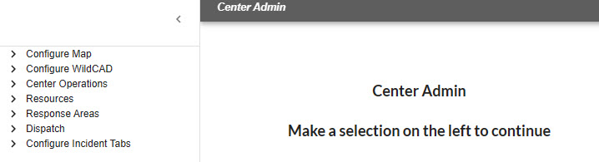
The first level pull-down menu provides the user with access to each of the following specific topics:
Configure Map
Configure WildCAD
Center Operations
Resources
Response Areas
Dispatch
Configure Incident Tabs
Each of these topics will have second level pull-down menu.

Part I: Configure Map
The Center Administrator can maintain five types of center-specific data layers:
- Point Data
- Hazard
- Custom Layers
- Place Names
- Milepost
When any of these layers are updated, the map page needs to be refreshed to show the updates. Map layers that are added from services outside of WildCAD-E may take longer to load when the map shows large areas of land. For the best results, zoom in before trying to turn on a layer.

Point Data, Hazard and Place Names
Point Data, Hazards and Place Names are maintained similarly. Point Data and Hazards show up in the layers list under WildCAD Data (if there is data for the category). Place Names can also be added and searched within the Find Icon.
Navigate to the maintenance screen:
- Allows users to add, edit and delete from the maintenance screen.
- Click a row (do not select the check box) to view the point on the map.
- Double click inside the row to start editing the attributes. When editing the Lat/Lon, you can preview your change by tabbing out of the cell.
- Click the save icon to keep the changes or the X icon to cancel the changes.
Figure 7 - Point Data allows the user to view the point on a map.
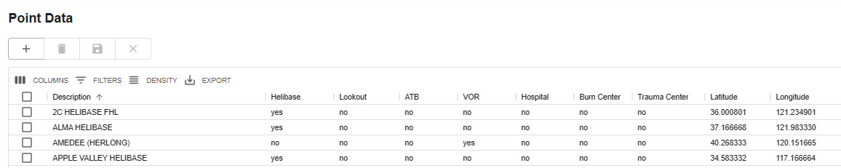
Figure 8 – When Point data is entered, the location is viewable on the map.
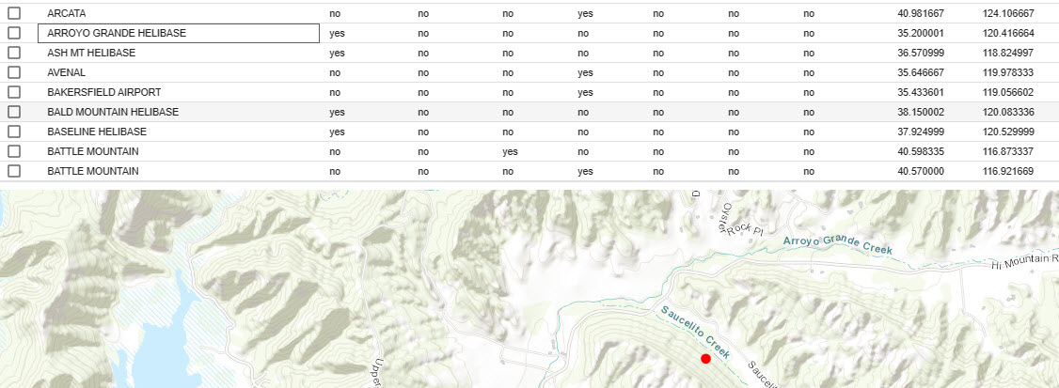

Add or Modify the Hazards Layer
Navigate to the maintenance screen.
- Click on a row (do not select the check box) to view the point on the map.
- Double click inside the row to start editing the attributes.
- When editing the Lat/Lon or the radius, the user can preview changes by tabbing out of the cell.
- Click the “Save” icon to keep the changes or the “X” icon to cancel the changes.
Figure 9 - Double click inside the row to begin editing attributes.
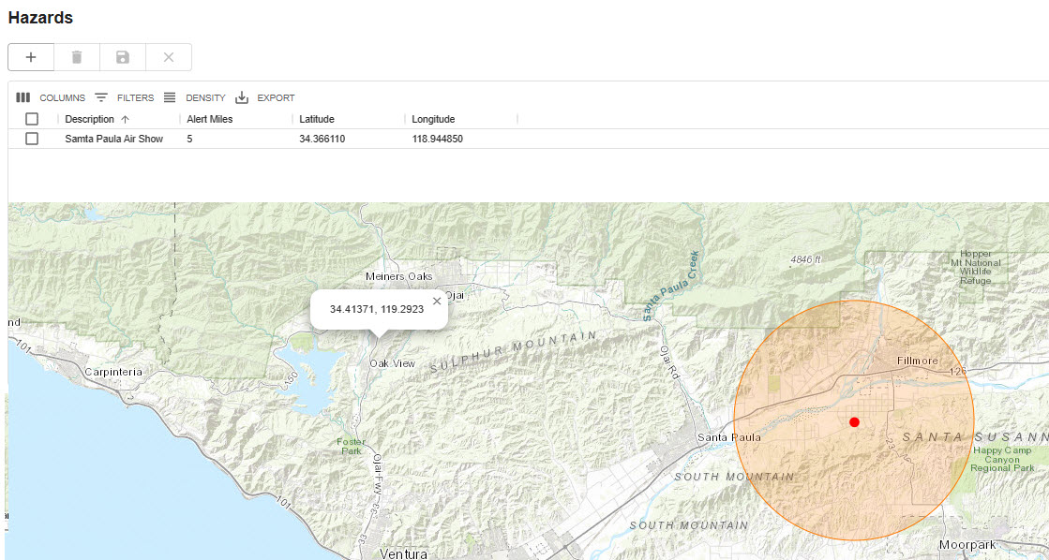

Custom Layers

Add or Modify Custom Layers
Figure 10 - Select either a zipped shapefile or an ArcGIS Web Service URL to add a custom data layer.
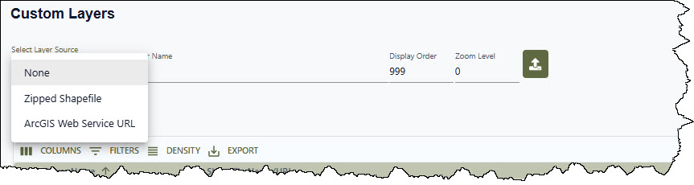
Custom data layers can be added by either uploading a zipped shapefile or adding an ArcGIS Web Service URL from various web-hosted map layers. To do so, navigate the maintenance screen.
Select either a zipped shapefile or a URL. To upload a zipped shapefile, it must have at least these four (4) file extensions: .shp, shx, .dbf, and prj. The URL must be valid ArcGIS feature or map service URL.
Once you select the shapefile option, users can browse to the zipped shapefile location.
Enter the Layer Name, Display Order, and Zoom Level.
Click the Upload Icon  button.
Figure 11 – Uploading a Custom Layer.
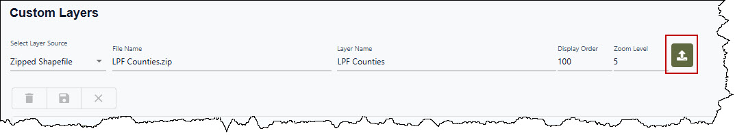
If there are any issues with uploading the file or URL, the user will be prompted with an alert message, and the new record will not be saved.
When adding a new layer, the layer name and attribute are only removed after the upload is completed.
Adding Display Fields, Color, Opacity Weight/Radius and if needed, adjusting Display Order, Zoom Level or Active Layer status. or Map Extent.
Each row in the data grid now has a radio button.” Select this button to view the layer.

Figure 12 – Viewing a Custom Layer with the Radio Button.
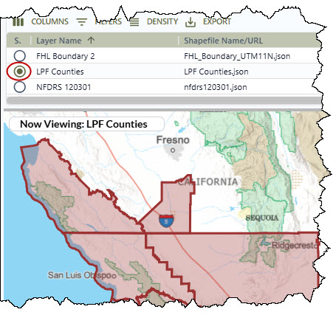
Display Fields – Click on any polygon with the layer to view the attribute list. Click on any area on the map to close the attribute list.
Figure 13 – Viewing the Attribute List.
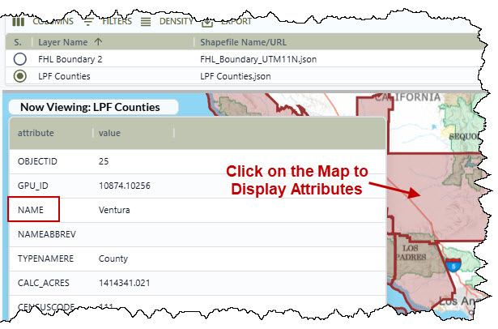
Double click on the “Display Field” cell to view the attribute list and then click on the desired attribute. To delete the display field (make it blank for that layer) - click once on the Display Field cell and use the backspace key on your keyboard. Then click out of the cell then click the Save button.

Figure 14 – Selecting an Attribute for the Display Field.
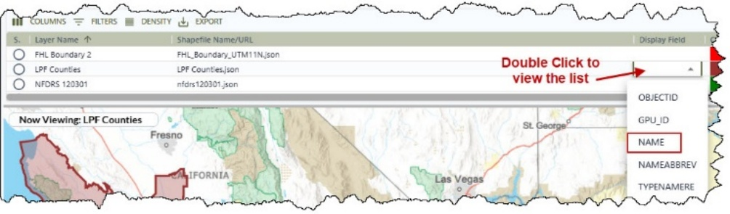
Color – To set the color of the use the “Color Picker” by clicking anywhere on the Color Palette.
Figure 15 – Selecting Color for Layer
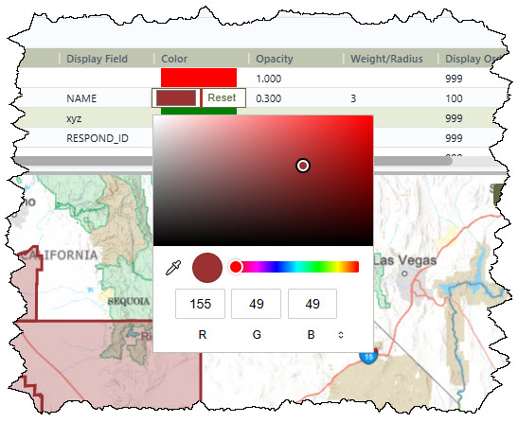
The user can customize the color by:
- Moving the slide bar to change the color palette.
- Using the ‘Ink” Icon to select a color from the map.
Figure 16 – Changing the Color Palette.
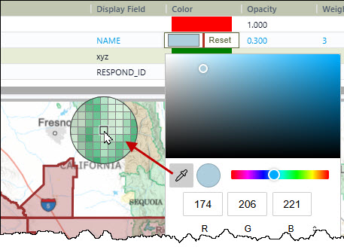
Opacity - Enter values between 0 (completely transparent) and 1 (solid). If blank, the default opacity for polygons is 0.2, and for lines/points is 1 (solid).
Figure 17 – Setting the Opacity
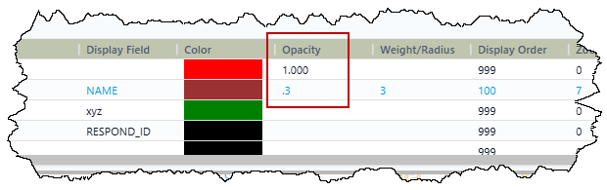
The hover over the Opacity to view the defaults
Figure 18 – Defaults for Opacity
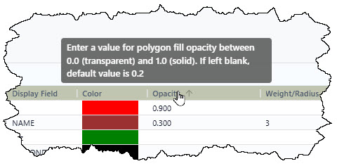
Weight/Radius - This will adjust the weight (thickness) of line files (not outlines of polygons), and the radius of points. If blank, the defaults are 2 pixels thick for lines, and 4 pixels for the radius of points.
Figure 19 – Setting the Weight/Radius.
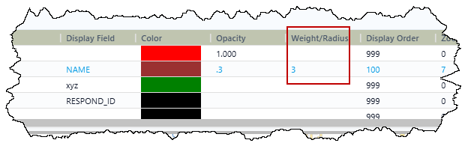
The hover over the Weight/Radius to view the defaults
Figure 20 – Defaults for Weight/Radius.
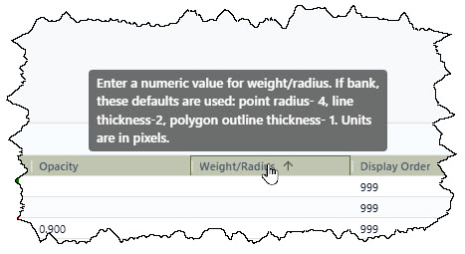
Display Order - Is the number that merely controls the order in which Custom Map Layers are listed in the Center Data.
Zoom Level - Users may also specify a "Zoom Level" parameter. After clicking the “show on map” radio button for selecting a map layer, click the “Zoom to Layer” button to view the entire layer at the pre-determined zoom level.
Figure 21 – Zoom to the Layer.
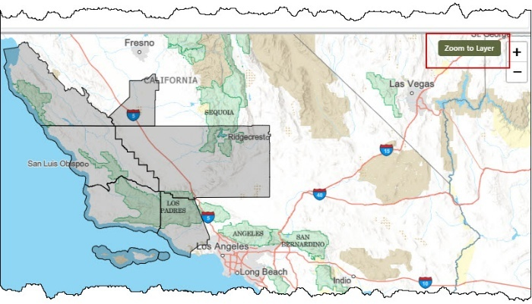
Layers will remain hidden until you reach the layer’s designated zoom level—in this example, Zoom Level 7. If the layer is not visible, a label will indicate that it is hidden.
Figure 22 – Hidden Layer.
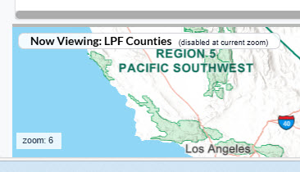
If there is an issue with the layer (broken URL, missing file, etc.), the label on the map will show “Error Loading <Layer Name>”
Figure 23 – Loading Error
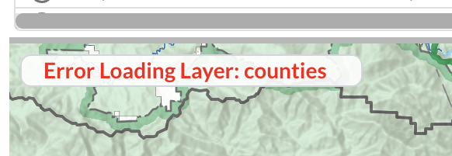
Active Layer – Controls which layers will be listed on the map’s layers list
Map Extent – Positions and centers the selected layer at the full extent of that layer’s features in the bottom display.
Figure 24 – Adding or Updating Display Order, Zoom Level, Active Layer or Map Extent.
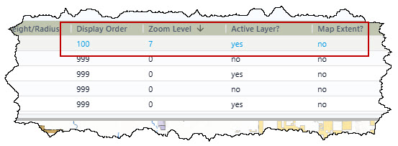
Once all the changes are complete, click the “Save” button.
Figure 25 – Completed Map Layer Addition.
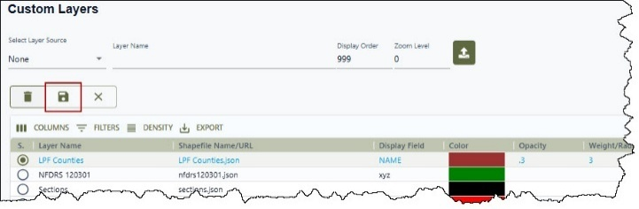
The grid and map can be resized using the Horizontal Splitter Bar that separates the two sections of the page. Hover over the bar and drag it up to make the map larger or down to make the grid larger.

Figure 26 – Horizontal Splitter Bar.
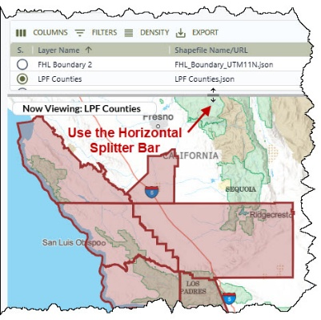

Place Names

Add or Modify Place Names
Navigating to the maintenance screen:
- Allows users to add, edit and delete from the maintenance screen.
- Click a row (do not select the check box) to view the point on the map.
- Double click inside the row to start editing the attributes. When editing the Lat/Lon, you can preview your change by tabbing out of the cell.
- Click the “Save” icon to keep the changes or the “X” icon to cancel the changes.

Figure 27 – Place Names allows the user to view the point on a map.
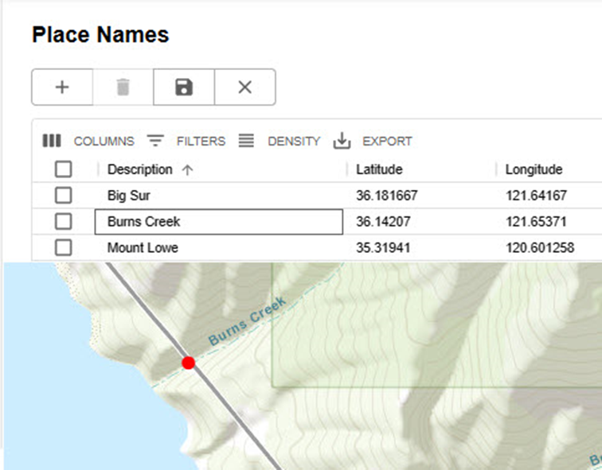

Milepost

Add or Modify Milepost Layers
Navigate to the maintenance screen.
- Milepost can be added by uploading a CSV (comma separated value) file to either add to or replace their current milepost data.
- The CSV file needs to have no column headers and contain 4 columns in this order: Road Name, Milepost #, Latitude, Longitude (positive number).
Figure 28 - Example of CSV file.
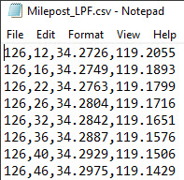
Figure 29 - Select CSV file to add milepost data.
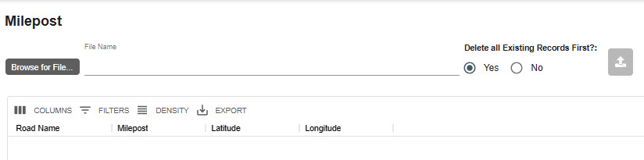
- Select the CSV file.
Figure 30 - In this example, if the CSV file is selected all existing records will be deleted.
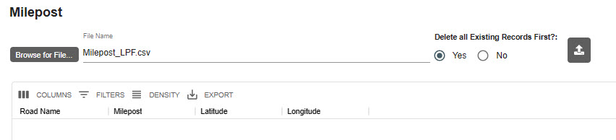
- Select either Yes or No – “Delete all Existing Records First” Yes will replace all records. No will just add new records.
- Click the upload icon button.
Figure 31 - The results of the upload.
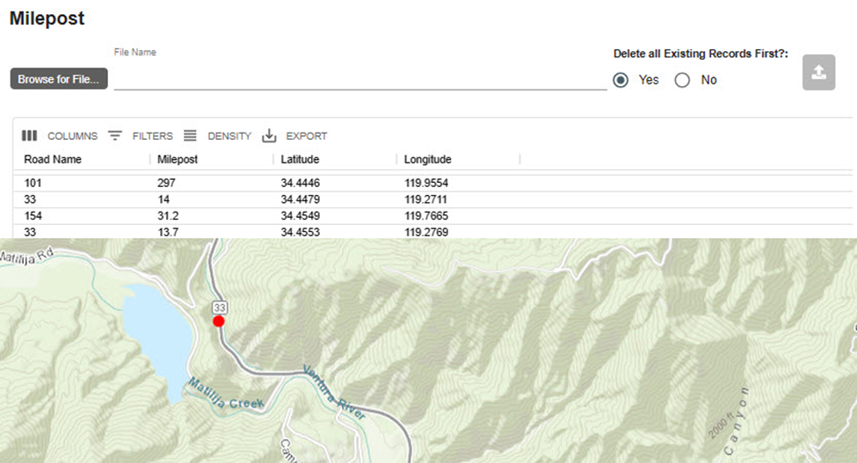

Response Area GIS Layer (Zip File)
The response area zipped shapefile must have at least these 4 file extensions: .shp, shx, .dbf, and prj.
The shapefile .dbf must contain one attribute with a maximum length of 6 characters. This is the only attribute used by WildCAD-E. Any other attributes in the table will be ignored.

The Response Area Shapefiles attribute containing the response area code can have any name.
The values in the code attribute of the shapefile should match the currently used values in the Response Area table (Center Admin/Response Areas). Matched values are used when:
- using the Map find panel to search for a response area and drop a point.
- populating the response area for an incident when starting the incident from the map

Part II: Configure WildCAD

Preferences
The System Administrator can manage the following WildCAD-E settings on the “Preferences” panel.
Figure 32 - System Administrator Preferences Panel
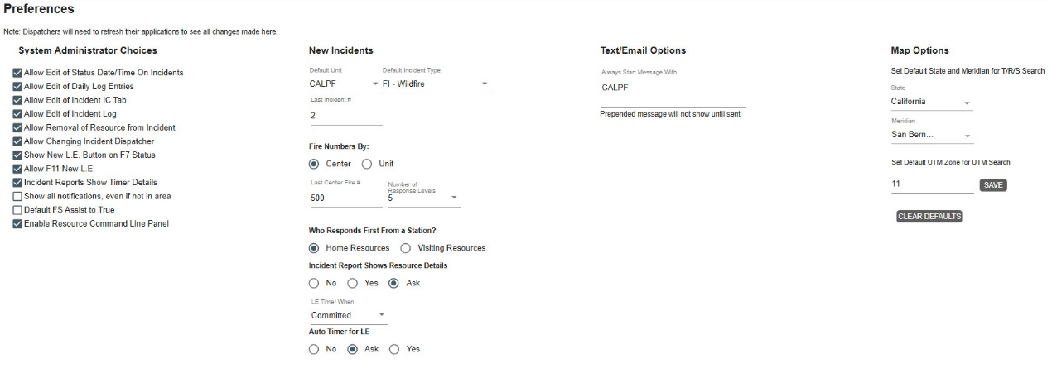

System Administrator Choices
System Administrator Choices – by checking the correlating boxes, the System Administrator allows the following:
- Allow the Edit of Status Date/Time on Incidents. Dispatchers will be able to edit the status, date, and times on incidents.
- Allow Edit of Daily Log Entries. Dispatchers will be able to edit the Daily Entries on incidents.
- Allow Edit of Incident Tab. Dispatchers will be able to edit the IC Tab on incidents.
- Allow Edit of Incident Log. Dispatchers will be able to edit Incident Log entries.
- Allow Removal of Resource from Incident. Dispatchers can remove resource(s) from an incident and delete all Action History for those respective resource(s).
- Allow Changing Incident Dispatcher. A change in Dispatchers.
- Show New Law Enforcement (LE) Button on F7 Status. Displays the “NEW LE” button when a resource is selected on the Resource Status screen.
- Allow F11 New LE. Enables the F11 key.
- Incident Reports Show Timer Details. The Incident Report will show all the timer details of the timers associated with the incident.
- Show all notifications, even if not in the area. Shows all notifications for any area.
- Default FS Assist to True. Every new incident will automatically check “FS Assist” on the Fiscal Tab.
- Enable Resource Command Line Panel. This feature allows a dispatcher to status a resource from a command line (i.e., “ENG11 AQ” command sets the status for ENG11 to Available Quarters)

New Incident
  - Set the Default Unit and Default Incident Type. Note: This global Default Unit can be overridden by using the per-user Default Unit on the Dispatchers screen.
  - Last Incident Number # means the next incident number assigned will be this number plus one. The number will then be automatically increased.
- Incident numbers are set back to 0 at the start of a new calendar year, the starting incident number would be set to Zero (0).
- IF the center chooses to have Incident Number with a Calendar Year the Centers may choose a year (YY) portion as part of the actual incident number when a new calendar year begins.
- Addition numbers and the calendar by editing this field like “YY0000”.

Fire Numbers
- Are auto assigned either by Center or Unit.

Who Responds First from a Station?
- Select either Home or Visiting Resources.

Incident Report Show Resource Detail
- Set this as a yes, no or ask.

LE Timer When
  - LE Timers set to start on what resource status.

Auto Timer for LE
- Choose yes, no or ask.

Test/Email Option
- Provides the user the opportunity to start every text message with a short, prepended message. Without a prepend message, the default is blank (null).

Map Options
- Set a default state and Meridiam for T/R/S searches.
- Set the default UTM zone for the center. This value is used as the default zone when searching by UTM on the map find panel. The length limit of 2 is set for the UTM Zone. Click the “Save” bottom to save the UTM Default.

Incident Types
Figure 33 - Incident Types
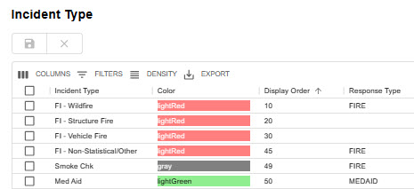
Enter the appropriate information in each column, as follows:
- Incident Types – Incident Types are set and cannot be changed. Appendix III – Incident Types contains the current list. Some Incident Types will have “Expired” dates, which will allow for searching, editing, and reporting incidents with expired types.
- Colors – Use the pull-down to change to the desired color for your center.
- Display Order – Enter the sequence number, so this order will be displayed in Incident Panel. The display order will show “none” for incident types that have not been given a display order. All incident types that do not have a display order will be sorted to the bottom of the list in ascending alphabetical order.
- Change the Center’s Color - Double click on the color; then, use the pull-down to change the color to the desired color for your Center.
- Response Type - Use the pull-down to change to the desired Response Type controlling the Dispatch Strategy.
- Save your work.

Part III: Center Operations
Figure 34 - Center Operations Pull-down Menu
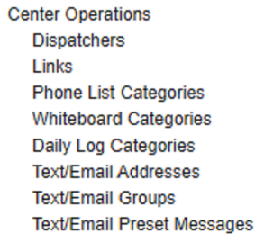

Dispatchers
The dispatcher list reflects people authorized a “Dispatcher Role” in FAMAuth who then login to WildCAD-E. The Center Admin can edit the following, but the Center Admin cannot add a dispatcher:
Unit – default unit when this dispatcher starts an incident (overrides the system-wide default set on Properties).
FI Authorized – (yes or no pull-down)
- If a user requires ‘FI Authorized’ access, before selecting YES ensure the following:
- User is a credentialed DOI or USDA employee who has been issued a DOI or USDA PIV card; and
- Users will only be accessing WildCAD-E from Government Furnished Equipment (GFE); and
- If user is a USDA employee, the user has completed the annual “FS-USDA Security Awareness Training” in AgLearn within the last 12 months (collect evidence such as a screenshot of the completion certificate indicating course name and completion date); and
- If user is a DOI employee, the user has completed the annual *course requirements for “DOI Role Based Privacy Training” in DOI Talent within the last 12 months (collect evidence such as a screenshot of the completion certificate indicating course name and completion date); and
- Users are aware that only permitted PII can be entered into WildCAD-E, specifically in the WildCAD-E Field Interrogation (FI) file only. Permitted PII includes:
  - First name and last name
  - Date of birth
  - Driver’s license number
  - Vehicle plate number
- The steps for DOI users to complete the Role-Based Privacy Training (RBPT) Course include:
- Download and read the following RBPT course document: Privacy for IT Personnel
- Review of the Privacy Resources and Glossary documents
- Complete the RBPT quiz
- Complete the annual RBPT Self-Certification
Initials – free text.
Figure 35 – Only one dispatcher is FI Authorized.
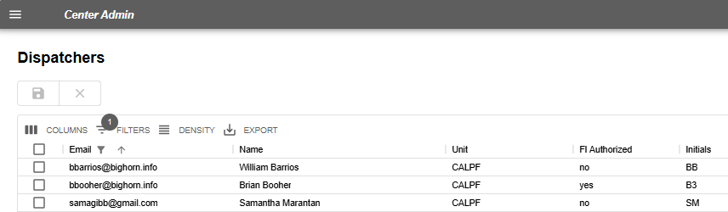

Links
In WildCAD-E, the Center Admin can create an optional new menu called, “Links.” The “Links” menu can contain a second-level menu (a “group”), using either a URL or a file.
Figure 36 - Center Admin can create an optional menu called, "Links."
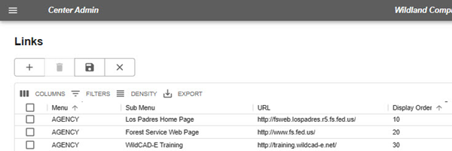
- To add a new item, select the appropriate button and enter the label to appear on the menu. If it is a URL or a file, enter the appropriate path.
Figure 37 – Links allows the user to select the appropriate button and enter the label to appear on the menu.
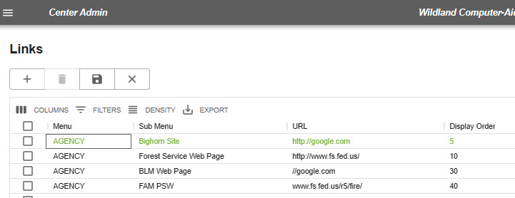

Phone List Categories
Figure 38 - Phone List Categories
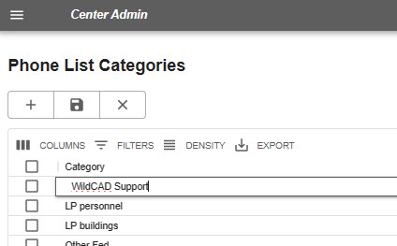
To add categories within a Phone List Category, the Center Admin will choose the following:
- Categories
- Click the “+” and Enter Category
- Click “Save” to add the category to the list.
To add choices within Choices Within a Category, the Center Admin will choose the following:
- Select a Phone Category from the pull-down.
- Enter a description.
- Click “Save” to add to the list.
Figure 39 - Phone List Categories and Choices within a Category
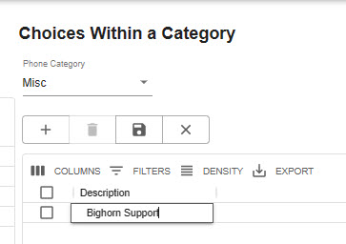

Whiteboard Categories
The Whiteboard is intended to be a place to post a few items of interest, typically for a day or other brief period.
There are three Whiteboard columns:
- Description
- WildWeb (Yes/No)
- Display Order Expired (Yes/No)
The Center Admin may opt to show information on a Whiteboard category on WildWeb, which then is viewable to the public.
Caution: WildWeb is viewable by the public.
Figure 40 - Whiteboard is a place to post items of interest.
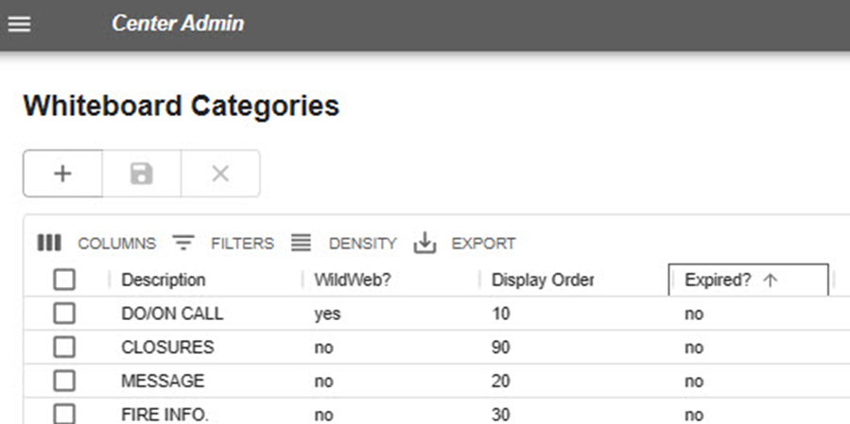

Daily Log Categories
Figure 41 - Daily Log Categories
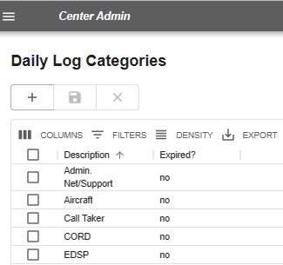
For each category:
- Enter Category Description
- Indicate if Expired (Yes or No)

Text/Email Addresses
Figure 42 - Text and Email Information is now available.
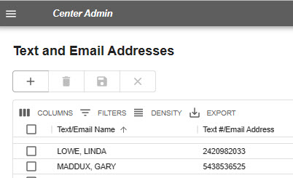
Text and Email names and addresses are entered by the Center Admin and then available in WildCAD-E.
For each address enter:
- Text / Email Name
- Cell Phone number or Email Address – any entry which is precisely 10 numeric characters is sent as a text; anything else is sent as email.

Text/Email Groups
The group names are the potential recipients of your text and/or email messages. For each group enter:
- Group name.
- Then, click “Save.”
Figure 43 - Groups are the text/email recipients.
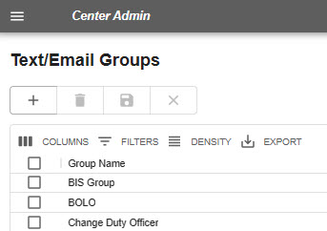

Assign Text/Email to a Group
Using the pull-down to select a group name previously created:
- Select the group name.
- Select the emails for those who are members of that group.
- Move them to the “In Selected Group” By clicking on the “>” or move them back by clicking on the “<.”
- Click “Save.”
Figure 44 - Create a group and populate with names and emails.
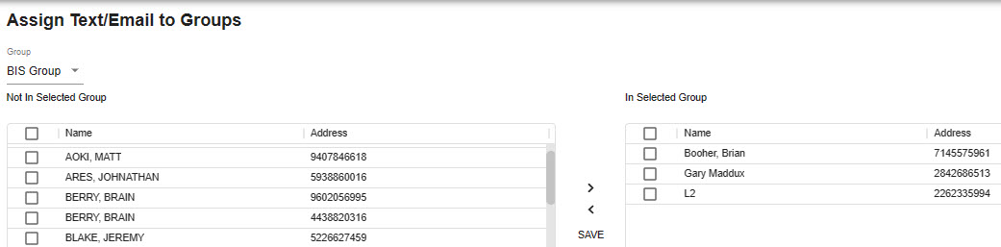

Text and Email Preset Messages
If the Center Admin routinely sends a certain type of message (e.g., the Morning Lineup), the Center Admin can create a list of preset messages, formatted with blanks for the dispatcher to complete prior to sending the message.
- Go to a line on this screen, enter:
  - The preset title followed by a colon (e.g., Agency Assist Medical:)
  - One or more prompts for the user to fill in, each followed by a question mark (e.g., District? Location? Age?). No colon is needed following the prompt.
Figure 45 - Add present, routinely used email and text messages.
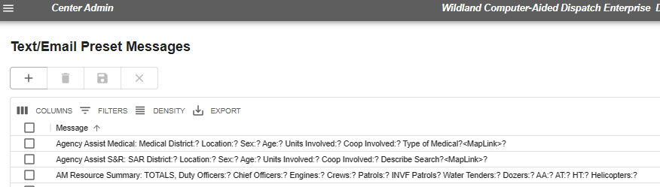

Part IV: Resources
The Resources sections include numerous grids which are configured by the Center Admin.
Figure 46- Resources Pull-down Menu
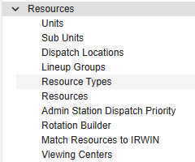

Units
Figure 47 - Units Panel
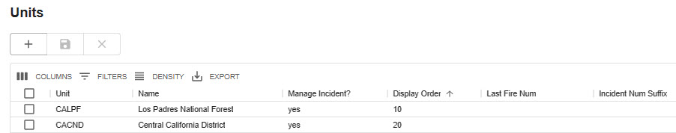

Enter the appropriate information in each column:
- Unit – enter free text (needs to match the NWCG standards).
- Name – enter free text.
- Manage Incident -yes or no pull-down if you manage incidents for this unit.
- Display Order – enter a number to create the order in which you want them to appear in Incident Panel.
- Last Fire Number - Set last fire number assigned – if fire numbers are per Unit.
- Incident Num Suffix – As example, if more than one center dispatches for a state land office, the user might enter a B here and save it. Now, every incident this user creates for this unit will have the letter B at the end of the incident number. So, if the incident number would normally be 1582 and if it is for this unit, the incident becomes 1582B or 231582B with the year prefix.
- Save your work.
If the user tries to save a duplicate unit. The user will now get an alert when trying to save a unit that already exists.
Figure 48 – The Alert of an Existing Units.
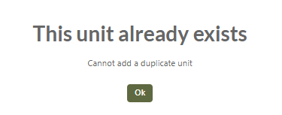

Subunits
Use Subunits to identify the administrative areas (Such as Ranger Districts) for purposes of tracking the fires occurring on the area on the Fires tab of the Incident Panel.
Figure 49 - Subunits allows the user to create a subunit.
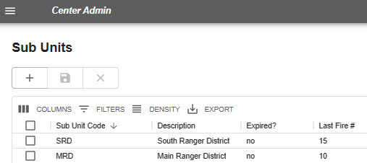
Enter the appropriate information in each column, as follows:
- Subunit Code – is the short identification of the administrative area.
- Description is entered as free text.
- Expired? yes or no pull-down.
- Last Fire Number Set last fire number assigned.
- Save your work.

Dispatch Locations
Figure 50- Dispatch Locations
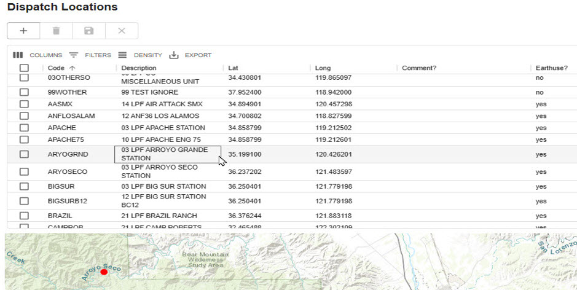
Dispatch Locations describes the location to which resources are dispatched.
- Enter the appropriate information in each column, as follows:
- Code Initial Dispatch Location (Code an identifier)
- Provide a Description
- Provide the Lat/Lon in decimal degrees.
  - Longitude is assumed to be west.
  - No minus sign used.
- Comment? – for future reference.
- Earth Use? Set to true if you want WildWeb to show this Dispatch Location (potential future enhancement.)
- Save your work.

Line Up Groups
Figure 51 - Lineup Groups
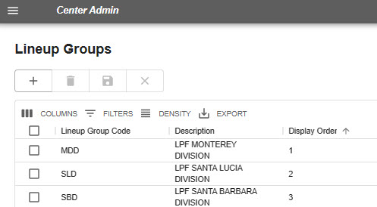
Lineup Groups allow the user to do morning statuses by group. Lineup Groups are typically created for different Districts, Field Offices, etc.
Create a separate Lineup Group for each agency in your center, if the morning Line Up comes in separately for each.
To do so:
- Enter the appropriate information in each column.
  - Lineup Group Code
  - Description
  - Display Order – number control the order on the Line Up Panel
- Save your work.

Resource Types
On the Resource Types panel, the Center Admin populates the information about each resource type used by the dispatch center.
Figure 52 - Resource Types (Fire, Other, LE, Medicaid, Structure, etc.)
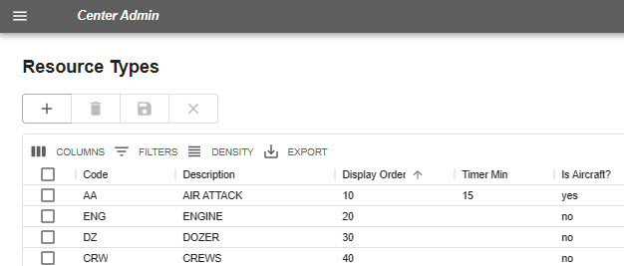
Enter the appropriate information in each column.
- Code is the name of the Resource Type
- Description is the description of the resource.
- Display Order is the number that merely controls the order in which responding Resources are listed on the Incident Panel.
- Timer Minutes is the default number of minutes for the Timer to run for each type of Resource.
- Is Aircraft? Use the pull-down menu and answer yes or no, as appropriate.
- Save your work.

Resources
Add a Resource
Click on the “Plus” button.
Figure 53 – Adding a Resource.
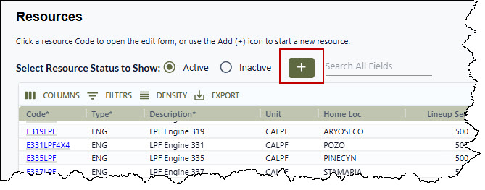
After clicking on the “Plus” button, a blank form will appear.

Figure 54 – Blank Resource Record Form
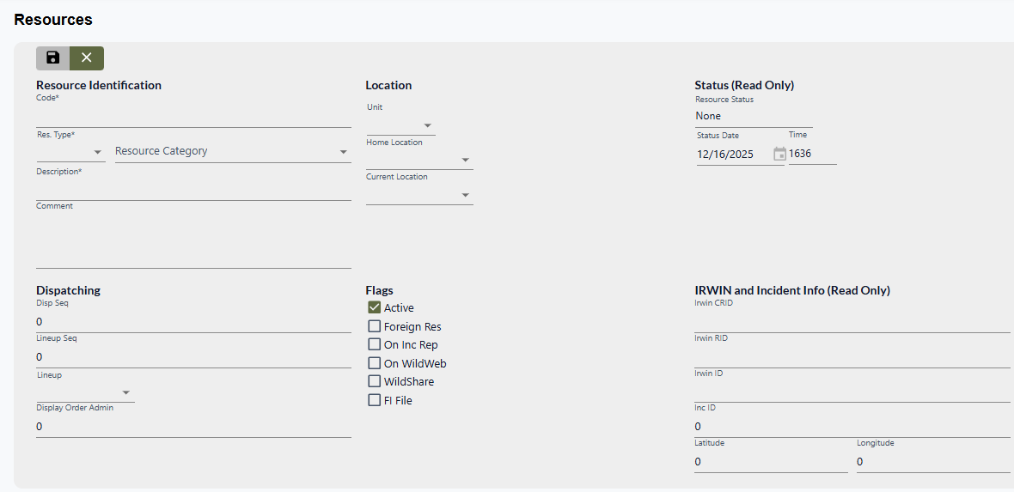
The following fields are required, Code, Res Type and Description. If one or more of the required fields are not completed a message will appear reminding the user to add the required fields.
Figure 55 – Message of Missing Required Fields.
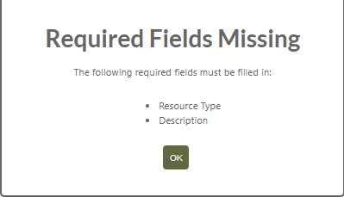

Resource Identification
- Code is the WildCAD-E name of the Resource. Keep this as short as possible, since it will be displayed on numerous reports and lists. For example, consider E31, not ENGINE31LPF.
- Res Type is pull-down list that was created in the Resource Type Grid
- Resource Category is a pull-down menu used to select the Resource Category/Type. This is required for any resources to be integrated with IRWIN.
- Description is the name or description of the resource.
- Comments may be entered and edited in the space provided.
Figure 56 – Resource Identification.
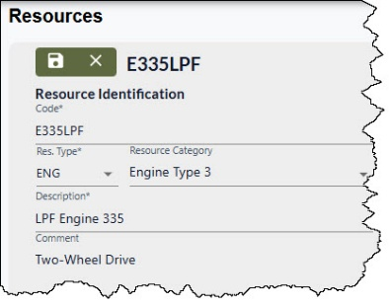

Dispatching
- Disp Seq is value set by a Dispatcher in the Daily Routines, Station Dispatch Sequence.
- Lineup Seq is the sequence control for the order in which Resources are listed on the Line Up Panel. This has nothing to do with the order in which they are dispatched - merely the appearance on the screen.
- Lineup is a pull-down list that was created in the Line Up Group Grid.
- Display Order Admin is value set by a Center Administrator in the Center Admin, Resources, Admin Dispatch Priority. Which is the “Default" value for the Station Dispatch Sequence. If Disp Seq is blank but Display Order Admin has a value, then that value is used for the sort of priority.
Figure 57 – Dispatching Information.
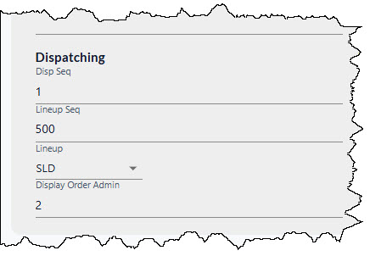

Location
- Unit is a pull-down list that was created in the Units Panel.
- Home Loc is a pull-down list that was created in the Dispatch Location Grid.
- Current Location is a pull-down list that was created in the Dispatch Location Grid.
Figure 58 – Location Information.
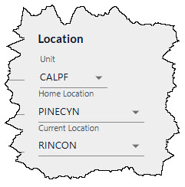

Flags (Click the check box as needed)
- Active - The Resource defaults to active. To set the Resource as inactive, unclick the box.
  - Resources cannot be set to inactive if they are assigned to an incident.
  - If a resource is set to "inactive," and they are part of a group, the resource will be removed from the group.
  - If the remaining group contains only 1 resource after a member is set to inactive, the group is cleared.
- Foreign Res indicates this resource is a foreign resource. Foreign resources are resources not from outside your units.
- On Inc Rep means you want this Resource listed on the printed Incident Reports.
- On WildWeb if this Resource will show on the internet reports; from WildCAD-E, as WildWeb.
- WildShare allows any center to make the status of one or more resources available to other centers. In turn, a center can view the status of another center’s shared resources.
- FI File indicated that the Resource shown is by default used by the law enforcement Field Interrogation File panel.
Figure 59 – Setting the Flags.
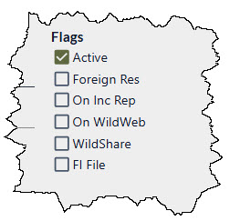

Status (Read Only)
- Resource Status Displays the current status of a resource.
- Status Date and Time Displays the date and time a status changed.
Figure 60 – Resource Status.
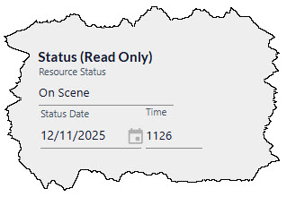

IRWN and Incident Infor (Read Only)
- Irwin CRID - Capability Request ID if resource is on a filled request
- Irwin RID - Resource ID if resource is matched in IRWIN
- Irwin ID - Incident ID if resource is on an IRWIN incident
- Inc ID – WildCAD-E Inc ID if resource is on a WildCAD-E incident
- Latitude and Longitude is a read only based on the status of the resource by either the incident location, home location or at a point designated on the map.
Figure 61 – IRWIN Information.
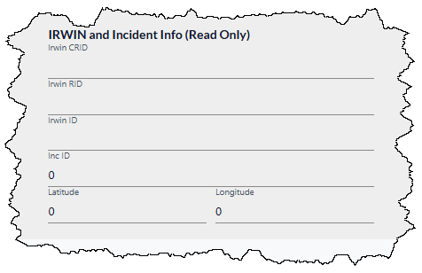
The user can toggle between viewing resources that are either Active or Inactive. Active resources are selected by default. This feature was necessary because if the center has too many resources for the browser to display, the resources page will not load.
Figure 62 - Toggle button between Active and Inactive
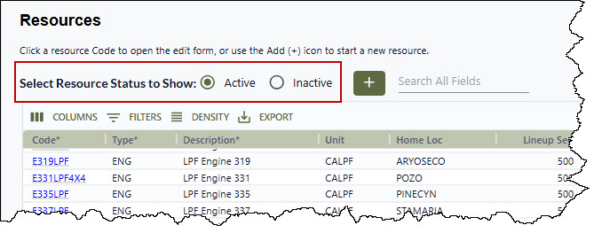
To save the resource record, click the “Save” button.
Figure 63 – Save Resource Information.
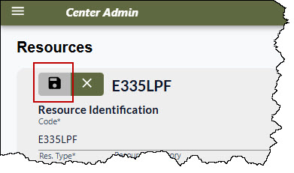
To close or disregard previous editing click on the “X” button.
Figure 64 – Closing or Disregarding Resource Information.
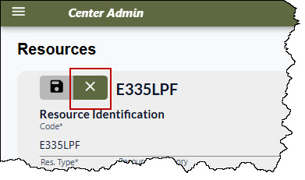
To Editing a Resource.
Select a Resource one of the following methods:
- Using the Seach All Fields;
- By entering a unique field from one of the columns;
Figure 65 – Seach All Fields.
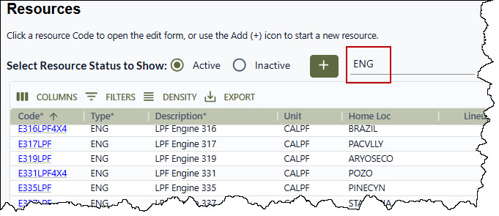
- Using the Filter by selecting a column, operator, and value; or
Figure 66 – Using the Filter.
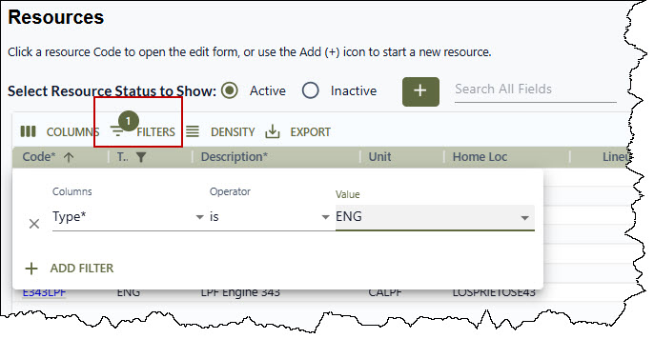
- Clicking on a resource in the Code column.
Figure 67 – Using the Code Column for selecting a Resource.
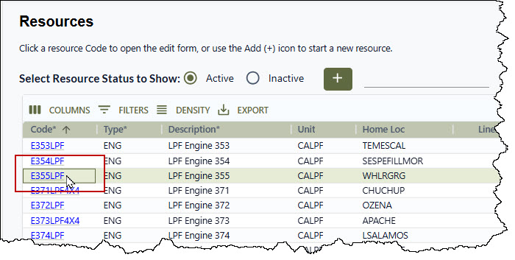

Admin Station Dispatch Priority
Figure 68 -Admin Station Dispatch Priority sets resource priorities by station.
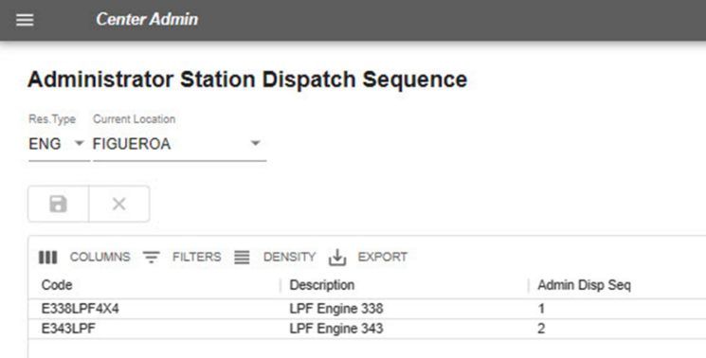
Sets resource priorities by station. To do so:
- Set the “Res Type.”
- Select the “Current Location.”
- Resources will then be shown.
- Enter the appropriate dispatch priority for each resource.
- Save your work.

Rotation Builder
Figure 69 – Builds rotation by resource type. Allows Center Admin to add, edit or delete the resources, as needed.
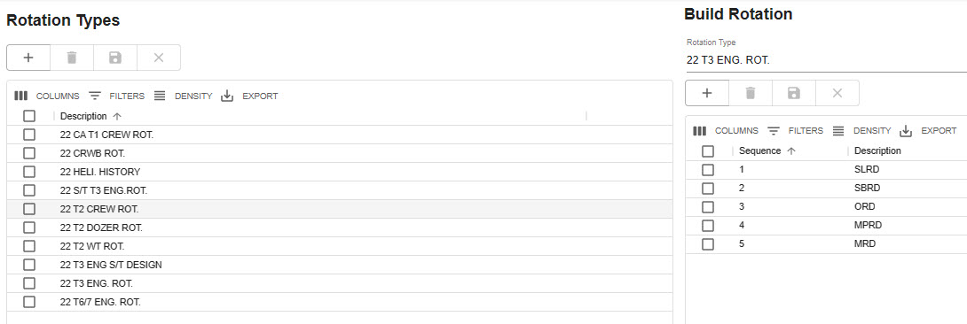
Builds rotation by type of resource (engines, dozers, crews, WTs, etc.) and allows the user to edit, add or delete those resources.
In the panel “Rotation Types:”
- Enter the appropriate “Description” on a row.
  - Save your work.
In the panel, “Build Rotation:”
- Select the rotation type from the Pull-down menu.
- Enter the appropriate information in each column.
  - Add the Sequence
  - Provide the Description
- Save your work.

Match Resources in IRWIN
“Match Resources in IRWIN” allows the user to match the same resources in both the IRWIN and WildCAD systems. WildCAD Resources are on the left side of the page, and IRWIN Resources are on the right side, matching the order that the user would select resources. In addition, when clicking a resource from either grid, if the resources have a match, the matching records from both grids will be highlighted green.

Figure 70- “Matching Resources in IRWIN” allows you to match the same resource in both systems.
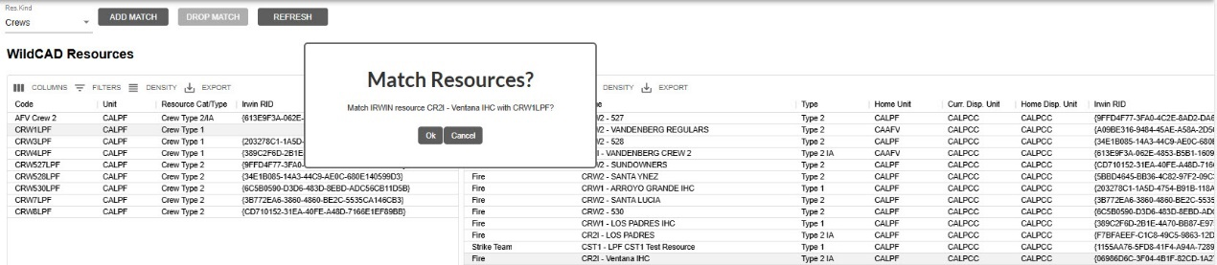
Select the type of resource (Res Kind) from the Pull-down menu.
  - Aircraft: Helicopters.
  - Crews: IRWIN ignores primary ability for crews when performing match resources.
  - Equipment: Include engines, dozers, water tenders, and tractor plows.
The panel will display all IRWIN resources whose current dispatch center or home dispatch center belongs to you. The WildCAD-E Resources are those whose Resource Cat/Type matches your Res Kind selection in the upper left, and whose Unit is one for which your dispatch center dispatches.
To add a match, select an IRWIN Resource and a WildCAD Resource. Choose “Add a Match.”
Figure 71 - Drop a previously matched resource.
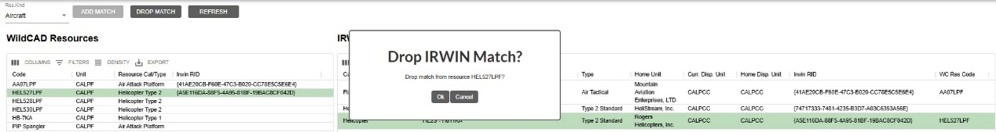
To drop a matched resource:
- Select the WildCAD Resource the user wants to drop from the match.
- Click the “Drop Match” button.
- To refresh any changes made, use the “Refresh” button.
  - Save your work.
Un-matching of resources:
Un-matching of resources is no longer allowed if the resource is currently rostered with at least one person, or the resource currently has a filled capability request. An error will be displayed when attempting to un-match these resources.
Figure 72 – Error if Resource is Rostered or on a Request.
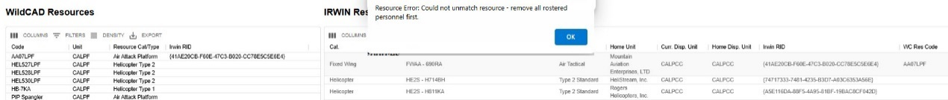

Viewing Centers (WildShare)
- The Center Administrator configures which centers and resources they would like their dispatchers to be able to view.
- Select the Dispatch Center.
- Select the resources to be viewed in the WildShare panel. In this example, the CALPCC Resource is being shared with CASBCC.
- Click Save
Figure 73 – Viewing Center Configuration
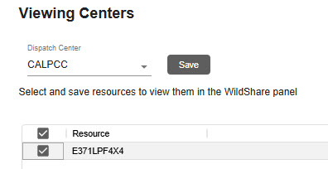

Part V: Response Areas
Figure 74 - Response Areas Pull-Down Menu
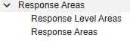
The Response Areas section includes two grids which are configured by the Center Admin. They include:
- Response Level Areas
- Response Areas
Each Response Area “lives” within one Response Level Area (RLA). If, in fact, the Response Area contains two or more RLAs, the user should either divide the Response Area into more than one or choose one RLA to represent the fire danger for the entire Response Area.

Response Level Areas
Figure 75 - Response Level Areas panel.
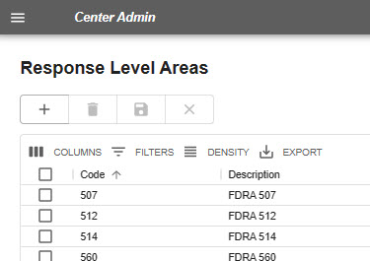
Response Level Areas are areas with common fire danger rating indices. For each Response Level Areas enter:
- Code
- Description
- Save your work.

Response Areas Panel
Figure 76 - Response Areas Panel with Information Populated and Associated Map
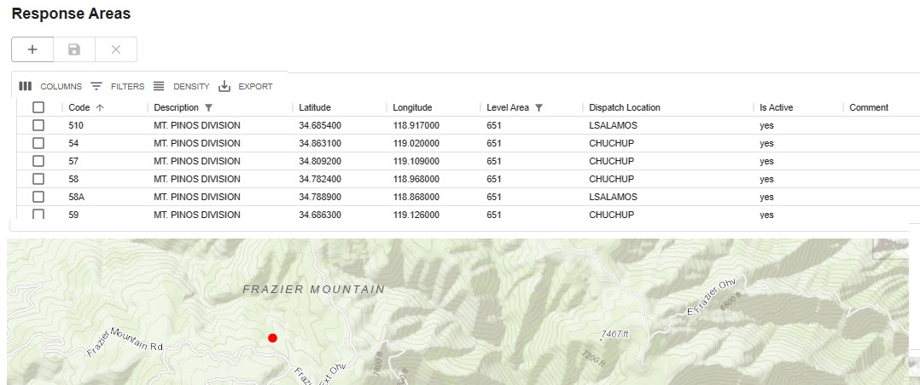

Response Areas – Data Entry
To populate this panel, enter the following information:
- Code: It is crucial that the “Code” (ID) entered for each Response Area is precise and matches the information in the Response Area GIS layer attribute table.
- Description: Enter a name or description of the area.
- Latitude / Longitude: The longitude is assumed west (no minus sign) and is entered in decimal degrees. This location represents the workload (e.g., fire occurrence) within the response area.
- Level Area: Select the Response Level Area for each Response Area from the Pull-down list of RLA’s you previously created.
- Dispatch Location: When Resources become “Available” from an incident, their location will be set to this station for the purpose of dispatch priority.
- IS Active: The user represents the Response Area remains valid by setting to “Yes.” If the Response Area is no longer valid, select “No.”
- Comment: This is merely for the Center Admin’s use and does not show elsewhere.
- Save your work.
- NOTE: The Response Areas have historical value and therefore cannot be deleted from the database. Instead, use “no,” which is set Active = false.

Part VI: Dispatch
Figure 77 - Dispatch Pull-Down Menu
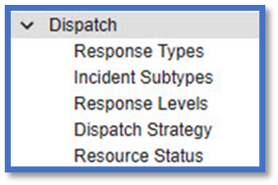
The Dispatch section includes numerous grids and panels which are configured by the Center Admin. They include:
- Response Types
- Incident Subtypes
- Response Levels
- Dispatch Strategy
- Resource Status

Response Types
The Dispatch Strategy is developed by Response Type, not by Incident Type, allowing you to use a Dispatch Strategy for more than one Incident Type.
For each response type, enter:
- Code
- Description
- Display Order
- Then, save your work.
Figure 78 - Response Type Panel allows the user to enter code, description and display order.
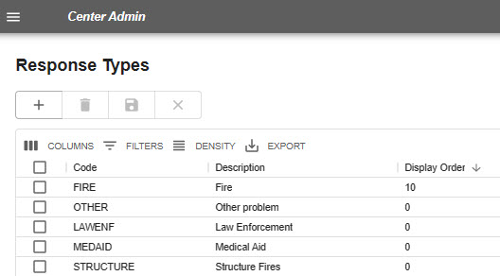

Incident Subtypes
Use the Incident Subtypes to display a more detailed definition of the Incident Type; you may list as many Subtypes as desired for each Type.
For each Incident Subtype enter:
- Incident type
- Description
- Display Order
- Expired?
- Save your work.
Figure 79 - Incident Subtypes panel is where the user describes any Incident Subtypes.
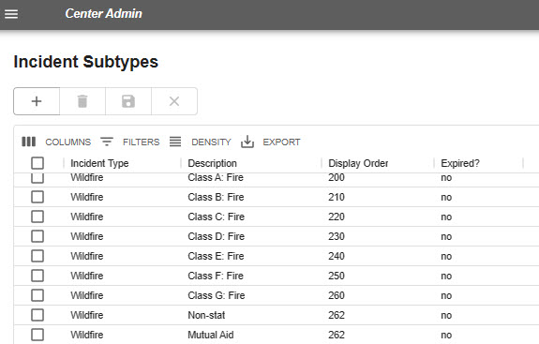

Response Levels
WildCAD-E allows you to develop standard responses based on up to six levels. Low, Moderate, and High (etc.) can be based on your choice of fire behavior or other factors. You may edit the Description of each Response Level to match the nomenclature you use in your center.
For each Response level enter:
- Code
- Description
- Display Order
- Active
- Save your work.
Figure 80 - The Response Level panel is where the user sets the type of response by level (low, moderate, high, second alarm, etc.).
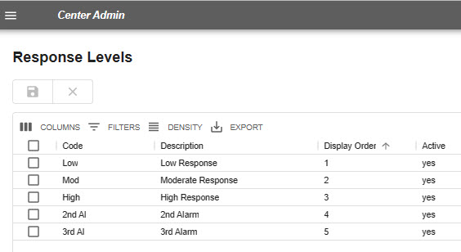

Dispatch Strategy
The user will use this screen to configure which resources WildCAD-E recommends at the start of an incident. WildCAD-E will recommend resources based on:
- Response Area is determined by WildCAD-E, using the incident latitude and longitude, as compared to your Response Area GIS layer; and allows the user to select response areas that are active.
- Response Type (e.g., “Fire” or “Law Enforcement (LE)” – Response Type is related to but different from Incident Type. Response types are groups of incident types.
  - Example: Response Types for a fire response could be used to build a preplanned response for wildfires, structure fires, or vehicle fires.
- Response Level (e.g., low, moderate, or high) is assigned each day to the Response Level Areas (RLA), which in turn is attached to an incident by the RLA of the Response Area, within which the RLA is located.
- The Closest Dispatch Locations to the response area.
- Desired Quantities of Resources are the desired number of a particular resource needed and are entered on the right-side panel.

How to Build the Dispatch Strategy
Figure 81 - Dispatch Strategy Panel
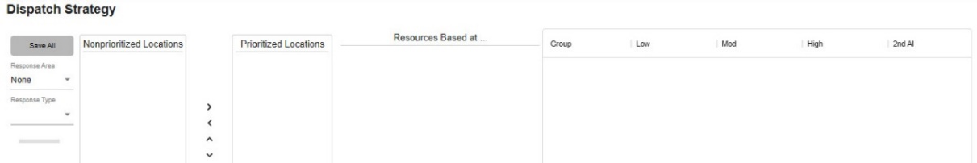

To build a Dispatch Strategy, the user will follow the steps below:

Step 1: Build a Dispatch Strategy
Figure 82 - Step 1 to Build a Dispatch Strategy
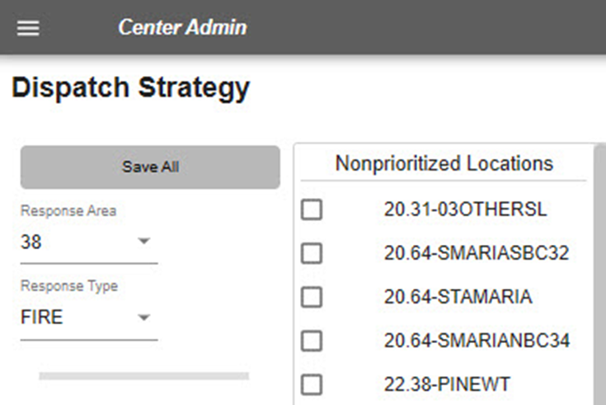
- Select a Response Area from the Pull-down menu.
- Select a Response Type from the Pull-down menu.
  - NOTE: Initially, all dispatch locations will be listed under “Nonprioritized Locations,” and ordered by the displayed air miles between the latitude / longitude of the Dispatch Location to the latitude / longitude of the Response Area.

Step 2: Prioritize Locations
Figure 83 - Step 2 in Building a Dispatch Strategy
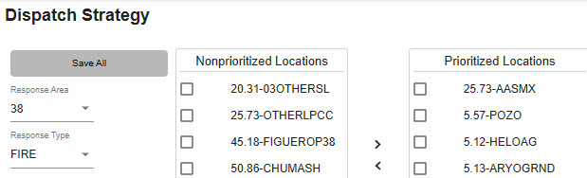
If resources based on a dispatch location under “Nonprioritized Locations” might initially respond to an incident within a selected Response Area:
- To add that location, select the location and move it under “Prioritized Location,” by using the “>” sign.
- To remove the prioritized location, select the location and move it back to the left, using the “<” sign.
- Use “up” and “down” to change the priority order.

Step 3: Desired Quantities
Figure 84 - Enter incremental quantities of resources by resource type at each Response Level.
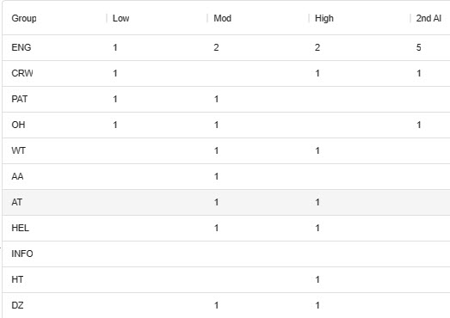
- On the left side of the Dispatch Strategy Panel, enter incremental (additional) quantities of resources by resource type to be sent at each Response Level.
- Looking at the example above, one engine will be sent when a Response Level is set to “low,” but an additional two (for a total of three) would be sent when the Response Level is set to “moderate.”

Step 4: Review Typical Cumulative Response
Figure 85 - Typical Cumulative Response
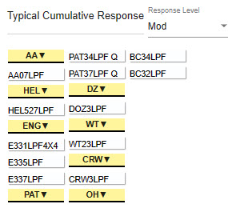
The “Typical Cumulative Response” provides the user a list of recommended resources for a particular response level provided all resources are at home and available. To see the “Typical Cumulative Response” for a certain response level:
- Under “Typical Cumulative Response,” to see a total response for “Moderate,” click one of the Response Levels within the pull-down to see which resources will be recommended (if all resources are available at their home location).

Step 5: To review what resources are at a Dispatch Location
Figure 86 - Step 5 Resource by Dispatch Location
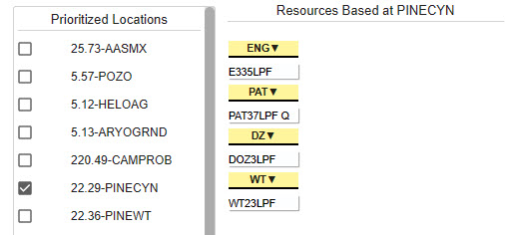
- Choose a Dispatch Location in the “Prioritized Locations.”
- View the resources under “Resources Based at.”
You can copy dispatch location priorities or resource quantities from the work you did in a different Response Area. You can also copy dispatch location priorities from a different response type. In all 3 situations, the information is copied INTO the currently selected (in the far upper left) Response Area and Response Type.

Copy Priority Locations from One Response Area to Another
Figure 87 – Copy one Station Priority to Another Response Area.
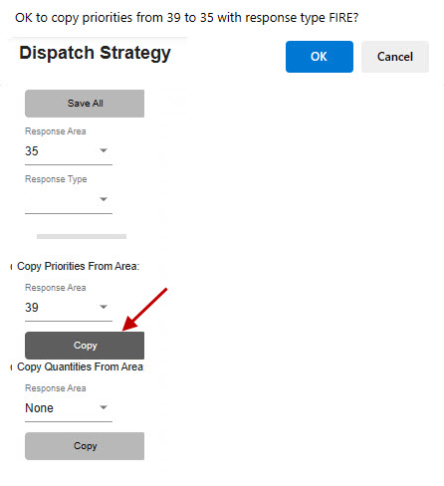

To copy dispatch location priorities from one response area to the response area presently selected in the upper left *ex. Area 35:
- Under “Copy Priorities from Area.”
- Select the Response Area from which to copy Dispatch Location priorities. (ex. Area 39)
- Click the “Copy” button (Red Arrow in Figure 59 above).
- From there you will be prompted with, “OK to copy priorities from (RA (39) with Priorities) to (RA (35) where you want the priorities copied).

Copy Quantities from One Response Area to Another
Figure 88 - Copy quantities to Another Response Area.
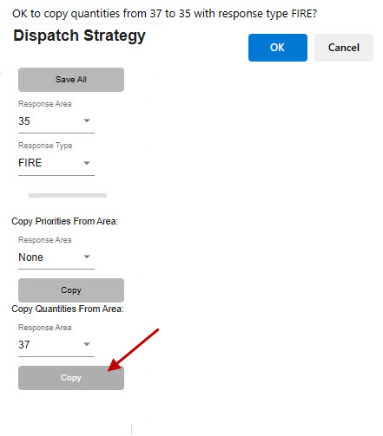
To copy resource quantities from one response area to the response area (35) presently selected in the upper left:
- Under “Copy Quantities from Area.”
- Select the Response Area (37) from which to copy resource quantities.
- Click the “Copy” button.
- From there you will be prompted with, “OK to copy resource quantities from (RA (37) with quantities) to (RA (35) where you want the quantities copied).

Resource Status
Figure 89- “Resource Status” is set to” yes or no,” by the Center Admin to determine which status the Dispatch Center will use.
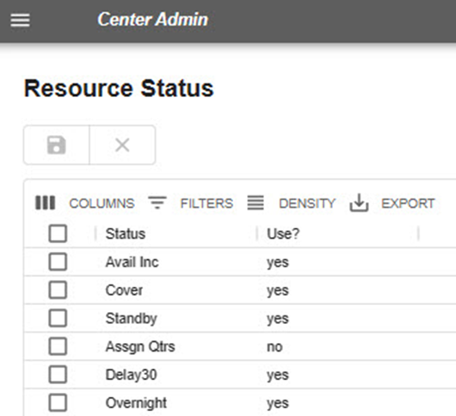
Under “Resource Status,” the Center Admin will select whether to use resource statuses in their respective dispatch center, as follows:
- In the “Use?” column, use the Pull-down menu to select:
- Yes, for use; and
- No, for do not use.
- Save your work.

Part VII: Configure Incident Tab
Figure 90 - Configure Incident Tabs Dropdown menu.
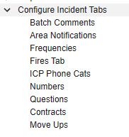
The configure incident pull-down list includes numerous tabs, many of which can be configured by the Center Administrator.

Batch Comments
Figure 91 - Batch comments provide information to potential recipients of your texts and email messages.
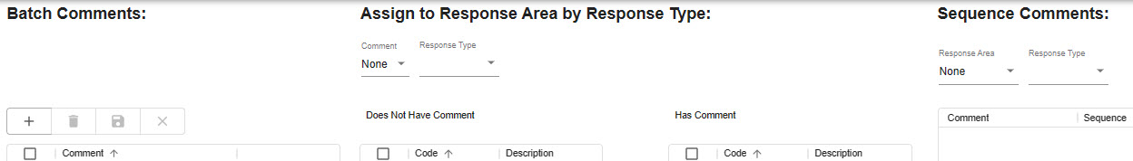
Figure 92 - Use the Batch Comments panel to create comments for use with a variety of incident types and response areas.
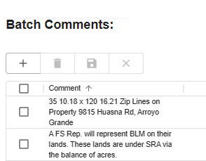
- Batch Comments provide information which will show on an Incident’s “Comments” tab. From this panel, the user can create comments by:
- Entering the comment.
- Click and Save.

Assigned to Response Area by Resource Type
Figure 93 - Batch Comments / Assign to Response Area by Response Type
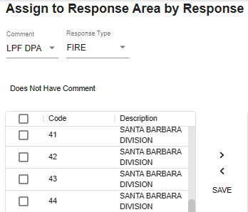
- Select a Batch Comment from the Pull-down menu.
- Select the Response Type from the Pull-down menu.
- From the “Does Not Have Comment,” move the desired comment to “Has Comment.”
Figure 94- Select comments to move from “Does Not Have Comment” to “Has Comments.”
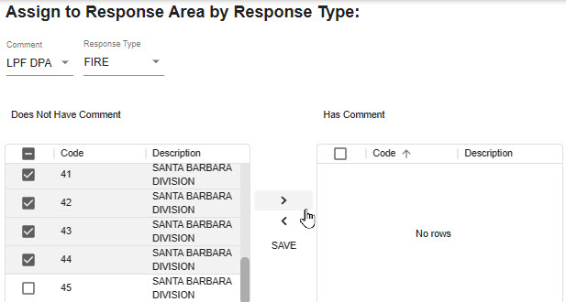
Figure 95 - Comments can also be removed by moving the comments back to “Does Not Have Comment.”
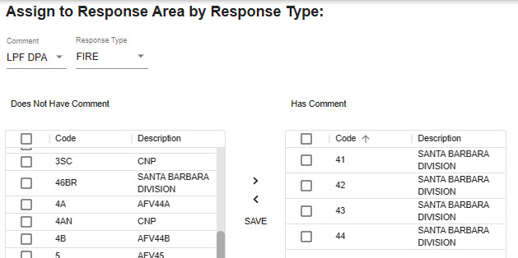
- The user can also remove comments from the list by moving the comments back to “Does Not Have Comment.”
- ALWAYS, click and save the entries.

Sequence Comments
Figure 96 – Sequence Comments
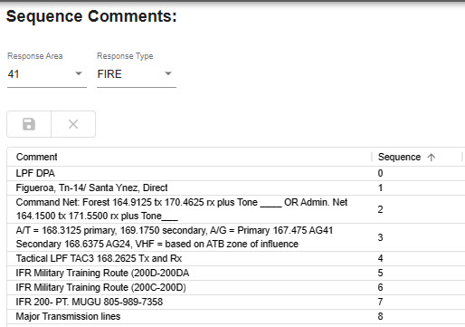
- Select Response Area from the pull-down menu. Use “ALL,” if the same batch comments apply to all response types.
- Enter the “Sequence” numbers are used only for the order in which data will appear.
- Click the save icon.

Area Notifications

Notification to Incident within Particular Response Area
Figure 97 - Incident Notification Panel is Used to assign notifications which will show on an incident’s Notify Tab for incidents within a particular Response Area
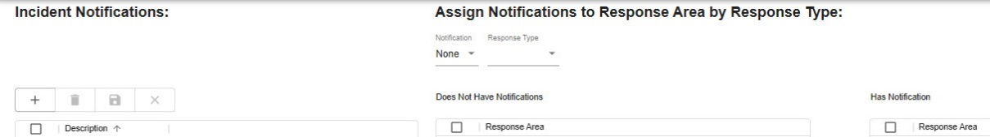
The Notify Tab on the Incident allows dispatchers to document contacts they have made throughout the incident. As Center Admin, if you want the dispatchers to always make certain contact whenever there is an Incident in a certain Response Area, use the Incident Notification Screen.
Figure 98 - Incident Notifications
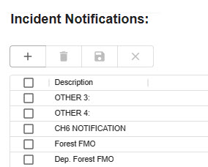
- On the “Incident Notification” Panel, enter the group to be notified.
- Save your work.

Notification to Response Area by Response Type
Figure 99 - To assign notifications to a Response Area by Response Type
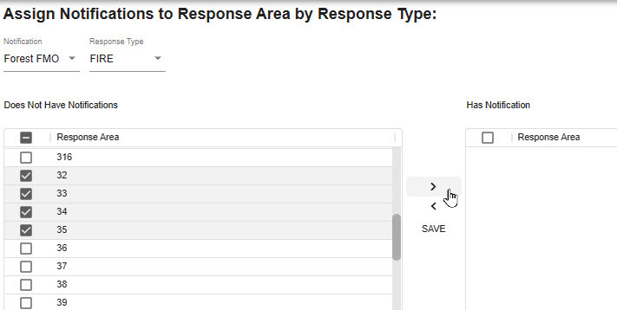
From the Pull-down menus:
- Select who gets notified under “Notifications.”
- Select the appropriate “Response Type.”
- Use “ALL,” if you want the same notification to apply to all Resource Types.

Next Step
- Choose the “Response Area” by checking the box.
- Select the “Response Area(s)” from the “Does Not Have Notification” by checking the corresponding boxes for the appropriate “Response Areas.”
- Move each response area from the “Does Not Have Notification” to the “Has Notification” panel, using the “>.”
- Click to save your work.
Figure 100 - Notify Response Areas of Notifications
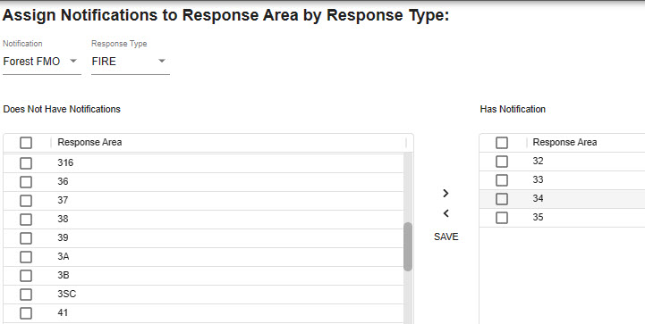

Frequencies
Figure 101 - This panel lists Frequency Types (Air, Ground, VHF, Command, etc.) and Default Frequencies
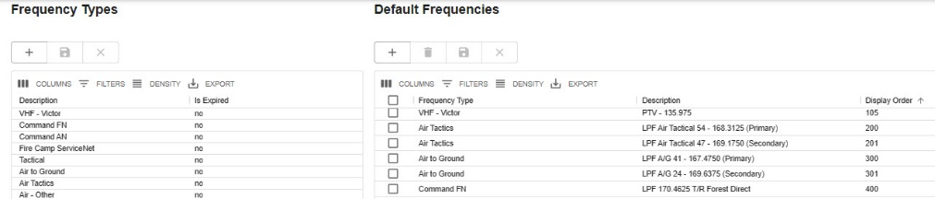
Build a list of commonly used frequencies on the screen. The sequence will set the order in which they appear. The initial sort for the default frequencies grid to be by Frequency Type and then by Display Order.
- Under the “Frequency Types,” enter:
  - The description and whether that frequency is expired (Yes or No).
  - Save your work.
- Under the “Default Frequencies,” enter:
  - The frequency type, description, and display order.
  - Save your work.

Fires Tab
WildCAD-E enables the Center Admin to configure a separate screen of fire information specific to their respective dispatch center. This screen becomes available from the Fires Tab by clicking the “Initial Report” or “Fire Report” button.
Figure 102 - Fire Tab Categories Panel
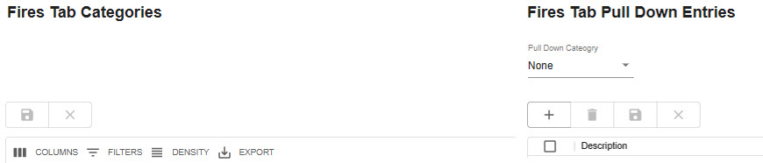
Use the “Categories” screen to create labeled blanks for the dispatcher’s use. The categories can be free text or a pull-down list (created by the Center Admin). You can enter up to 20 rows for Fire Report, and up to 20 rows for Initial Report.
Figure 103 - Use the "Categories" screen to create labeled blanks for dispatchers to complete.
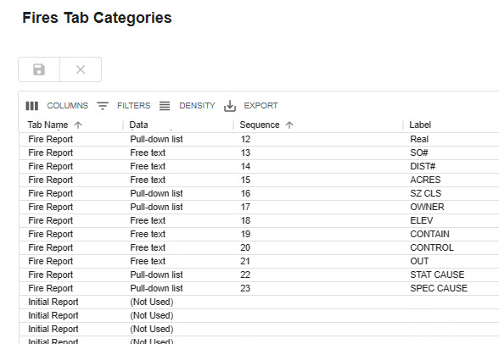
On the Fire Tab Categories Panel:
- Select a row with either “Fire Report” or “Initial Report.”
- Under Data, choose Free Text or Pull-down
- Enter Sequence
- Enter Label
- Save your Work.
Figure 104 - Fire Tab Pull-down Entries Panel
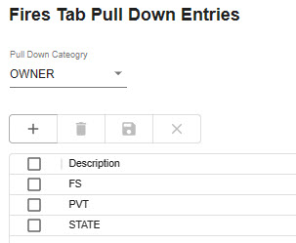
On the Fire Tab Pull-down Entries Panel,
- Select the Pull-down Categories from the list created in the Fire Tab Categories Pan.
- Enter the description.
- Save your work.

ICP Phone Categories
Figure 105 - ICP Phone Categories Tab
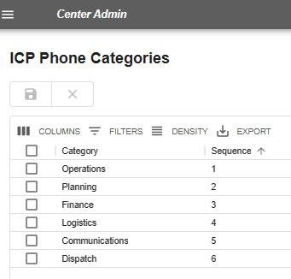
Use this screen above to configure the (up to six) categories of phone numbers on the ICP Phone Tab.
Enter the appropriate information under each tab:
- Enter the category.
- Reorder the sequence, as necessary.
- Save your work.

Numbers
Figure 106 - The Numbers Tab allows up to 20 characters.
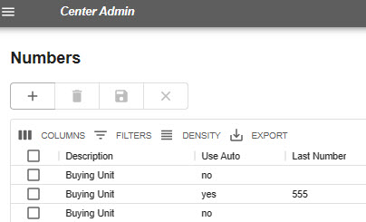
Use the screen above to configure the Numbers Tab, which allows up to 20 characters. This screen was originally created for numbers such as the incident fire number or FireCode that now have other dedicated locations. Currently, use it for any other brief information.
- “Use Auto” will allow the dispatcher to click “Auto” and receive the next number.
  - Enter the appropriate information in each column.
      - Enter the description.
      - Select Use Auto (Yes or No).
      - Enter Last Number.
      - Save your work.

Questions
Figure 107 - This tab's name will change according to the incident type.
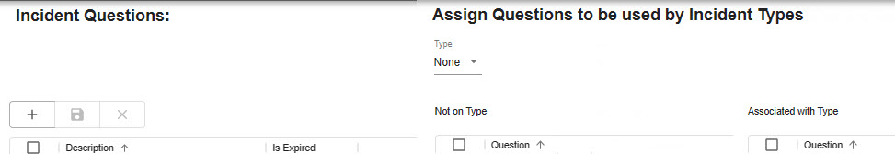
This Incident Tab’s name will change according to the Incident Type (e.g., if the incident is a wildfire incident, the tab will be called “Wildfire.”) The Center Admin will configure incident questions to be used by the specific incident type.
Using the Incident Question Section:
- Enter the question on the row under “Description.”
- Indicate Yes or No under “Is Expired.”
- Save your work.
Figure 108 - Incident Question Panel
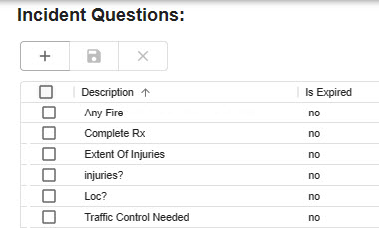
To Assign Questions to be used by Incident types:
- Select the Incident Type from the “Type” Pull-Down
- Select the “Question” from the “Not on Type”
Figure 109 - Assign questions to be used by incident type by using the ">"
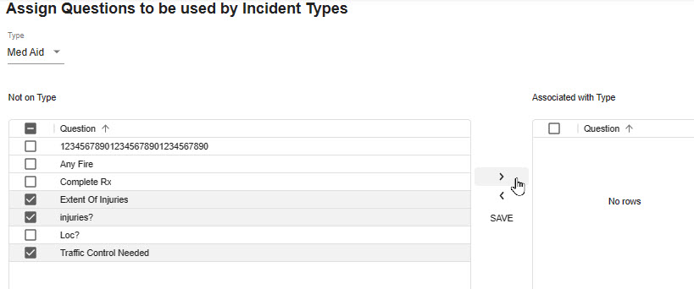
- Move each question from the “not on Type” to the “Associated with Type” panel using the “>”
Figure 110 - Move each question to the “Associated with Type” panel.
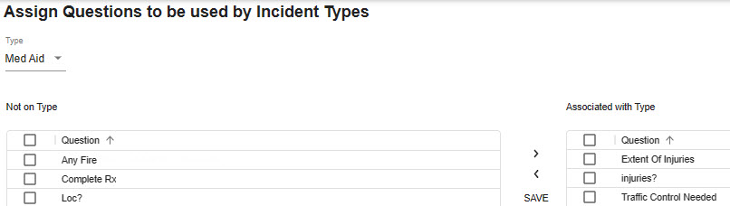
- Save your work.

Contracts
Figure 111 - Contract Type Panel
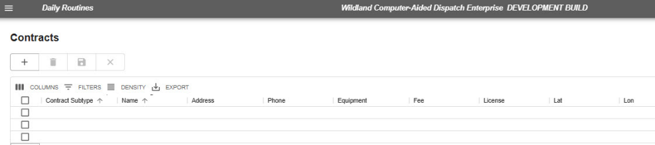
On the “Contract Type” panel:
- Enter the description of the contract and save your work.
- Save your work.
On the “Sub Type” panel:
- Select the “Contract Type,” from the Pull-down types of lists created in the Contract Type Panel
- Add or edit the (Sub Type) Description.
- Save your work.
Figure 112 - Contract and Contract Sub Types
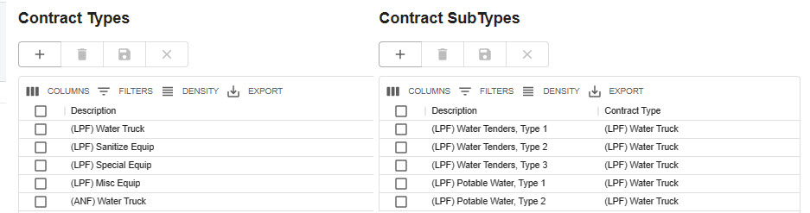

Move Ups
Figure 113 - Specify desired move ups on the "Move Ups" screen.
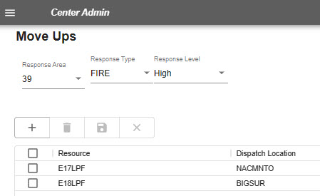
The Move Up Tab will remind dispatchers to move certain resources to cover the Incident.
- Assign Questions to be used by Incident type Panel.
  - Select the “Response Area,” from the Pull-down menu.
  - Select the “Response Type,” from the Pull-down menu.
  - Select the “Response Level,” from the Pull-down menu.
  - Enter the Resource and Dispatch Location to move up to.

Appendices

Appendix I – Icons and Function Keys
When a function key is available, users can either use the icon or function keys to access those panels within WildCAD-E.
Table 1- Table of WildCAD-E Icons
WildCAD-E Icon | Function Key | WildCAD-E Icon Definition
 | F9 | Create a New Incident Panel Icon - Starts a new Incident, although the user will have to enter all information such as location and response area.
 | N/A | Create a New Complex Panel Icon – There is no function key available for “Create a New Complex Panel.” Users will use the icon to access this function.
 | F8 | Open Incidents Panel Icon – Opens the screen that displays existing, open Incidents.
 | F2 | Open Incidents Panel Icon – Opens the “Search Incident Panel” for the user
 | F7 | Resource Status Icon – Opens the screen where you can perform status changes that are not related to Incidents, such as “In Service.”
 | F12 | Daily Log Panel Icon – Opens the screen that display the “Daily Log,” where you can document the activities not directly related to a specific Incident.
 | F5 | Map Panel Icon – Opens the WildCAD-E map.
 | F4 | Open Timers Panel Icon – Opens the Timers Panel for the user
 | N/A | Create a New Timer Icon – There is no function key associated with the “Create a New Timer” icon. Users will use the icon to access this function.
 | F3 | Create a New Field Interrogation Fire (FI) or be able to search for existing FI files.

Appendix II - Grids
Grids are a spreadsheet style interface with a variety of features available to those with Center Admin access to WildCAD-E.

Sort Order of a Grid
- Click on any column heading or label.
- Sort by ascending (alphanumeric) with the arrow pointing up, by clicking once.
Figure 114 - Ascending pull-down menu.
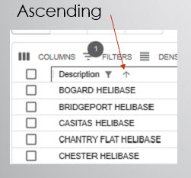
- Sort by descending with the arrow pointing down, by clicking twice.
Figure 115 - Descending pull-down menu.
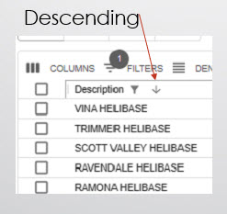
- For no sort, click a third time.
Figure 116 - Click three times to choose no sort.
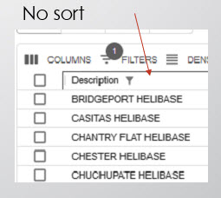

Add a Record or Row to the Grid
Figure 117 - The "+" sign opens a blank row at the top of the grid.
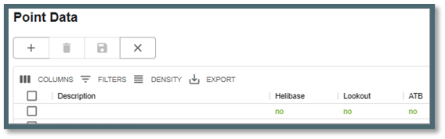
- Click the plus “+” sign to open a new blank row at the top of the grid.
- Enter all information across the row.
Figure 118 - The "Disc" icon saves a new record or edits an existing record.
- When done, click on the “Disc” icon. Use the “Disk” icon to save a new record or edit an existing record.
Figure 119 - Use the "x" icon to cancel the new record.
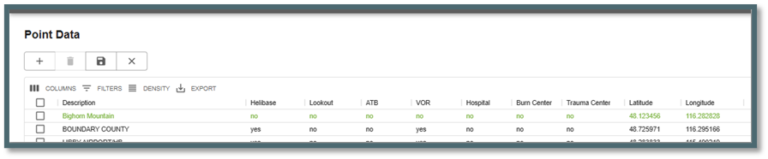
- Cancel a new record by clicking on the “x.”

Delete a Row to the Grid
Figure 120 - Select row for deletion by checking the box.
- Select the row for deletion by checking the box to the left of the row.
- Click the “Trash Can” icon.
- Click the “save” icon to complete deletion of the row.

Actions and Settings at the Top of the Grid

Columns
- On the grid, columns can be either hid or viewed.
- To hide, turn off the “slider” for the respective column.
Figure 121- Slider column.

Filters
- Filters allow the user to search for records.
  - Select “Filter;” then the column.
  - Using the “Operation” pull-down menu, select contains, starts with or equals.
  - In the “Value” area, type in what you want to search for.
Figure 122 - Filters allow the user to search for records.

Density
- Density slightly changes the width and height of the information on the grid.
Figure 123 - Density slightly changes the height and width of the information on the grid.

Export
- Export typically downloads to a CSV file.
Figure 124 - Export is used to download a .csv file.
- The .csv file will download into the user’s workstation “Download” folder.
Figure 125 - .CSV file downloads to the Center Admin or users station download files.
- If the user sorted the grid record first, the sorted information would be the only information exported to the .csv file.

Appendix III – Incident Types
Table 2 - Table of Incident Types
Code | Description | Expired?
A/C Down (expired 4/2024) | Aircraft Down | Yes
AC – Air Accident | Aircraft Accident | No
AC – Marine Accident | Marine Accident | No
AC – Motor Vehicle Accident | Motor Vehicle Accident | No
AC – Rail Accident | Rail Accident | No
AC – Structure Accident | Structure Accident | No
Aircraft | Aircraft | No
AP – Critical Incident Stress Management / Peer Support | Critical Incident Stress Management / Peer Support | No
AP – Law Enforcement (internal) | Law Enforcement | No
AP – Management Event (internal) | Management Event (internal) | No
AP – Resource Programs (internal) | Resource Programs (internal) | No
Emerg Stby | Emergency Standby | No
F1 – Debris /Product Fire | Debris Fire | No
F1 – Non-Statistical/Other | Nonstatistical Fire | No
F1 – Prescribed Fire | Prescribed Fire | No
F1 – Structure Fire | Structure Fire | No
F1 – Vehicle Fire | Vehicle Fire | No
F1 – Wildfire | Wildfire | No
FM – Complex Incident | Complex | No
FM – Emergency Stabilization | Emergency Stabilization | Yes
FM – False Alarm | False Alarm | No
FM – Fire Rehabilitation | Fire Rehabilitation | Yes
FM – Incident/Event Support | Incident/Event Support | No
FM – Out of Area Response | Out of Area Response | Yes
FM – Preparedness/Preposition | Preparedness/Preposition | No
Hazmat (expired 04/2024) | Hazmat | Yes
HZ – Biological or Toxic Conditions | Biological or Toxic Conditions | No
HZ – Explosives or Electrical Dangers | Explosives or Electrical Danger | No
HZ – Flammable as, Oil, and other liquid conditions | Flammable Gas | No
HZ – Radioactive/Nuclear Conditions | Radioactive/Nuclear Conditions | No
Med Aid | Medical Aid | No
Misc | Miscellaneous | No
MRO | Manage Res Obj | No
N/A | N/A | No
NatDisastr (expired 04/2024) | Natural Disaster | Yes
ND – Earthquake | Earthquake | No
ND – Flooding | Flooding | No
ND – Hurricane/Typhoon | Hurricane/Typhoon | No
ND – Landslide/Mass Earth Movement/ Avalanche/Sinkhole | Movement/Avalanche/Sinkhole | No
ND – Severe Winter Weather | Severe Winter Weather | No
ND – Thunderstorm/Tornado/High Winds | Thunderstorm/Tornado/High Winds | No
ND – Tsunami | Tsunami | No
ND – Volcano | Volcano | No
PA – Community Event | Community Event | No
PA – Infrastructure Event | Infrastructure Event | No
PA Public Service Organization Event | Public Service Organization Event | No
Pub Asst (expired 04/2024) | Public Assist | Yes
Resc Order | Resource Order | No
SAR (expired 04/2024) | Search & Rescue | Yes
Smoke Chk | Smoke Check | No
SR – Marine Search/Rescue/Recovery | Marine Search/Rescue/Recovery | No
SR – Medical Assist | Medical Assist | No
SR – Urban Search/Rescue/Recovery | Urban Search/Rescue/Recovery | No
SR – Wildland Search/Rescue/Recovery | Wildland Search/Rescue/Recovery | No
TR – Classroom Training | Classroom Training | No
TR – On-the-Job Training | On-the-Job Training | No
TR – Proficiency & Currency Event | Proficiency & Currency Event | No
TR – Simulation | Simulation | No

Appendix IV - Alternate Authentication When FAMAuth is Unavailable
Alternate Authentication feature enables users to log into WildCAD-E using a secure alternative method. If FAMAuth is experiencing an outage and is unavailable, users are automatically redirected to this feature when attempting to log into WildCAD-E.

If FAMAuth is unavailable, the user can access WildCAD-E by going directly to the URL associated with the desired environment:

- WildCAD-E OAT is accessible at: wildcadoat.firenet.gov.
- WildCAD-E PROD is accessible at: wildcade.firenet.gov.
In the case where FAMAuth is fully functional, WildCAD still has “AltLogin” is enabled (mode=on), WildCAD-E will allow the user to login through the portal rather than forcing the alternate login method.
WildCAD-E will do “health checking” and error handling for cases where the FAMAuth hosted server is up but doesn’t fully load the FAMAuth page or starts loading then resets the connection.
Previously, a user must have accessed at least one center in WildCAD-E via the FAMAuth method to successfully use the alternate authentication. After entering the URL for OAT or PROD and WildCAD-E detects that FAMAuth is unavailable, the user is prompted to generate a one-time secure code.

To start the process, click on “Generate Code.”
Figure 126 - Select Generate Code
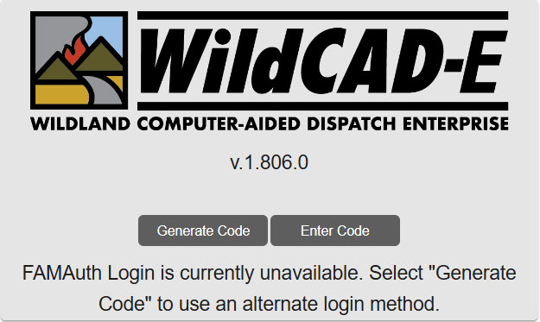
The user is prompted to enter their email associated with their FAMAuth ID account for the code and link to log into WildCAD-E. Then click on “Go.”

Figure 127 - Enter Your Email
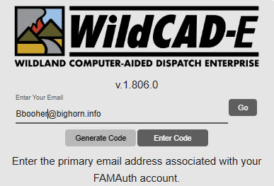

Go to the user’s email. The code/link is only valid for 2 minutes.
Figure 128 - Go to Your Email
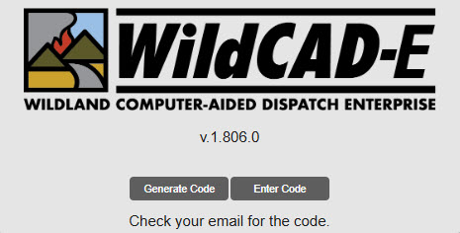
The user can click directly on the link in the email or copy the code and enter the code back to the WildCAD-E login page.
Figure 129 - Email Link or Code
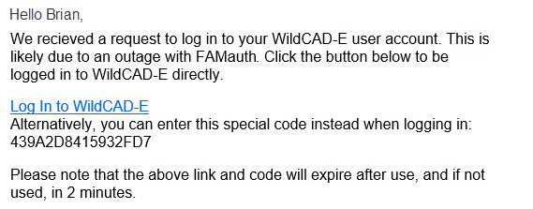
Entering the code in the WildCAD-E login page, then click on “Go.”

Figure 130 - Using the Code
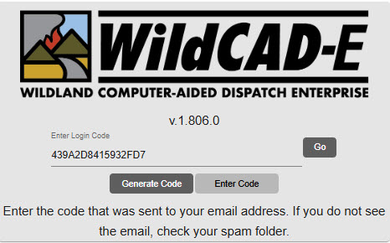
Users will be logged into the last center or select a center with the same roles assigned as the last time you were working in that center.
Figure 131 - Select a Center
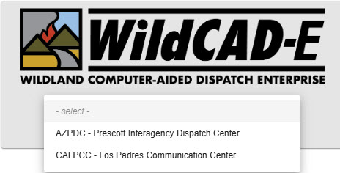

WildCAD-E
Users Guide for Center Admin
Version 2.0.1
December 2025

